
Executive Director of Education Services
Education Glasgow City Council
Maureen McKenna City Chambers East Building
40 John Street
Glasgow G1 1JL

Our Ref MMcK/SMcC
Date 23 June 2021

To Parent/Carer

Dear Parent/Carer

Free School Meals – Summer Payment Eligibility

As we reach the end of the school term, I wanted to inform parents and carers who currently meet the eligibility criteria for free school meals that they will receive an additional one-off summer payment of £100 by Wednesday 30 June 2021.

This is part of the Scottish Government’s pandemic financial support.

You do not need to contact us or make a new application if your family is already in receipt of free school meals and if you have received previous free school meal holiday payments in the last year.
The money will automatically be paid directly into your bank account by 30 June and along with your footwear and clothing grant of £110 for each eligible child in your family.

Families who are only entitled to footwear and clothing grant will receive £110 for each eligible child in their family by 30 June.

The additional summer payment is for existing pupils in our schools only and will only be paid to eligible families and not to all pupils in P1 -P4 who receive universal free school meals in a Glasgow primary school.

New applicants (excluding new August P1 intake) who apply before 13 August 2021 and meet the eligibility criteria will be paid the £100 additional summer payment and will receive this within two weeks of the new application being made.

If you think that your family might qualify for free school meals please visit our website to find out more details on the eligibility criteria and fill out an application at https://www.glasgow.gov.uk/schoolsandlearning - there’s also a list of frequently asked questions which may help with any enquiry you have.

Thank you once again for your support during a very challenging year and please enjoy the summer holidays when they come.

Yours sincerely
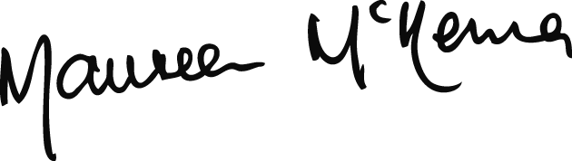

MAUREEN McKENNA
Executive Director of Education Services

