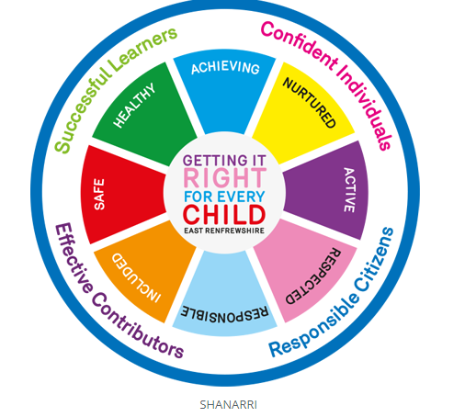

Many of the key components of GIRFEC can be found within a nurturing approach, including the focus on wellbeing, an understanding of resilience. A nurturing approach recognises that positive relationships are central to both learning and wellbeing. A key aspect of a nurturing approach is an understanding of attachment theory and how early experiences can have a significant impact on development. It recognises that in school settings all staff have a role to play in establishing the positive relationships that are required to promote healthy social and emotional development and that these relationships should be reliable, predictable and consistent, where possible. A nurturing approach has a key focus on the school environment and emphasises the balance between care and challenge which incorporates attunement, warmth and connection alongside structure, high expectations and a focus on achievement and attainment.

Partnership With Families

Parents, carers and families are by far the most important influences in a child's life. Their support can play a vital role at all stages of education. Parents who take on a supportive role in their children's learning make a difference in improving achievement and behaviour. Positive relationships between school and home allow the child to feel safe, secure and confident.

What is Nurture?

‘To Nurture is to care and protect someone or something while they are growing’

What does a Nurturing School mean?

Nurture groups and nurturing approaches are increasingly being introduced across primary, secondary and early learning and child care (ELC) settings. Research clearly demonstrates the impact that nurture can have on attainment as well as social and emotional competences. At the heart of nurture is a focus on wellbeing and relationships and a drive to support the growth and development of children and young people, A nurturing approach has been promoted as a key approach to supporting behaviour, wellbeing, attainment and achievement in Scottish Schools.

What is a Nurture Group?

Nurture groups offer a short term, focused intervention which addresses barriers to learning arising from social, emotional or behavioural difficulties, in an inclusive, supportive manner. Children and young people continue to remain part of their own class group. The nurture group works alongside the whole school nurturing approach.

How does Nurture fit with Scottish Education?

Getting it Right for Every Child (GIRFEC) places children and young people’s wellbeing at the centre of all assessment and planning. It recognises that children and young people will have different experiences in their lives and have the right to expect appropriate support from adults to allow them to grow and develop and reach their full potential.

**Hillington Primary**

**Nurture**



**What is a Nurturing School?**



The Nurturing Principles

A Nurturing School is based on the understanding of 6 Nurturing Principles.

1. Children’s learning is understood developmentally

All children are different and learn at different rates. Individuals should feel supported and challenged in their learning. Sometimes children face barriers to learning, in a Nurturing environment staff provide support, guidance and

model positive relationships

2. The environment offers a safe base

Children should feel welcome and safe in school. Pupils know staff are interested in them. Pupils have a safe space to go to in times of distress

and anger.

3. The importance of nurture for the development of wellbeing

At Hillington Primary we celebrate success, we build on skills and strengths and create an environment where children can succeed.

4. Language is a vital means of communication

We believe in positive, consistent, respectful interactions with a clear articulation of expected behaviours.

5. All behaviour is communication

Behaviour is a child’s way of trying to tell us something. We respond in a calm, consistent way while setting clear boundaries and expectations.

6. Transitions are important in children and young people’s lives

We provide clear, predictable routines with key staff supporting children.

