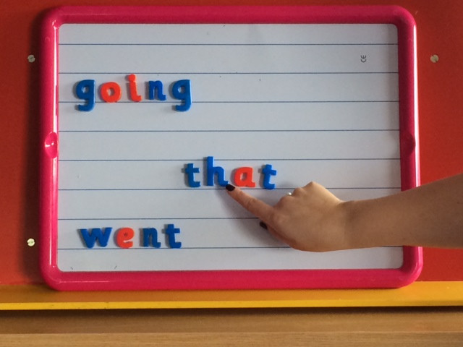

Assessment

Children are no longer assessed purely on the basis of a single word spelling test. Teachers can make judgements about a child’s ability to spell words by placing them in a context e.g. a dictated sentence.

Spelling Strategies

The strategies the children are taught are:

* Using Phoneme Knowledge (sounding out)
* Syllabification – breaking words down into syllables. The children can clap out words to identify syllables e.g. go-ing/An-drew
* Word Shape – Look at letter shape, size, ascending and descending letters.
* Tricky Letters – Looking at the position of tricky letters as an aid to spelling.
* Compound Words – Breaking the compound word into simple words e.g. into makes in and to.
* Mnemonic – using an aide memoire e.g. because – Big Elephants Can Add Up Sums Easily
* Using Analogy – If you know how to spell one word you can spell similar words e.g. if you can spell hill, you can spell mill, will, fill etc.

Introduction

The aim of this leaflet is to provide you with information about how your child is taught spelling at school and to allow you to support your child at home with spelling. Spelling and Phonics are taught separately at this stage and a different methodology is adopted for each. As such, they have been outlined in separate leaflets.

In Class

Spelling is taught with one main focussed lesson in the week, followed by short daily activities to reinforce the learning. The words from the taught lesson are known as common words. These are the words which the children are most likely to come across when reading simple texts. They will also use these words in writing.

Children have opportunities throughout the week to work with a partner. This is called reciprocal teaching. They take turns to dictate words and sentences. The activity alternates between partners and they then check their partner’s work for correct formation and accurate spelling.

Children are taught Strategy Spelling. Strategy Spelling teaches children to problem solve and enables them to spell tricky words. Tricky words are words which don’t always follow patterns or rules.



Spelling

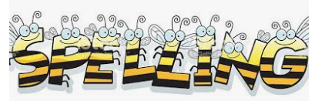

A Guide for Parents

Stage 1-3

Spelling

At Home

When your child comes home with a list of common words, you could discuss with them what strategy they would use to help them remember to spell each word.

In addition to reinforce the learning they could use the Look, Say, Cover, Write, Check method to practise the words. You could also take turns to dictate simple sentences, which contain the common words and take turns to be the ‘teacher’ and check each other’s work.