Hillhead High School

iPad Support

Table of Contents

This booklet will include support with accessing:
1. Zoom
2. Magnifier
3. Display Text and Font Size
4. Reader View
5. Speech
6. Speech and Highlighting
7. Definitions
8. Typing: predictive text, typing feedback, voice recognition
9. Immersive Reader

Where can I find the Accessibility Features?
The largest part of the accessibility features that Apple have incorporated into the system are located within the Settings App.
To find them:
Open the Settings App > Tap Accessibility.

- Zoom

You can use this for: full screen, magnification mode, a moveable lens and colour enhancing features.

A three-finger drag is then used to pan around the contents of the screen.

Go to Settings > Accessibility > Zoom

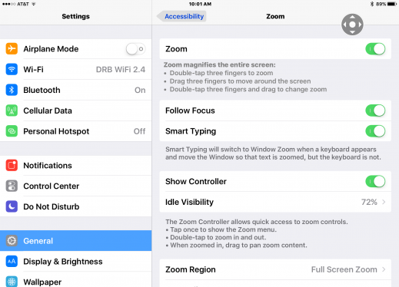

- Magnifier

Your iPad also has a magnifier

This allows for text or objects to be magnified at any chosen level, the colour palette and contrast to be set and the screen image to be captured and read.

Go to Settings > Accessibility > Magnifier

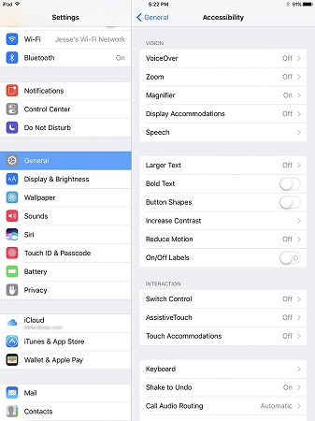

- Display and Text Size

You might want to change the brightness of your screen by using dark mode/display.

-Bold: All on-screen text can be made bolder for all applications

Go to Settings > Accessibility > Display & Text Size, then turn on Bold

-Larger Text: All text can be displayed at a higher point size than standard

Go to Settings > Accessibility > Display & Text Size > Larger Text, then turn on Larger Accessibility Sizes

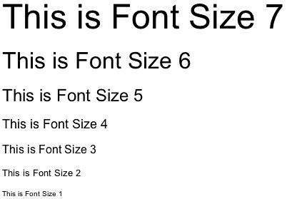

-Display Accommodations: Many low vision users or users with colour deficiencies find that changing the colour palette and contrast is a good way of seeing the screen more easily.

-A colour inversion is a popular colour scheme that takes away the white, bright backgrounds, that some people find difficult to look at, and turn this into a black background with white text that is often easier to look at.

Go to: Settings > Accessibility > Display & Text Size

- Reader View

Reader View is a feature that strips away clutter like buttons, ads and background images on a web page.
Reader view changes the page's text size, contrast and layout for better readability.

To use Reader View, simply go to a website and press the 'aA' at the left hand side of the URL bar.

Select Show Reader View

Press the 'aA' again to change font or back ground settings (or to turn off
Reader View).

Use Website Settings to choose if Reader View is used automatically

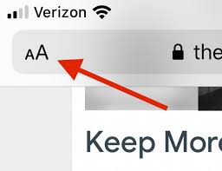

- Speech

There are two speech options: highlighted text can be read or full text can be read out loud.

To enable text that is selected to be read aloud:

Go to: Settings > Accessibility > Spoken Content > Turn Speak Selection on

Now, within your text or website, select the text and then from the menu that appears, tap speak.

To enable the contents of the screen to be read out:

Go to Settings > Accessibility > Spoken Content > Turn Speak Screen on

Now, within your text or website, use a two finger swipe down gesture from the top of the screen and iOS will begin to read to you. A small control panel also opens to allow you to skip sections and change the reading speed.

You can choose your 'voice' also.

Go to Settings > Accessibility > Spoken Content > Voices

You can change the voice, dialect and break down the words to sound them out or spell them

- Speech and Highlighting

Some learners like to have the text highlighted as it is read aloud.

Go to Settings > Accessibility > Spoken Content > Highlight Content and switch it on
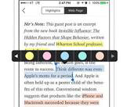

- Definitions

When you are reading a text you may encounter words that you do not understand.

If this is the case, you can easily find the definition.

Tap to select a word > tap once more to open the small menu > tap Smart Lookup

A short definition now appears; this can be read aloud also.

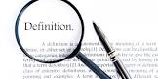

- Typing

Predictive Text: Your iPad has a built-in predictive text system that suggests words as you start to type them. A number of suggestions will appear along the top of the keyboard and you can chose one just by tapping the one you want.

Go to: Settings > General > Keyboard > and switch on Predictive
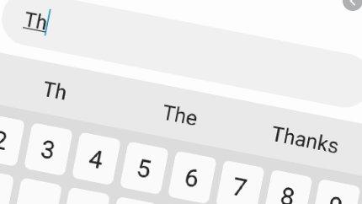

Typing Feedback: When typing on your iPad, typing feedback (in the form of the text to speech voice) can be enabled to hear the words as you type them.

Additionally auto-corrected words will be read out and predictive suggestions can be read aloud by touching and holding each suggested word.

Go to: Settings > General > Accessibility > Voice Over >Typing>Typing Feedback and select the options you require.

Voice Recognition: As an alternative to typing, Voice Recognition can be used on your iPad. Your voice can be recognised and appear in a chosen application by just pressing the microphone symbol on the bottom row of the keyboard and speaking.

Go to: Settings > General > Keyboard > Enable Dicta
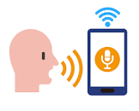

- Immersive Reader
Learners can also access the 'Immersive Reader' when they download the Microsoft Word App to their iPad.

Simply open your word document and click 'View' then toggle on 'Immersive Reader'.

Immersive Reader can do a number of things. For example:

Column Width: changes line length to improve focus and comprehension.
Page Colour: can make text easy to scan with less eye strain.
Text Spacing: increases the spacing between words, characters, and lines.
Syllables: shows breaks between syllables, to improve word recognition and pronunciation.
Read Aloud: lets you hear your document as each word is highlighted.
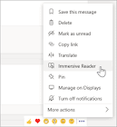

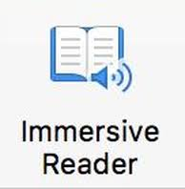

Further support: online videos

Check out Mr Tait’s videos on our school YouTube channel for videos on using many of these tools: https://www.youtube.com/channel/UCGGLSsvH065TkKC8e4bnByg/videos

For more support, check the Apple guide. This includes further ways to support vision, hearing and physical/motor skills.
https://support.apple.com/en-gb/guide/ipad/ipad9a2465f9/13.0/ipados/13.0

Useful apps:

Translate- translator for a variety of languages
OneDrive- saves all of your files and access anywhere on the app or through Glow
Teams- class work, homework, discussions

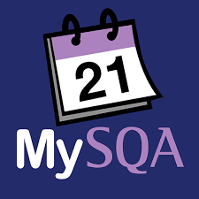
My Exams- and Sqa Study Plan create a study timetable, link to SQA info, organise study plans
Sumdog- maths, grammar and spelling games to practice
Libby, by OneDrive- ebooks and audiobooks to borrow. Adjust text size, background colour, zoom in and more!
Quizlet- create your own revision flashcards

If you need any help come to Support for Learning M104 or M105 to see:
Miss S McGuire (Faculty Head SfL, EAL & Nurture)
Mr J Pache (Teacher of SfL)
Miss E Rothery (Teacher of English & SfL)
Pupil support assistants:
Mrs Drummond
Ms Forsyth-Potter
Ms Bollands
Miss Nelson
Miss Pollitt
Miss Muirhead
Ms MacKenzie

Put together with the Glasgow Gaelic School

