Hillhead High School

Higher Physical Education Exam Preparation Guide

Contents

Each part of this preparation guide will be split up into the following areas of the Exam component of the Course Assessment:

- The Structure of the Paper

- Approaches to Gathering Information

- Approaches to Developing Performance

- Approaches to Monitoring and Evaluating Performance

- The Scenario

- Question Papers with Model Answers

The Sections will make significant reference to the command words that you will be required to address when answering questions, specifically:

Describe – Paint a picture and provide a step by step account of what you did
You may wish to use one of the following structures to assist you with a describe answer;
P-People, who was involved? What did they do?
E-Equipment, what equipment was used? What resources were required? If using a schedule or questionnaire, what did it look like?
E- Environment- Which working area was used?
T- Time- How long did the specific task last?

Alternatively you may wish to use ;
Before- What did you do before? Did you warm up? Set equipment up? Teacher explain protocol? Create teams?
During- Did you play a game? Complete the test? Were there any rules? Was there an audience?
After- Did you cool down? Review scores? Create Targets?
Explain – Give reasons why you used the approach
When answering an explain question you must understand the relationship between Cause and Effect.
When you make a point, ask yourself “So What?, This should assist you in creating an Effect. “

Evaluate – Make a comment, look at both sides. You should consider benefits and limitations. You should include some kind of judgement
“ a benefit of this approach is… this means that…”

Analyse – Inspect and make deductions or inferences. Consider the possibilities. Make an interesting comment.
A useful structure you may wish to use is
Point – What point do you wish to make?
Evidence- is there any Qualitative or Quantitative data to support this?
Impact- What is the impact of this?

Failure to address the command word in the question will result in 0 marks being awarded for your answer.

Each section will have several different model answer examples.

The Structure of the Paper

The paper is split up into three sections and you have a total of 2 hours and 30minutes to complete all 3 sections. There are a total of 50 marks available.
The question paper assesses your ability to integrate and apply knowledge and understanding from across the course.

Section 1- 32 marks
Section 2- Marks will range from 6-10 marks
Section 3- Marks will range from 8-12 marks

You have a total of 50 marks to achieve in 150 minutes, therefore as a rule of thumb, you should allocate 3 minutes to each mark.

Section 1 is worth 32 marks.

Section 1 focuses on the four factors impacting on performance and covers one or more of the five broad areas of skills, knowledge and understanding. This section is worth 32 marks in total.

Section 1 will contain 5 questions, composed of the following;

You should spend approximately 96 minutes of your time on this section.
Specimen paper example.

Section 2 focuses on your experience of creating and implementing a Personal Development Plan (PDP) over a minimum of three sessions and covers at least two factors impacting on performance. Marks range from 6-10 marks. You should therefore allocate 18- 30minutes on this section.

Section 3 is based upon a scenario. The scenario may include text, images, graphs or other information. This section focuses on one or more of the five broad areas of skills, knowledge and understanding, snd samples two of the factors impacting on performance. You must respond using the two factors identified in the question. Marks range from 8-12 marks. You should allocate approximately 24- 36 minutes of your time on this section.

Approaches to Gathering Information

Approaches to Gathering Information will be the area of the course asked within Question 1 of Section 1 of the Paper.

You will need to know:

- At least TWO approaches to Gathering Information for EACH Factor.
- You may be asked to either describe, explain, evaluate or analyse the approach (s).
- You may also be asked to summarise the information gathered / explain what it means for your performance in an activity.
- The purpose / importance of Gathering Information.

Approaches to gathering information to find out / identify the extent to which a factor / feature impacts on your performance.

It is important to gather information on your performance so that you can:

- Identify Factors and Features that impact positively and negatively on performance / Strengths and Weaknesses.
- As a result of identifying positive and negative features specific short, medium and long term goals can be set.
- Suitable approaches to developing performance can be identified and put into place as part of a PDP.
- Provides a means of motiving yourself to improve performance.
- Provides evidence which can be reviewed later on for monitoring purposes.

Approaches can be both quantitative and qualitative.

Mental | Emotional | Social | Physical
-Video with an experienced coach -Questionnaire  -Personal Reflections for a standalone or series of sessions  -Teacher Feedback | -Video with an experienced coach  - Questionnaire  -Personal Reflections for a standalone or series of sessions  -Teacher Feedback | -Video with an experienced coach  - Questionnaire  -Personal Reflections for a standalone or series of sessions  -Teacher Feedback | -Video with an experienced coach  -12 Minute Cooper Run  -Illinois Agility Run  -Personal Reflections for a standalone or series of sessions  -Questionnaire  -Teacher Feedback

The 12 Minute Cooper Run (Physical – CRE)

Describing the Cooper Run as an Approach to Gathering Information on the Physical Factor.

One approach to gathering information on CRE within the Physical Factor is the Cooper Run. The Cooper Run is a standardised test where you have to run as far as you can in 12 minutes round a measured track. While running a partner counts the number of laps you achieve and at the end of the 12 minutes you multiply the number of laps by the distance of the track. Once you have you total distance you can then check which category you fall within on a national scale for your age and gender (Poor, below average, average, above average or excellent).

Explaining the Cooper Run as an Approach to Gathering Information on the Physical Factor.

One approach to gathering information on CRE within the Physical Factor is the Cooper Run. The Cooper Run is a standardised test which means results can be compared to others around the world for your age and gender, providing valid and reliable information. A partner counts the number of laps you achieve because it would be easy to lose track while running for this period of time. Once your result is compared to the national norms you can set appropriate and achievable targets such as moving from poor on a national scale to average on a national scale. This also allows a Personal Development Plan to be put in place, such as Continuous Training or Fartlek Training.

Evaluating the Cooper Run as an Approach to Gathering Information on the Physical Factor.

The Cooper run was beneficial in gathering information on my CRE as I was able to compare my results on a national scale. This allowed me to set an appropriate and achievable target to improve my CRE. It also allowed me set up a PDP specific to my level, involving continuous training. I was also able to gather this information very easily. This was because minimal equipment was required; all that was required was an open space, a stop watch, a measuring tape and a partner to count my laps. One problem with my partner, however, was that he did the 12 minute run first. This meant that when he was counting for me he lost count on two occasions because he lost concentration, meaning the reliability of my result was compromised. Another limitation that I experienced was that I never had access to the same gym hall when I did my re test. This meant I was unable to repeat the conditions of the first test, reducing the reliability of my comparison.

Analysing the Cooper Run as an Approach to Gathering Information on the Physical Factor.

One approach I used to gather information on my level of CRE in Volleyball was the Cooper Run. We completed the Cooper Run at the start of the block so that it would assist with our monitoring and evaluating. The layout of the Cooper Run was adapted from the standard laps of a track to up and down a 20 metre gym hall. This meant the reliability of the result when compared to standardised norms was reduced because going round a track requires no turning. By having the constant change of direction it slowed my time down so I didn’t travel as far as I might have. By having the turning and changing of direction it also meant the test became closer to the movements of the activity of volleyball as volleyball requires you to be quick on your feet in response to the changing demands of long rally’s. This meant the information gathered was more valid than that of the normal cooper run because this is more specific to the activity. On the day of the test I was wearing running trainers. This meant that the result I achieved was more accurate as running trainers make it easy to run for a prolonged period of time. This is required given the lengthy nature of the Cooper Run. One problem with the environment, however, was the heat in our gym hall. The radiators were very warm which meant I actually became tired quicker than I normally would and my pace dropped. This reduces the reliability of my result because in a normal temperature I may have performed stronger. This also meant the validity of my comparison to the national norms may have been reduced as I was under the category of having a below average level of CRE, when I may have been average.
Video with an Experienced Coach (ALL FOUR FACTORS)

KEY POINT - Remember that Video with an Experienced coach can be used to gather information on all 4 Factors Impacting on Performance. If using this approach for a specific Factor, however, reference MUST be made to features within the asked Factor

Describing Video with an Experienced Coach as an Approach to Gathering Information on the Physical Factor.

Another approach to gathering information on skill repertoire within the Physical Factor is Video with an experienced coach. I gathered information on the effectiveness of my lay-up in basketball by performing a series of lay ups while being videoed on an IPad by a peer in my class. I performed the lay up under different conditions including no pressure, passive pressure and active pressure. At the end of the period my coach provided detailed feedback on my execution of the lay up in line with detailed success criteria of the lay-up.

Explaining Video with an experienced Coach as an Approach to Gathering Information on the Physical Factor.

We used video with an experienced coach as an approach to gather information on the physical factor as it is the most accurate method of gathering information. As footage can be watched over and over this allows for the data to be checked ensuring that mistakes are kept to a minimum. This ensures that the strengths and development needs that are identified are as accurate as possible. A further reason why video was used to gather information on the physical factor is that it allows a skill to be analysed in slow motion allowing for a deeper analysis. The skill can be slowed down and paused allowing the coach to point out any issues in the performers form. This allows for corrections to be made in training which will help to improve the performer’s skill repertoire.

Evaluating Video with an Experienced Coach as an Approach to Gathering Information on the Physical Factor.

One benefit of using video with an experienced coach is that the footage serves as a permanent record. This means that footage can be looked back upon in future dates and compared to current performance. This allows for an analysis of progress to be made which would allow the performer to make necessary adaptions to their PDP. One limitation of video with an experienced coach as that the footage could be of poor quality. If the recorder is inexperienced they may not capture every event. This could lead to missed information which decreases the accuracy of the information gathered. This could prevent the performer for accurately identifying their strengths and development needs.

Analysing Video with an Experienced Coach as an Approach to Gathering Information on the Physical Factor.

One method that I used to gather information on my performance was the use of video. At the start of our block the whole class were recorded participating in games for one period. The reliability of the data gathered was strong for me because I was heavily involved in the game but players who were less involved had little information to analyse. This meant it was difficult for some of them to find an area for development based on that performance setting. It may have been more reliable to video the class over three periods and then watch the video back, but time restraints meant this could didn’t happen.
The validity of the data could also have been increased if each individual was the focus of the video, a bit like a ‘player cam’. A lack of specialist equipment meant this wasn’t possible. What we did do, though, was slowed down the video using an app on the tablet, and watched the data repeatedly. This meant my weakness was clear and I knew what I needed to work on.
The validity of the information gathered also depended on the person videoing. We were recorded by an experienced teacher who was able to keep up with play to get a full picture of our performance. This meant none of the footage was missed which meant the validity was strong for this aspect. The use of video placed an increase pressure on everyone in the class and put us in a situation that we are not normally in. This meant people with less confidence made more mistakes and therefore the validity of the data may have been reduced. This is because the more confident players would have found it easier than the less confident players.

Questionnaires to Gather Information (ALL FOUR FACTORS)

KEY POINT - Remember that Questionnaires can be used to gather information on all 4 Factors Impacting on Performance. If using this approach for a specific Factor, however, reference MUST be made to features within the asked Factor.

HINT – It would be worthwhile remembering some questions / statements for Specific Factors… This will make it easier when doing your revision!

For example,

“Do you feel you can complete a range of skills when performing?” -> Physical Examples
“Do you feel you get fatigued towards the end of the game?”

“Do you feel you can make correct decisions performing?” -> Mental Examples
“Do you feel you ever get distracted during a game?”

“Do you feel you give up when the going gets tough?” -> Emotional Examples
“Do you feel you get angry when the referee makes a call against you?”

“Do you feel you share the same goals as your team mates?” -> Social Examples
“Do you feel you communicate with your team?”

Describing Questionnaires as an Approach to Gathering Information on the Mental, Emotional, Social or Physical Factor.

“A questionnaire on mental factors could be completed following performance in an activity. Questionnaires consist of different questions such as ‘Did you feel you made appropriate decisions during your performance’. Each question is answered honestly on a scale of 1-10; 10 being a strength and 1 being a weakness. All of the answers are then considered to identify which features are most prevalent to the performance. A peer or teacher can also review the questionnaire. ”

“A questionnaire on emotional factors could be completed following performance in an activity . Questionnaires consist of different questions such as ‘Did you feel you got angry during your performance’. Each question is answered honestly on a scale of 1-10; 10 being a strength and 1 being a weakness. All of the answers are then considered to identify which features are most prevalent to the performance. A peer or teacher can also review the questionnaire. ”

“A questionnaire on social factors could be completed following performance in an activity. Questionnaires consist of different questions such as ‘Did you feel you communicated well within your team’. Each question is answered honestly on a scale of 1-10; 10 being a strength and 1 being a weakness. All of the answers are then considered to identify which features are most prevalent to the performance. A peer or teacher can also review the questionnaire. ”

“A questionnaire on physical factors could be completed following performance in an activity. Questionnaires consist of different questions such as ‘Did you feel you could change direction quickly’. Each question is answered honestly on a scale of 1-10; 10 being a strength and 1 being a weakness. All of the answers are then considered to identify which features are most prevalent to the performance. A peer or teacher can also review the questionnaire. ”

Benefits and Limitations of Questionnaires as an Approach to Gathering Information

Benefits:

-Permanent record of work that can be repeated at a future date to compare for improvements
-Numerous questions within a questionnaire make it easy to pin point specific features within a Factor that are strengths and weaknesses / Positive and Negatives
-Once features have been identified as development needs targets can be made to improve them. Once targets have been made suitable approaches to developing performance can be identified / PDP created.
-A generic questionnaire can also be used for numerous activities allowing different levels of performance to be compared between activities. This may assist with the selection of a One Off Performance activity in Higher Physical Education.
-Questionnaires can be filled out very quickly, providing instant feedback about performance
-Can be checked by an experienced teacher to ensure reliability of information gathered
-Having a scale of 1-10 allows a performer to re visit areas that are not of priority immediately, but maybe once most important features have been developed
-Questionnaire can be completed whilst watching a video of performance, making information more valid and reliable

Limitations:

-Generic questions limit the ability to be clear on activity specific development needs. The performer then might need to gather more information to be clear on what they need to improve.
-Questionnaires completed in the presence of others can lead to pressure to respond in a manner that looks stronger to peers, leading to invalid information and inappropriate approaches to developing performance.
-Pupils who are overly critical of themselves may find that they have too many development needs, leading to a drop in confidence.

Practice Questions for Approaches to Gathering Information

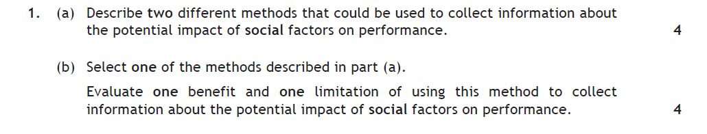
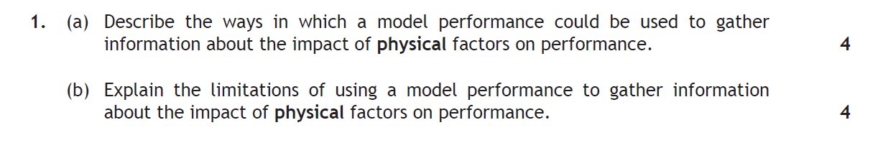
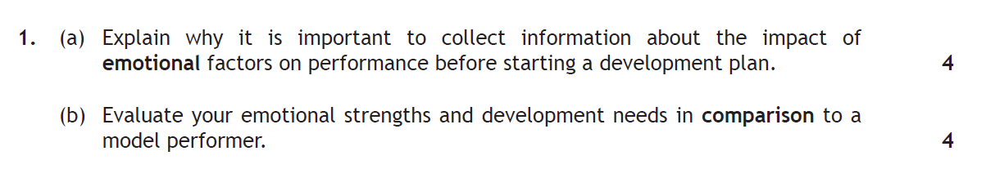
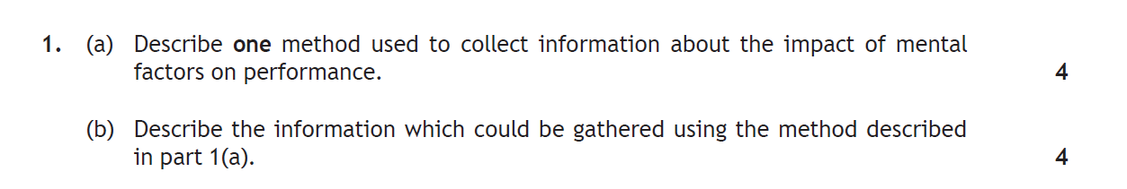

Tip – For extra practice simply change the Factor asked within the Question!

Approaches to Developing Performance

Approaches to Developing Performance will be the area of the course asked within Question 2 of Section 1 of the Paper

You will need to know:

- At least TWO approaches to Developing Performance for EACH Factor.
- You may be asked to either describe, explain, evaluate or analyse the approach (s)
- How and why you may have made changes while undertaking a PDP.
- The purpose of Developing Performance

Approaches to developing performance IMPROVE factors and features that impact on your performance.

Mental | Emotional | Social | Physical
-Scenario Training  -Deep Breathing  -Team Building Activities  -Self-Talk | -Scenario Training  -Deep Breathing  -Team Building Activities  -Self-Talk | -Scenario Training  -Performer Conversations  -Team Building Activities | -Scenario Training  -Continuous Training  -Interval Training  -Agility Circuits  -Fartlex Training  -Repetition Practices  -Gradual Build Up

Scenario Training (ALL FOUR FACTORS)

“One approach I used to develop my anxiety within the emotional factor was to use scenario training. Scenario training is when you practice game related situations in training. The scenario we focussed on in basketball was to practice being 2 points down with 10 seconds to play. We practiced how we would overcome this problem several times in practice and came up with a solution that everyone in the team knew. This meant that if this situation arose in the game we would know exactly what to do, therefore helping to reduce my anxiety.”

“One approach used to develop reduce anger within the emotional factor is to use scenario training. Scenario training is when you practice game related situations in training. The scenario we focussed on was playing with a poor referee. The teacher within our class acted as the poor referee which meant that when decisions went against a player they had the opportunity to practice deep breathing. This then allows players to experience what it is like to have that situation and then have practice in overcoming it. This will then mean that the player will avoid receiving unnecessary cards for disagreeing with decisions the referee gives and not have to worry about risky tackles that could later lead to them being sent off.”

“One approach I used to develop decision making within the mental factor was to use scenario training. Scenario training is when you practice game related situations in training. The scenario we focussed on in basketball was to practice being 2 points down with 10 seconds to play. We focused on practicing the types of decisions you would make to overcome this problem several times in practice and came up with a solution that everyone in the team knew. Some of the decisions we had to consider for this particular scenario included the person taking the inbound pass, person taking the game winning shot and the spaces players would move into.”

“One approach I used to develop communication within the social factor was to use scenario training. Scenario training is when you practice game related situations in training. The scenario we focussed on in basketball was to practice being 2 points down with 10 seconds to play. We discussed how we would overcome this problem several times in practice and came up with a solution that everyone in the team knew. By discussing how to overcome the problem we were developing our communication skills and were therefore more comfortable talking to one another, which would then all transfer onto court during games.”

Evaluating the impact these approaches had on your performance

“Scenario Training had a positive impact on my performance. Prior to participating in scenario training I used to panic at close points in matches and often made inappropriate decisions such as passing to an ineffective shooter in my team. This then reduced the team’s chances of winning or closing out the match. After practicing several high pressure scenarios I knew exactly what I was supposed to do in these types of high pressure situations. This meant that when I received the ball I knew who the best player in my team was to take the shot so I was more often able to quickly make the decision to pass to this player in our team, leading to us being more able to close out high pressure games. By knowing what to do in particular situations I was far more confident and comfortable because I knew what my exact responsibilities were within my team.”

Note – Major Limitation of Scenario Training – Not every Scenario can be prepared for! Think about what this might mean when an unfamiliar situation arises!

Continuous Training to Develop (CRE)

Description of Approach –

“One approach to develop Cardio Respiratory Endurance (CRE) within the physical fitness factor is Continuous Training. An example of a continuous training session I did for basketball involved 20 minutes running up and down the court within my training zone, aiming to go at a consistent pace. While I did this my partner counted the number of lengths I ran for monitoring purposes. Over time I gradually made this more difficult as my level of fitness was improving. I also used this approach within the activity by dribbling a ball up and down the court and attempting lay ups for a period of 20 minutes.

Explanation of why it is used -

“Continuous training was used to develop CRE because it is a recognised way of improving CRE. By working for a minimum period of 20 minutes inside your training zone, which can be checked, improvements to CRE will be made. This would then have a positive impact on performance in any activities that last for a longer period of time as continuous training replicates the endurance demands of longer activities, e.g., football. Continuous training was also chosen because it is simple to set up and can be done anywhere and anytime as no access to specialist equipment is required. Continuous training was also chosen as it is easy to make more difficult by simply increasing the duration you run for, e.g., 20 to 25 minutes or 25 to 30 minutes. This means you can continually challenge your fitness and make further improvements.”

Limitations – Can become boring and demotivating when continuous training is completed out with the activity. This could result in a wasted training session if performer not working within training zone and no improvements being made
-Can be difficult to monitor progress due to expensive cost of HR monitors. When pulse checks are used they are very difficult to keep accurate and can break the continuous part of the session

Interval Training (Speed Endurance)

Description of Approach –

“Another approach I used to develop my speed endurance was interval training. Interval training involves short burst of intense exercise followed by a recovery. I sprinted from one side of the court to the other and this took me 5 seconds. I then took a recovery break of 30 seconds. I repeated this 5 times and that was 1 set. After 1 set I took a longer recovery for 3 minutes and then after the recovery I started my next set. I continued until I completed 3 full sets. I made this harder over time by adding more sets and reducing the recovery time.”

Explanation of why it is used –

“Interval training was used to develop speed endurance as it is a recognised way of improving speed endurance. The alternating periods or working at high intensity followed by rest will mean that towards the end of activities performers will still be able to make intense bursts of pace. Similarly to continuous training, interval training requires minimal equipment and be completed anywhere and anytime. The work to rest ratio can be changed to suit the level of fitness the performer, allowing fitter performers to be further challenged. Interval training can also be done within the activity. Interval lay ups in basketball allow the performer to improve their skills and fitness at the same time, while being motivated and interested, due to the combination of fitness and skills in a session.”

Limitations -Can be difficult to monitor progress due to expensive cost of HR monitors. When pulse checks are used they are very difficult to keep accurate and can break the continuous part of the session

Team Building Activities (Social Factor)

One approach to developing the social factor out with the activity is team building activities. Team building activities are a series of progressive activities that can be gradually made more difficult as the team’s ability to cooperate improves. The idea behind team building activities is for teams to work together to identify a solution to a problem that is presented to them. 3 progressive examples which move from simple, to moderate, to complex, are described below.

Simple – In a group of 5 we had to get from one side of the hall to the other without anyone in the team touching the floor. The only equipment we were provided with was 2 mats. The simple solution is for everyone to stand closely together on one mat and pass the next one round. Everyone then slowly steps onto the next mat and we repeat this until we get to the other side.

Moderate – In the next problem our teacher introduced a gymnastics box and gave us an additional mat to stand on. The problem was still to get to the other side without falling in, but also navigate over the box without allowing the mats to touch the box. The solution was similar but required more patience and to really identify individual strengths of the team. For example, the strongest person stayed on the top of the box and gradually helped up other members of the team who would struggle to climb on top of the box.

Complex – In the final challenge, we repeated the simple challenge but made it competitive against other groups. This meant we had the added pressure of time. With added pressure it increases the possibility of mistakes. Also, the challenge had to be completed by everyone in the team going through a hoop without any part of their body touching it. If someone touched it then the team had to go back to the start. The way we solved this problem was by taking our time going through the ring. One person put through two hands through the hoop and to the safe side. The person behind then slowly lifted their legs and the person walked their hands until they were safely through. We then repeated this till the last person. The last person had to be extra cautious as they had to bring their legs through on their own.

Note – This is a combination of describing and explaining Team Building Activities to develop the Social Factor. As part of your revision you might want to highlight the describe / explain parts of the answer!

Benefits of Team Building Activities –

- Numerous activities to select from
- Alternative enjoyable activities that can be used to improve team morale following defeat / dip in form
- Team Building activities can be easily adapted to make them gradually more difficult. One example might be only allowing one person to speak who is usually quiet in the activity.
- Other Factors also developed at the same time such as Emotional – Confidence and Mental – Decision Making

Limitations of Team Building Activities –

- Team building activities not specifically related to the activity
- Improved team relationships / communication may not transfer back into the activity
- Important performance training time wasted
- Difficult to monitor progress
- Would not form part of a long term PDP
- Domineering team members may continue to take charge and no improvements will be made
Deep Breathing to Develop Performance (MENTAL AND EMOTIONAL)

Evaluating the impact Deep Breathing has on your performance

“Deep Breathing had a positive impact on my performance on most occasions. Prior to using deep breathing I often used to get angry or frustrated when I was making poor decisions that led to points for my opponent, such as leaving the shuttle to go out and it then landing in. By learning how to use deep breathing techniques I was able to quickly move on from these types of mistakes and concentrate on the next point of the match.

Sometimes deep breathing was ineffective, however. Depending on the severity of the mistake, such as making an inappropriate decision that led to my opponent winning, I was not able to use deep breathing effectively. This meant I then displayed my anger at the fact I lost, resulting in me getting disqualified for the next match.”

Self-Talk to Develop Performance (MENTAL AND EMOTIONAL)

“I used self- talk to reduce my anxiety from the mental factor. Sometimes during important moments in a game I become extremely anxious and this can cause me to panic and make mistakes. When I feel this happening I use self-talk. For example before I take an important free throw I will talk to myself and say “Stay calm” “you can do this” This then calms me down and allows me to focus on my free throw, increasing the likelihood of success.”

“Self-talk had a positive impact on my motivation. Prior to using self-talk I used to get de motivated when my opponent started to go more than 4 points up against me. After learning how to use words associated with success, such as ‘next points big’, I was able to re motivate myself to focus fully on the next point of the game. This meant I could use self-talk to get myself slowly back into matches and try my hardest to win.”

Visualisation to Develop Performance (MENTAL AND EMOTIONAL)

“One approach that I used to develop my motivation from the mental factor was visualisation. Before a match if my level of arousal is too low I may not try my best and may put in poor effort in my football match. To help prevent this I would complete a motivation exercise before the match. I would sit down in the dressing room 20 minutes before the match and picture myself playing well. I would think about all of the positive outcomes that could occur in the match. Finally I would picture myself after winning the game and seeing how happy I was. This would then increase my motivation levels. I would then go into the game feeling more positive and as a result I would put in more effort. If at any point during the game I felt demotivated I would complete this visualisation exercise at an appropriate time, for example at half time.”

Practice Questions for Approaches to Developing Performance

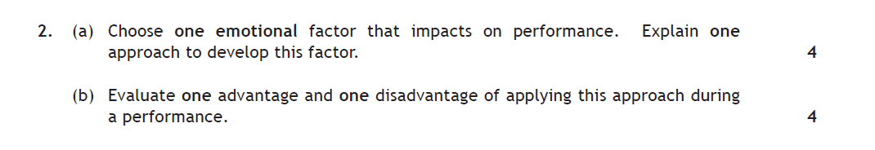
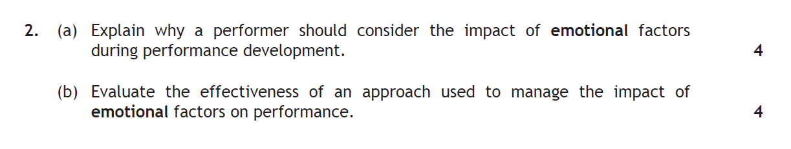
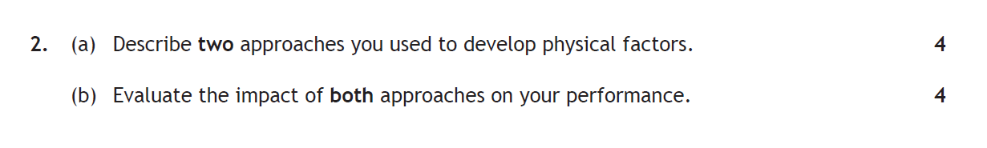
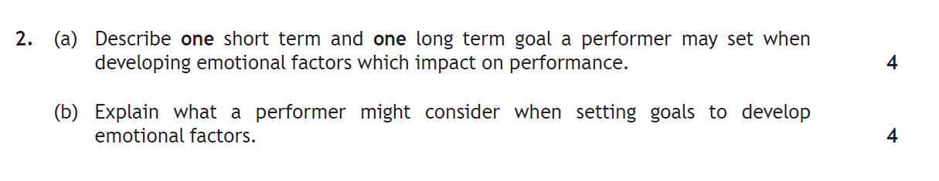

Tip – For extra practice simply change the Factor asked within the Question!

Approaches to Monitoring and Evaluating Performance

Approaches to Monitoring and Evaluating Performance will be the area of the course asked within Question 3 of Section 1 of the Paper.

You will need to know:

- The purpose of Monitoring and Evaluating Performance
- At least TWO approaches to Monitoring and Evaluating for EACH Factor. You may be asked to either describe, explain, evaluate or analyse the approach.
- The benefits of Monitoring and Evaluating using both Quantitative and Qualitative Approaches.
- Target Setting
- Explaining future development needs.

Approaches to monitoring and evaluating track the success of the approaches you are using to develop performance

- These approaches USUALLY INVOLVE THE REPEATING of Approaches used to Gather Information, sometimes on a weekly or session by session basis

The purpose of Monitoring and Evaluating Performance:

During the process of a Performance Development Plan (PDP) it is vital that progress is monitored. Monitoring and evaluating progress allows the performer undertaking a PDP to track progress to check to see if improvements are being made. During this process, depending on the success and effectiveness of the PDP, the performer can make decisions to either make the approaches to developing performance easier if the PDP is too challenging, or more demanding if the PDP is becoming too easy. By monitoring progress and seeing improvements this acts as a motivational tool, allowing the performer to continue to improve. Monitoring performance also means that goals can be reviewed and during the evaluation process at the end of the PDP future development needs can be identified by looking back at all the information monitored.

Mental | Emotional | Social | Physical
-Personal Reflections  -Repeating Video and comparing with original with experienced coach  -Repeating the same Questionnaire | -Personal Reflections  -Repeating Video and comparing with original with experienced coach  -Repeating the same Questionnaire | -Personal Reflections  -Repeating Video and comparing with original with experienced coach  -Repeating the same Questionnaire  -Retaining Scores | -Personal Reflections  -Repeating a fitness test every session during your PDP and entering this onto a graph  -Record of Results  -Repeating Video and comparing with original with experienced coach  -Heart Rate Monitoring and entering results onto a HR Graph

Personal Reflections to Monitor and Evaluate Performance (ALL FACTORS)

“Another approach to monitoring and evaluating performance is writing down personal reflections after every session. Personal reflections are when you write down how you feel you performed in that session. Personal reflections are completed underneath the scores of the games and should be an honest evaluation of how you felt you performed. A teacher or a classmate can sign off on your personal reflection entry or offer additional feedback to include.”

“One approach to monitoring and evaluating the physical factor that I have used is a personal reflections diary. In this diary I would record how I felt after every session. As soon as my session was complete I would right down how tired I felt or how comfortable I felt completing various skills. Before my next session I would look back upon my reflections from the previous week and use this information to improve my physical features in the next session. I would continue to monitor and evaluate for the duration of my 6 week PDP. I would also ask my coach to sign off each session if he agreed with my comments.”

Repeating a Fitness Test to Monitor and Evaluate Performance (PHYSICAL)

“One quantitative approach to monitoring and evaluating CRE within the physical factor is repeating the 12 minute cooper run at weekly intervals during a 6 week personal development plan. The 12 minute cooper is a standardised test where the participant runs as far as possible in 12 minutes. Each distance achieved for each cooper run is compared week by week, allowing gradual increases to be checked for.”

Record of Results to Monitor and Evaluate Performance (PHYSICAL)

“One quantitative approach to monitoring and evaluating the physical factor is retaining a record of results. For every game you participate in you write down the score of the match, the date and the person or team you played against. After the lesson you can then write down the total number of wins and losses and calculate a total win rate for that lesson. For example if you played 5 matches and won 3 of them your win rate would be 3/5.”

Coaches Feedback (ALL FACTORS)

“Another approach to monitoring and evaluating the physical factor that I have used is coach’s feedback. During each training session and match my coach would observe my CRE and skill repertoire. Either during the session or immediately after the session my coach would then provide me with feedback which I could then use to adapt what I was doing in the match or practice to ensure I was fully developing my physical factor. I would write down this feedback to keep a record of the information received.”

Heart Rate Monitoring to Monitor and Evaluate Performance

Describing Heart Rate Monitoring as an Approach to Monitoring the Physical Factor. (COULD ALSO BE USED FOR SPEED ENDURANCE)

“One approach to monitoring CRE within the Physical Factor is Heart Rate (HR) Monitoring.HR monitoring is when you track your HR throughout the period of a fitness based PDP session and this can be done within and out with the activity. The way I did this was by firstly calculating my HR after the warm up before the start of each session. I did this by counting the number of Beats Per Minute (BPM), placing my thumb at my wrist, counting over 6 seconds and multiplying the number by 10. I repeated this process every 5 minutes during the fitness session and noted down each BPM in my PDP diary. I then checked that all of these were above 60% of my maximum HR. You can then enter this information onto a HR graph. This process was followed during every fitness session over the course of my 6 week PDP.”

Explaining Heart Rate Monitoring as an Approach to Monitoring the Physical Factor.

“One approach to monitoring CRE within the Physical Factor is Heart Rate (HR) Monitoring.HR monitoring is when you track your HR throughout the period of a fitness based PDP session and this can be done within and out with the activity. This allows the performer to check they are working within their training zone and therefore know their training is working. This also allows the performer to gradually make their training more difficult as they are beginning to work more easily within their training zone. At the end of every session the HR’s of performer can be entered onto a HR graph. This provides the performer with a very clear and visual recorded piece of information that they are working within their training zone. ”

Evaluating Heart Rate Monitoring as an Approach to Monitoring the Physical Factor.

“One approach to monitoring CRE within the Physical Factor is Heart Rate (HR) Monitoring. HR monitoring is when you track your HR throughout the period of fitness based PDP session. While using this approach it was very difficult to keep an accurate track of the number of beats per minute because I counted over 6 seconds and multiplied by 10. This meant that there was an uncertainty of a factor of 10, meaning I couldn’t be sure of my HR. Moreover, our teacher was calling to start counting and stop counting with several distractions in the room, also leading to inaccuracies when counting. Another limitation was that we counted our HR at 5 minute intervals. This meant I couldn’t be sure I wasn’t working within my training zone in between the HR checks while running. To try and reduce the uncertainty we worked out our HR over a 20 second period and multiplied by 3.”

Questionnaires to Monitor and Evaluate Performance

Describing Questionnaires as an Approach to Monitoring and Evaluating the Mental, Emotional, Social or Physical Factor.

Hint - You can answer this question exactly the same way as you answer an Approaches to Gathering Information Question…

THE MAIN DIFFERENCE IS THAT YOU MUST MENTION THAT YOU REPEATED THE QUESTIONNAIRE CAN COMPARED IT

“A questionnaire on mental factors could be repeated and compared at the start and end of a PDP. Questionnaires consist of different questions such as ‘Did you feel you made appropriate decisions during your performance’. Each question is answered honestly on a scale of 1-10; 10 being a strength and 1 being a weakness. All of the answers are then considered to identify which features are most prevalent to the performance. A peer or teacher can also review the questionnaire. ”

“A questionnaire on mental factors could be repeated and compared at the start and end of a PDP. Questionnaires consist of different questions such as ‘Did you feel you got angry during your performance’. Each question is answered honestly on a scale of 1-10; 10 being a strength and 1 being a weakness. All of the answers are then considered to identify which features are most prevalent to the performance. A peer or teacher can also review the questionnaire. ”

“A questionnaire on mental factors could be repeated and compared at the start and end of a PDP. Questionnaires consist of different questions such as ‘Did you feel you communicated well within your team’. Each question is answered honestly on a scale of 1-10; 10 being a strength and 1 being a weakness. All of the answers are then considered to identify which features are most prevalent to the performance. A peer or teacher can also review the questionnaire. ”

“A questionnaire on mental factors could be repeated and compared at the start and end of a PDP. Questionnaires consist of different questions such as ‘Did you feel you could change direction quickly’. Each question is answered honestly on a scale of 1-10; 10 being a strength and 1 being a weakness. All of the answers are then considered to identify which features are most prevalent to the performance. A peer or teacher can also review the questionnaire. ”

The Benefits of Monitoring using Quantitative and Qualitative Approaches

- Amount of information to track progress
- More information validates approaches being used to develop performance, or, easily allows changes to be made of approaches are to difficult
- Accurate future development needs can be made given the amount of information available to reflect on
- Targets and Goals can be modified
- Variety of information that is either objective, subjective or a combination of both

Target Setting

Describe performance development goals that a performer could set for mental factors.

“Performance development goals for mental factors that impact on performance could focus around different features of the mental factor.

Concentration is the ability to maintain focus. One goal might be for a performer to remain concentrated for the full game of basketball.

Decision making is also within the mental factor. Decision making is the ability to make the most appropriate decisions throughout a performance. One goal in relation to decision making in badminton might be to consistently make the right judgement to either play the shuttle if it is going to land inside the court boundary, or leave the shuttle if it’s going to land outside the court boundary.

Another feature from the mental factor is level of arousal. One goal that a performer might set is to have the optimal level of arousal before performance so the performer can fulfil their potential.

Anticipation is another feature from the mental factor. A high level of anticipation allows a performer to read or quickly predict an opponent’s movements or shots. A performer could set them self the goal of anticipating their opponents next shot so they can easily return it.”

YOU WOULD BE EXPECTED TO BE ABLE TO PROVIDE PERFORMANCE DEVELOPMENT GOALS FOR ALL FOUR FACTORS THAT IMPACT ON PERFORMANCE.

E.g.,

Physical – One target for me is to improve my level of CRE. At the moment I become very tired not long after half time. I struggle to keep up with the pace of the game and my skill level drops by giving the ball and making unforced errors.

Emotional – One target for me is to improve my resilience. At the moment I have the tendency to give up when my team start to lose. My effort levels drop and I don’t have the same drive to maintain a high performance level.

Social – One target for me is to improve my communication. At the moment I am very quiet and don’t call for the ball when I am in space. The game often passes me by even when I am in a good space.

Practice Questions for Approaches to Monitoring and Evaluating

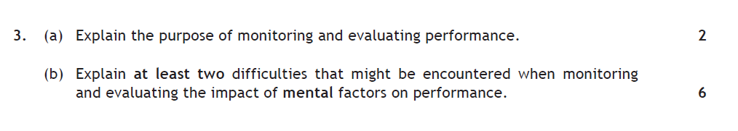
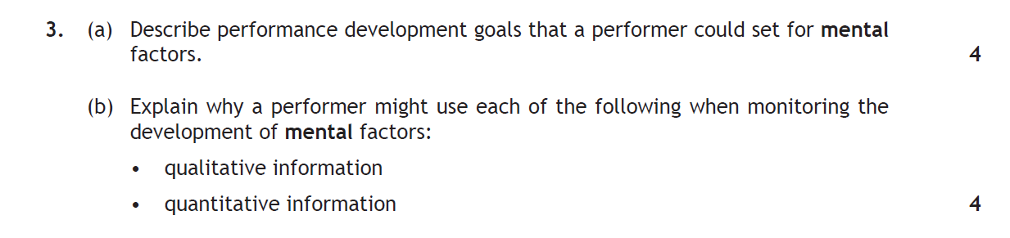
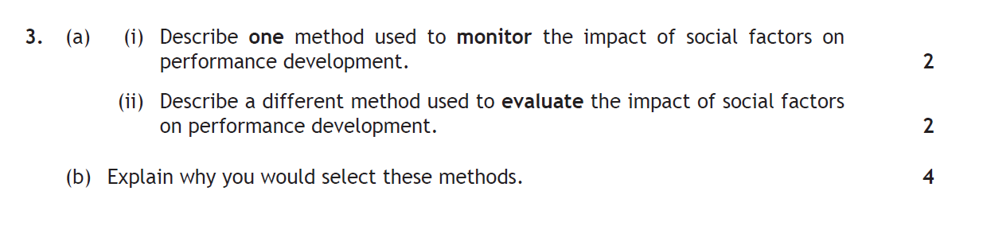
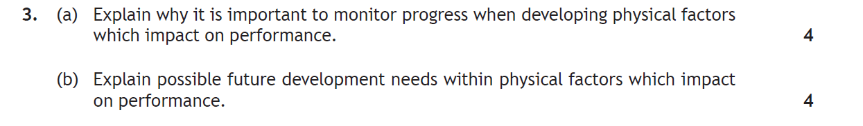

Tip – For extra practice simply change the Factor asked within the Question!

The Scenario- Setion 3

Below is an example take from the 2015 Scenario

Read the scenario below and attempt the question which follows.

This is an extract from a questionnaire completed by a student studying Higher Physical Education.

Questionnaire on Impact of Mental Factors on Performance

Statement – Response by student

Before I perform, I am relaxed. – Never
When I perform, I am highly motivated. – Sometimes
When I perform, I concentrate fully. – Sometimes
When I perform, I make appropriate decisions – Sometimes

- Analyse how the responses in the table above could affect this student in an important performance. (8)

Your answers must make reference to mental factors and one other selected from physical, emotional or social.

“The third statement from the extract suggests the performer goes through spells of their activity concentrating to their full potential. A lack of concentration at particular times in an important performance could lead to silly mistakes. For example if the activity was badminton loss of concentration could lead to unforced errors such as hitting the shuttle into the net. A loss of concentration in football might mean a performer fails to stay close to their man, giving the opponent the chance of scoring a header. By only sometimes making appropriate decisions a performer may not achieve the best mark they can. An example of this in basketball might be opting to take a risky shot from distance rather than pass to a player close to the basket. This can cause the team the crucial opportunity to score more baskets. This could also lead to the performer losing marks in a one off performance as effective decision making has 16 marks attached to it. The first statement links closely to levels of anxiety. It is clear the performer never feels relaxed and therefore must have a high level of anxiety. This may cause them to over think about their performance not execute simple skills that they would normally would with ease. The pressure of teachers and spectators watching in a one off performance environment may cause them to free and shy away from completing complex skills. In gymnastics, for example, someone who can perform a front somersault in practice may only attempt a tuck during an assessment. This increased anxiety makes the safer option more sensible to them. By only sometimes being motivated a performer may struggle to overcome challenge in the face of adversity. They may also choose when to put effort in and when not too. This will make it difficult for them to continually achieve their goals. A target to beat a particular opponent in table tennis, for example, may not be achieved because crucial methods of practice may have been missed. This would mean the performer would be less likely to beat that player in the important performance.”

- Explain how knowledge of a model performance could assist this student to develop the factors identified in part 4(a).

“Knowledge of all of the aspects that contribute to a model performance would allow a performer to create a plan in relation to their development needs. A model performer would have:

High levels of motivation

High levels of concentration

Appropriate decision making and information processing abilities due to experience

The ability to anticipate

The internal drive to constantly achieve goals and further improve

The ability to manage emotions

Low levels of anxiety

Knowledge of all of these features from both factors would enable the performer to identify and compare what ones were most appropriate to them and required most development. If the performer struggled with making decisions in high pressure games they would set this as a target for improvement. This would then allow them to participate in scenario activities, for example. Scenario based activities are problem solving activities that give you the opportunity to rehearse how to solve problems. A team might have to rehearse what they would do if they were 2 points down with 10 seconds to play. Knowledge of a model performer or a model team performance would allow them to look at the types of decisions or plays they would create so they could try and implement them. This would then have a positive impact on performance because scenarios that games present would be prepared for. Knowledge of a how a model performer copes when making mistakes would enable a performer have a coping mechanism when they make a mistake. Model performers usually take a moment to adopt deep breathing. By knowing this a performer can practice this in class and gradually start to introduce this in games. This will help them alleviate the mistake and move on with the rest of the activity. A model performer also provides inspiration for a performer who is still learning. This can help to motivate a learner and give them a standard to aim for. This will make them work harder when using approaches to develop performance.”

Below is an example taken from a 4th Year Prelim Scenario

Look at the pictures below and attempt the questions that follow.

The pictures show an elite Tennis player at different points during a tournament.

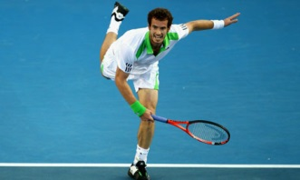

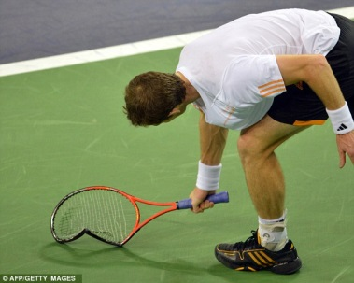

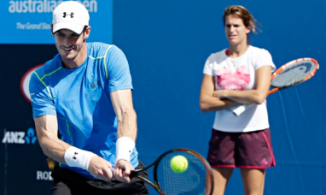

1. (a) Analyse the possible factors and features that may have impacted on this performer. In your answer you must refer to the following factors impacting on performance: emotional and one other — from physical, social or mental.(8)

“In picture 2 you can see that the performer has smashed his racquet off the ground, potentially in anger. Because he is angry he may not be fully focused on the match. This means that he may start to make silly mistakes in the match such as hitting the ball into the net on an easy smash. This means that he will lose more points and make more unforced errors making his opponent more likely to win the match.
If the performer cannot control his anger he may start to lash out at the umpire if a decision goes against him. This could create a hostile environment for the match. If this continues the umpire may sanction the player which would lead to a potential ban. This would prevent the performer from competing in future matches and could harm his overall progress.

The performer may also be suffering from anxiety due to a previous loss against his opponent. This anxiety may be causing him to panic which could result in him making incorrect decisions. For example he may try to lob his opponent when his opponent is in the middle of the court. This would give his opponent the opportunity for an easy smash and would cost the performer basic points, possibly leading to another loss.

In picture one the performer looks to have just played a powerful serve. Because the performer is powerful on his serve he can play the serve with a lot of pace which could catch his opponent off guard. This would give his opponent less time to think and less options for where he plays his serve return. As a result the performer can then pick up easy points from his opponents weak serve return.

The performer also looks balanced and agile in picture one. Good agility is beneficial to this performer as it allows him to move around the court at speed. This means that he can return difficult shots from anywhere on the court. This makes it more difficult for his opponent to get winners and makes it more likely that the performer will win points.

In the final picture you can see the performer has hit a weak backhand shot. This can be seen as the ball has not hit the sweet spot of the racquet. A weak backhand shot means that he cannot put his opponent under pressure from this side. His opponent may notice this and start to play more attacking shots to his backhand. If he cannot return them with power or accuracy then he may hit the ball out meaning his opponent gains more points and is more likely to win the match.”

(b) Explain the possible approaches this performer would undertake as part of their performance development.(8)

“Deep Breathing is an approach the performer could use to manage their anger during high pressure points in games. When the player makes unforced errors he should take large deep breaths. This will allow him to forget about his mistake and carry on with the next point fully focussed. Deep Breathing will also calm the player down and lower his heart rate, possibly resulting in him going onto win the next point. Alongside Deep Breathing he could use positive self-talk. Positive self-talk, like deep breathing, can be used in response to mistakes. The performer would use words associated with success, such as ‘next point big’, as a means to be fully motivated to win the next point, rather than the mistake having a lasting effect on him.

During his practice sessions the performer may wish to play scenario based games such as handicap matches. A handicap match such as being 2 sets down would force him to practice the deep breathing and self-talk techniques in an effort to win 3 straight sets to come back and win matches. This will allow him to experience similar situations to what he will have in competitive matches and will then know exactly what to do if any such situations arise.

During his practice sessions the performer might also practice his weak backhand by doing repetition practices. A repetition practice is a practice where the same skill is repeated over and over again, e.g, 15 backhands in a row. This will allow the performer to build up consistency with the shot and be able to play it automatically. The practice can be made more game like and used from different areas of the court, meaning that wherever his opponent plays shots to he will be able to return it with his improved backhand.”

Practice Questions for the Scenario

