Hillhead High School

Physical Education Prelim Exam (Higher)

November / December 2016

Total marks — 40

SECTION 1 — 24 marks

Attempt ALL questions.

SECTION 2 — 16 marks

Attempt ALL questions.

Write your answers clearly in the answer booklet provided. In the answer booklet, you must clearly identify the question number you are attempting.

Before leaving the examination room you must give your answer booklet to the Invigilator; if you do not, you may lose all the marks for this paper.

SECTION 1 — 24 marks

Attempt ALL questions

1. (a) Describe two different methods that could be used to gather information about the potential impact of physical factors on performance. (4)

(b) Select one of the methods described in part (a).

Evaluate the appropriateness of one of the approaches you described in part (a). (4)

2. (a) Describe one approach to developing the social factor. (4)

(b) Evaluate the benefits and limitations of the approach you described in part (a).(4)

3. (a) Describe two different approaches to monitoring and evaluating the emotional factor. (4)

(b) Explain the benefits of using both quantitative and qualitative approaches to monitoring and evaluating your performance. (4)

SECTION 2 — 16 marks
Read the sports magazine excerpt below and answer the questions which follow.

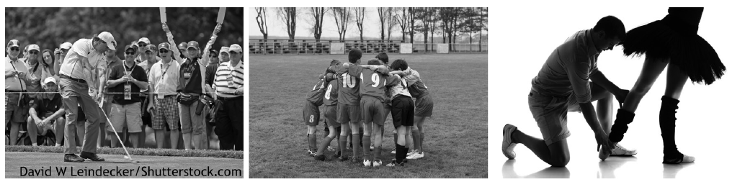

“Participation in an activity is rarely carried out in complete isolation. This can be training, practising or performing with, against, or in front of others. The presence of others can be positive or negative”.

4.(a) Explain why the presence of others can positively and negatively impact performance, practice or training.

In your answer you must refer to the following Factors:

Mental and one other factor from social, emotional or physical (8).

(b) Analyse approaches which may be used to overcome the negative impact of the presence of others during performance, practice or training.

In your answer you must refer to: Mental factors and one other factor from social, emotional or physical. (8)

[END OF QUESTION PAPER]

