Hillhead High School
Oakfield Avenue
Glasgow G12 8LJ
Phone 0141 582 0100

Head Teacher
K McAlaney

05.01.2022

S6 Telephone Parents Evening – 18.01.22 4.15pm to 6.45pm
Booking opens 07/01/22 at 2:30pm – Booking closes 14.01.22 at 3.00pm

Dear Parent / Carer,
Prior to the 2019/2020 school session, in order to report pupil progress to parents, our school provided both tracking reports as well as in-person parents evenings. Unfortunately, COVID 19 control measures has prevented us from hosting such events.

We are pleased to be able to write to you and provide details of a new system that will allow us to report to you through pre-booked telephone calls. Like in-person parents evenings, parents will be able to ‘book’ appointments with teachers of their choice.

Parents/carers are asked to book telephone consultations using an online system. Teachers will then call at the pre-arranged time. Please note:
- Calls will be strictly time-limited and the system can lead to them ending abruptly - to ensure time is available to all parents/carers.
- When calls are made, the number may appear as ‘Unknown Caller’

Telephone consultations can be made at https://parents-booking.co.uk/hillheadhs
Detailed instructions can be found overleaf.
Yours Sincerely

J. Richardson
Depute Head Teacher (Acting)
- To identify yourself to the system you must correctly enter the details as prompted on the right:
- If you have any details accessing the system please contact the school office (01415820100)

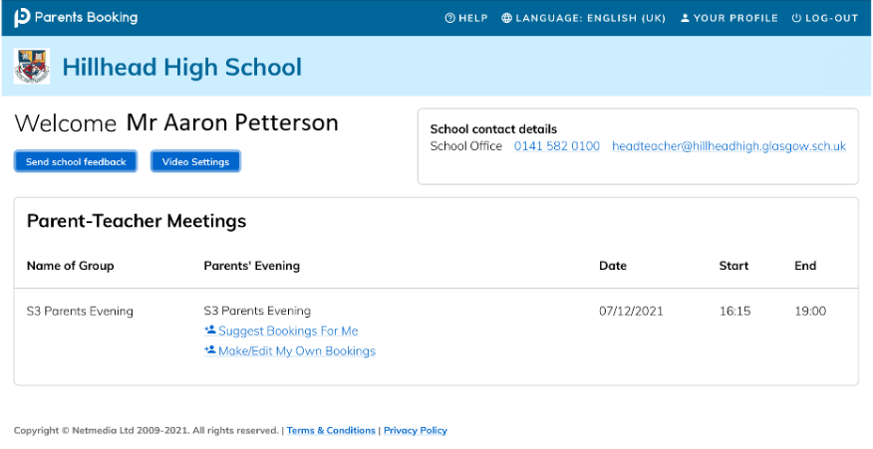
- Once you are logged in it is essential that you confirm the details held using ‘YOUR PROFILE’
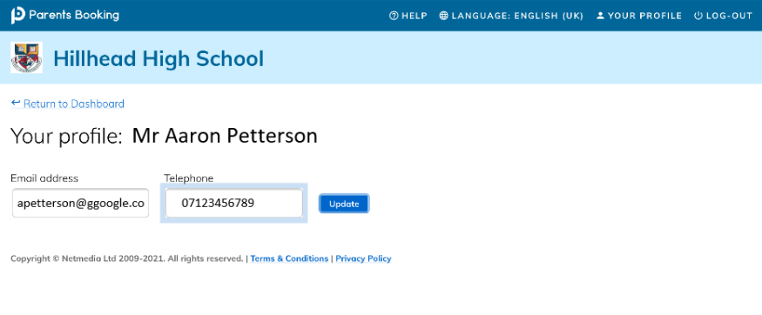
- Once in ‘YOUR PROFILE’ please ensure that your phone number is entered correctly. This will be the number provided to teachers to call you.

- Once your phone number is confirmed you can ‘Return to Dashboard’ and select either:
  - Suggest Bookings for Me
  - Make/Edit My Own Bookings
If using ‘Suggest Bookings For Me’ you will see this:
This way the system will automatically make bookings during the time available
‘Tick’ the subjects/teachers you wish to have consultations with and then press ‘Make my bookings for me’ – you then must confirm.
If using ‘Make/Edit My Own Bookings you will see this:

This way allows you to choose subjects/teachers and times. In the example above ‘Graphics’ has been selected and the first available appointment is shown. You can click ‘Book’ and then ‘Make Booking’ to confirm. You can then do this for other subjects/teachers individually.

