GLASGOW GUARANTEE

A Guide to Completing the Application Form

“We are keen to support you on your journey to employment.

This guide will start you on the process in planning / preparing an application tailored to the requirements of Glasgow Guarantee’s application form for modern apprenticeships and jobs.

We hope the hints and tips you get from this guide will support any future applications you make and better prepare you for securing an apprenticeship or job”

Glasgow Guarantee Team

Glasgow Guarantee Application Form
My Account

The Glasgow Guarantee application form is made up of 6 sections, some of which is information that you can provide by completing your Glasgow Guarantee account.

Please make sure, before you start an application form that you have completed the following areas on your account:

- Qualifications
- Work Experience
- Key Skills
  - The information you provide in these 3 areas will be pre-populated into the application form
  - You will still have the option to edit/amend these areas within the application form

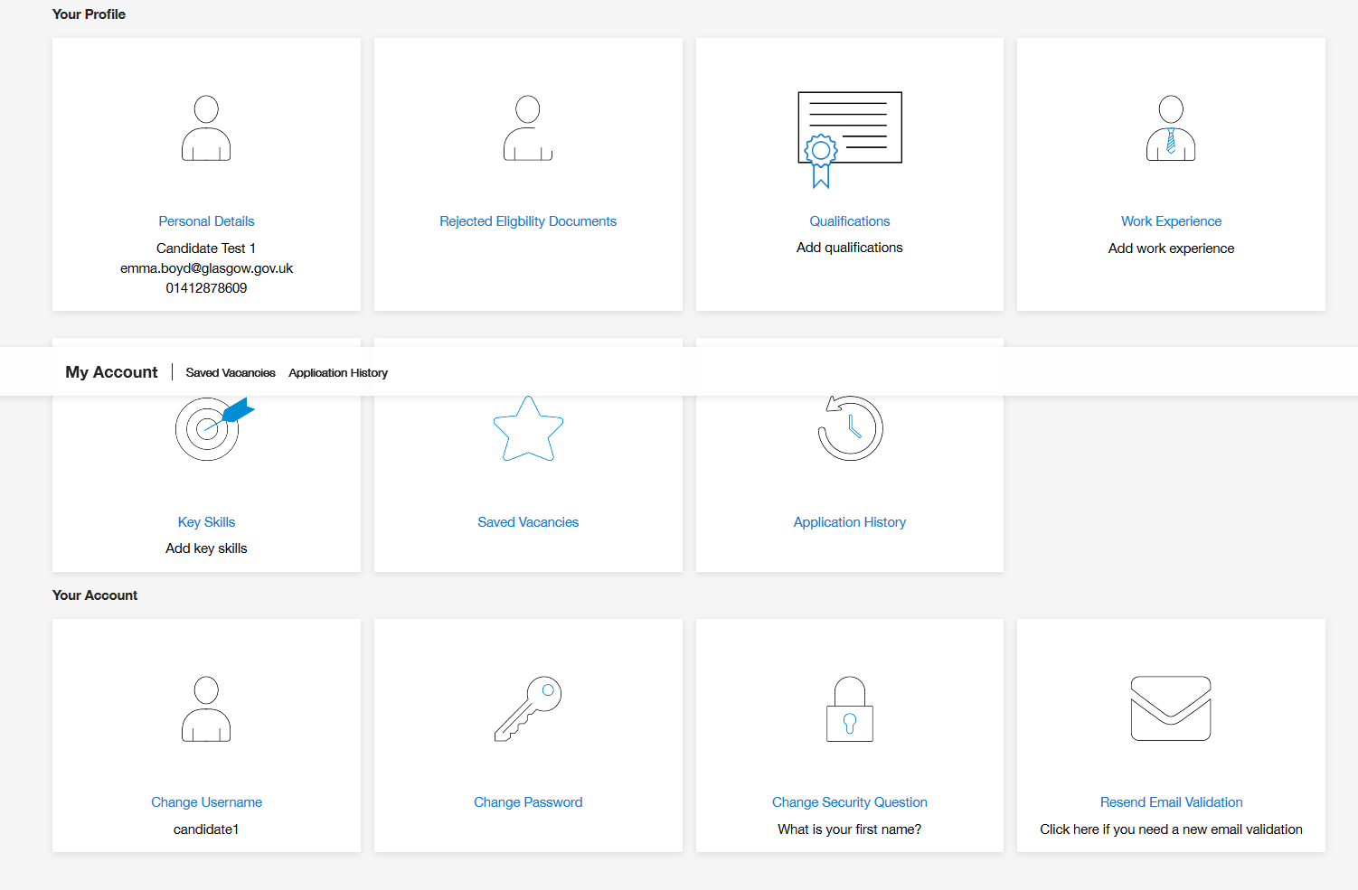

Glasgow Guarantee Application Form
How do I Apply?

When you have found an apprenticeship or job opportunity that you want to apply for, you will see at the top and bottom of the job description an ‘Apply’ button.

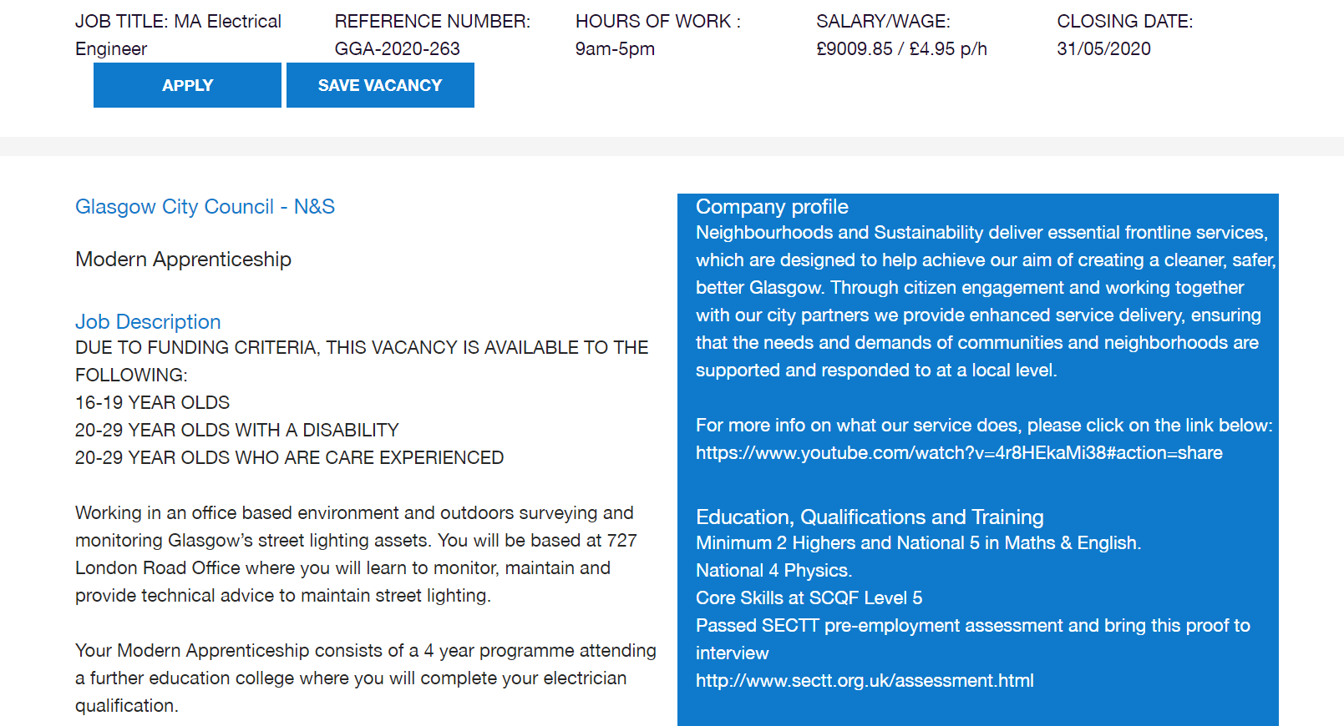
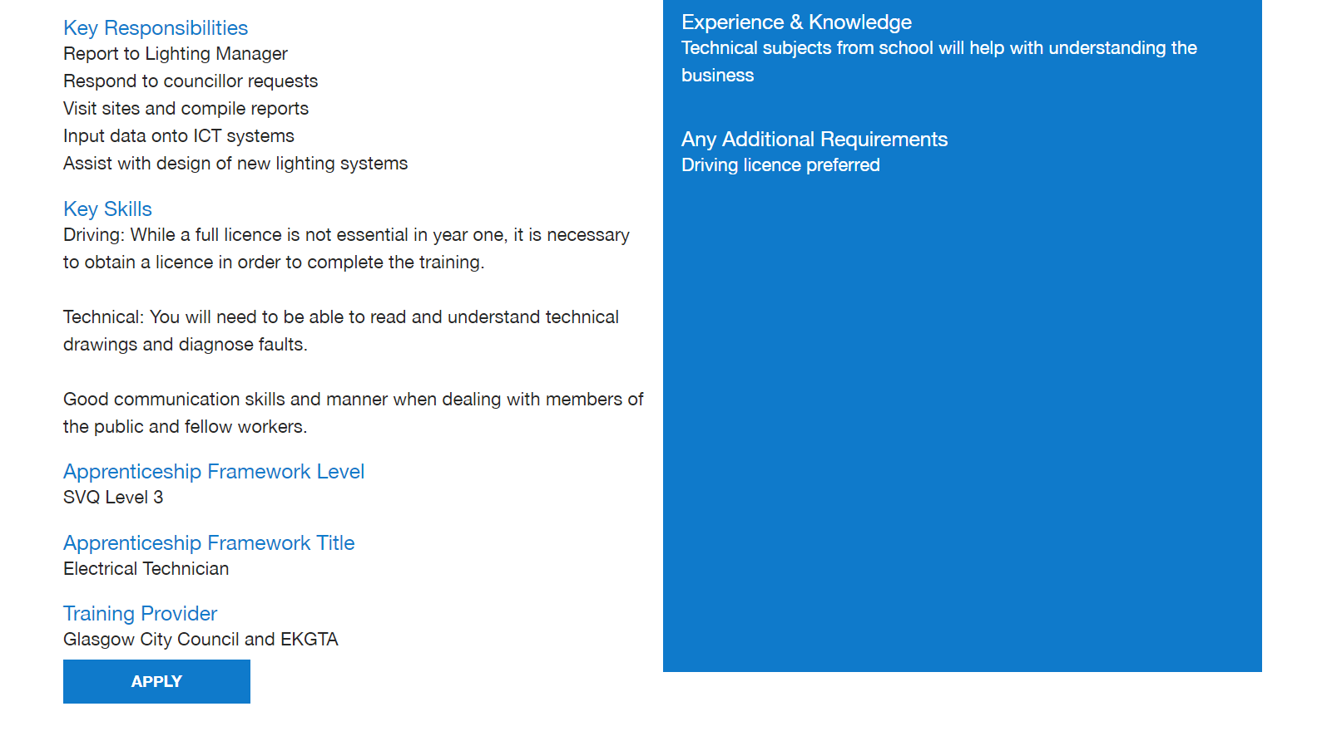

Glasgow Guarantee Application Form

At the top of the application form is the job description and person specification, so you can easily view and refer to this when completing your application form.

The application form will look like the following:

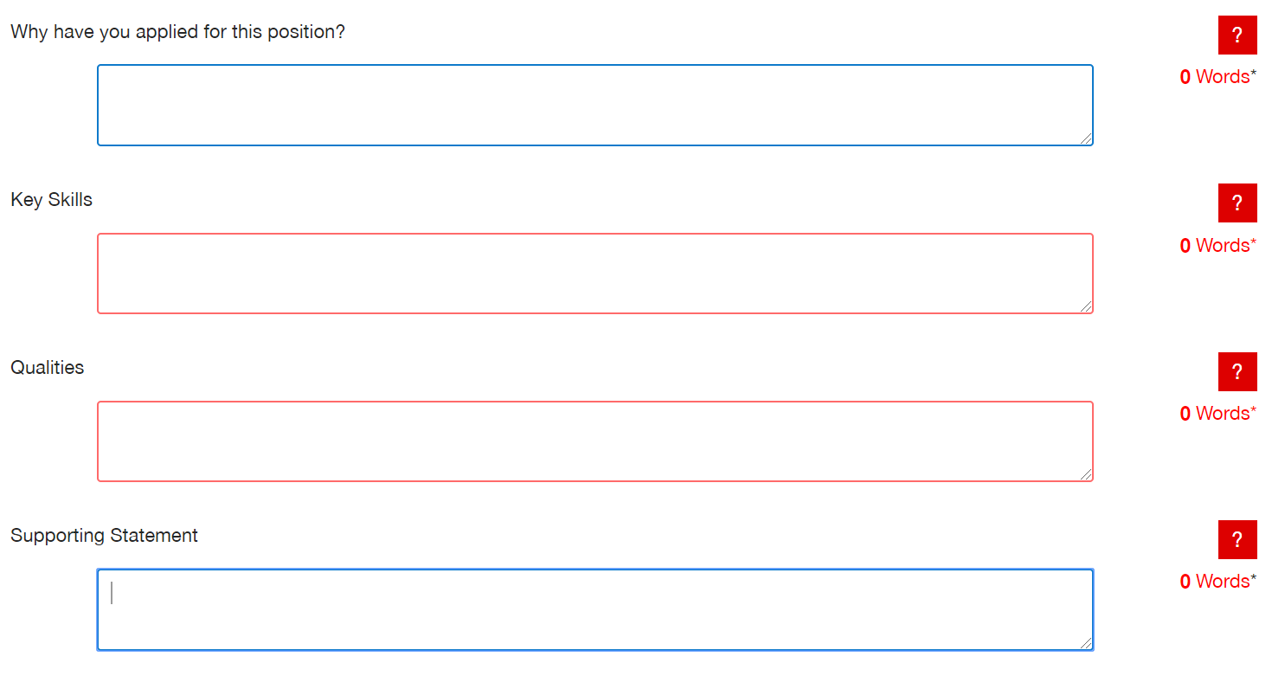
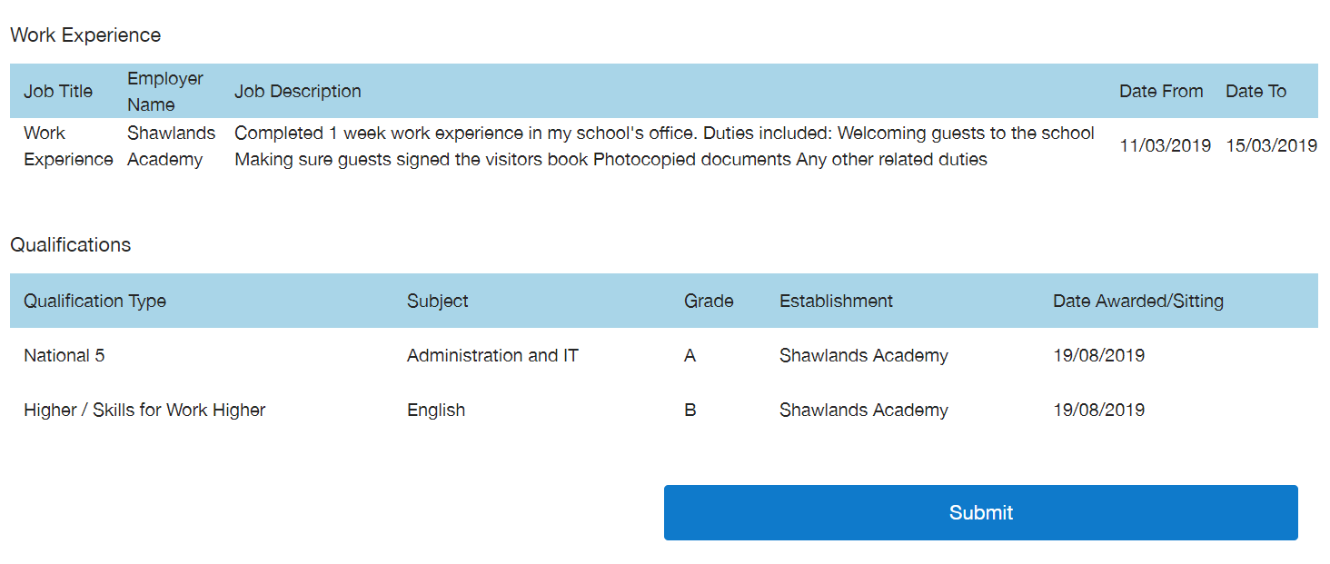

- The red question mark provides hints and tips
- Word count is available to check how many words have been written
- There is a 1 HOUR time limit on completing the application
  - An alert will pop up when the hour is near
  - You can submit your application and edit/amend it later from the ‘Application History’ as long as the vacancy is still live.

Glasgow Guarantee Application Form

Key things to consider in your answer:
- Why are you interested in this apprenticeship/job?
- Why do you think you would be good at the apprenticeship/job?
- What do you know about the apprenticeship/job and what is involved?
- What do you know about the company you are applying too? If nothing, please do some research!

Key things to consider in your answer:
- What key skills do you have, which are relevant to the role you are applying for?
- Look at the job description and think about what you need to be good at, to do the job/apprenticeship.
- Give examples of things you have done or studied that show your skills, which match the job/apprenticeship you are applying for.
- Some examples of skills are: team work, organisation, customer service, communication, IT literate, time management and problem solving.

Glasgow Guarantee Application Form

Key things to consider in your answer:
- What qualities do you have, which are relevant to the role you are applying for?
- Look at the job description and think about what qualities you need, to do the job/apprenticeship.
- Some examples of qualities are: honesty, kindness, good work ethic, loyalty, trustworthiness, responsibility and reliability

Key things to consider in your answer:
- Any other information you may wish to be considered in your application that is relevant to the apprenticeship/job.
- What are your hobbies and interests: are you a member of any clubs/groups/teams?
- Mention any work experience including work placements and voluntary work.
- Some roles require a driving licence, so you could mention if you have one or are currently taking lessons.

Glasgow Guarantee Application Form
Qualifications

You can add qualifications by clicking on the qualifications icon in your account

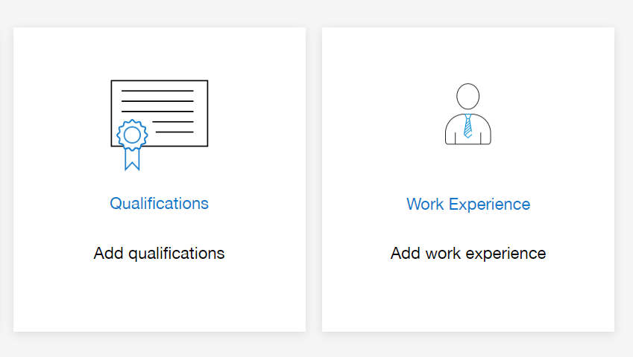

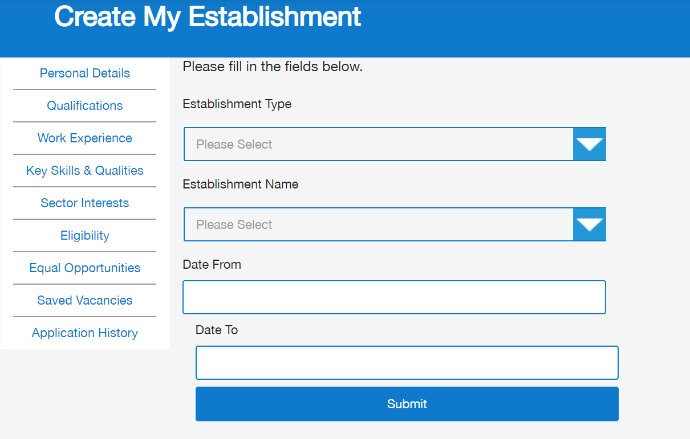

- Select school / FE/HE / Other from Establishment Type
- Select your school / college / university from Establishment Name
- Enter the dates you attended
  - If you haven’t left school/college, enter the date you will leave
Glasgow Guarantee Application Form
Qualifications

- Select Create Qualification

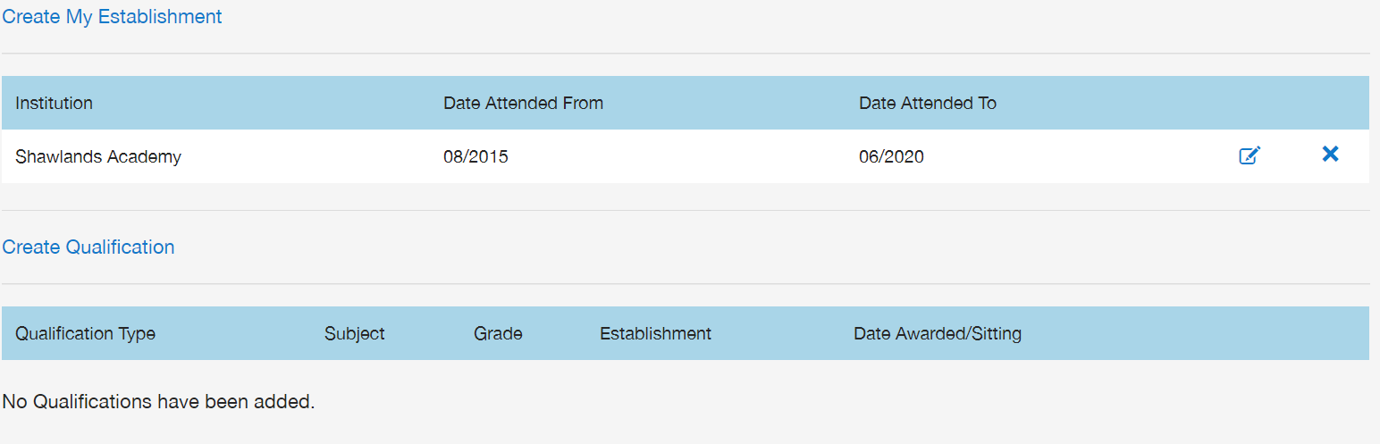

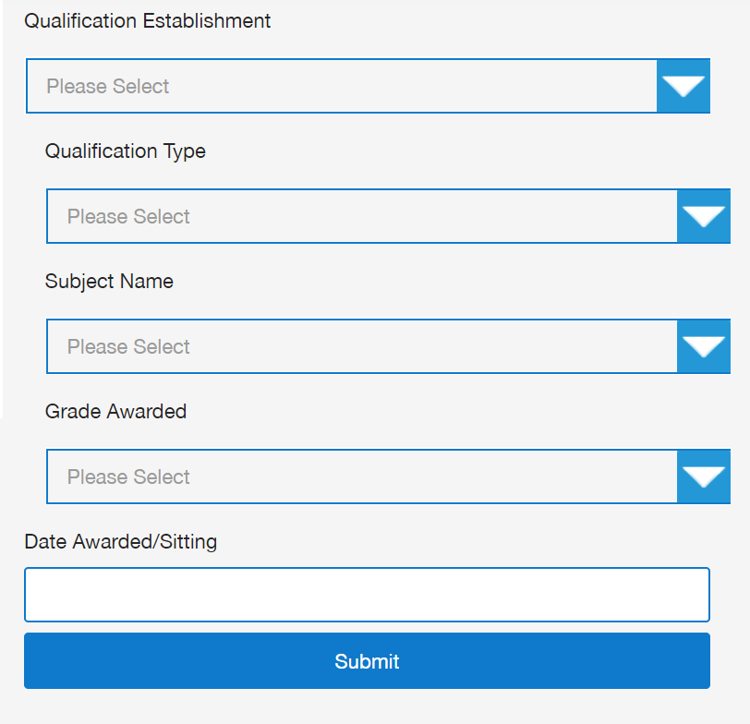

- You can select your qualification type, subject name and grade
  - If you haven’t received your grade yet, please select ‘Pending’
  - Enter the date you were awarded the grade or the date you will be sitting your exam

Glasgow Guarantee Application Form
Work Experience

You can add details of any voluntary, paid and unpaid work experience by clicking on the Work Experience icon in your account.

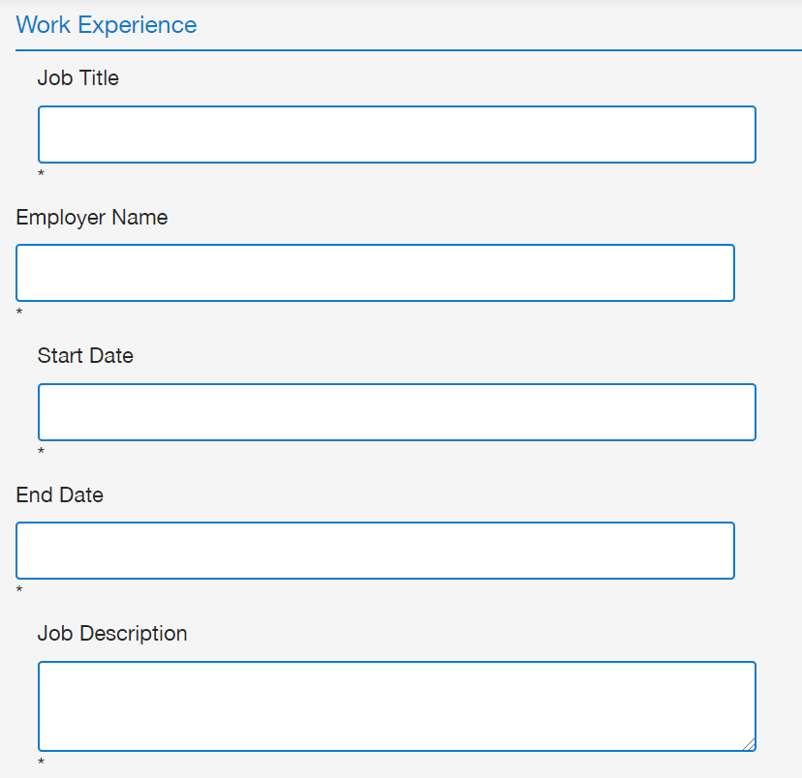
Glasgow Guarantee Application Form:
Examples

This section may be useful for school leavers or young people who are interested in applying for apprenticeships/jobs but may not have much experience of writing an application form. These examples can be used as a guide to help you write your own application

Why have you applied for this position?

Key things to consider in your answer:
- Why are you interested in this apprenticeship/job?
- Why do you think you would be good at the apprenticeship/job?
- What do you know about the apprenticeship/job and what is involved?
- What do you know about the company you are applying too? If nothing, please do some research!
Example 1 (Childcare):

I really love working with children and I would be really interested in working for ‘Childcare Company’ as a childcare worker. This would be a great role for me because I am very friendly and approachable and have experience in nursery settings during a recent work placement. I am also very well spoken and have great communication and written skills. I believe I could make a positive impact on young children and help children develop through the early stages of their lives.

I understand the role of childcare worker would involve working as part of a team, creating and setting up activities for learning and play and helping with the children’s social and emotional development. ‘Childcare Company’ employ 10 staff members and provide care and learning to 90 children between 0-5 years. I am a very hard-working young person and would give 100% effort to all tasks asked of me and when completing my training. I feel an apprenticeship is the right option for me at this stage in my career development, as I learn best by doing. I am ready to leave school and enter the world of work and continue to gain new skills and experience.

Example 2 (Construction):

I have always been very interested in the construction trade and would love to become an electrician. I am interested in this apprenticeship because I know that this would give me the stepping stones I need to start a successful career in the trade. ‘Construction Company’ is a very successful company who I believe would help me obtain the skills, training and knowledge that I need to develop into a successful electrician. I believe I would be a good electrician, as I have gained some knowledge and practical skills by completing a National Progression Award in Building Services at College. During the course, I learned basic electrical installation operations as well as plumbing, heating and ventilation, refrigeration and air conditioning operations. The work based on electrical installation was my favourite and I really enjoyed all aspects of this and did well in my course work. I have also completed 4 weeks work experience as a labourer to an electrician and learned a lot from this. I would be able to use this experience if successful in securing this apprenticeship.

I know that ‘Construction Company’ has been operating since 2003 and has an excellent reputation for being a professional company with highly skilled electricians. They provide services to residential, commercial and industrial clients and are involved in the installation of systems that control heating and ventilation.

Example 3 (Administration):

I have applied for the role of administration apprentice as business administration has always been my favourite subject in school. I also completed work experience in an office last year and I loved it, which is why I am sure that this is the career route that I want to take.

I have researched ‘Housing Association’ and found that you have over 1000 customers over the Glasgow area and have been established for the last 20 years. I see on your website that you have over 50 employees and that you commit to training and developing your staff, I feel that this would be a great place to start my career in administration.

Glasgow Guarantee Application Form:
Examples

Key Skills & Qualities

Key things to consider in your answer:
- What qualities do you have, which are relevant to the role you are applying for?
- Look at the job description and think about what qualities you need, to do the job/apprenticeship.
- Some examples of qualities are: honesty, kindness, work ethic, loyalty, trustworthiness, responsibility and reliability
Example 1 (Childcare):

To be a successful childcare worker, you need to be an excellent communicator, as you will be working with children of various ages and written/spoken abilities. I feel that I am very good at communicating with others including children and adults, as I have experience communicating with young children during my work experience placement and within my personal life, as I have two younger siblings, who I have helped looked after since birth. I can also talk very well with adults, a skill I have developed during school in presentations and also in my part time job in my local retail shop. I am a very organised person and always completed school work on time and to a high standard. I also have experience organising activities and day trips for my brothers and sisters. When I am babysitting, I make sure that I have the day planned out and all activities and food prepared. This helps me stay focused and in control and I would be able to use my organisation skills during an apprenticeship. Another skill I feel is important and one that I have, is being responsible. I am often in charge of looking after my brothers and sisters and will always remain calm in any difficult situation. Finally, I have lots of experience working as part of a team. I have completed school group based projects and helped nursery staff when I was on work experience placement. I feel I coped well and got on with others. I am very confident and chatty and would be able to fit in well to a team.

Example 2 (Construction):

I believe I have all the relevant skills and qualities that make me right for this apprenticeship. Firstly, I am a practical individual who has experienced physical work during a work experience placement as a labourer. Through this opportunity, I learned the importance of health and safety in the workplace when dealing with tools and machinery and I understand the need for Personal Protective Equipment (PPE). I am also a very methodical worker and have demonstrated this through my NPA College course and school work. My practical nature can be further evidenced through helping my dad with basic electrical odd jobs around the house. I have also undertaken a project at my local community centre, where I helped to paint the centre with a team of other volunteers. This project has demonstrated my time management skills, as we were working to a deadline, as well as my ability to get on well with others. I believe my hardworking nature is reflected in the fact that I have a part time job. I currently work at my local pizza takeaway at the weekends and have responsibility for helping customers and cash management. Balancing this with my full-time studies demonstrates my ability to manage workloads. I always give 100% in all that I do and I would continue to work hard if given the opportunity to take up the apprenticeship.

Example 3 (Administration):

For the last 3 years in school I have studied Business Administration. This year I studied Higher Administration, which I feel has provided me with a good foundation to go on and do an apprenticeship. I have gained basic skills, which I feel will benefit me in the role of an administrator including knowledge of Microsoft packages and excellent keyboard skills. I am highly organised and can prioritise my workload and time manage. An example of this is when I was on my work experience, I had to update a database with customers’ details by a set date; this was something I had to do whilst also doing other tasks like typing letters and answering the phone. I had to prioritise my working schedule to meet this time deadline and managed to complete the task early. I have developed good communication skills and feel confident in communicating with others either in a face to face environment, over the telephone or via email and letter. I am polite and presentable and have a positive attitude along with a helpful, friendly and approachable personality, which would ensure that customers of ‘Housing Association’ would feel welcomed and comfortable when contacting the company. At school I was part of our year book and prom committee. This helped to develop my communication skills greatly, as I had to contact suppliers as well as work as part of a team to make sure that the tasks were completed on time.

Glasgow Guarantee Application Form:
Examples

Supporting Statement

Key things to consider in your answer:
- Any other information you may wish to be considered that is relevant to the apprenticeship/job.
- What are your hobbies and interests: are you a member of any clubs/groups/teams?
- Mention any work experience including work placements and voluntary work.
- Some roles require a driving licence, so you could mention if you have one or are taking lessons.
Example 1 (Childcare):

I feel I have gained a lot during my time in school and am proud of my achievements. I am now ready to leave school and continue to the next stage of my learning. An apprenticeship is the best option for me, as I learn well by doing and I am also very interested to gain more qualifications and skills and look forward to continuing my study. As I mentioned previously, I have some experience of the workplace during placement within a local nursery and within my part time retail job. I feel I am ready to develop my work experience and I would be able to handle the duties and requirements expected of me. I often help-out at my local community centre and set up the hall for activities and sports. I also help with serving snacks.

Example 2 (Construction):

I feel I am now ready to explore working life and gaining an apprenticeship is the next step for me, as I would like to continue to learn while gaining practical experience at the same time. I feel that a modern apprenticeship is the next step for me, as I already have experience of the world of work and within construction during my work placement. I appreciate the demands and responsibilities that come with full time work. I have recently gained my CSCS Card and have passed the SECTT test and have very good numerical and practical skills. I am also very active and physically fit, as I attend the gym most days and would be able to undertake any physical and heavy tasks. I am also able to work at height. I am currently undertaking driving lessons and hope to pass my driving test soon. I would welcome the opportunity to work for ‘Construction Company’ in the future and hope to be successful with this application.

Example 3 (Administration):

In my spare time I enjoy keeping fit and active. I regularly go to the gym and I also swim a few times per week. I also love socialising and going out with my friends and family. I am now reaching the end of 6th year and I feel that an apprenticeship is the route that would suit me best. I like the idea of being able to work whilst doing a qualification and getting on the job training; I feel that this is a great way to learn. As I have mentioned, I have always enjoyed administration throughout school and having had my work experience in an office, I got a feel for what it would be like to work as an administration assistant in the future.
Now It’s Your Turn

You are now ready to complete the Glasgow Guarantee application form but before you do, you might want to write some ideas on what you want to say in the following sections. This can be copied and pasted into the Glasgow Guarantee application form, when you are ready to complete it. Remember to spell check!!

Please use the space provided:

Why did you apply for this position?

Key Skills

Qualities

Supporting Statement

