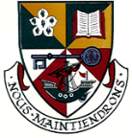
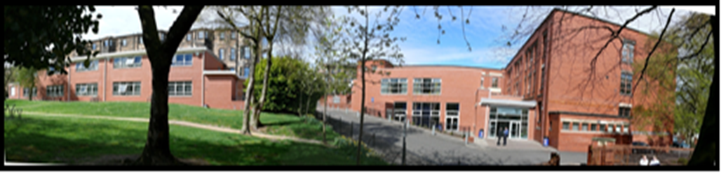
Head Teacher’s Report - Mon 29th October 2018

Senior Phase Pathways Evening

- Information Evening took place on Tues 9th October. Input from Senior Leadership Team, Senior Pupils, Skills Development Scotland and Principal Teacher of Raising Attainment. PowerPoint presentation is now on the school website and a link to it was sent out by text the following day.

S1 Parents’ Evening

- Excellent turnout at last week’s meeting – almost 90%, Updated questionnaire issued on communication. Also information shared on Group Call. Moving to Group Call will save money and will allow information to be shared better.

My World of Work Week

- This took place before the October break and involved S1-S6. All pupils shown how to sign up for the site and how to make best use of different features.
- Parental site now also launched - www.mykidscareer.com. As shared at the last Parent Council Meeting this website supports parents with information on jobs in demand / career paths and career discussions.
- There are plenty of resources on the school website to further support with careers and options choices.

Duke of Edinburgh

- This year’s Award Ceremony takes place on Wed 21st November.
- Mr Gillespie has completed his Mountain Leader training and as a result we can now offer Gold Duke of Edinburgh in school. A letter was issued last week to senior pupils about the award. There are two options: one fully funded and one involving fundraising.

Senior Pupils Leadership

- Columba 1400 residential in Skye has now taken place and all involved are back in school leading our committees.

S5 Information

- Supported Study programme was updated as a result of staff, pupil and parental feedback and we are now in week 4 of a 6 week block for S5.
- S5 prelims begin on 19th November and a prelim timetable has been issued.
- Target group of pupils are working with Youth Mindfulness.
- There will be special assemblies to support pupils in preparation for prelim exams.
- Study Skills Support Evening / Event – date t.b.c.

Period Equality

- The Scottish Government has invested £5.2 million in order to supply all students with free sanitary products Two school captains and group of S2 pupils are leading this initiative. Pupils have visited St. Paul’s Secondary School in Glasgow who, in conjunction with social enterprise company Hey Girls, have have successfully provided free sanitary products to all girls in their school.
- School Captains spoke to all staff at our In-Service Day on 12th October.
- They attended year group assemblies last week.
- There will be special assemblies next week with girls only. These will be led by pupils.
- Information will be shared on the school website.

Staffing:

- Ms Hyslop will be absent for the next 10-12 weeks. Ms Ruddy appointed Acting Principal Teacher of English in her absence.
- Post of Acting Principal Teacher of SFL/EAL and Behaviour is currently being advertised to cover Ms Black’s maternity leave which is due to begin in December.

Free School Meal and Clothing Grant:

- Letter issued before October week encouraging all families who are eligible to sign up for Free School Meal and Clothing Grant. Information also on school website.
- School ties now back in stock.
- Ongoing work with local churches and Parent Council and donations of clothing – especially for winter- are welcomed.

Staff Training

- All staff took part in training from LGBT Youth Scotland in August and in October. Feedback was very positive and we continue to work towards our Charter Mark.

School Assemblies

- Our weekly year group assemblies are linked to our five school values. There is also input from staff across the school as well as outside partners.
- This week S1 received a talk from the Scottish Fire Service about fireworks and fire safety. Miss Shaw (Humanities) also came along to introduce the plans for our new Eco Group which will be open to S1-S6 pupils.
- Next week is Remembrance Week and Mr Elder (PT Humanities) and a group of staff have been working with Bernie to put plans in place for the week.
- w/b 12th November is Anti-Bullying week and Ms Robison (Science) has led work on this with pupils and staff. Pupils will be involved in delivering assemblies.

Art, Music & Drama

- Mr Reid has produced a video showcasing the work of the Art Department. A link to it was tweeted last week.
- There are several exhibitions and performances over the next few weeks. Higher Music Composition performance. This will takes place from 4.00-5.30pm on Wed of this week in the Drama studio and staff, pupils and parents are invited to attend. Pupils have been working with the composer John Harris and professional musicians from the Red Note Ensemble, to compose their own piece.
- Advanced Higher Art Exhibition – This takes place on Fri 23rd November 5.00.7.30pm. As well as showcasing the work of current Advanced Higher Art Students there will also be an exhibition of work from former pupils who are now at Art School.
- Annual Art Exhibition – This is an exhibition of one piece of work of every pupil in the BGE and all who choose Art in the senior phase as well as all who choose an art activity for MTA. Exhibition takes place on Wed 12th December from 5.00pm-8.00pm and Thurs 13th December from 4.00pm-6.00pm
- Art Calendar – Any parent who knows of a local business who may wish to sponsor our Art calendar for £50 contact please contact Mr Reid gw10reidross@glow.ea.glasgow.sch.uk. Calendars will be on sale late November for £4.00 per 3 for £10.

Winterfest

- Takes place on Saturday 1st December. There will be face- painting /stalls / tea /coffee and biscuits
- Local businesses are paying a fee to have a staff and staff and pupils also there to raise money for school funds and charity. Please contact Miss Jackson gw16jacksonnicola@glow.ea.glasgow.sch.uk if you would like more information.

