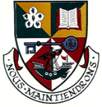
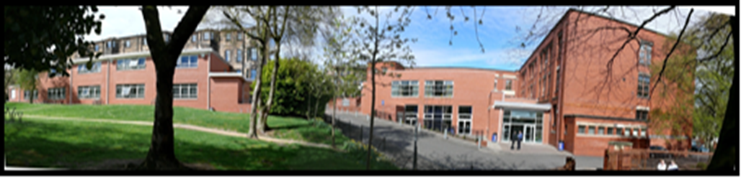
Head Teacher’s Report - Mon 17th September 2018

Successes Last Session

- School Inspection.
- Pupil Equity Funding (PEF) spending, including impact of 3 Principal Teachers of Raising Attainment.
- Partnership work with Parent Council and a wide range of partners.
- Tracking of achievement and increased accredited achievement –e.g. highest number of D of E awards, introduction of level 6 Leadership Award.
- Increased support for pupils most at risk of leaving school with no qualifications including Pathways Group led to improved attainment.
- Teacher Learning Communities - we have 7 in the school and these were identified as an example of national best practice to be shared more widely.
- Leadership opportunities for staff and pupils.
- Sharing of effective practice at Leadership Team Meetings.
- Better communication.
- S6 Induction Week and vision for the senior phase.

Pupil Leadership

- School Captain interviewed – 10 interviewed. School Captains are Lena Weeks and Zoe Richard-Campbell.
- Fire Up Scotland
- Columba 1400 – next week.
- My World of Work Ambassadors
- Committee Structure
- Youth Mindfulness

SQA Exam Results:
- Overall trend of improvement over last 4 years since introduction of new senior phase model.
- Slight dip on last year’s S5 results – which were best ever or second best ever in each category
S5:
- 20.5% of pupils achieved 5 or more Highers (compared to 22% last session)
- 34.3% of pupils achieved 3 or more Highers (compared to 35% last session)
- 57% of pupils achieved 1 or more Higher (compared to 63% last session)
- 33% of pupils achieved 5 or more Nat 5s

- Strong S6 results:

S6:
- 27% of pupils achieved 1 or more Adv. Higher (best ever)
- 32% of pupils achieved 5 or more Highers by end of S6

- College results still to be factored in

- Senior Phase curricular model encourages almost all pupils to stay on until the end of S5 which has a very positive impact on attainment for pupils from the most deprived backgrounds.

- Positive destinations for pupils remains very strong.

- Departmental / Faculty analysis of results taken place and Link Meetings to take place over the next two weeks.

School Improvement Plan:
3 whole school priorities for this session:
Maximise attainment and achievement - with a particular focus on closing the poverty related attainment gap
This session we have the largest ever senior phase cohort. Our priorities are:

- Increasing % pupils achieving at least 5 level 5 qualifications by the end of S5.
- Targeted support of some of S5 cohort – including supported study, tracking of attendance etc.
- Increase S6 Attainment – options choices, attendance, progress, positive destinations.
- Appoint 2 new Principal Teachers of Raising Attainment
- More information to parents /carers on pathways and developing skills for work.
- Sharing of best practice across the school in terms of tracking and self-evaluation.
Learning and Teaching: sustaining a culture of learning and improvement increasingly informed by evidence
- Appointment of PT Raising Attainment (L&T) to further support our seven Teacher Learning Communities to develop approaches to sharing best practice.
- Development of leadership at all levels, including supporting practitioner-based enquiry.
- Development of a whole school digital learning strategy to enhance learning.
Develop approaches to growth mindset, leadership and inclusion
- Support emotional wellbeing of pupils.
- Targeted support for most vulnerable pupils including: after school support with homework; MCR Pathways mentor programme; clothing and resources.
- Increased leadership opportunities for pupils and accreditation of achievement.
- Training sessions for all staff by LGBT Youth Scotland to support towards achieving Charter Mark.
Continued focus on “basics” – i.e. attendance, timekeeping and uniform
Pupil Achievements:
- Over 500 awards at school prize-giving in June
- Almost all of S1 completed John Muir Bronze Award last session
- 3000 hours of volunteering logged as part of Saltire Awards
- 15 pupils completed Level 6 Leadership Award as part of Columba 1400. 16 pupils will be involved this session.
- Mukadass Javaid is a finalist in this year’s Young Scot Awards - ceremony on 30th November.
- 14 pupils have signed up to complete OU modules and 42 pupils have expressed interested in Top Up Programme which will start in January.
- 8 pupils have signed up for Volunteer Tutor Organisations (VTO).
Staffing News:
- School fully staffed at the start of term
- 3 further Principal Teachers of Raising Attainment appointed last week through our Pupil Equity Fund:

Miss Rothery – Supported Study / Study Skills
Mr Gillespie – Learning and Teaching
Miss Hamid – Targeted S6 Group

Posts will last until June 2018. Mr Richardson, Miss Ayton and Mrs Mullin continue in their posts also.

Campus Police Officer:
- PC Barry Hynds. Working between Hillhead, Hyndland and Notre Dame on a rolling 2 day programme.
- Introduced at assemblies.
- Will support with wider achievement, PSE lessons, arrange and/or deliver talks on social media / drugs / the law etc.
Equity:
- Record numbers of pupils undertaking Duke of Edinburgh this session. 3 more staff trained and storeroom of kit has been created.
- All S1 pupils issued with a maths kit at the start of the session.
- School uniform designed to be as cheap as possible and information shared on applying for clothing grants. Information on school website updated.
- Bank of revision textbooks, stationery, school bags, school clothing available through Pastoral Care.
- Class libraries topped up and additional funding issued to departments to help support children most in need.

