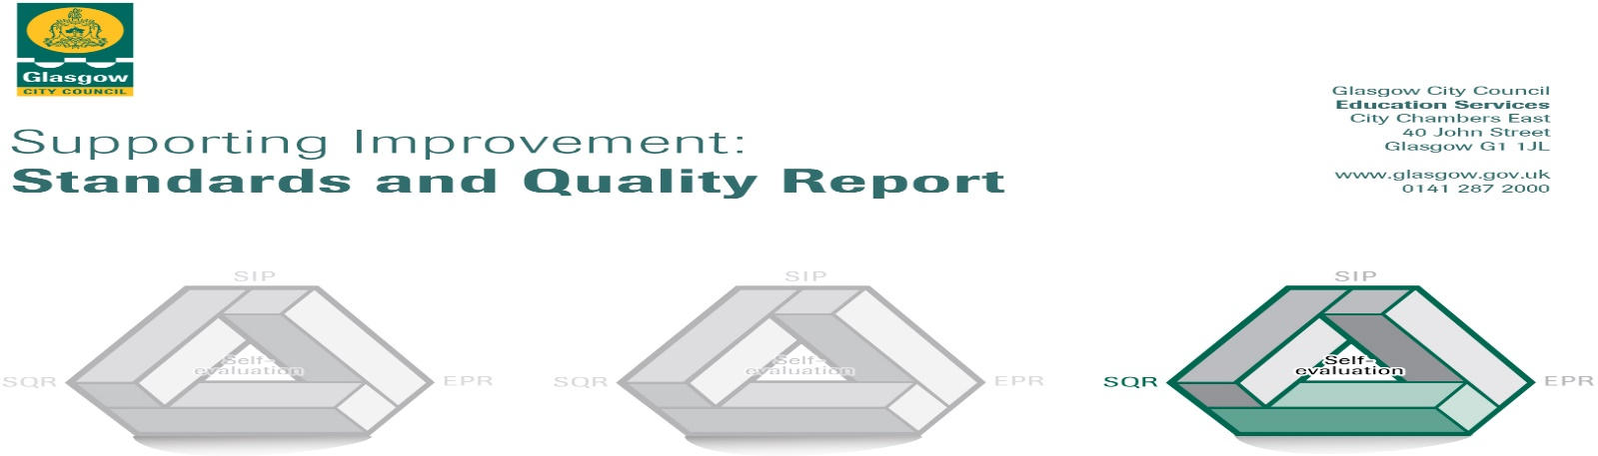

The summary report is provided for parents/carers and partners to outline our achievements this session and our priorities for next session. Throughout this session we have taken forward our priorities as detailed in our School Improvement Plan. Through our processes of self-evaluation, we have identified how we can improve outcomes for our children and young people.

Our achievements and improvements this year.
I am delighted to inform you about the on-going improvements at Highpark Primary School and LCR for session 2020-21. The school continues to be committed to improving the high-quality teaching and learning that our young people receive. This is under-pinned by our core vision of Resilience Leads to Brilliance, and our values of Fairness, Respect, Inclusion, Honesty, Kindness and Achievement. Covid obviously played a part in our progress towards our four main areas of improvement as listed below. However, we endeavour to continually strive for the best outcomes for our learners moving forward in this academic year.
There were four main areas of improvement of the School Improvement Plan. The summary of our progress is noted below.

- Literacy –To further raise attainment in reading and writing and enhance the teaching and learning of talking and listening.
The school uses the Glasgow Literacy for All programme, Routes Through Writing, as our main tool to plan for teaching and learning within Writing. We teach each genre and the children are continually developing their ‘tools for writing’ – this includes vocabulary, punctuation and spelling skills. This is proving very successful in our quest to support our pupils. This approach helps to guide learners to understand the importance of different types of writing, and the purpose of these. Mrs King is our Challenge Leader of Learning, and she has been working with small groups, both within and out with the classroom, to further promote Literacy and enhance the skills of our learners. We have also purchased a brand-new reading book scheme from the Oxford Reading Programme, which is supported by digital materials to use within the class. This has ensured that Highpark Primary celebrates our love for reading. Alongside the launch of our new scheme, we have revamped our school library and Mrs McKenzie has purchased many new fiction and non-fiction books to supplement resources.
2. Improving attainment – the school continues to use the self-evaluation processes to make decisions around Pupil Equity Funding (PEF) spending.
The school improvement process involves the use of a self-evaluation tool which has highlighted the need for greater consistency of data, and this has resulted in staff working in teams to further develop our approaches and interventions to reading, writing, data and family learning. It is hoped that many of our family learning and engagement initiatives, such as ESOL and Parent Matters, can be re-established once restrictions allow. We also hope to strengthen our pupil voice via our Pupil Council, House Captains and Vice-Captains.
3. Improve moderation and assessment to inform best individualised support for every pupil.
Our staff at Highpark are dedicated to improving the outcomes for all our learners. Moderation allows staff to explore standards within Curriculum for Excellence and ensure that children are being supported and challenged.
We are aiming to work alongside St. Cuthbert’s Primary to further enhance this aspect of our development.
Teachers regularly meet with the Senior Leadership team to ensure there is support and challenge for all our learners.

4. To Further Strengthen our Inclusive Practices
Staff from mainstream and the LCR plan co-operatively to ensure that inclusion for our pupils from the LCR is a smooth transition. This has resulted in Inclusion being one of our school improvement priorities. This has ensured that the school firmly embeds the ethos of inclusion. Inclusion remains a positive aspect of learning within the school, with pupils utilising the LCR and vice versa. This academic year, the pupil Inclusion team have created and delivered presentations for all classes throughout the Benview Campus, on themes of interest such as bullying and Cop 26.
In addition to areas on the School Improvement Plan, there have been a number of developments within the school. Ms. Beveridge was appointed as our Principal teacher in June this year. We are delighted to welcome her in her promoted role within our school. The Parent Council membership has continued to grow in numbers and this has been very beneficial for our whole school community. The Parent Council has helped greatly with communication during the period of school closures due to covid and continues to strengthen the partnership we have with our families.
Mr Stanfield leads the Pupil Council and also our outdoor education experiences which the pupils have been able to utilise skills and the variety of resources in the Ruchill community. Mr. Stanfield is our Digital Leader of Learning which was crucial in the period of lockdown to ensure that pupils had the resources required for digital learning. Seesaw continues to be used for homework activities.

Here is what we plan to improve next year.
The school has four main areas for development outlined in the School Improvement Plan 2021-22.
- To further improve Teaching and Learning to ensure progress and raise attainment.
- To explore and further embed inclusive practices.
- To further improve the use of self-evaluation to include pupils, partners, parents and carers views.
- To further develop wellbeing, equality and inclusion within the school.
Our School Community and Partners
The school was allocated almost £138,000 for 2021-22 for PEF. We acknowledge the outstanding value of our Support for Learning Workers (SFLW’s) to raise standards and support our pupils. Our sflw’s are trained in supporting our learners to learn more effectively. We have increased our ratio by two additional sflw’s since the beginning of PEF which have added individualised and whole school benefits.
We also understand the importance of health and well-being in the wake of our covid experience. Nurture Connections (Hazel) continues to support our school with her dedicated commitment to our families and their health and well-being. Our Health and Well-Being Support Worker (Scott McHarg) also supports the pupils in the playground and with individual sessions on such themes as resilience and self-regulation. The school was awarded the Model School Status in our PATHS programme which means that we are recognised as a school who has ensured consistency of standards in our quest to support positive relationships both within the classroom and in the playground. We can support other schools who are also on this journey. We are working towards our Rights Respecting School Bronze Award.
Our intergenerational sewing project, Sewing Together, with Gabbi Cullen and the Four Seasons Care Home has had to be suspended due to Covid, however Gabbi has been able to work with small groups of children, from mainstream and our LCR, to enhance their sewing and social skills. We hope to re-start our intergenerational projects in the next academic year.
Mrs. Vanderflier has partnered with our universities to train under-graduates in the Scotland Reads Programme to help support our pupils read more fluently. This has proven to be a great success in previous years and makes a direct impact on pupils reading achievements. The volunteer tutor programme also supports an after-school homework club for some of our learners.
Mrs McDowell is trained in the Parent Matters programme and is really looking forward to working with Primary One parents when restrictions allow.
How can you find out more information about our school?
Please contact us directly if you require further information or if you wish to comment on the report.
The contact e-mail address is: Headteacher@highpark-pri.glasgow.sch.uk

Our telephone number is: 0141 946 7073
Our school address is: Highpark Primary and LCR, 100 Bilsland Avenue, Ruchill, G20 9NY.

Further information is available from school and class newsletters, the school website, Twitter, Facebook and the school handbook.

