Hampden Primary School
Standards & Quality Report
Session 2024 – 2025

This summary report is provided for parents/carers and partners to outline our achievements and improvements during session 2024 - 2025 and to share our improvement priorities for 2025 - 2026. Throughout last session we took forward our improvement priorities as detailed in our school improvement plan. Using our approaches to self-evaluation, we have detailed in this report the impact of our work and identified how we plan to continue to improve outcomes for our children and young people.

The context of the school
Hampden Primary School is an inter-denominational school situated in Oatlands, Glasgow. The school is a specialist provision for children with complex learning difficulties from across Glasgow City Council. Almost all children require support with personal care and almost all children have significant language delay or impairment. The school roll is 66. The Glasgow City Council Area Inclusion Group places children at the school. The headteacher is supported by a depute headteacher and two principal teachers. 46% of children live within Scottish Index of Multiple Deprivation deciles 1 and 2. There is a significantly higher level of children who are entitled to free school meals than the national average. 34% of families have English as a second or other language and 6% of families are asylum seekers or refugee.

Our achievements and improvements 2024 – 2025
Our school improvement priorities for session 2024-25 are set out below. Our long-term target or
Grand Challenge 2023-2026 ‘To reduce the incidence of distressed behaviour in our school. Reduce the impact that that this has on learning, engagement, families and staff. To increase self-regulation and communication skills for all our children.’

Challenge: Embed the use of SCERTS as a means to assess and target set for our pupils.
Challenge: Based within the rights agenda, develop communication and numeracy skills of all (pupils, staff, parents, wider school community).
Challenge: To develop children’s engagement in play activities, supporting self-regulation skills
Challenge: To improve the health and wellbeing of staff which leads to a reduction in staff absence levels.

SCERTS is now well embedded into planning and assessment for children in the school. Almost all staff feel confident/fairly confident in the use of SCERTS to support the children in the school. (New school staff are being given appropriate information on the use of SCERTS and how each adult is best able to support our learners). Almost all staff understand the role they play in supporting the children with their SCERTS targets. Over 95% of our parents are happy with our use of SCERTS as a means to assess and target set for their child. Almost all parents are seeing some improvement in their child’s communication and improvement in regulation skills. In session 2024-2025 64% of children achieved all of their targets and 74% achieved 3 of the 4 targets set. HT and PT also presented at NAIT, Neuro Affirming conference about work the school has been doing around SCERTS and Pupil Voice. HT and some other staff continue to be part of the Glasgow SCERTS implementation group.

Work to develop numeracy in the school took place alongside Ashton Secondary School. Together staff developed materials for the early levels of the curriculum and joint training and collegiate idea sharing took place. Alongside the procurement of new and more appropriate numeracy resources and some individual targeted work with children we are beginning to see attainment increase in terms of levels of engagement and achievement. Greater assessment and collection of data will take place during session 2025-2026.
HT attended Hirstwood Numeracy conference and cascaded information about very early mathematical and mathematical language development to all staff. Communication continues to be a clear focus for the school and we now see 70% of children achieving all their communication targets. A group of staff and parents were supported to attend Makaton Level 1 training.

Play to help support our learners was developed to include bucket time, schematic play and sensory massage. All strategies that engage our learners in play appropriate to their development are great building blocks for future progress. One member of staff completed their Diploma in Play Therapy, allowing the school to have that resource available for specific learners. We are further developing our outdoor spaces, to increase the opportunity for outdoor play, with the creation of a third safe playground. Our PT is part of the city wide Play Pedagogy team and is working to support Play across all ASL schools in the city.

All staff have access to a wide variety of supports that allow then to access services as and when they need them. Staff wellbeing was a focus as part of the Feb in-service day.

Other highlights of session 2024-2025
McTaggart Construction completed the initial preparation of the gym hall, with removing partition walls, making the walls good and painting.
Children’s Aid funding the refurbishment of the soft play area in the school.
Staff across all levels successfully achieving various qualifications from massage to play therapy.
Flourishing Partnerships with: Martec Engineering, SEAL, Spirit Aid, Hollybrook Academy, Variety of local primary schools.
Fundraising for Breast Cancer Now and the Prince and Princess of Wales hospice. Ice Bucket Challenge fundraising for school fund.
Our children being represented at the Pupil’s Forum. Some of our children achieving their Urban Adventure Award, our children taking singing their hearts out and being part of the video to mark Glasgow’s 850th birthday! Hampden children taking part and succeeding in so many sporting activities from Boccia to Boxing. So many fantastic achievements across the year.
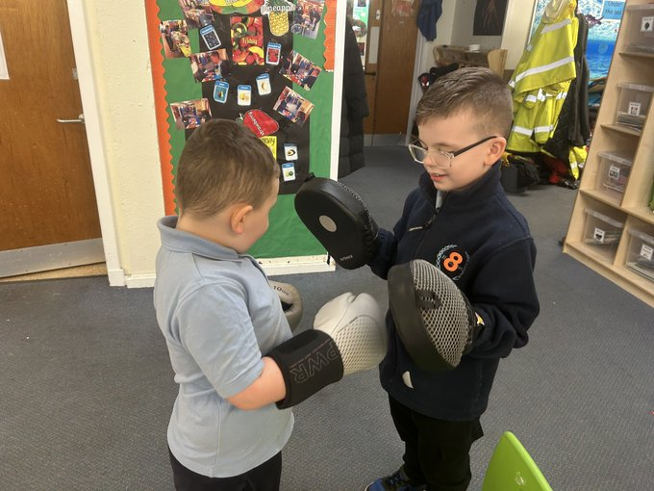
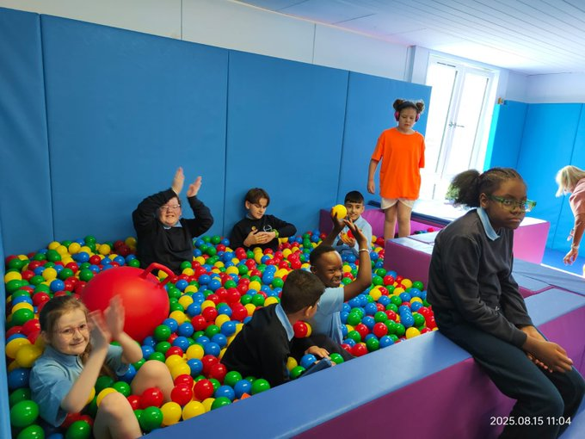
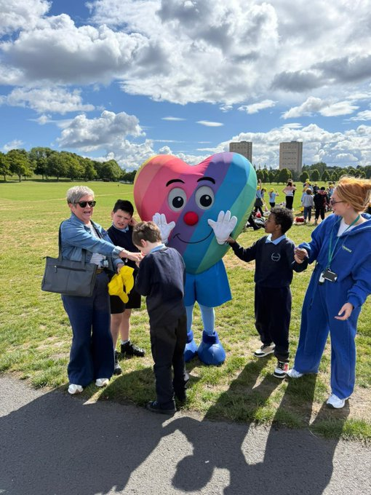
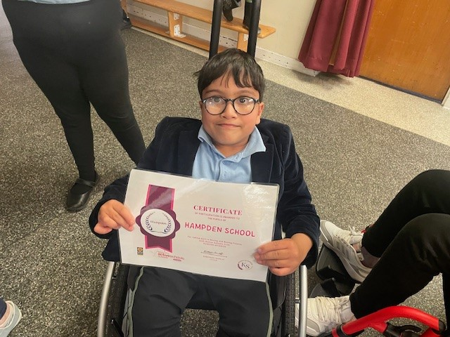
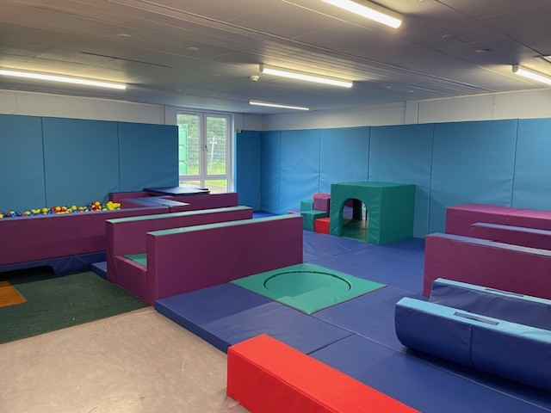
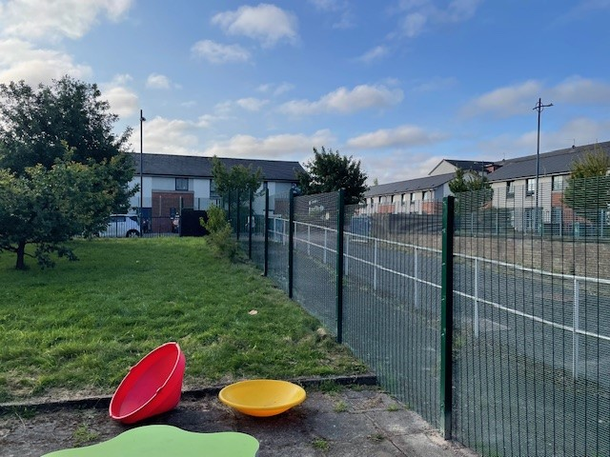

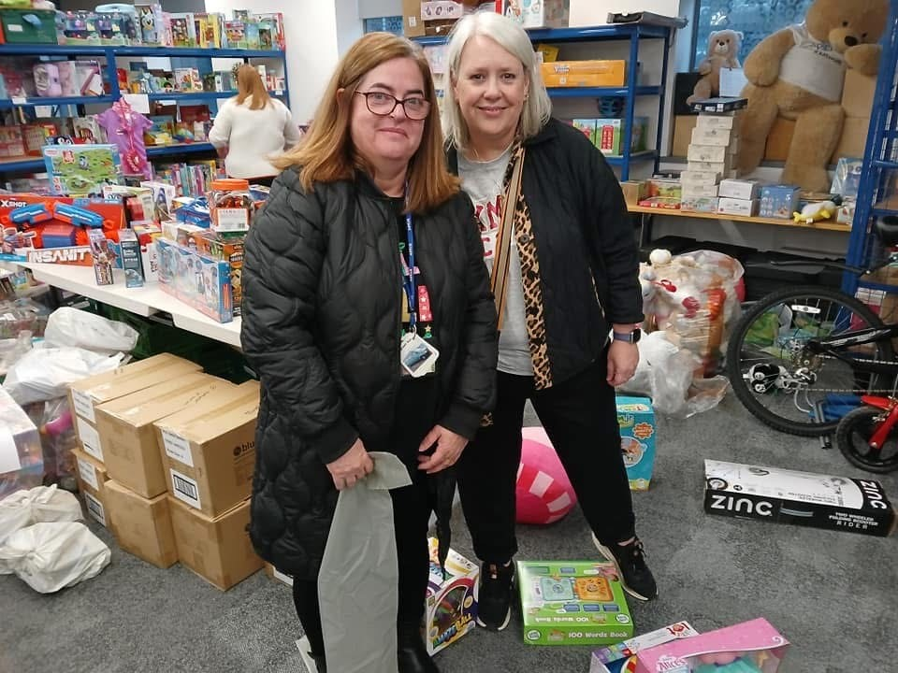
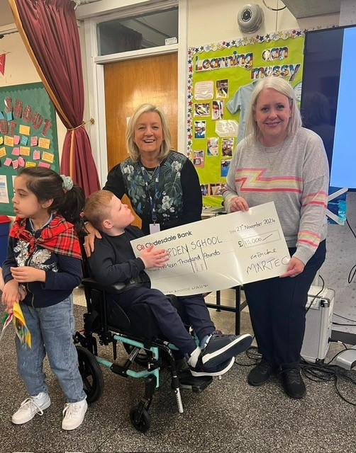
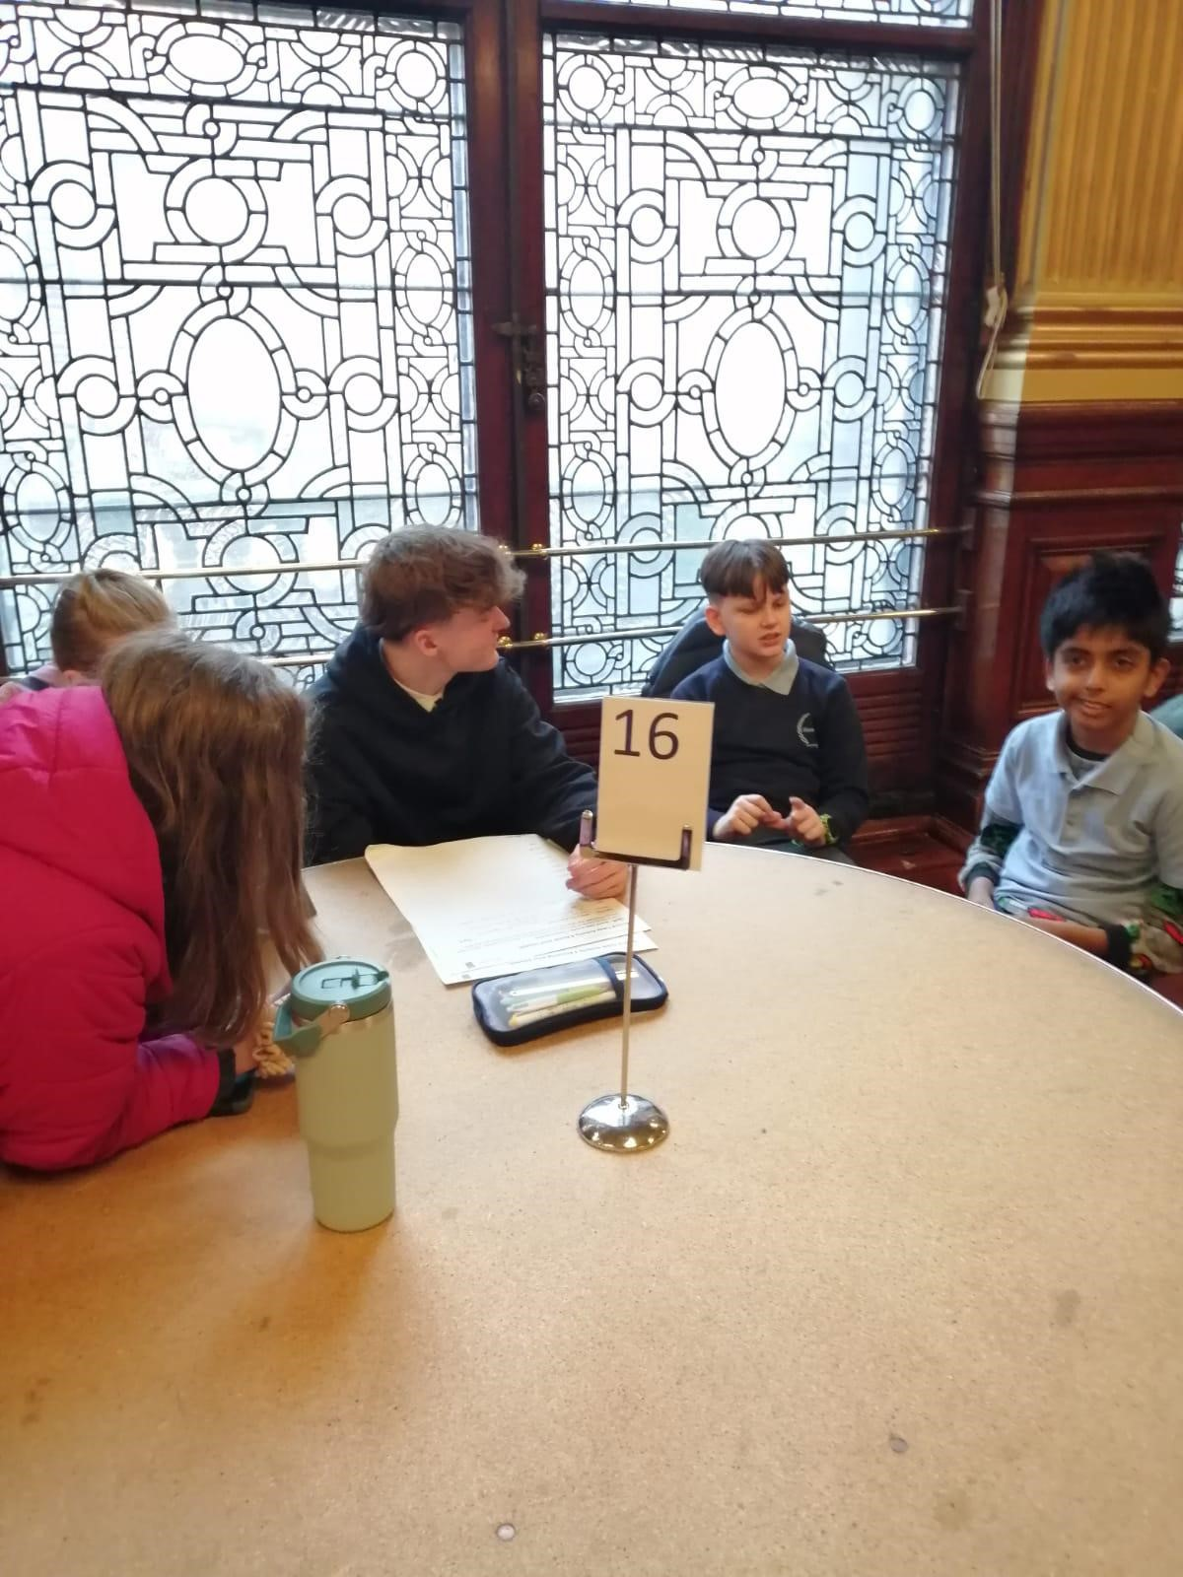
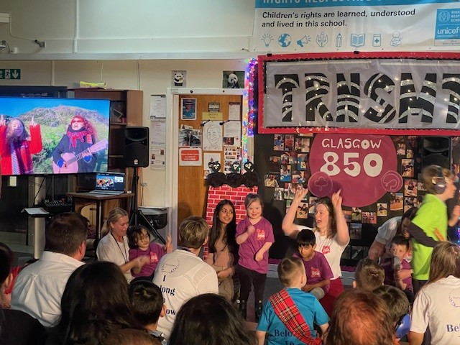
Attendance and Exclusion data
In 2020/21, there was 91.2%attendance, which was in line with the national average, in 2024-25 attendance sat at 92%
There were no school exclusions.

Our improvement plan priorities 2025 – 2026
Our grand challenge: To reduce the incidence of distressed behaviour in our school. Reduce the impact that that this has on learning, engagement, families and staff. To increase self-regulation and communication skills for all our children.
• Achievement and Progress
• Networked Learning Organisation
• Wellbeing and Learning

Our school Improvement priorities:

-To become a Language and communication friendly establishment. To improve the communication for all children and getting the environment right
-Numeracy and Literacy: increasing attainment and developing systems for data collection and use
-To develop children’s engagement in play activities, supporting self-regulation skills and relationships, working towards Play Scotland Play Pedagogy Award
-Maintenance: Planning and preparing for Gold RRS re-accreditation

 | How Good Is Our School 4 Quality Indicator (QI)  Based on HMIE Inspection of Jan 2024 | Evaluation
 | Leadership of Change (QI 1.3) | Very Good
 | Learning Teaching and Assessment (QI 2.3) | Very Good
 | Ensuring Wellbeing Equality and Inclusion (QI 3.1) | Very Good
 | Raising Attainment and Achievement (QI 3.2) | Good

How to find out more about our school
Contact us directly if you require further information about our school or if you wish to comment on this report.

Our contact e-mail address is: headteacher@hampden-pri.glasgow.sch.uk

Our telephone number is: 0141 429 6095

Our school address is: Hampden Primary School, 18 Logan Garden, Glasgow G5 0LJ

Further information is also ‘X’, weekly update, the school website, and the school handbook. We also communicate with parents via SeeSaw and Groupcall.
https://blogs.glowscotland.org.uk/gc/hampdenschoolwebsite/

