Applying for School Free Meals, Clothing Grants and School Age Payment Guidance.
Step 1 – go to Glasgow City Council online and select Schools and Learning
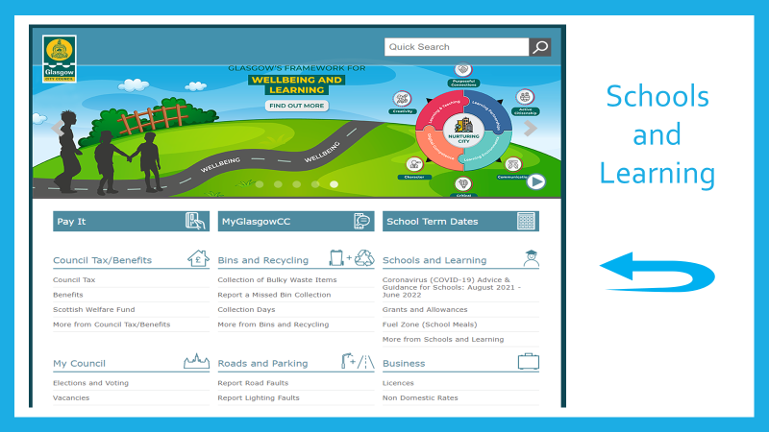
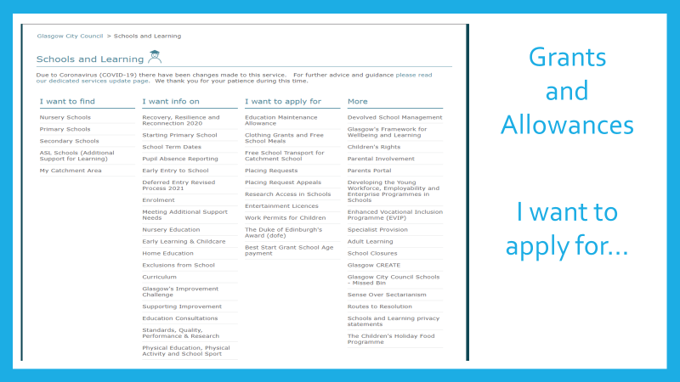
Step 2
Step 3 – Select Application link
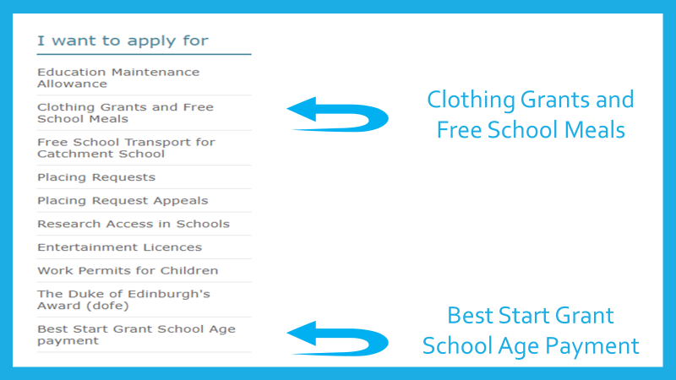

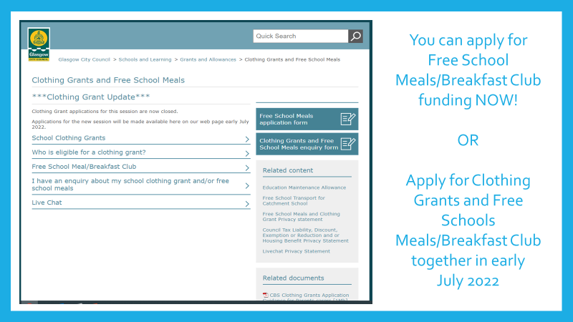
Clothing Grants and Free School Meals – please make this application even though P1 receive free lunch.

School Age Payment

