Antiracist Critical Thinking Model Forward Planning Template

The aim of the model is to breakdown planning in a way that encourages critical analysis of what is taught and how it can be more representative of our society in modern 21st Scotland. It especially encourages teachers to think about why perspectives of some groups have often been missing and the impact that has on wider learners.
The series of 6 questions can be applied to any aspect of planning in school whether it is for topics, individual lessons, resources or planning of events.
Considerations:
- Is this topic or resource used year after year, whatever the demographic of the pupils?
- Do images or language used in lessons or resources actually promote stereotypes?
- Do images or language used in lessons or resources promote a variety of perspectives and narratives?
- How can we include new or diverse examples, stories, voices, images?

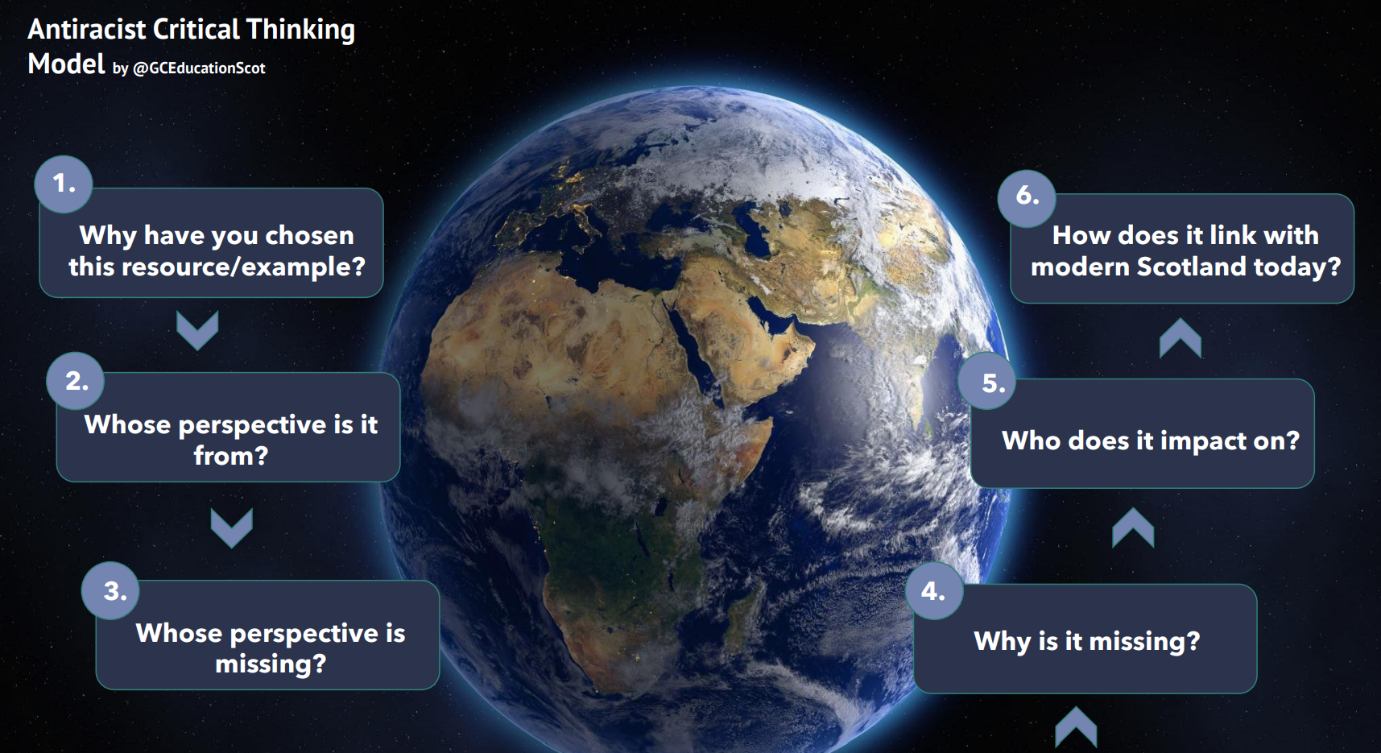

Antiracist Critical Thinking

Why have you chosen this example/topic or resource?
Whose perspective is it from?
Whose perspective is missing?
Why is it missing?
Who does it impact on?
How does it link with modern Scotland today?
What resources do you still need that may help you?

