Straplines

The following possible straplines for the cover were discussed by the editors:

Have they the courage to break down the barriers?

Breaking through the barriers of the past...

Old tensions. Old loyalties. But a new future...

The future in their hands...

When ‘tradition’ means ‘distrust’...

The editor wrote the following email to the author about straplines:

From: Sue Cook
To: Theresa Breslin
Re: Straplines

Dear Theresa,

I am delighted that the cover has moved on and we now have the final design agreed and ready to go. We do, however, need a strapline for the front cover and I have a couple of suggestions. What do you think to:

Breaking through the barriers of the past...

or

Are they brave enough to break down the barriers?

or

The future in their hands...

or

Old tensions. Old loyalties. But a new future...

Do please let me know what you think.

Best wishes,
Sue

The author responded as follows:
From: Theresa Breslin
To: Editors
Re: Straplines

Dear All

I’ve gone with an amended strapline from Sue, as follows:

Old tensions. Old loyalties. A new future...

Best wishes
Theresa
Song Lyrics

The first manuscript included quite a few quotations from songs, including several old songs which are now out of copyright, plus supporters’ songs from the terraces. There was also a scene in which the lyrics of You’ll Never Walk Alone were quoted; this song is in copyright, so if the lyrics are included, permission has to be granted and a fee paid. Sometimes it is possible only to obtain permission for a stated number of copies, which can be very difficult for publishers as they would aim to reprint regularly and would therefore have to ask for the right to use the lyrics each time the book is reprinted, paying an additional fee each time. This is both difficult and costly, so it is usually best to avoid including copyrighted material unless it is absolutely essential to the storyline.

Discussions with the author about this particular scene included the following:
From: Sue Cook
To: Theresa Breslin
Re: Song lyrics

Dear Theresa,

We do have one small problem still – the permission to reproduce the lyrics for You’ll Never Walk Alone. It would probably be advisable to drop the actual lyrics and change the wording in this scene, as discussed. …My recommendation is to amend the relevant section, and here is my suggested amendment.

I look forward to talking to you soon.

Best wishes,
Sue

Original version

Ten minutes to the end of the match.
They began to sing. Quietly at first.

[and you then begin to quote lyrics within the text]

Suggested amendment [using your text as much as possible but rewording to avoid any actual quotations]

Ten minutes to the end of the match.
They began to sing. Quietly at first. The familiar opening words of You’ll Never Walk Alone.
Rippling from row to row the pulsing throbbing tune, carried by the throats of the crowd, swept round the stadium, building strength as extra voices joined in, their hearts swelling as they roared out the well-known words. The great rolling anthem gathered strength. Tens of thousands of Celtic voices, singing in unison. Pride, support and faith in every word, flowing out towards their heroes on the pitch. Eleven players. But not alone. No, never alone.
Taken up by the people behind Joe, the singing rose to a deafening crescendo, pulling him out of his seat to join in. Now every Celtic supporter was on their feet. A veritable army of fans, all as one, all throwing every ounce of their strength and support behind their team.
Kerr had the ball. He was running to goal.
Final Text

The final text for this scene is as follows.

Ten minutes to the end of the match.
They began to sing. Quietly at first.
A few brave voices, from the terraces high above where Joe sat. He turned to his dad and grinned as they both heard the familiar opening lines of You’ll Never Walk Alone.
‘If that doesn’t lift them, nothing will.’
The singers had started slowly, pacing the first words, allowing the song to unfurl. Pulling like a powerful undercurrent.
‘You have to sing along with that one, Dad,’ said Joe.
His dad nodded. ‘It’s a song of such tremendous human spirit,’ he said, ‘yet it always makes me want to cry.’
Rippling from row to row, the pulsing, throbbing tune was carried by the throat of each fan. The crowd caught the mood and it became unstoppable.
The great rolling anthem gathered strength.
Taken up by the people beside Joe, sweeping round the stadium, drowning out everything else, soaring and soaring. The singing rose to a deafening crescendo, pulling him out of his seat to join in.
A song of defiance, of courage, but above all, hope.
Every Celtic supporter on their feet.

Kerr had the ball. He was running to goal.
(Pages 95–96)

Interviews with Asylum Seekers

Below are some of the notes made by the author, Theresa Breslin, when interviewing asylum seekers.
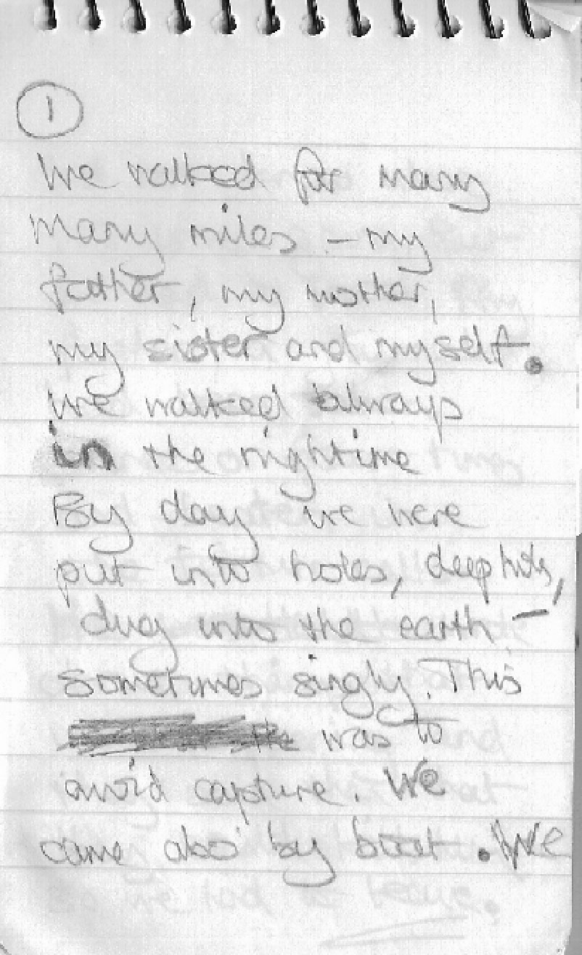
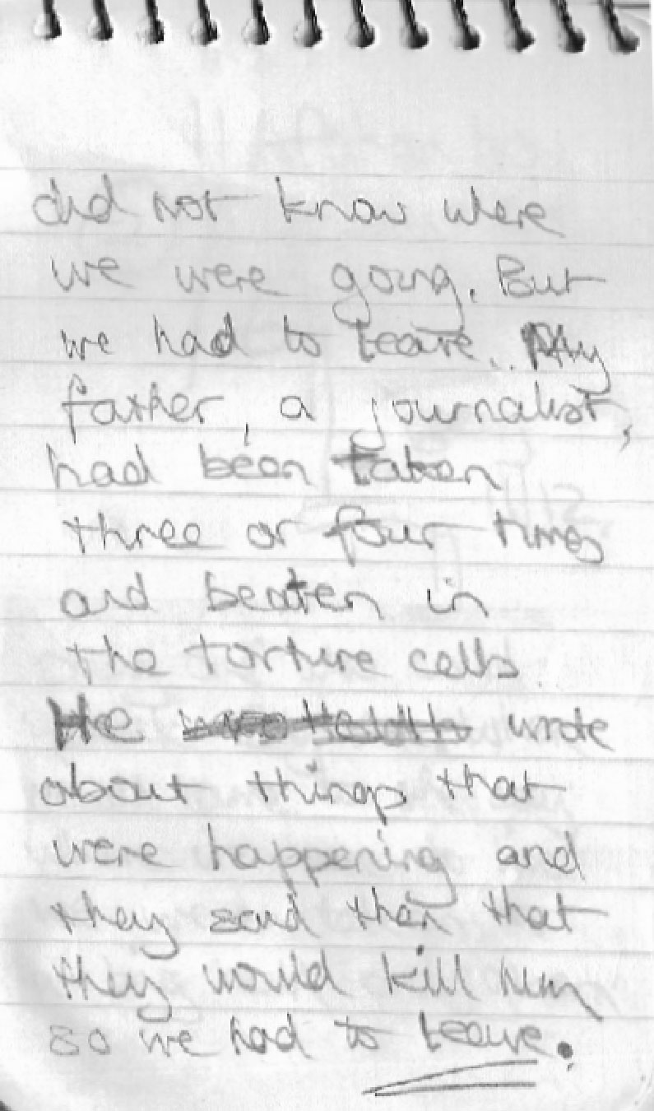
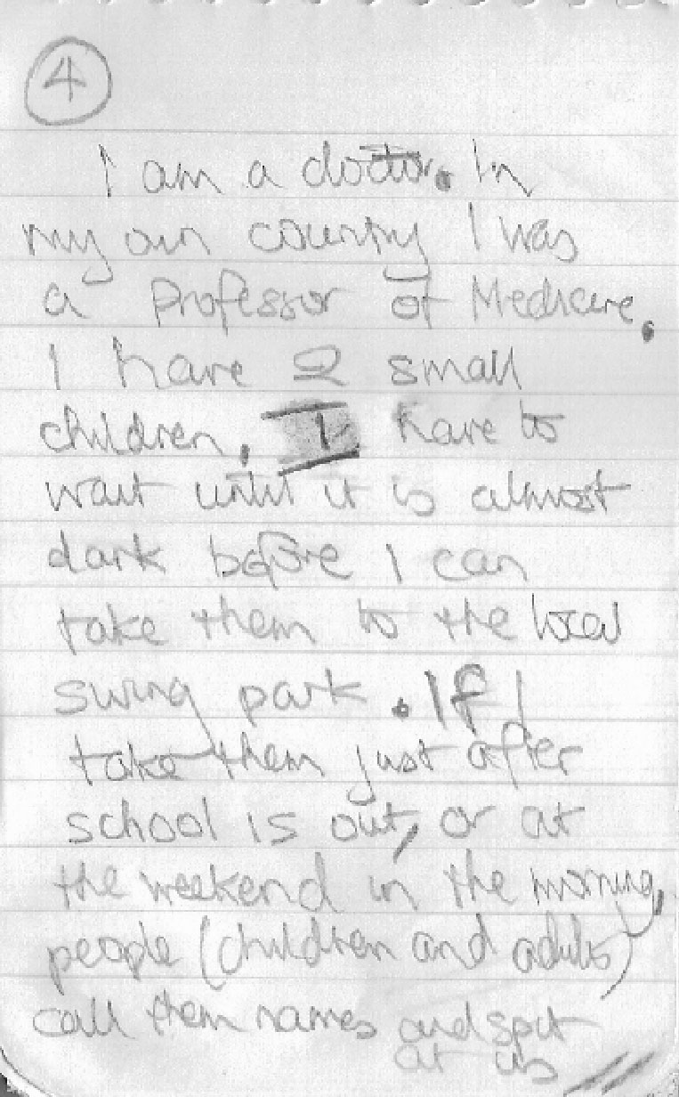
Original Opening of the Novel

Below is the original opening of Divided City.
As soon as he heard the noise behind him Graham knew he was in trouble.
He was walking fast, eating from his bag of hot chips as he went. Taking a short cut down Reglan Street – the kind of street his parents had warned him never be in. The kind of street where your footsteps echoed loud. Too loud. Because there was no one else around. From either side the dark openings of the tenement building mawed at him. It was the beginning of May and now fairly light at this time in the evening but even so… Graham glanced around him. The sky was densely overcast and shadows were gathering. He shouldn’t have lingered so long after football training.
But the football had been great tonight. Fantastic.
Their first proper game against a local senior boy’s club and he’d scored a goal! Just at the end. Collected a pass from the fair-haired boy, who, like Graham, never missed a training session. A neat cross, right to Graham’s feet. They had trained regularly together since this special football training had started, but never played on the same side. Then tonight the coach, Jack Burns, had decided they should play together for this match, Graham in centre mid-field and the other boy in defence. The boy, Graham only knew him as Joe, had come up on the wing in the dying minutes of a no score match. A frustrating game against a team of boys who were technically better and heavier, but Graham’s team had held them off for an hour and more. And then, at the death, it happened. A long kick-out from the keeper, picked up by Joe, and, suddenly, there’s electricity in the air. Eyes on the ball, Joe sweeps downfield, running towards the bye-line.

In the original story the assault on Kyoul took place in Chapter 3. The editor of the book sent the following e-mail to the author.
From: Sue Cook
To: Theresa Breslin
Re: Phone discussion about opening
We agreed that you would look again at the very beginning to make sure the fantastic impact and tension of the first few lines isn’t lost by moving onto the football recollections too soon – and you are aware of my worries about the book seeming too focused on football in the first few pages as it may give the impression of a different type of story to a casual browser… the beginning does need to show the assault.

Judging a Book by its Cover

You may have been advised in the past to ‘not to judge a book by its cover’, but a great deal of thought goes into the design of book covers. What can you tell about Divided City from its cover? With a partner fill in the boxes below.

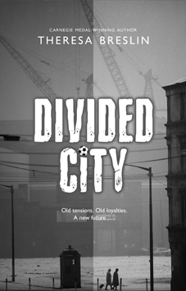 |  | What do the two colours suggest?
 |  | What does this information suggest?
 |  | Why is this part in red?
 |  | What does this football suggest?
 |  | What does this strapline suggest about the story?
Basing your ideas on the cover only, write down your ideas on what you think Divided City is about. |  | What does this photograph suggest about the setting of  the book?

Graham’s Dilemmas

Graham takes normal way home
Graham takes short cut

He refuses to take Kyoul’s message

He ignores the incident

Graham finishes football practice

He sees boys chasing Kyoul
Graham helps Kyoul
He agrees to take Kyoul’s message


He refuses to go with Kyoul to hospital
Graham phones for an ambulance

He accompanies Kyoul to hospital

1 Use the diagram above to think about the choices Graham makes in Chapters 1 and 3. Write the reason for Graham’s actual choice by each arrow.
2 What would have happened if Graham had taken the choices marked ?
3 Write a paragraph on what Graham’s choices show about him as a character.
4 What might happen next?

Into Enemy Territory

1 As you read Chapter 7, try to imagine how Graham, a Protestant Rangers supporter, feels as he looks around Garngath. For each of the quotations below write down how you think it makes him feel.

Quotation | How Graham must feel
YOU ARE NOW ENTERING FREE GARNGATH
(page 33)
NO HUNS
NO BILLY BOYS
(page 35)
St Veronica’s… A Roman Catholic school
(page 36)
‘You don’t belong here.’
(page 36)
‘You’ve got a Protestant face.’
(page 37)

2 How do you think Joe would feel walking around the Garngath on this day? Write your ideas in the box below.

3 Do you think that the people who wrote the graffiti expected it to be read by Rangers fans? Why do you think they wrote it?

Glaswegian

1 The following Glaswegian words and phrases all occur in Chapters 1 to 5 of Divided City. Find them in the novel and then fill in the other columns.

Word or phrase | Meaning | Accent or dialect
Heid  (page 10) | Head | Accent
Stoat  (page 10) | Bounce | Dialect
See you!  (page 10) | Hey you! | Dialect
Ma
(page 10)
Windae
(page 10)
Aye
(page 18)
Wee
(page 18)
Polis
(page 18)
Buddies
(page 19)
Pape
(page 22)
Och
(page 22)
Hinging
(page 22)
Prods
(page 22)
Bairns
(page 22)
Yin
(page 24)
Naw
(page 24)
My man
(page 26)

2 What are the advantages and disadvantages of using words and phrases that many people will find unfamiliar in a novel? Is it usually possible to work out what people
are saying in Divided City?

3 Make a similar table and keep a running glossary of Glaswegian words and phrases. You may need two or three pages to keep a full list.

Plot and Subplot

In the film Ice Age a small creature spends most of its time trying to safely store an acorn it has found. We never learn this creature’s name and its actions do not affect the events in the main part of the film.

The main events of a story are known as the plot, while the things that happen to minor characters are known as the subplot. A self-contained part of a story is often called a plot strand. In the film Lord of the Rings, for example, different plot strands start up when the Hobbits are separated from each other.

1 Write down the three main plot strands in Divided City in the boxes below.

1

2

3

2 What are the advantages for a writer in using different plot strands? (Hint: think about what happens at the ends of chapters)

3 What are the disadvantages of using different plot strands?

4 Write down one subplot in Divided City.

Sectarian Tension

Storm as goalkeeper pays Sign of the Cross penalty

Scotland inflamed as Celtic player gets legal caution for religious gesture

Lorna Martin, Scotland editor
Sunday August 27, 2006
The Observer

A furious row has erupted after a Celtic footballer was given a formal caution for blessing himself during an Old Firm game. Artur Boruc, the Polish goalkeeper, was accused of inciting violence and angering rival supporters by making the gesture in front of Rangers fans at Ibrox stadium in Glasgow.

The Crown Office’s decision to give him an official warning has provoked a strong reaction, with politicians and church leaders saying it will make Scotland the ‘laughing stock of the world’ as players often cross themselves in football grounds. Boruc was cautioned for a breach of the peace.

The Catholic church has condemned Scottish prosecutors, with spokesman Peter Kearney saying many Catholics would feel subject to persecution following the decision. ‘It’s an alarming development, especially since the Sign of the Cross is globally accepted as a gesture of religious reverence,’ he said. ‘It was commonplace throughout the World Cup.
It is extremely regrettable that Scotland seems to have made itself one of the few countries in the world where this simple religious gesture is considered an offence.’

The Crown Office said a caution was issued as an alternative to prosecution. A spokesman said that as Boruc made the gesture before a crowd in the charged atmosphere of an Old Firm game it constituted a breach of the peace and had ‘provoked alarm’.

However, Rangers Supporters Group said it was ‘disappointing’ Celtic did not take action after the game. Stephen Smith, spokesman for the group, added: ‘Professional footballers are meant to set an example. What he did was deliberately provocative and completely
done to wind up the fans.’

The fixture takes place in a highly charged atmosphere and has produced no shortage of controversy. Time, the international news magazine, once described it as 90 minutes of sheer hatred.

Note: The sign of the cross is a gesture in which someone touches his or her forehead,
then stomach, then both shoulders to make a cross. It is used by Catholics to show reverence, to bless themselves, or to give thanks to God.

Answer the following questions.

1 How did the Protestants react to Boruc’s gesture?
2 How did the Catholics react to the protest?
3 Do you agree with the Crown Office’s decision?
4 Should people of one religion always avoid practices that give offence to other faiths?

Building Tension

Below is a short passage from a novel. It is written as one paragraph without punctuation. How should it be punctuated?

How might it be written and punctuated to make it flow best?

How might it be punctuated and arranged to make it most dramatic?

Makes suggestions to produce three different versions.

Version 1: Add simple punctuation

A dog barked the wind rustled through the trees in the distance the thunder rumbled a few drops of rain spotted the ground the night was dark and getting darker we were far from home and we were getting tired suddenly lightning flashed in the distance a castle black and menacing was outlined against the sky.

Version 2: Flowing – Add connectives where appropriate

A dog barked the wind rustled through the trees in the distance the thunder rumbled a few drops of rain spotted the ground the night was dark and getting darker we were far from home and we were getting tired suddenly lightning flashed in the distance a castle black and menacing was outlined against the sky.

Version 3: Dramatic – Use punctuation and paragraphing

A dog barked the wind rustled through the trees in the distance the thunder rumbled a few drops of rain spotted the ground the night was dark and getting darker we were far from home and we were getting tired suddenly lightning flashed in the distance a castle black and menacing was outlined against the sky.

When you have completed your three versions of the passage read them out loud. Which one do you think sounds best?

Building Tension
Single verbless paragraph – everything has stopped
One down.
Losing to the enemy.
A goal gone to them.
It lay like a cold pie in the pit of Joe’s belly.
Simple simile – relevant to situation
Unthinkable defeat. Celtic had their last league game next Sunday against Hearts while Rangers would play Kilmarnock. If Celtic lost by any margin to Rangers this week, then Rangers would almost certainly win the Championship.
The play went on.
Ten minutes to the end of the match.
They began to sing. Quietly at first.
A few brave voices, from the terraces high above where Joe sat. He turned to his dad and grinned as they both heard the familiar opening lines of You’ll Never Walk Alone.
‘If that doesn’t lift them, nothing will.’
The singers had started slowly,
pacing the first words, allowing the song to unfurl. Pulling like a powerful undercurrent.

Divided City, page 95

Creating Atmosphere

Annotate the following extract to show how the author builds and changes tension.

Rippling from row to row, the pulsing, throbbing tune was carried by the throat of each fan. The crowd caught the mood and it became unstoppable.
The great rolling anthem gathered strength.
Taken up by the people beside Joe, sweeping round the stadium drowning out everything else, soaring and soaring. The singing rose to a deafening crescendo, pulling him out of his seat to join in.
A song of defiance, of courage, but above all, hope.
Every Celtic supporter on their feet.

Kerr had the ball. He was running to goal.
‘Pass it! Pass it!’ Joe’s dad cried out. ‘Carmichael’s in the clear!’
Desmond was incandescent. ‘Give it to Carmichael, you great big galoot!’
‘To Carmichael!’ Joe screamed. ‘To Carmichael!’
Kerr tried his own shot. The goalie punched the ball aside. A Rangers defender gathered it and booted it down the park.
Joe, his dad, and Desmond fell back into their seats, energy spent.

Divided City, page 96

Song Lyrics

Look at the material in Writer’s Craft 6.1 about song lyrics that were once included in the book. Then carry out the following task in your groups.

Group 1

Look up a copy of the lyrics of You’ll Never Walk Alone on the Internet. Then re-read the passage in Divided City where Theresa Breslin wanted to include the lyrics.

In your group discuss whether the passage would have been better with the lyrics included.

Be prepared to report your findings back to the class.

Group 2

In your group read the two versions of the scene carefully and make notes on the changes that Theresa Breslin has made.

Discuss the following:
• What kind of changes has Theresa Breslin made?
• How do they improve the way that you read the scene?

Choose one or two of the changes that Theresa Breslin has made and be prepared to explain to the rest of the class how they improve the passage.

Writing a Commentary

Use the following sentences to help you write about the extract from page 96 that you have been studying.

The author builds atmosphere in this passage by using a number of techniques. When she is describing the effect of the song she uses …..........

………………………………………………………………………………………..

For example ………………………………………………………………………..

When she is describing the match she uses …………………………………..

For example ………………………………………………………………………..

The author uses short paragraphs in two different ways. In the first part …..

………………………………………………………………………………………..

In the second part ………………………………………………………………….

In the middle of the passage the author uses two verbless sentences. These
show how……………………………………………………………………………

The author’s choice of words is often interesting. For example, when she is
describing how people speak in the second part ………………………………

………………………………………………………………………………………..

This shows …………………………………………………………………………

The overall effect of this passage is …………………………………………….

………………………………………………………………………………………..

Points of View

How we behave is often open to interpretation. The people who do something have one point of view and the people who see that behaviour have a different point of view. Look at the examples below and explain the different points of view. The first one has been filled in for you.

Behaviour | How those involved see it | How others see it
Wearing hoodies and hanging out in shopping centres | Hoodies are just a fashion item. Shopping centres are good places to meet your mates. | Hoodies hide the identity of criminals. Gangs of youths encourage each other to commit crimes.
Wearing a veil that hides your face

Smoking in a public place

Wearing a T-shirt that says ‘Adolf Hitler – European Tour 1939–45’

Making the sign of the cross at Ibrox Park

Talking Your Way Out of Trouble

Work in pairs to complete the following exercise.

Decide whether you are Student A or Student B and then act out the situation outlined in the boxes. Quick wit and invention is likely to be necessary for Student A.

Student A

You have been found in your older sibling’s room where you are not allowed. You had secretly borrowed a CD and were attempting to return it.

You will need to think of ways to explain:
- what you are doing in the room
- why you are holding the CD
- why you thought it was OK for you to break the rules
- why your sibling should not be angry with you.

You could think about giving logical excuses, or you could try wild and fantastic stories.

Student B

You have found your younger sibling in your room. This is not allowed and your parents support you in maintaining your privacy.

Your sibling is holding one of your CDs, but you haven’t noticed that a CD is missing so you don’t know why.

You will not be angry if your sibling comes up with a reasonable excuse, or if he or she invents a story that you find amusing. But do not let your sibling off the hook too easily.

Be prepared to act out your improvisation for the rest of the class.

What We Know of Kyoul

What I know about Kyoul | What I want to know about Kyoul | What I have learned about Kyoul

More Back Stories

Many of the characters in Divided City have back stories. How many can you recall? Write down the answers in the space provided.

How did cousin Jammy get his name?

Why is Joe’s dad depressed?

How does Graham’s mum know about asylum seekers?

What did cousin Bernadette steal when she was babysitting Joe?

What crossword is Joe’s dad good at?

As well as personal back stories there are also historical ones. How many of these can you remember?

Why do Orangemen remember the Battle of the Boyne?

Why do the Orangemen march every July?

After what event did many Irish Catholics move to Glasgow?

Why would Catholics be offended by having potatoes thrown onto the pitch?

If we know about someone’s personal history it is often easier to understand his or her behaviour. Discuss with a partner whether you think this is also true of the history of groups of people.

Truth and Lies

Is Graham a truthful person? Look at the examples below and fill in the blanks to help you to decide.

Behaviour | Reason for not telling the truth | Who benefits, and why?
He takes a short cut home that his parents would not approve of
He does not tell his parents about the incident with Kyoul
He does not give his name at the hospital

He does not tell his parents that he is going to look for Leanne
He lies to Jammy about how well he knows Joe

He allows himself to be known as Gregory to Joe’s family
He does not tell his parents which school Joe goes to
He deliberately deceives people at the hospital

He does not go to the police or tell anyone at school about Kyoul

What do you think would have happened if Graham had told his parents the truth from the start?

Explain whether you would trust Graham or not. Explain why he told some of the lies mentioned above to justify your opinion.

Under Pressure

1 Graham is under pressure from many different directions in Chapters 36 and 37. Fill in the boxes to show how each issue is worrying him.

The police
His parents



His friendship with Joe
Granda Reid

Football training
Kyoul and Leanne

2 What do you think is worrying him the most? Fill in the table below in worry order, that is, with the most worrying thing first. Use quotations to show how worried Graham is.

Order | Cause of worry | Quotation showing Graham’s worry
1
2
3
4
5
6

Rising Tension

1 The pressure on Graham, and the tension for the reader, increases gradually until it reaches a peak in Chapter 37. Study the graph below and for each chapter choose one event that puts pressure on Graham. Label the graph with the event.

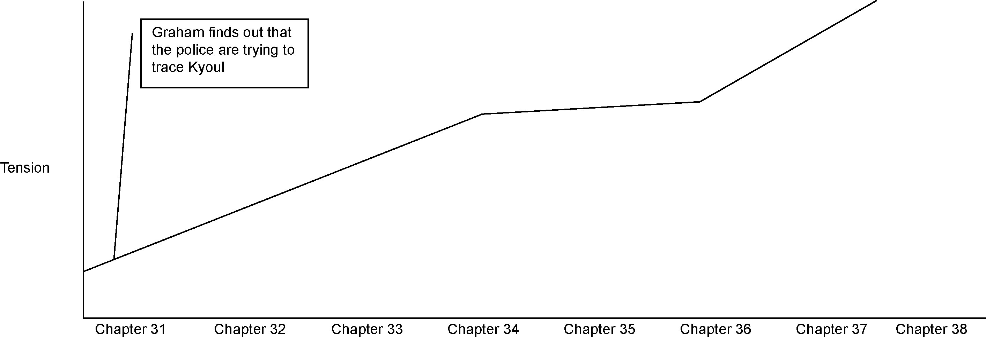

2 What happens to the tension in Chapter 38? Continue the line for this chapter.

3 Were you surprised by the events of Chapter 38?

Tension Graph

1 Draw and label a tension graph for the final section of the novel.

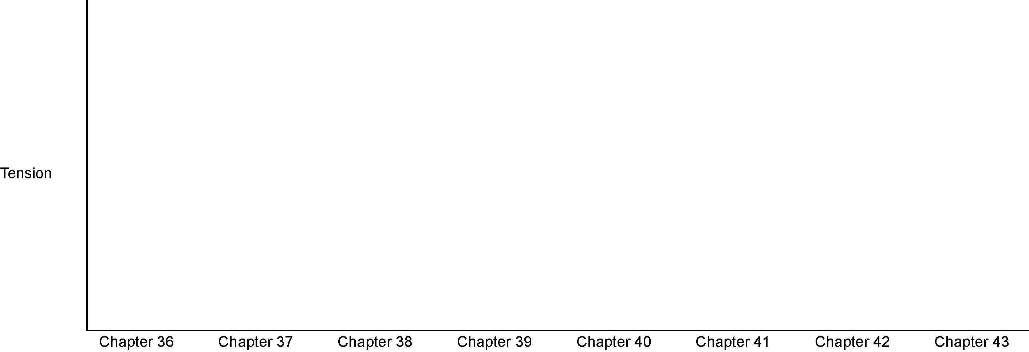

2 Write down your explanation of the shape you have found.

3 Is this a better way for the novel to end than the simple shape you drew on the previous graph?

Diamond Nine

Cliffhanger – all unresolved
The mystery is solved and life can go on
The good end happily and
the bad are punished
The end is unexpected –
a real twist to the tale
Back to the beginning in some way: same words, place, or things
Main character has achieved goal – returns as hero(ine)
Everything has changed and the central character feels very sad
Two endings are given and the reader is left to decide the ending he or she prefers
Promise of another book to follow to sort things out
I Was Angry With My Friend

Read the following poem carefully.

A Poison Tree

I was angry with my friend,
I told my wrath, my wrath did end.
I was angry with my foe:
I told it not, my wrath did grow:
And I watered it in fears,
Night and morning with my tears;
And I sunned it with smiles,
And with soft deceitful wiles.
And it grew both day and night,
Till it bore an apple bright,
And my foe beheld it shine,
And he knew that it was mine,
And into the garden stole,
When the night had veiled the pole:
In the morning glad I see
My foe outstretched beneath the tree.

William Blake

The above poem is about anger (wrath) and friendship.

1 What happens if you tell your friend about your anger? What happens if you keep your anger to yourself?
2 In Divided City, why is Joe angry with Graham?
3 In what way is Joe responsible for Graham’s actions?
4 What advice would you give to Joe about dealing with Graham’s feelings?
5 How would continued anger between the two friends affect their chances of playing
well for Glasgow City?
6 What other problems in Divided City are the result of long-stored-up anger?

The End

The three main plot questions at the beginning of Divided City are:
1 Will Graham and Joe be picked to play for Glasgow City?
2 Will Graham and Joe succeed in their role as messengers between Kyoul and Leanne?
3 Will Leanne and Kyoul ever be together?

In the spaces below, explain how each of these questions was answered.

1 Will Graham and Joe be picked to play for Glasgow City?

2 Will Graham and Joe succeed in their role as messengers between Kyoul and Leanne?

3 Will Leanne and Kyoul ever be together?

Other questions included:
• Will Graham take part in the Orange march?
• Will Joe’s dad’s depression improve?
• Will Kyoul escape from the hospital?

Think back over the novel and ask yourself:
• whether these questions were answered in interesting and surprising ways
• whether you found the characters’ actions believable
• whether you cared about the characters and what happened to them
• how the author helped you to understand the characters
• how the historical background of Glasgow affected the lives of the characters.

When you have thought about these questions, write a paragraph explaining whether the final chapter makes a good ending to the novel.

Write a review of the novel explaining what is good about it and what readers might enjoy
in it.

The Language of Football

In Chapter 2 Joe imagines playing for Scotland and makes up the following commentary in his head. This is meant to be a spoken text. Below are some of the characteristics of this type of text.

A high kick from Scotland’s captain. It’s a loose ball. Anybody’s. But here’s Flaherty! Joseph Flaherty, Scotland’s hero, has captured the ball!

Joe Flaherty is storming down the field! This undersize, underage, football player from Glasgow has full mastery of the ball. Demonstrating incredible talent from someone of his age! Although he is years younger than his team-mates, the international squad insisted he should be included. Only months ago, at an extraordinary meeting of the Scottish Football Association the board unanimously agreed that this boy from the great city of Glasgow should be allowed to play for Scotland. And now, in this final of the World Cup, they’ve been proved right.

He’s heading straight for the goal mouth! The keeper runs out to meet the attack as he sees the approach of this human fireball. Flaherty feints to the left. The ball rockets from the toe of Flaherty’s boot. The keeper leaps to save it. But the ball is curving towards the RIGHT-hand corner. The keeper has dived the wrong way! The ball goes whizzing past his ear. Blootered into the back of the net! What skill! What amazing dexterity! What cunning! Flaherty sent the keeper for a fish supper and drove the winner home!
It’s a goal! It’s a goal!
There goes the final whistle!
Yes! Yes! Yes!
Short statements. Many are not sentences

Single word sentences
Repetition of names

Many exclamations

Alliteration

Shouting shown by use of capital letters
Metaphors used to add colour and for variation

Occasional use of colloquial language

Repetition showing excitement.

This text has many characteristics of the spoken word. Discuss with a partner whether it
is fully convincing. Are there some parts that you would not normally hear in a live football commentary?
Metaphors used to add colour and for variation
Shouting shown by use of capital letters
Occasional use of colloquial language
Repetition showing excitement.

Be prepared to report your ideas back to the class.

Match Report

Below are some extracts from a report of a match played by Celtic in 2006. Read this and discuss its features with a partner.

Aberdeen 2–2 Celtic
Sunday May 07 2006 2:00
Despite there being little riding on the game, Celtic and Aberdeen served up an end of season thriller at Pittodrie.
Both sides displayed high levels of commitment and energy throughout as they battled to a 2–2 draw.
After sustained opening pressure Celtic took the lead on five minutes. McGeady’s first-time volley from 20 yards cannoned off the bar and rebounded to John Hartson, who had a simple task to head home from six yards out.
Patient build-up play by the home side almost brought its reward on 33 minutes. Barry Nicholson’s short free-kick to Gary Dempsey saw the midfielder flight a tremendous ball to the far post where Andrew Considine had peeled off his marker, but the youngster just failed to keep his header on target.
The Dons continued where they had left off in the first half when within minutes of the restart Dempsey’s 25-yard effort had Marshall scrambling across to hold.
On 58 minutes a wicked dipping corner from Nicholson on the left found the head of Richie Byrne but his effort flew wide.
Aberdeen gave themselves a lifeline on 69 minutes when substitute Chris Maguire fed John Stewart whose perfectly timed run took him beyond the Celtic rearguard. The young striker coolly rounded Marshall before sliding the ball home.
With their tails up Aberdeen quickly grabbed a leveller on 72 minutes. Again Maguire was the provider when his cross evaded the Celtic defenders to allow Stewart the easiest of tasks to knock the ball home from eight yards.
Celtic looked to have settled matters on 83 minutes when Pearson ran clear of the Dons defence to latch on to a long Stanislav Varga ball only to bring out a top drawer save from Esson which kept the matter level.
From http://www.football.co.uk/match_reports/aberdeen_celtic_ 852503.shtml

Teams involved, result, date of play and start time

General comment on the match as a whole

Detailed description of a goal including when it occurred, and who was involved

Detailed description of attacking play

Description of exciting play even if there was no goal at the end of it

Changes in players are recorded
More goals

How the match ended

Divided City ends with Joe and Graham taking part in a football match, but it is not described. Write either a short piece of live commentary on the match or a newspaper match report.

Reading Assessment Progress Sheet

Tick the column that applies to your reading of Divided City:

AF | AF description | You practised this when: | I do this well | I can do this sometimes | I need to practise this | Teacher comment
AF2 | Understand, describe, select or retrieve information, events or ideas from texts and use quotation and reference to text | You collected ideas and quotations on characters.  You used evidence from the text to illustrate themes and ideas in the novel e.g. prejudice, religion, family relationships.
AF3 | Deduce, infer or interpret information, events or ideas from texts | You thought about what characters did and what that might mean about them.  You tried to work out why characters behave as they do.  You used clues in the text to make predictions about what would happen.
AF4 | Identify and comment on the structure and organization of texts, including grammatical and presentational features at text level | You thought about the writer’s techniques – how the author built up tension and suspense.  You annotated extracts from the text.  You identified how the writer prepares the reader for the ending.  You completed tension graphs and gave a personal response to the last chapter.
AF5 | Explain and comment on writers’ uses of language, including grammatical and literary features at word and sentence level | You investigated how the writer created setting, mood and atmosphere through her choice of language.  You examined how the writer conveys a character’s emotions through speech and description.  You explained how the writer selected sentence types to create a particular effect.
AF6 | Identify and comment on writers’ purposes and viewpoints and the overall effect of the text on the reader | You identified how the writer feels about the characters in the story.  You explained how the writer held your interest by creating empathy for Kyoul.
AF7 | Relate texts to their social, cultural and historical contexts and literary traditions | You thought about how the writer created a sense of time and place.  You debated the current issues of asylum seekers and football violence.

Reading Strategies

Tick the Reading Strategies that you have used in your work on Divided City and write down the activity in which you did each one:

Strategy |  | I did this when
See images
Hear a reading voice
Predict what will happen next
Speculate
Ask questions – tease at puzzles
Make comments
Feel
Empathize
Rationalize what is happening
Reread
Reinterpret
Interpret patterns
Relate to own experience
Pass judgements – likes, dislikes
Relate to previous reading experience
Establish a relationship with the narrator

