

BunSgoil Ghàidhlig Ghlaschu Agus sgoil àraich

Digital Learning Policy

Our Vision
At Bunsgoil Ghàidhlig Ghlaschu, our vision is to use digital technology purposefully, creatively, safely and responsibly to enhance learning, teaching and assessment.
We aim to ensure equity of access and empower every learner, member of staff and family to develop the confidence, independence and digital skills needed for learning, life and work.
As a Gaelic-medium school, we will use digital technology to strengthen Gaelic language, culture and identity, connect with the wider Gaelic community and provide inclusive and personalised learning opportunities that raise attainment, achievement and ambition.
Our Aims
- use digital technology meaningfully to enhance learning, teaching and assessment.
- ensure equitable access to appropriate technology, resources and accessibility tools.
- remove barriers and provide inclusive and personalised learning experiences.
- develop progressive digital literacy, computing science and computational-thinking skills.
- promote creativity, collaboration, critical thinking and independent learning.
- support safe, responsible and ethical digital behaviour, including an age-appropriate understanding of artificial intelligence (AI).
- develop staff confidence through professional learning, leadership and collaboration.
- strengthen Gaelic-medium learning and partnership with families.
- regularly evaluate the impact of digital technology on engagement, inclusion, attainment and achievement.

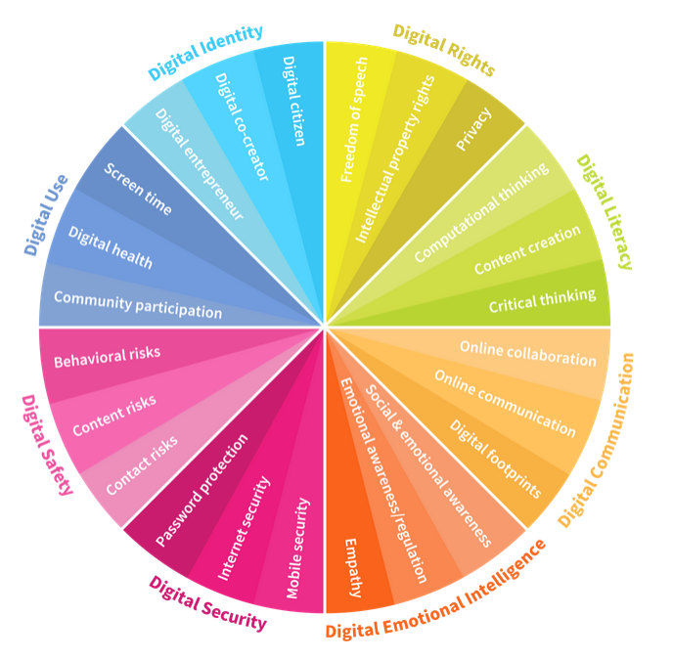
What does this mean for our Learners
Every learner will have the opportunity to develop the skills, confidence and knowledge needed to use digital technology safely, responsibly and effectively.
Our learners will:
- experience high-quality learning in which technology is used for a clear purpose
- develop digital skills progressively from Nursery to P7
- have equitable access to individual or shared GCC-managed devices, in line with current Glasgow City Council provision. (Nursery-Keyworkers have iPads to use with children, P1-P5 shared iPads in class, P6-P7 1:1 individual iPads)
- use accessibility features and digital tools that support their individual learning needs
- use technology to create, communicate, collaborate, solve problems and become more independent
- use digital technology to support their Gaelic language skills and connect with Gaelic language and culture
- learn how to stay safe online, protect personal information and report anything that concerns them
- critically evaluate online information and recognise unreliable, misleading or false content
- understand how to use online content safely, legally and responsibly
- develop an appropriate age understanding of AI, including its potential benefits, limitations and risks
- understand the importance of balancing technology use with health, wellbeing, play and other learning experiences. (Pupils will have Tech Free time every Friday afternoon during Feasgar saor)
- have opportunities to share their views and influence digital learning across the school
- develop leadership skills through the Sgiba Teic Group.

What this means for our staff
Digital learning will be a shared responsibility across the school. Supported by the Senior Leadership Team, Digital Leader of Learning, teaching staff and support staff.
Our staff will;
- use digital technology purposefully when it adds value to learning, teaching or assessment.
- Plan progressive digital learning opportunities across the curriculum
- Use technology and accessibility features to remove barriers and support differentiation, personalisation and inclusion
- Provide opportunities for learners to be creative, collaborative, independent and involved in evaluating their digital experiences
- Use digital technology to strengthen Gaelic-medium learning and increase access to high-quality Gaelic resources
- Model and tech safe, responsible, respectful and ethical digital behaviour
- Develop learner’s understanding of online safety, cyber resilience, media literacy and the benefits, limitations and risks of AI
- Use only GCC-approved platforms, applications and digital resources
- Follow safeguarding, data-protection, copyright and information-security guidance
- Use school approved platforms, including Seesaw, to communication with families, share home -learning activities and celebrate progress and achievement.
- Use school-approved digital platforms, including Magma and Sumdog, to provide personalised practice, targeted support and immediate feedback, while monitoring learners’ progress and identifying next steps in learning.
- Take part in career-long professional learning related to digital learning and share effective practices through collaboration and professional dialogue
- Communicate clearly with families about digital learning, online safety and expectations.
Digital Leadership and support
The senior leadership Team and Digital Leader of Learning will:
- Provide strategic leadership and support the implementation of the school’s digital policy
- Keep staff informed about current Glasgow City Council guidance, developments and professional-learning opportunities
- Provide or coordinate practical support, modelled lessons, coaching an in-house training
- Create opportunities for staff to collaborate, share effective practice and evaluate digital learning
- Gather feedback from learners, staff and families to inform future improvement priorities.
What this means for our families
We will work in partnerships with families to help them understand and support their child’s digital learning, safety and wellbeing at home and in school.
- receive clear information about how digital technology is used to support learning
- be offered guidance and support to help their children use technology safely and responsibly
- understand the school's expectations for the appropriate use and care of GCC devices
- complete relevant user agreements and annual data-consent forms
- support appropriate routines and boundaries for technology use at home
- encourage children to protect their personal information and report online concerns
- use school-approved platforms to access communication and home-learning opportunities
- have opportunities to attend digital-learning information sessions and workshops
- be encouraged to share feedback about digital learning and raise any concerns with the school

Access to Digital resources
Learners will have access to a range of age-appropriate digital resources, including iPads, programmable devices, robotics and coding equipment. These will be selected and used to support creativity, problem-solving and computational thinking.

Safe and Responsible use
The school will:
- follow Glasgow City Council safeguarding, data-protection, cybersecurity and acceptable-use guidance
- use appropriate filtering and security systems on GCC-managed devices
- ensure that personal information is stored and shared securely
- respond appropriately to online-safety and digital-safeguarding concerns
- teach learners how to behave respectfully online and respond to cyberbullying
- ensure that learning about AI is age-appropriate and follows current GCC guidance
- provide clear procedures for reporting lost, damaged or misused devices

Leadership and Responsibilities
Senior Leadership Team and Digital Leader of Learning: oversee the implementation and ongoing development of this policy.
All staff: provide safe, inclusive and purposeful digital learning experiences and follow current guidance.
Learners: follow the school's acceptable-use expectations and use devices safely and responsibly.
Families: support the school's digital agreements, encourage safe use at home and communicate any concerns.
Monitoring and Review
The school will evaluate the impact of digital learning through:
- learner, staff and family feedback
- classroom observations and learning visits
- planning and assessment evidence
- participation and engagement information
- attainment and achievement data
- evaluation of staff confidence and professional-learning needs
This policy will be reviewed regularly to reflect changes in technology and updated Glasgow City Council, Education Scotland and Scottish Government guidance.

