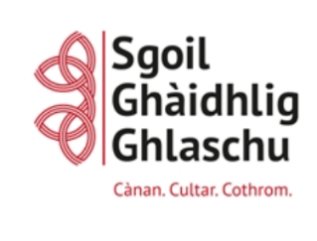
Poileasaidh Litearrachd
Bun-sgoil Ghàidhlig Ghlaschu

Our Priorities, Values & Aims:
At Sgoil Ghàidhlig Ghlaschu we are confident that our Literacy Policy will ensure the following: Throughout their education, children and young people should experience an environment which is rich in language and which sets high expectations for literacy and the use of language. Children and young people spend time with stories, literature and other texts which will enrich their learning, develop their language skills and enable them to find enjoyment. Spoken language has particular importance in the early years. Teachers will balance play-based learning with more systematic development and learning of skills and techniques for reading, including phonics.
(Curriculum for Excellence, Literacy and Gaelic Principles and Practice)

At Bun-sgoil Ghàidhlig Ghlaschu our Literacy Policy aims to enable children to:
- Develop their Gàidhlig language skills to enable them to understand and communicate effectively and accurately in Gàidhlig
- Feel equally confident in the use of Gàidhlig and English
- Use both Gàidhlig and English in a full range of situations within and out with school
- Develop and foster positive attitudes towards Gàidhlig language and culture
- Read and write a variety of different genres in both Gàidhlig and English
- Enjoy opportunities to experience a variety of different types of texts

Who are we?

Bun-sgoil Ghàidhlig Ghlaschu is unique in that:
- We are the first school to deliver Gàidhlig Medium Education (GME) in Glasgow and are the only 3-18 school delivering GME from Nursery to Secondary.
- Children come to Gàidhlig education from a wide variety of backgrounds. These vary from a household where Gàidhlig is spoken to an environment where no Gàidhlig is spoken. Currently, at Sgoil Ghàidhlig Ghlaschu, only 2% of the primary school role have registered Gàidhlig as being a main language of the home which is important to take into consideration in our delivery of the curriculum. Teachers will ensure that Gàidhlig is the language of learning and of communication, and that all areas of the curriculum are taught through the medium of Gàidhlig (Literacy & Gàidhlig: Principles & Practices, 2015).
- Gàidhlig and its associated culture are at the heart of everything we do as a school and remains our main priority. We endeavour to ensure that we are providing our pupils and their families with the support they require to ensure that they can access the curriculum. The number of pupils who have attended Gàidhlig nursery also varies greatly, as does the number of years attending a Gàidhlig nursery. Currently (2020-21), 46% of our primary 1 pupils attended a Gàidhlig nursery to varying degrees. All stakeholders, must consider and will ensure pupils who have had no previous exposure to Gàidhlig whilst also ensuring that they are recognising and building on the skills of those who have attended a Gàidhlig nursery or have Gàidhlig in the home environment.

We are also unique in that our school brings pupils from across Glasgow together, beyond the confines of one catchment area. This comes with its own challenges in that, as a school, we must create our own community which encompasses the culture and ethos of the Gàidhlig language and of the school. It also means that we may not be able to engage with families in the same way. This requires us to be creative in the ways in which we engage with and build relationships with our families. As a result of our unique ‘catchment’, our number of pupils living in areas of deprivation (SIMD 1-3) is also different to that of other schools; currently 23% of our pupils live in SIMD 1-3. It is important to take this into consideration when supporting pupils by ensuring that every child has the same opportunity to succeed, with a particular focus on closing the poverty-related attainment gap.

In order to reflect our school profile, we commit to providing excellence and equity through:
- High standards of learning and teaching
- High expectations for all
- Ensuring that Gàidhlig literacy skills are given the highest priority with each class ensuring that Èisteachd is Labhairt (Listening & Talking) is taught daily in P1-3 for 30 minutes and for at least 2 hours a week in P4-7
- Ensuring that Literacy across Learning is evident to make the most of all literacy learning opportunities
- Ensuring that a combination of Summative and Formative Assessment are used to identify pupils who would benefit from further support and challenge. Targeted intervention through the form of differentiation, personalised SMART targets, parental involvement, SfLW support and/or CLOL must be in place for those pupils to ensure that the learner’s needs are being met and to achieve equity in education
- Pace and challenge being appropriate to the learning needs of pupils learning an additional language through Gaelic Medium Education
- Continuous self-evaluation and monitoring of tracking of progress
- Involving our children, parents, carers and community in shaping our Literacy identity

In our school, our staff’s vision for Literacy for our children and young people looks like this:
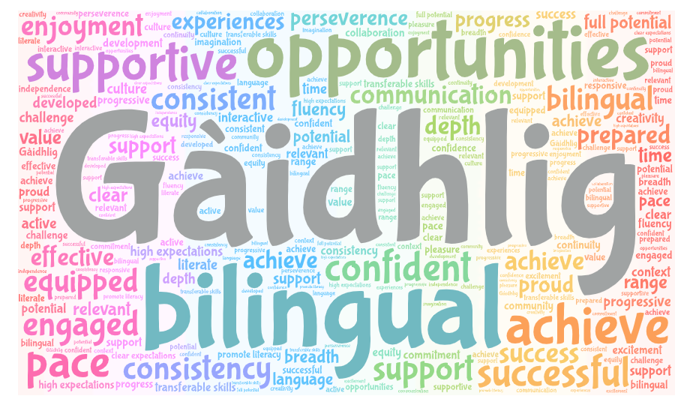
We will review this section of the policy every year to ensure that it reflects our context and local and national priorities and advice.

Gaelic Medium Education Immersion Model:

Total Immersion: In Gaelic Medium classes, learning and teaching is wholly through Gàidhlig during the Total Immersion phase from P1 to P3. Children and young people need to experience high-quality total immersion as part of Gaelic Medium Education until they have a secure foundation in the language and a level of fluency that will enable them to build on the progress made in Gaelic. To achieve this, learning will firstly have a very strong focus on listening and talking in Gaelic through a play-based curriculum.

Staff will model high quality Gaelic to children and play alongside the children as an effective approach to learning. Teachers will ensure that Gàidhlig is the language of learning and of communication, and that all areas of the curriculum are taught through the medium of Gàidhlig. The exceptions to the total use of Gaelic includes comforting a child who is distressed, for an emergency situation or for explaining issues connected to health, safety and wellbeing.

As learners acquiring Gàidhlig enter a Gàidhlig Medium class, they hear and will in time, speak, read and write Gàidhlig and be actively involved in working out the structure and rules of the language. They may take some time to develop sufficient confidence to use their newly acquired Gàidhlig. Children are encouraged to start using Gàidhlig as soon as possible, firstly with isolated words and phrases and then with more open-ended talk as they progress from the latent to active phase in acquiring the language.

The meaning of new words will be indicated through visual cues such as gesture, mime and pictures, rather than through explanation in English. Songs including action, repetition, language games, structured play and visual materials will be used extensively in the early stages of P1 and throughout. In this, there is an important emphasis on developing children’s social language so that they can begin to speak Gaelic for real and purposeful reasons. When a child wants to talk about an experience but can only express it in English, he/she is able to do so but the teacher sensitively retells the story in Gàidhlig. Teachers model and scaffold the accurate use of Gàidhlig and encourage children to improve their language structures.

The learning environment will be a literacy-rich and visually stimulating place, which will encourage language development which focuses on the correct uses of language and subject-specific vocabulary.

A few children attending Sgoil Ghàidhlig Ghlaschu are fluent Gàidhlig speakers and some will have attended Gàidhlig nursery. They will continue to develop Gàidhlig oral language in the Immersion Phase and will be challenged appropriately, they may also progress in reading and writing earlier than their peers.
(Advice on Gaelic Education, 2015)

Immersion Phase: The next stage of Gaelic Medium Education is the ‘immersion phase’. In this phase, the curriculum in its entirety continues to be taught through the medium of Gaelic across all four aspects of learning, as defined in Building the Curriculum 3. As such, the approaches detailed above continue to apply to the immersion phase. English language is gradually introduced from Term 3 of Primary through the medium of Gàidhlig with Gàidhlig remaining the predominant language of the classroom in all areas of the curriculum. See English Language Policy for further information.

Teachers’ monitoring and tracking of progress and achievement should confirm that children now have a secure base in Gaelic language to transfer to developing reading and writing skills in English language and to learning at a quicker pace across the curricular areas and contexts.
(Advice on Gaelic Education, 2015)

Èisteachd is Labhairt/Listening & Talking:

An emphasis needs to be placed on listening and talking at all stages to allow learners to practise, use and enrich their Gàidhlig. Understanding by teachers of the stages of oral language acquisition will help to ensure a clear understanding of when and why Gàidhlig language and grammar is taught in a structured way. The Building Blocks of Language are a useful tool for identifying where learners are in their language acquisition.

Teachers should ensure that Gàidhlig literacy skills are given the highest priority with each class ensuring that Èisteachd is Labhairt is taught daily in P1-3 for 30 minutes and for at least 2 hours a week in P4-7 (For P4-7 this can take place in smaller blocks or larger lessons at teacher discretion). This can also take the form of informal and informal games throughout the day and across the curriculum. Transition times and snack times for example, should also be utilised and used as opportunities for listening and talking games and activities.

The SGG Gàidhlig Continuum breaks down the order of teaching into terms and classes and should be followed for consistency and progression of skills and fluency. This should be used alongside the LfA framework tracker for each stage for progression and consistency. For further guidance on this see the Èisteachd is Labhairt Poileasaidh. For the teaching of new vocabulary, the Word Aware approach and resources should be used across the school with P1-2 introducing concepts through Cat air Cuairt.

Children should hear Gàidhlig from a variety of sources in and out with school e.g. from their own teacher, other staff members, visitors, older children, class monitors, members of the community, buddies, captains, school trips, radio, internet and TV programmes.

Leughadh/Reading:

Phonological Awareness is the foundation for learning to read. It is the ability to recognise and work with the sounds in spoken language. A good understanding of phonological awareness is said to be the greatest predictor in a child’s later success in reading. Although most children pick it up naturally, others need some help to do this.

A big emphasis should be placed on phonological awareness in Gaelic in the first term of Primary 1, following the Phonological Awareness Progression guide for Teachers (P1-3, beyond if required). This should then be reinforced and revisited continually, particularly in P1-3 to support and prepare pupils for reading in both languages. Children will be then assessed using Ready Steady Read. Children who are having difficulty with reading should be assessed for gaps in their Phonological Awareness and supported accordingly. The Bogsa-Ciùil should be utilised to teach and enhance Phonological Awareness skills in Gàidhlig. Resources for the teaching of Phonological Awareness and support for parents can be found here.

Gaelic reading skills will initially be acquired through class talking and listening activities, alongside the phonics program (Facal is Fuaim & Fios air Fuaimean), which has been slightly adapted and changed into a new order. This new order of teaching the phonics (fuaimean) allows teachers to begin teaching the concept of blending (coimeasgachadh) the sounds after the first 3 fuaimean have been taught. Word lists of decodable words should be introduced to help pupils develop this skill alongside the Common Words (Faclan Cumanta). The children are introduced to the key vocabulary they encounter in reading activities and across other areas of learning. Once children can blend most words (including those with digraphs) and recognise the first set of common words, they are ready to progress on to reading books (See order of reading books).

To ensure that the children are also building on their comprehension skills in reading, Leughadh Luachmhòr (Reciprocal Reading) is used throughout the school. Leughadh Luachmhòr uses characters, props and question prompts to help children to engage with and gain a greater understanding when reading a piece of text. It develops the skills of Predicting, Clarifying, Summarising, Illustrating and Questioning, whilst encouraging group work and Gàidhlig discussion around a text. The Leughadh Luachmhòr progression guide ensures that the children are building on prior knowledge and developing their comprehension skills.

Reading lessons should be planned for and skills and strategies taught explicitly. Before, During and After Reading posters should be displayed in class and used from P3-P7 to build on skills, knowledge and understanding of a piece of text. The LfA Framework trackers should be used to inform planning at each stage to ensure consistency and progression through the curriculum. The Close Reading grid for P3-P7 should also be used in planning to ensure that children are experiencing effective questioning (literal, inferential and evaluative) in different forms which will provide them with various strategies for understanding and engaging with a piece of text. It is important to note that children should be experiencing and engaging with a variety of different texts and genres remembering that “texts not only include those presented in the traditional written or print form, but also orally, electronically, or on film” (Curriculum for Excellence).

Sgrìobhadh/Writing:

At Sgoil Ghàidhlig Ghlaschu, writing skills will initially be developed through talking and listening activities with a great deal of structure. Foundations of Writing will be followed to develop children’s drawings and telling of stories through pictures. Opportunities will arise to develop sentence structures at news time and through morning routine and books. Children will use sounds, letters and words they have explored and learn to write short texts. Pie Corbett’s Talk for Writing will be used to develop sequencing and retelling of familiar stories whilst building up their Gàidhlig vocabulary. Teachers will begin to scribe the children’s stories until their oral competence, reading skills and phonics development are secure enough to enable them to write independently. Teachers always encourage children to ‘have a go’.

Writing will then be taught and assessed using a genre-approach to writing, LfA Routes through Writing. Routes through Writing planners and assessments have been adapted to better suit a GME context. To ensure children are covering all genres by the end of a level, an overview for Writing genres has been created (more detailed overviews can be found here):

STAGE |  | GENRE
 |  | Term 1 -Non Fiction | Term 2 – Non-fiction | Term 3 - Fiction | Term 4 – Non Fiction
FIRST | P2 | RECOUNT | PROCEDURAL | CHARACTER | EXPLANATION
FIRST | P3 | RECOUNT | REPORT | CHARACTER & SETTING | EXPLANATION
FIRST | P4 | RECOUNT | PROCEDURAL | CHARACTER & SETTING | PERSUASIVE

STAGE |  | GENRE
 |  | Term 1 -Non Fiction | Term 2 – Non-fiction | Term 3 - Fiction | Term 4 – Non Fiction
SECOND | P5 | RECOUNT | REPORT | CHARACTER, SETTING & PLOT | PERSUASIVE
SECOND | P6 | RECOUNT | REPORT | CHARACTER, SETTING & PLOT | ARGUMENT
SECOND | P7 | RECOUNT | REPORT | CHARACTER, SETTING  & PLOT | DISCUSSION
This allows for a balance of assessed genres over the 2 levels. Please note that other genres such as procedural, explanation and poetry should be incorporated where appropriate, if they lend themselves to IDL or another curricular area, just not formally assessed writing pieces.

Teachers should use the LfA Genre Writing posters to support them when introducing each genre. Teachers in P3-7 should also use the Before, During and After Writing posters to structure the format of the lesson. The LfA Framework trackers should be used to inform planning at each stage to ensure consistency and progression through the curriculum. Modelling and examples of good pieces of writing should be used to show learners the high expectations set. Lessons should be chunked into parts where possible, using timers or breaks after paragraphs/parts/sentences to discuss and share work produced. This will allow pupils who require support to get ideas and also helps not to overwhelm pupils with a full piece of writing in one go.

Exciting and engaging stimulus for writing should be used where possible to encourage the children to want to write. The Good Writing Lesson booklet can be used to guide the format of Writing lessons. The success criteria for the lesson should reflect the criteria of the genre being taught. Separate Structural Targets can be set as criteria as well. The teaching of Grammar Progression plan should be followed to ensure consistency and progression across the school.

Litreachadh/Spelling:

Initially the teaching of spelling should focus on decodable words using the phonics already taught. Spelling rules should be taught explicitly and not just set for a test without input. Common words can be included when they follow the specific rule being taught and should be age and stage appropriate. Various fun, sensory spelling activities should feature in classes to try and help children who learn in different ways.

ASN & Literacy:

Children who require support in literacy should receive this at their level as early as possible. As it is difficult to get a diagnosis early-on for Dyslexia in a GME setting, should you suspect dyslexia, it is important to begin gathering evidence of this from an early stage. Support tools should be available to children who require it, for example overlays of different colours, magnetic letters or typing for those who struggle with their fine motor skills. Dictionaries, word banks etc should be easily accessible and encouraged. PM Benchmarking assessments can be used to calculate a reading age in English and should be used if teachers have concerns to ascertain gaps and next steps.

Digital Literacy:

Digital Literacy should be incorporated into day-to-day teaching and should not be a standalone. Children should be given digital opportunities where possible for all areas of literacy.

Beurla/English: See English Literacy Policy

Measadh/Assessment:

Assessment is both formative and summative (see Summative Assessment Calendar) and information is used to ensure that learners’ needs are met in addition to on-going observation. A variety of school reading assessments are carried out bi-annually and Routes through Writing assessments are used each term to help formulate next steps. Primary 1 pupils are assessed early in Term Two using the British Picture Vocabulary Scale (BPVS) to ascertain their vocabulary age in English. Primary One pupils are assessed in term 4 using observational assessment (Ready Steady Read) that helps us to provide the right level of balance and support.

The YARC assessment is used in English to assess English abilities and competence prior to commencing the introduction of English. A Gàidhlig equivalent of the YARK has been devised to assess pupils in Primary 4 to highlight gaps in learning and next steps. Differentiation is evident in our planning and we use a variety of tools to help pupils identified as ‘not yet on track’, achieve at an appropriate level. Good use is made of the benchmarks and the LfA trackers to plan assessments collegiately and to enhance dialogue around attainment. Our assessment jigsaw highlights the main tools and opportunities used to measure progress and make secure professional judgements:
Will add YARK and PIRA
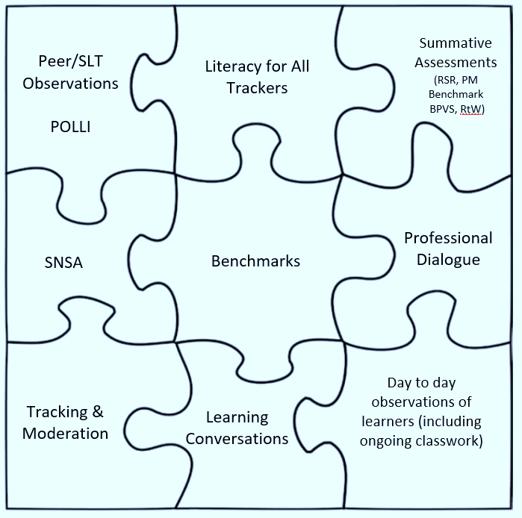

The Four Contexts for Learning:

Across the school, we ensure that Literacy is an integral part of the four contexts for learning. We have a range of opportunities that enhance personal achievement and we value and plan for interdisciplinary learning as a way of developing breadth, challenge and application. Literacy should be embedded in the life and work of our school communities. The four contexts help develop our learners’ knowledge, skills and attributes.
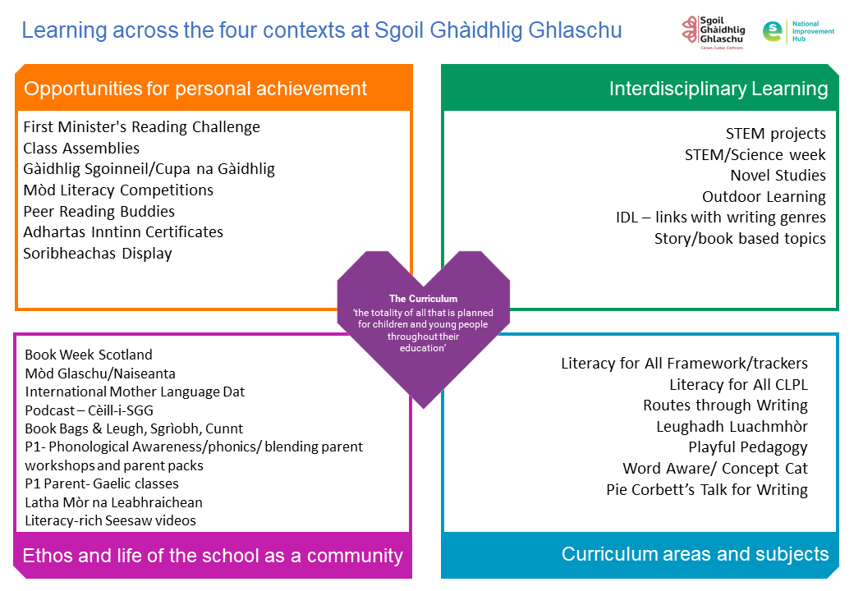
Will add Mo Shlighe Ionnsachaidh & personal Projects (P6&7)

Staff Development and CLPL

We use the GCC Literacy for All approaches across the school and our staff team undertake high quality CLPL on a regular basis, updating their professional development in line with our School Improvement Plan. LfA training made relevant to our school context are recorded and delivered by the CLOL and are available to all new staff and current staff, to refresh their knowledge of LfA approaches to ensure consistency in delivery across the school. All LfA staff training can be found here. CfE and the LfA trackers are embedded in our collegiate planning process to meet the standards within the experiences and outcomes. Learners access and explore a wide range of texts, including multimodal texts. Digital enhancements are used to increase engagement, improve learner experiences and meet needs.

In our school our Year Plan for Literacy is (insert link to how year is divided up e.g. non-fiction/fiction). Please see QA calendar for information on monthly focus, tracking and monitoring etc.


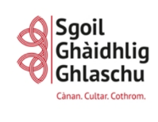
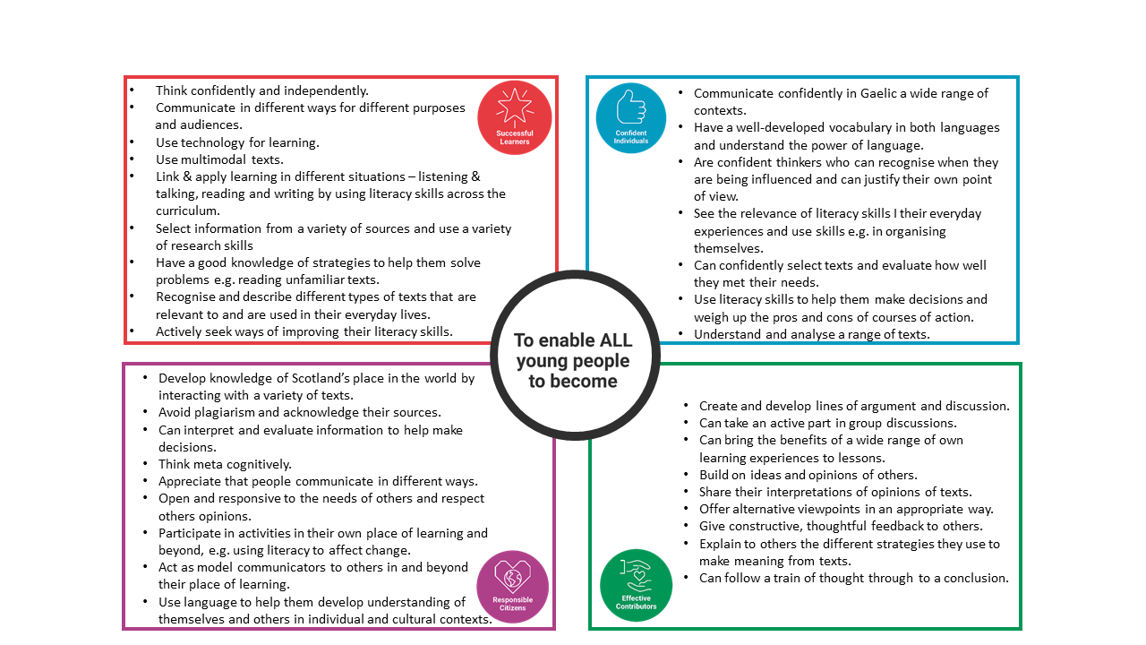
Literacy and the Four Capacities
We develop the four capacities specific to Literacy and these are embedded in our planning:

Our Literacy Policy and the Design Principles:

Our literacy provision takes account of the seven design principles (Building the Curriculum 3):
We deliver breadth, challenge and application by:
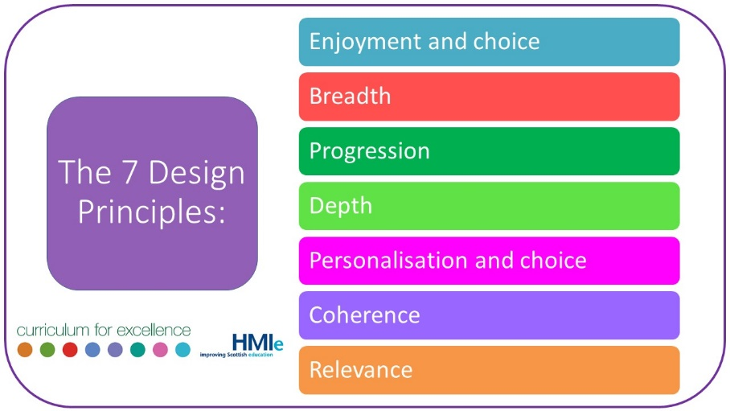
- Referring closely to the Experiences and Outcomes in our planning
- Making use of increasingly complex texts
- Encouraging independence
- Providing opportunities to apply skills in a variety of contexts
- Encouraging individuals to become more adept at evaluating their own and other’s learning
- Ensuring that learners are demonstrating a growing confidence and competence in skills for learning, life and work
- Engaging in professional dialogue and making professional judgements to ascertain best next steps for learners

We provide Challenge and Enjoyment through incorporating planned opportunities for active, challenging and enjoyable learning, using a range of resources designed for learning that responds to the needs of all children. Planning reflects the differing needs of all learners, providing challenge and support where required. Children’s interests and enjoyment are considered during planning to enhance engagement and progress.

We ensure that there is depth by promoting different types of thinking and learning through effective questioning and encouraging learners to explain their thinking and the strategies they have used. A variety of strategies are modelled by teachers in reading and writing lessons guided by the Before, During and After questions, to ensure a deeper engagement with a variety of texts.

Breadth and progression are embedded in GCC Literacy for All framework which staff use to ensure breadth of learning and to have a clear picture of what progression looks like within and across levels (insert link to framework). The framework is used to ascertain gaps in learning and next steps to support progress within stages and levels. The benchmarks feature in the LfA framework and in our tracking conversations.

Personalisation and choice are incorporated through taking account of the learner’s prior experiences, learning and interests, to provide ‘customised’ support and feedback. Opportunities for choice in activities and pursuing aspects of learning independently are provided, particularly predominant in play-based classrooms. Children are given opportunities to demonstrate creativity in the ways in which they present their work and learning.

Our Literacy curriculum is coherent and relevant in that we deliberately and consistently make links with other curricular areas – this is reflected in our planning. All staff make reference to the relevance of Literacy skills for learning, life and work (SLLW), building on and incorporating the Developing the Young Workforce (DtYW) initiative, to connect the world of work with the world of education.

