Sgoil-àraich Bunsgoil Ghàidhlig Ghlaschu

Feallsanachd
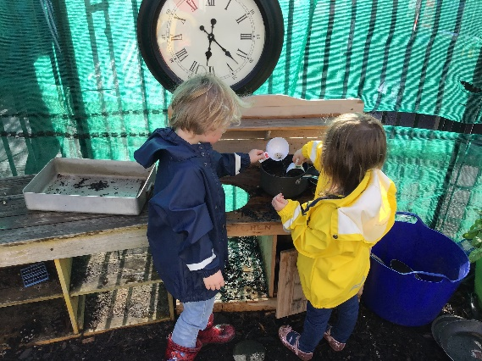

Curriculum Rationale

URRAM¦Respect UALLACH¦Responsible
DÌCHEALL¦Diligence COIBHNEAS¦Kindness

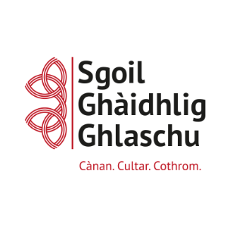
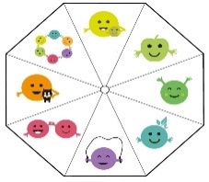

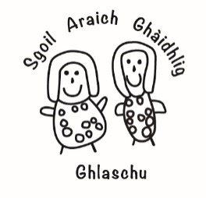

By Curriculum Rationale we mean, that everyone involved with the nursery and school can answer the questions ‘What is it we want for learners?’ and ‘What are we going to do to achieve it?’
Key messages for the Gaelic total medium immersion stages
Take a Child Centred Approach.
The basis of learning during the total immersion stages, as reflected in Realising the Ambition, states that interactions with children in Gaelic are a key driver.
Use intentional and reflective interactions, experiences and spaces.
“Interactions in Gaelic are a key driver in planning progression in the curriculum for GME” Realising the Ambition
…learning will firstly have a very strong focus on listening and talking in Gaelic through a play-based curriculum, which is widely evidenced to be the most appropriate approach for the development of young children’s early learning. Education Scotland Advice on Gaelic Education Gaelic Medium Education: total immersion

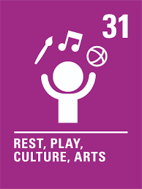
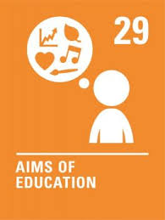
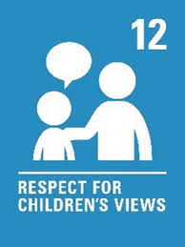
An t-ionnsachadh og, an t-ionnsachadh boidheach!
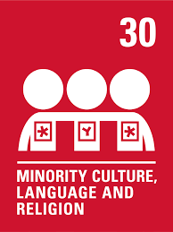

What do we want for our learners?
Our nursery values are shared by our community - respect, responsible, diligence and kindness
To feel safe and happy in our nursery
To have pride and confidence in ourselves.
To respect the Gaelic language.
To make responsible choices
To be kind, friendly and compassionate to everyone.
To become aware of their achievements in and out with nursery.
To have good awareness of digital technology
To have opportunities to be active.
To develop literacy and numeracy skills through play
To make good and healthy choices
To celebrate diversity

What informs our practice?

Glasgow Gaelic Primary School and Nursery Class’s Vision and Values- All children attain and achieve their potential, are proud ambassadors of the Gaelic language and are empowered to actively and responsibly improve the world around them through the 4 key values
URRAM¦Respect UALLACH¦Responsible
DÌCHEALL¦Diligence COIBHNEAS¦Kindness
The Curriculum for Excellence and the 7 Principles of Curriculum Design (Challenge and Enjoyment, Breadth, Progression, Depth, Personalisation and Choice, Coherence and Relevance)
Getting it Right for Every Child principle and the wellbeing indicators
(Safe, Healthy, Active, Nurtured, Achieving, Respected, Responsible and Included)
United Nations Convention on the Rights of the Child
Care Inspectorate policies, guidelines and publications
Advice for Gaelic Medium Education (Feb 2015) (updated 2022)
Realising the Ambition: Being Me- National Practice Guidance for Early Years in Scotland (2020).
Education Scotland’s How Good is our Early Learning Child Care
National Health Care Standards (2018)
Barnardo’s PaThs Emotional and Social Programme
The Language and Communication Friendly Establishment: Supporting Glasgow’s Learners
Glasgow City Council’s Curricular Frameworks – Literacy for All
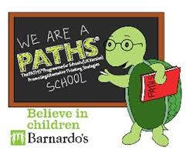
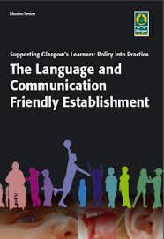
Glasgow Counts
CREATE Music
STEM Glasgow
Families in Partnership.

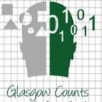

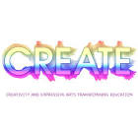
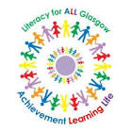

How do we achieve what we want for our children?
Curriculum Areas
Literacy & Ghàidhlig > Numeracy & Mathematics > Health & Wellbeing > Expressive Arts > Sciences > Social Studies > Technologies > Religious & Moral Education

Contexts for Learning  Total immersion  Learning through play – indoors, outdoors and free flow  Culture and music  Quality environments which promote curiosity, creativity and inquiry  Literacy and Numeracy rich spaces  Loose parts play  Access to natural resources  Local attractions and community links  Child led interests and voice  Snack  Celebrations of various cultural & festival | Learning & Teaching Approaches  A shared ethos of learning through play  A holistic approach to planning, learning and assessment  LCFE Talk Techniques  LCFE Indicators – supportive practice  Responding to children through observations, interactions and inclusive approaches to learning  Home Learning  Responsive and intentional planning  Tracking and monitoring children’s progress. Significant learning and next steps.  Links with primary 1 – music, science week, garden time
Assessment Approaches  Observations  Responsive to children’s needs and next steps/progression in development.  Tracking Literacy, Gaelic Listening and Talking & Numeracy.  Periodic data across the year  Teaching Talking development overviews  Circle Framework – optimizing the children’s’ potential  Staged Intervention and Supports plans | Recognising Achievement  Daily recognition  Documentation of learning  Wider achievements  Nursery certificates - rionnag  Assembly award – teddy for the week  Sports day  Learning journey wall
Parental Engagement
Parent group
Stay and Play
Organising trips to local area
Supporting school/nursery events – graduation, performances
Information evenings
Personal care plan/regular reviews
Wellbeing and Assessment Plan
Sharing progress, newsletters and presentations on GME

