Family Learning Team Case Study May 2026
Initial Teacher Education Strathclyde University Family Learning Placements
The Family Learning Team has a strong track record of supporting probationary and newly qualified teachers through bespoke family learning and engagement training and coaching. Building on this experience, in August 2025, Education Scotland and Strathclyde University approached the Family Learning Team to explore involvement in a national programme offering placements for final year primary education. This was building on a pilot programme in response to the Learning Together National Action Plan – ‘The Scottish Government will engage further with Initial Teacher Education (ITE) universities and early learning and childcare colleges in order to improve how parental involvement and engagement are reflected in relevant qualifications and courses, and to share expertise’. The team welcomed this opportunity and established a new partnership.
The Professional Specialisation module enables them to explore an area of educational interest in greater depth. This is achieved through project-based learning, combining campus-based study with practical, off-campus experiences. For the first time, Family Learning and Engagement was introduced as a placement option. Ten students expressed interest in this pathway. Through ongoing collaboration between Strathclyde University and Family Learning Team, a structured four-week placement model was developed.
Family Learning Officers (FLOs) contacted schools which were outstanding in their family learning practise to enquire about their capacity to host students. Schools responded positively and as a result, students were placed in St Patrick’s, St Albert’s, St Ninian’s, Haghill Park and St Mary’s Primaries.
The programme began with the Family Learning Team delivering a tutorial titled “Principles and Practices of Parental Engagement and Family Learning in Glasgow.” This session showcased highly effective practice within host schools and partner projects, while also providing an opportunity for students and FLT staff to meet. Students were then asked to select their preferred placement locations.
As part of the placement requirements, students completed a 1,000-word professional reflection. This encouraged them to:
• Connect practical experiences with academic learning
• Reflect on relationships observed in practice
• Consider how these experiences shaped their understanding of engagement with
children, parents, carers, and professionals
These reflections supported students in recognising the importance of strong, respectful relationships as the foundation of effective family engagement and contributed to their professional development as future teachers.
Throughout the four-week placement, FLOs visited groups to provide support and respond to student queries.
Feedback from host establishments:
School staff highlighted the students’ willingness to engage, learn, and actively contribute to sessions from the outset.
They commented that students were open to engaging and were not afraid to join in. While some initially observed activities, they quickly “rolled up their sleeves and got stuck in.” Their genuine interest in listening to parents and families helped to build trust and positive relationships.
Establishments also noted that:
- Students actively participated in ensuring families felt included and engaged well within sessions.
- They became increasingly confident in their interactions and demonstrated a strong willingness to learn.
- Students engaged positively with both families and children and supported the smooth running of activities by helping prepare and organise resources to ensure sessions started on time.
Partners recognised the value of the placement experience and identified opportunities for further development. Suggestions included providing students with more opportunities to independently lead activities, for example by planning and co-leading final-week sessions alongside Glasgow Life leaders.
Feedback from Students
Student reflections demonstrated a strong understanding of the importance of family engagement in supporting children’s learning and wellbeing.
One student reflected:
“This connection between theory and practice has helped me understand that family engagement isn’t simply about organising events — it’s about cultivating everyday opportunities for trust, respect and partnership. As a future teacher, I aim to create spaces that honour parents’ voices and cultural identities, building relationships that support children’s learning and wellbeing holistically.”
Students also highlighted several key learning points from their placement experiences:
- Building trust and open communication with parents and carers is essential.
- Careful listening and observation help teachers understand how families support their children.
- Parents should be valued as key partners in supporting children’s learning and wellbeing.
The placement experience enabled students to strengthen their confidence, develop professional skills, and gain a deeper appreciation of the role of family learning and engagement within education.
At the conclusion of the programme, an evaluation and reflection session was held at Strathclyde University. Students shared their experiences, learning, and key insights. This event brought together all stakeholders and highlighted the success of the initiative.
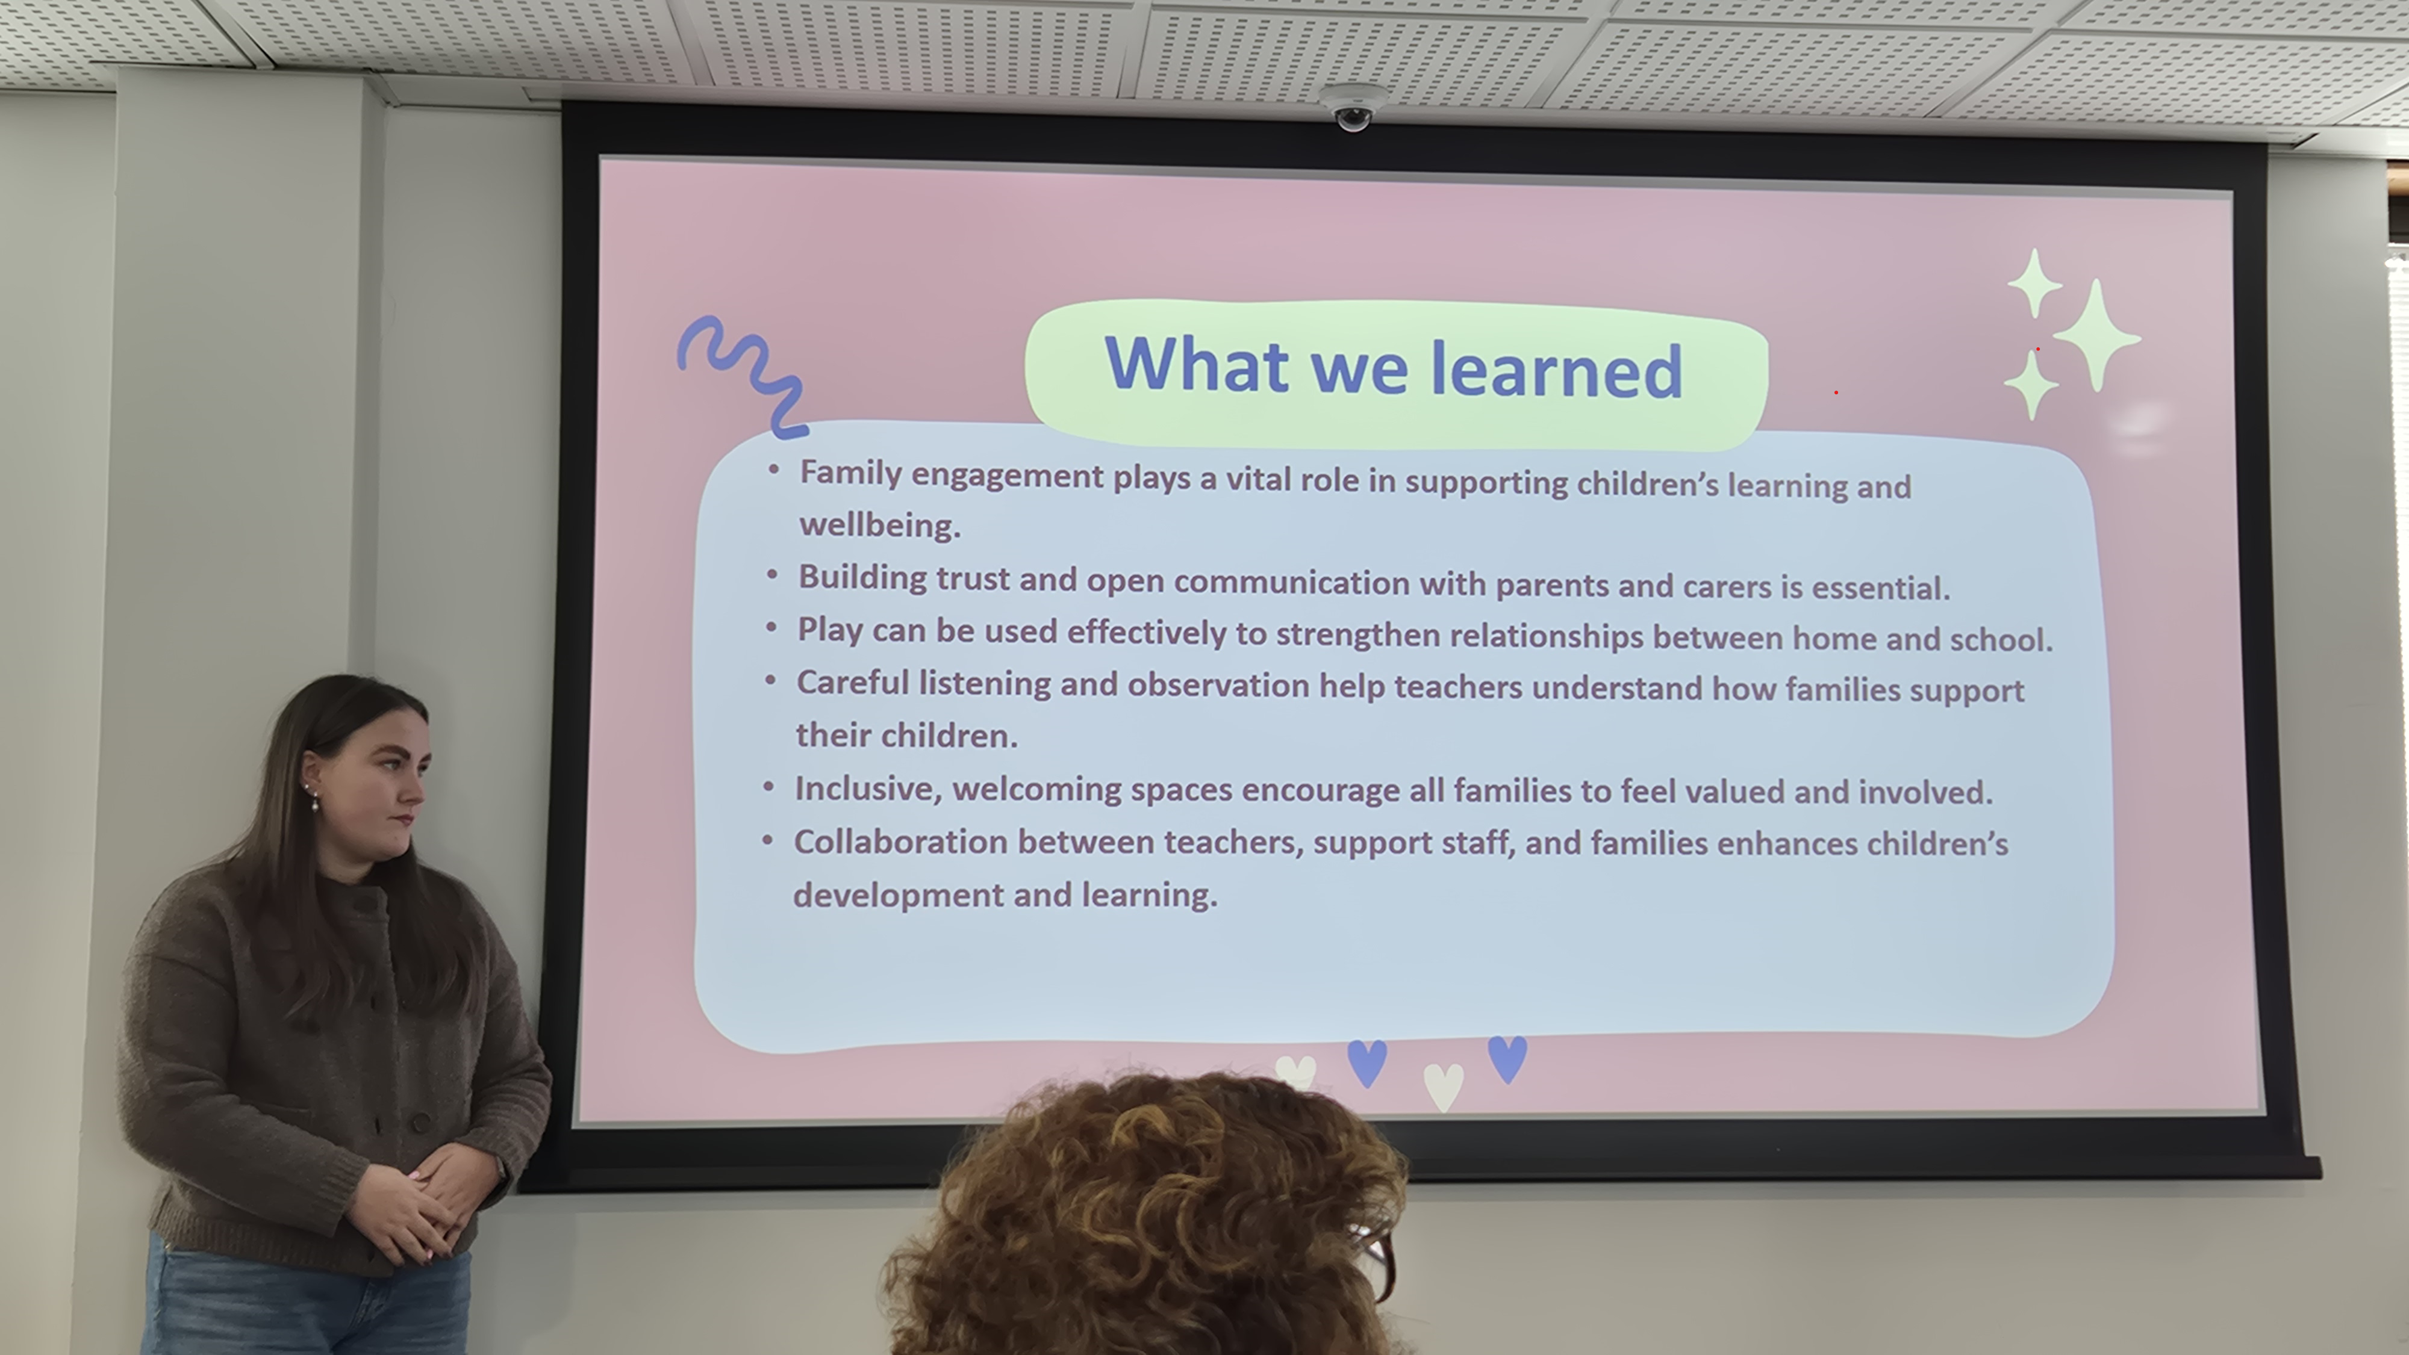

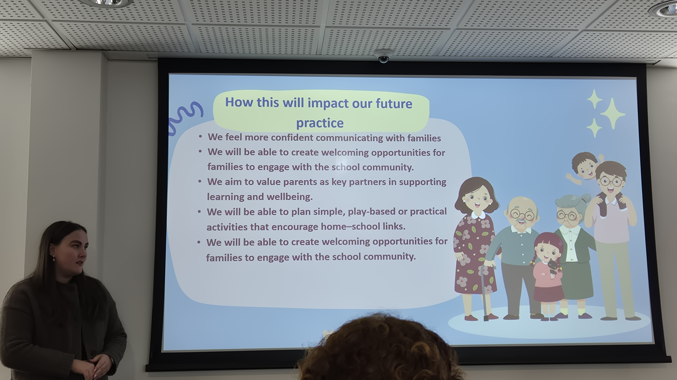

Next Steps
Planning is now underway to expand and deliver this initiative again in September 2026, building on the positive outcomes and lessons learned. As part of future planning, work will begin earlier in the summer term to identify Family Learning and Engagement placement opportunities and strengthen preparation for host establishments and students alike.

For more information please contact:
Laura.kennedy@glasgowlife.org.uk
Fatemeh.doost@glasgowlife.org.uk

