
Embedding Family Learning Case Study

Name of establishment | Ibrox Nursery Class
Case Study Written By  Name and Job Title | Claire Bradley, Family Learning Officer  Charlene Murphy, Team Leader, Ibrox Nursery Class
Date Completed | June 2026
Setting the Scene
Brief description of your establishment
At Ibrox Nursery Class, we provide a nurturing, inclusive, and inspiring environment where children aged 3 to 5 are empowered to learn, grow, and flourish. We are committed to fostering each child’s unique potential, ensuring they develop the confidence, resilience, and curiosity needed to embrace future learning and opportunities with enthusiasm.
Our vision is to make Ibrox Nursery Class a centre of excellence in early years education, where every child is supported to achieve their fullest potential and leaves with a strong foundation for lifelong learning. Through high-quality experiences, meaningful relationships, and a culture of continuous improvement, we strive to create an environment in which children are encouraged to dream ambitiously and reach for the stars.

Number of Places: 40/40
SMID 1
EAL: 86.2%

Our Aim
At Ibrox Nursery Class, we are committed to providing a safe, nurturing, inclusive, and stimulating learning environment where every child is respected as an individual and supported to reach their full potential. Our practice is informed by the principles of Realising the Ambition: Being Me, Getting it Right for Every Child (GIRFEC), and Scotland’s Quality Improvement Framework, ensuring that children’s wellbeing, learning, and development remain at the heart of all we do.
We promote a family-centred approach that recognises the vital role of parents and carers as children’s first and most influential educators. Through strong partnerships, high-quality interactions, and meaningful collaboration with families and the wider community, we provide responsive learning experiences that reflect the needs, interests, and strengths of every child.
Our aim is to foster curiosity, confidence, resilience, and a lifelong love of learning, ensuring that all children develop the knowledge, skills, and self-belief required to thrive both now and in the future.

Early Level Experiences and Outcomes

Recognising Parents and Carers as Partners
At Ibrox Nursery Class, we recognise parents and carers as children’s primary educators and value the significant contribution they make to their child’s learning and development. We are committed to building positive, respectful, and collaborative relationships with families to ensure continuity and consistency between learning at home, within the community, and across educational settings.
By working in partnership with parents and carers, we create a shared understanding of each child’s strengths, interests, and needs, enabling us to provide the highest quality early years experiences and support positive outcomes for all children.

Action/Approach Taken
Detail the actions taken in order to develop and embed family learning into your establishment. What was done and how? What staff and partners were involved? What were the costs and timescales?
Family Learning and Parental Engagement Journey
Approximately five years ago, in the period following the COVID-19 pandemic, nursery staff identified that many parents were experiencing feelings of isolation. Through informal conversations at drop-off and pick-up times, families shared concerns about managing children's behaviour, including autism-related traits and challenging behaviours.
In response, staff provided practical strategies for use at home, such as sticker reward charts to encourage positive behaviour and Boardmaker visual supports to help children understand routines and instructions. Where appropriate, families were also connected with speech and language professionals to access additional support.
One parent in particular expressed that she felt unsupported by her wider family network. She was invited to participate in nursery-based activities such as Book-bug and Stay and Play sessions. Through ongoing conversations, she shared her desire to do something for herself and develop her own skills and confidence.
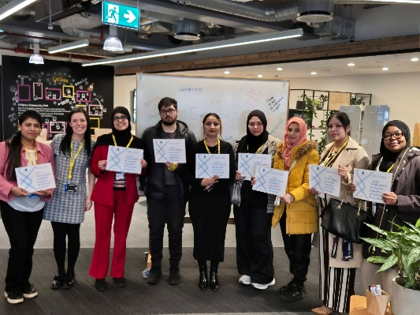
Building on an existing partnership with Barclays, developed through previous collaborative work in the local library around CV writing and internet safety, staff contacted the Barclays team to explore opportunities for parents. This led to the introduction of the Jump Start Programme, with this parent becoming one of the first participants. Information sessions were subsequently offered to other parents, many of whom expressed an interest in pursuing opportunities for themselves as their children prepared to start school.
The programme initially consisted of a five-week training course and has since expanded to seven weeks. The final session includes mock interviews, helping participants prepare for employment opportunities. Feedback indicated that while parents valued the programme, some still lacked confidence in taking the next steps.
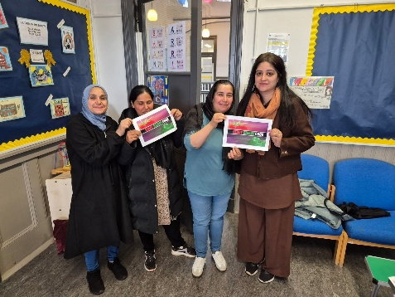
Through further consultation, staff discovered that many participants shared a passion for cooking. As a result, a monthly cooking class was established. Parents contribute £2 towards the cost of ingredients, and any left over money we have a big celebration at the end of term where we purchase an afternoon tea and some sweet treats. The cooking classes have become a valued opportunity for families to build confidence, develop skills, and strengthen social connections.
Additional activities have included pakora-making sessions led by a father and "Ready, Steady, Cook"-themed events. One parent expressed an interest in learning nail techniques, and another parent used nursery resources to develop these skills and share them with others.
The success of the cooking initiative led some families to complete Food Hygiene Certificates, supported through a Food for Thought grant. Funding also enabled the purchase of new hobs, utensils, and other cooking equipment, further enhancing learning opportunities.
Families have increasingly contributed ideas for activities beyond the nursery setting. While "Curry Karaoke" began as a light-hearted suggestion, discussions have evolved into plans for professional cooking experiences with local Glasgow curry houses. An Italian cooking programme is also being developed, with children participating alongside their parents to promote intergenerational learning.
The nursery’s action plan places a strong emphasis on family learning opportunities. Practitioners actively encourage families to view the nursery as a welcoming space for the whole family, fostering meaningful involvement in children’s early learning experiences.
Family voice remains central to planning and evaluation. Parents contribute to the Family Learning Tree, provide feedback through social media, questionnaires, and the nursery's Big Book. These approaches ensure that the nursery listens to families, responds to their interests and needs, and continues to provide relevant and engaging learning opportunities that strengthen family wellbeing, confidence, and community connections.

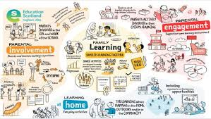

Developments:
What new projects or initiative did you establish from initially engaging with parents?


Developments and Family Learning Initiatives

Oral Health and Wellbeing
The nursery team identified a high incidence of tooth decay among children, with many requiring treatment at the local dental hospital. This highlighted a need to improve families’ understanding of oral health and preventative care.

To address this, families were invited to an Open Doors Health and Wellbeing event delivered in partnership with the Health Improvement Team. During the event, families received information about oral health, including translated resources and practical guidance on maintaining good dental hygiene. Support was also provided to help families register with local dental practices.

The nursery recognised that some families with English as an Additional Language (EAL) experienced communication barriers when accessing dental services. Staff worked closely with families and dental practitioners to facilitate communication and ensure children received appropriate treatment. In one instance, a child awaiting dental extractions was supported throughout the process. Following treatment, staff observed a significant improvement in the child’s wellbeing, confidence, and readiness to engage in learning experiences.

Oral health promotion was further embedded within the nursery curriculum through activities such as tooth-brushing charts, certificates, and rewards that encouraged positive dental habits both in the setting and at home. Families also took part in a pilot Childsmile Training Programme and received certificates for participation.

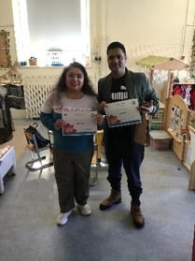
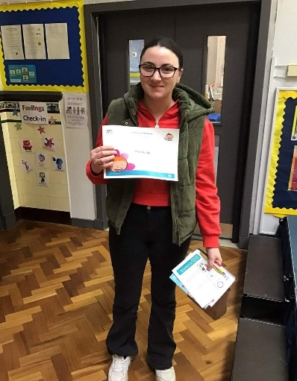

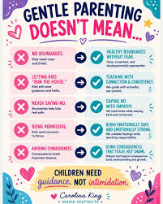
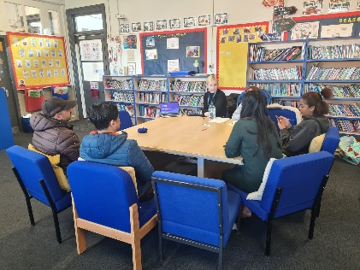
Partnership with the Central Parenting Team
Staff identified a number of children transitioning to school who were still wearing nappies, had inconsistent bedtime routines, or were arriving without having eaten breakfast. A parental survey revealed that many children were going to bed late, impacting their wellbeing and readiness to learn.
In response, the nursery worked alongside the Central Parenting Team to provide support and guidance for families on key areas of child development, including toilet training, establishing healthy sleep routines, setting appropriate boundaries, and promoting age-appropriate nutrition. This collaborative approach aimed to strengthen family wellbeing and support positive outcomes for children.

NSPCC Emotional Resilience Programme
As part of an NSPCC pilot initiative, nursery practitioners and eight children participated in a six-week Emotional Resilience Programme designed to help children and families recognise, understand, and manage emotions effectively.
The programme was introduced following observations that some children were experiencing difficulties managing their emotions, affecting their behaviour, relationships, and engagement in learning. NSPCC practitioners provided training for staff, equipping them with strategies to support children's emotional wellbeing and embed these approaches into daily practice.
The programme aimed to help children identify a trusted adult or safe place for support, recognise and express their feelings, and develop a better understanding of their own emotions and those of others.
Mindfulness activities were included at the end of each session to promote self-regulation and emotional wellbeing.
Information was shared with families through the nursery's social media platforms to encourage consistency between home and nursery. The programme had a positive impact on children's emotional literacy, self-awareness, and ability to seek support when needed. Following the success of the pilot, plans are in place to extend the programme across the nursery and continue strengthening partnerships with families.

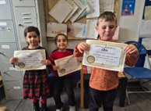
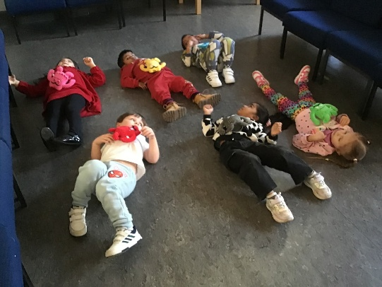

Family Cooking Classes
The nursery offers family cooking sessions focused on preparing healthy, low-cost meals, including vegetable soup, pasta dishes, and homemade pizzas. Families are actively involved in selecting recipes, promoting ownership and engagement.
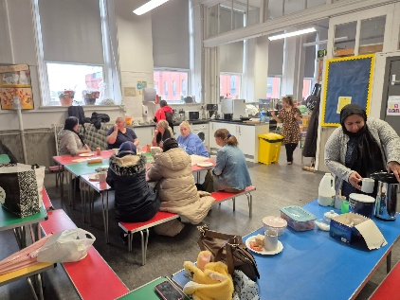
Regular tasting sessions provide opportunities for families to share meals they have prepared at home, exchange ideas, and build confidence in healthy cooking. A future development will see families collaborate to produce a community cookbook featuring recipes and ideas gathered through the programme.


Community Tai Chi and Wellbeing Opportunities
The nursery actively promotes community wellbeing initiatives, including local Tai Chi sessions held in the community garden.
Through conversations with parents, distribution of information leaflets, and promotion on the nursery’s social media platforms, families have been encouraged to participate in these sessions.
As a result, a number of parents now regularly attend the classes alongside other members of the local community. The nursery maintains strong partnerships with the community garden, providing families with opportunities to participate in planting, growing, and seasonal community events throughout the year, including Halloween celebrations and other local festivals.
Produce grown in the community garden has also been incorporated into family cooking sessions, creating meaningful links between health and wellbeing, sustainability, and community engagement.

Nursery Allotment Project
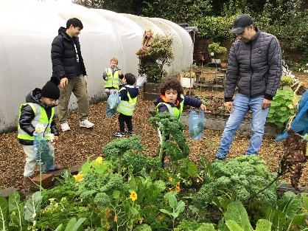
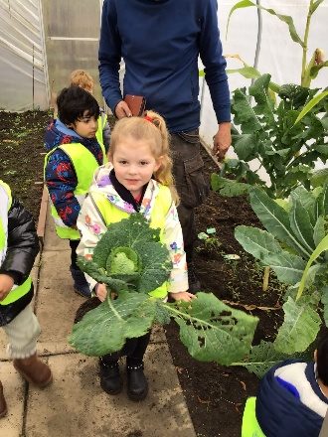
The nursery allotment provides valuable opportunities for children and families to learn about growing their own food. Working in partnership with the community garden worker, families are supported to develop skills in planting, nurturing, and harvesting a variety of vegetables.
Families are introduced to different crops and are often provided with seeds and plants to grow at home. This encourages continued learning beyond the nursery environment and enables families to enjoy healthy, home-grown produce in their own meals. The project supports children's understanding of sustainability, healthy lifestyles, and environmental responsibility.

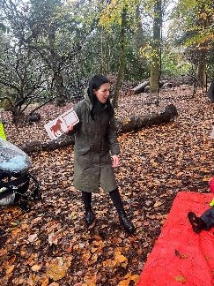
Extended Learning and Family Engagement Events

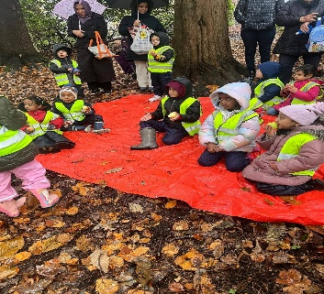
Families benefit from a range of extended learning opportunities designed to strengthen home learning experiences. One example involved the story The Very Busy Spider, which was used as the focus for literacy-based family learning. Story bags containing books and related resources were loaned to families to encourage shared reading at home.
This learning was further enhanced through family visits to a local park, where children and parents participated in activities linked to the story, including bug hunts, songs, rhymes, and parachute games. These experiences helped reinforce literacy skills while promoting family engagement and enjoyment.

Celebrating and Recognising Achievement
The nursery recently hosted a joint Eid and Easter celebration, bringing together families from a wide range of cultural and ethnic backgrounds. The event promoted inclusion, community cohesion, and mutual understanding while celebrating the diversity of the nursery community.
This event complemented the annual Spring Tea, where children perform for their families and showcase their learning. These celebrations provide valuable opportunities for parents to engage with the nursery, learn about their children’s achievements, and strengthen relationships within the wider community.
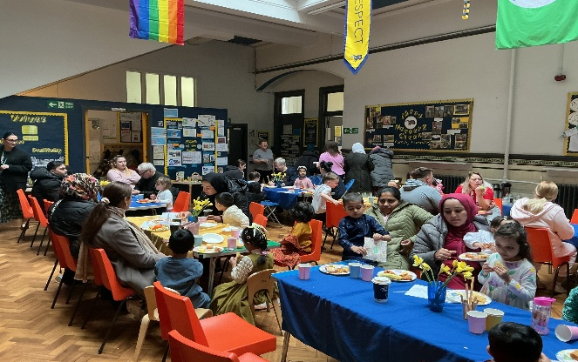

Obstacles and Issues What obstacles or difficulties, if any, did you have to overcome?

Obstacles and Challenges

Several challenges can impact the successful delivery of family learning programmes. Limited funding can restrict access to the resources and equipment needed to provide engaging and effective learning opportunities. Staff often face time pressures when planning, organising, and delivering family learning activities, as well as meeting monitoring and reporting requirements for funders. Staffing levels can also be affected by illness or absence, reducing capacity and sometimes impacting the consistency, quality, and regularity of family learning provision.

Results and Impact Outline the results of the actions taken. What impact and positive changes occurred (include impacts on parents, children and staff), were there any unforeseen benefits?
- Strengthened family engagement and involvement in children’s learning.
- Helps children come to nursery ready to learn and participate.
- Improves children’s learning, curiosity, and independence, encouraging them to take ownership of their learning.
- Builds staff confidence in supporting child-led learning approaches.
- Encourages creative practice among staff, contributing to ongoing professional development.
- Embeds a positive culture of family engagement across the nursery, with staff confident in delivering and promoting the benefits of family learning.
- Creates stronger partnerships between families and nursery staff, leading to better outcomes for children.

Next Steps Briefly describe the future of the project or related initiatives. For example, how you intend to maintain the momentum of the action you have taken so far, how you will monitor the success of your actions, or how you intend to build on/create new initiatives.
- Continuing family cooking class
- Produce a healthy cooking cook book that families make with their own recipes
- During enrolment and induction days, fully promoting oral health

What Parents Said:
💬 "I learned new ways to support my child's language at home."
💬 "The nursery activities gave us lots of ideas for learning through play."
💬 "I feel more confident helping my child with early maths skills."
💬 "We now read together every day and talk more about stories."
💬 "The workshops helped me understand how my child learns best."
💬 "I enjoyed learning alongside my child and seeing their confidence grow."
💬 "The family learning sessions gave me practical ideas I could use at home."
💬 "I have learned how everyday activities can support my child's development."
💬 "Taking part in nursery events helped me feel more involved in my child's learning."
💬 "I now understand the importance of play in my child's learning journey."
💬 "The support from nursery has helped me build my own skills and confidence."
💬 "I enjoyed meeting other parents and sharing ideas."
💬 "The activities helped us spend quality time learning together."
💬 "I can see how much progress my child has made since we started joining in."
💬 "The nursery has helped me feel more confident supporting learning at home."
💬 "We loved trying the home learning activities together."
💬 "I learned simple ways to encourage my child's communication and language skills."
💬 "Being involved has strengthened my relationship with my child."
💬 "The sessions were welcoming, friendly and easy to take part in."
💬 "I feel proud of the new skills both my child and I have developed.”

