
 |  | 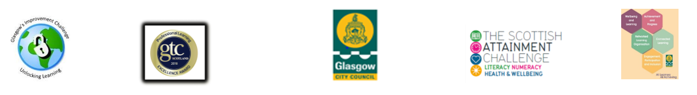
Q.I. 2.5 Family Learning Guidance for Best Practice

Q.I Question | Answer | Evidence
What data/method is being used to identify family learning need across the school? | Combination of schools data, community profiles and consultation with parents/families  % FSM | - School Data  - Parental Consultation
Are family learning programmes universal or targeted and why? | Universal to introduce Family Learning to all P1 families.  Some programmes are targeted at specific families where there is known need | - Programme overview  - Family Learning Action Plan  - School data sets
How are barriers to participation in family learning programmes reduced? | Parents are consulted around best days/times for families to attend.  Evening provision for working families  Resources being sent home when parents can’t attend  Child Care is provided.  Soft touch engagement e.g. schools gates, phone calls, texts. 1:1 meetings, support worker, home visits  Activities and programmes are free and all resources are provided  Additional support needs are considered and provided for (physical disability/mental ill health)  Translators provided | - Parental Consultation  - Resources for home use  - Child Care Agreement / Invoice etc.  - Family Learning Action Plan  - Programme feedback/evaluation  - Feedback from support staff.  - Family Learning Action Plan.
How are the family learning programmes minimising the effects of poverty? | Families are learning about financial capability and financial inclusion via information workshops  Families are reducing financial hardship by knowledge of how to access benefits.  Some programmes are providing Improved employability skills and some families are securing employment or doing better in the workplace  Food and refreshments are provided free to families participating in family learning  Free cultural and leisure activities are leading to social inclusion and wider experiences for families in financial hardship  Families are learning how to cook and prepare healthy food on a budget which is impacting health and wellbeing  Some parents are developing skills, knowledge and confidence to support their children’s learning and development which is leading to an improved home learning environment and parents’ self efficacy in supporting their children.  Some families are being linked into free community initiatives and services, strengthening family bonding and quality time together | - Partnership agreement  - Programme Overview  - Programme feedback  - Family Learning Action Plan  - Programme feedback  - Programme overview  - Programme feedback  - Programme overview  - Observation  - Case studies  - Learner progression  - Programme feedback  - Take home resources  - Programme overview  - Programme feedback  - Observations  - Case studies
How are families involved in the planning, design and delivery of their learning and progression? | Families are consulted on their learning needs and help to shape their learning in discussion and using learning logs and learning plans | - Learning plans/logs  - Parent questionnaires  - Focus Groups
How are the family learning programmes reviewed and evaluated? | Mid and end evaluations are used to take feedback about what families are learning and how the learning is impacting the family | - Pre, post and mid-point feedback.  - Direct observations  - Learning plans/logs  - Attendance/Retention rates.
How are next steps/continued support planned with the families? | There is ongoing consultation with families  Families are sign posted to other programmes, partners’ programmes and community initiatives | - Learner consultations  - Learning plans/logs  - Partner agency programmes and feedback on uptake  - Feedback from families  - Focus groups
What partnerships and collaborations are supporting family learning programmes? | Save the Children  NHS – Health Improvement Team  Glasgow Life Staff - Communities/Learning/  Museums etc.  Police Scotland  Fire Services  J&BG  Science Centre  Colleges | - Partnership Agreements  - Emails  - Minutes of meetings  - Family Learning Action Plan  - Partner Programme Overview and Partner Feedback  - All stakeholder feedback
How are you measuring the quality of family learning programmes? | Peer evaluation  External evaluation – e.g. for evidence based programmes | - Observations  - Feedback  - Learning plans/logs  - Session plans
How are family learning programmes being celebrated? | Celebration events  Certificate presentations | - Photographs  - Certificates
How are family learning programmes being sustained? | Partnerships  Volunteering  Funding bids  PEF  Capacity building of staff | - Volunteering framework/roles/remits  - Funding applications  - CPD programme overview

