

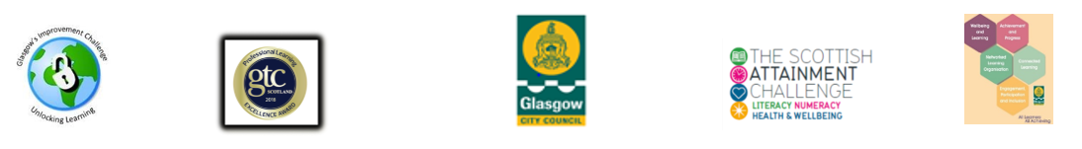
Embedding Family Learning Case Study

Name of establishment
Case Study Written By
Name and Job Title
Date Completed
Setting the Scene
Brief description of your establishment
Action/Approach Taken
Detail the actions taken in order to develop and embed family learning into your establishment. What was done and how? What staff and partners were involved? What were the costs and timescales?
New developments
What new projects or initiative did you establish?
Obstacles and Issues What obstacles or difficulties, if any, did you have to overcome?
Results and Impact Outline the results of the actions taken. What impact and positive changes occurred (include impacts on parents, children and staff), were there any unforeseen benefits?
Lessons Learned What are the key learning points? What worked particularly well? What would you do differently next time? What advice and recommendations would you give to other people dealing with a similar situation?
Next Steps Briefly describe the future of the project or related initiatives. For example, how you intend to maintain the momentum of the action you have taken so far, how you will monitor the success of your actions, or how you intend to build on/create new initiatives.
Any Other Information Detail here any further information you would like to include in your case study, e.g. photos, impact statements, suggestions for further reading

