
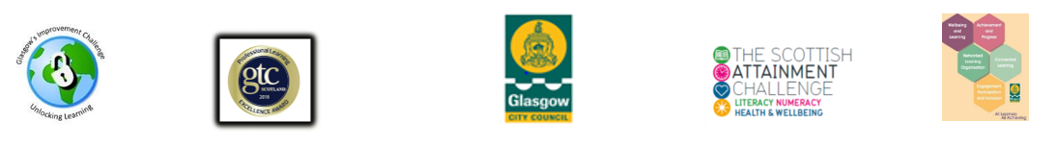

Template for Case Studies

Case Studies should be around 200 words in length.
Guidance Notes:
- This could relate to an individual, group or to a specific event, activity and/or programme. Your case study should best reflect the impact of your services / activities on an individual, group or a neighbourhood.
- Your case studies should address each of the six components below.
- Where appropriate, provide photos or examples of resources, e.g. CDs and DVDs. Include confirmation that permission has been given by individuals to include names and/or photographs.
1. Background Information on Individual or Group

2. Reasons for Seeking Services / Learning

3. Finding Out About and Accessing Services / Learning (include a very brief description referral and placement process if appropriate)

4. Form or type of Service / Learning (This should be brief but contain sufficient detail to give a sense of the service / learning (e.g. the length of provision, how often the individual/group comes and for how long, whether it’s individual, group or a range of services.)

5. Individual / Group Impressions of Services / Learning (Direct quotes or indirect statements work well. Staff’s impressions can be included but case studies with individual/group impressions are much stronger.)

6. Impact of Service / Learning (How is the service / learning impacting on the individual or group’s personal, family, community, working or cultural life. Is it impacting their physical health, mental wellbeing or financial circumstance?)

7. Permissions
Have you gained permission to use the name(s) of the individual(s) featured in this case study if names have not been changed? YES / NO

Have you gained permission to use photos/video of the individual(s) featured in this case study? YES / NO

N.B. Organisations should ensure that appropriate permission forms have been completed if names and/or images are being used.

