
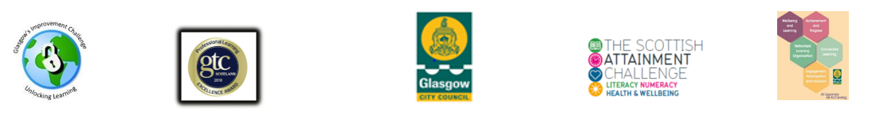

ESOL for Parents at Saint Roch’s Primary, Individual Case Study

- Background Information on Individual or Group

Suganthy is from Sri Lanka and is Mum to one child at Saint Roch’s in Primary 5/6.

- Reasons for Seeking Services / Learning
‘I wanted to speak more English. I don’t speak it enough and I don’t have time for other classes’.

- Finding Out About and Accessing Services / Learning

‘My son gave me a leaflet from school. He said I must go! I felt happy because the time is good for me, I come after my morning work cleaning at a secondary school’

- Form or type of Service / Learning
The ESOL Group is delivered in partnership with the North Glasgow Integration Network and meets in the school every Wednesday morning at school drop off time. The group targets parents/carers from the school, however other community members are welcome. This supports the group’s aims of increasing parent’s confidence in everyday transactions with the school and beyond, and building school/community links.

- Individual / Group Impressions of Services / Learning
‘ The English Class has helped me improve. I feel happy because when I go home it’s all cooking and cleaning. I always think about the class and want it to come because it’s a change for me. It’s very friendly, we talk and eat and learn together’.

- Impact of Service / Learning (How is the service / learning impacting on the individual or group’s personal, family, community, working or cultural life. Is it impacting their physical health, mental wellbeing or financial circumstance?)

‘It helps me feel better. At work I feel shy so I don’t speak much English but here I don’t feel shy. It has also helped me with filling in forms and getting information about my son’s school’.

7. Permissions
Have you gained permission to use the name(s) of the individual(s) featured in this case study if names have not been changed? YES

Have you gained permission to use photos/video of the individual(s) featured in this case study? NO

