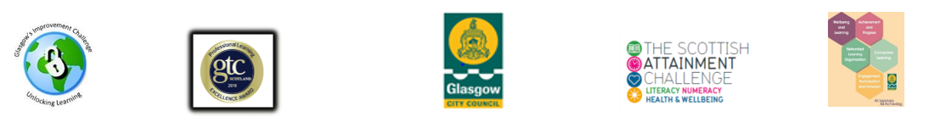


Family Learning Sign In Form

Group Name: ______________ Staff Name (s): ___________________ Date: _______

Parent/Carer Name | Your children’s name(s) | Your children’s class(s) | I agree to be responsible for my children (Please tick)
1.
2.

3.

4.

5.

6.
7.
8.
9.
10.

