
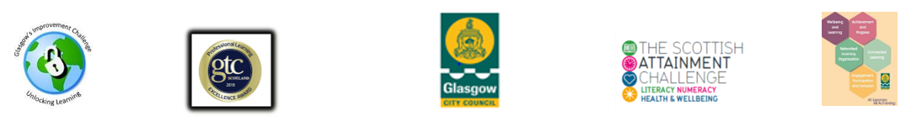

Group or Individual Learning Log/Evaluation Pro Forma

Name/Group Name: |  | Date:
Place / Time of Programme:
Facilitator:

What is your reason for coming to the family learning sessions?

What do you want to be able to do, at home, in your child’s school, at work, at college, in your community?

Week 1 – Work covered. What have I learned?

Week 2 – Work covered. What have I learned?

Week 3 – Work covered. What have I learned?

Week 4 – Work covered. What have I learned?

MID POINT REVIEW

What was your goal?

What have you worked on?

What have you learned?

Week 5 – Work covered. What have I learned?

Week 6 – Work covered. What have I learned?

Week 7 – Work covered. What have I learned?

Week 8 – Work covered. What have I learned?
Did you reach your learning goal(s)?

What did you enjoy?

What did you not enjoy?

What was a good way of learning for you?

How do you know you can do it?

Please tell us in what way you will now be more able or confident to support your child’s learning?

What other opportunities or programmes would you like to see running in school to support your family?

What would you like to do next in school, at home or in your community?

