**What is Family Learning?**

A fact sheet for parents/carers written by the

Glasgow Life Family Learning Team.

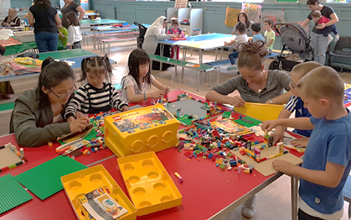 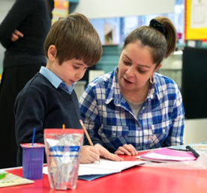 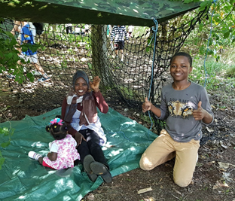

Did you know………

Children in Scotland spend approximately only 15% of their waking hours in school. The remaining 85% of children's time is spent at home or in their communities. This means that YOU have an important role to play in your child’s education, and family learning aims to help you with this.

Family Learning is about family members learning together, and may include reading, writing, numbers, money and health and wellbeing. It can also mean supporting parents on their own to learn how to support their children’s learning.

Learning together as a family is a good way to support your child’s learning in a fun, informal way.

For some adults family learning can be the first step to taking up further learning and training, opportunities, gaining a job or developing new skills.

Ask in your child’s nursery or school about Family Learning opportunities.

There are also many other services where family learning may be taking place such as your local library, community centre or museum and sports centre.