
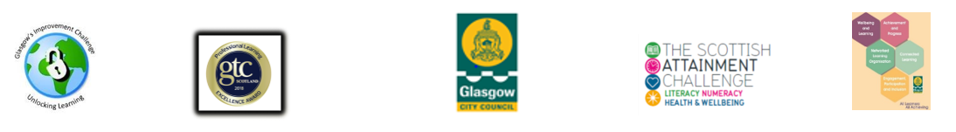
Q.I. 2.5 Family Learning Guidance for Best Practice

Q.I Question | Answer | Evidence
What data/method is being used to identify family learning need across the school?
Are family learning programmes universal or targeted and why?
How are barriers to participation in family learning programmes reduced?
How are the family learning programmes minimising the effects of poverty?

How are families involved in the planning, design and delivery of their learning and progression?
How are the family learning programmes reviewed and evaluated? |  | .
How are next steps/continued support planned with the families?
What partnerships and collaborations are supporting family learning programmes?
How are you measuring the quality of family learning programmes?
How are family learning programmes being celebrated?
How are family learning programmes being sustained?

