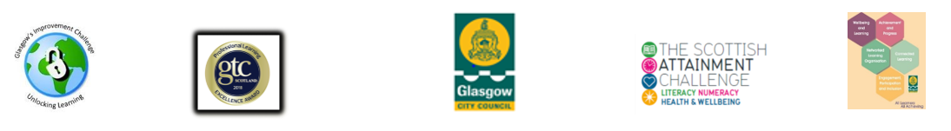

AN Other School
Exemplar Action Plan

Item | Family Learning Programme or Input | Target Families | Start Date and Duration | Planned Family Engagement with Timescales | Programme Delivered by | Inputs | Outputs | Outcomes | Evidence of Intervention and Impact
1 | Families Connect | Primary 1 Universal and SIMD 1 and 2 specific | 22 October 2019  8 weeks | August,  September and October 2019  Meet the teacher  Flyers at school gates  Parents’ night promotion  Coffee mornings  Word of mouth/parent advocates  Website and social media  Telephone calls and reminder texts  Families Connect display | Nurture Teacher  Principal Teacher  (both Families Connect trained) | 2 staff  2 day FC training for staff  Venue  Activity/Resources  Take home resources  Food and refreshments  Creche  Ongoing preparation time  Promotion and engagement time ongoing  Monitoring and evaluation | 10 parents engaged in evidence based FL programme  10 parents successfully completed Families Connect | Parents learn tools and techniques using play and games to support their children’s learning and are more confident to support their child via praise, talking and listening, encouraging and engaging in literacy and numeracy  Children enjoy learning via play and games with their parents  Learning is extended into the home environment  Families build relationship with school staff and more confident to engage with school.  Parents consulted on next steps/progression for continued learning | Save the Children M&E  Feedback from parents  Teacher feedback on focus child  Children’s feedback  Direct Observation of Families Connect facilitators
2 | Homework Club | Whole School | Tuesdays throughout the school year | Meet the Teacher  Parents Nights  School gates  Word of Mouth/parent advocates  Flyers/posters  Website and social media  Phone calls and texts  Coffee/tea/chat sessions | Principal Teacher  CLOLs | Homework activities  Educational Board Games  Books for reading and taking home  FL lead in school and CLOLs  Refreshments / food | 30 families are welcomed into school  30 children are provided with a hot snack  30 families take part in educational activities with their children  30 families are supported with children’s homework  30 families are given top up homework activities to extend the learning into the home environment | Parents are supported with children’s homework and become more confident to support their children’s learning and development  Children complete their homework  A neutral, stress free environment for homework is provided  Parents have 1:1 time with their child without distractions, in a supportive environment with help at hand | Register of attendance/sign in sheet  Completed class homework  Feedback from parents  Feedback from class teachers  Feedback from children  Direct observation and feedback of Homework Club staff

