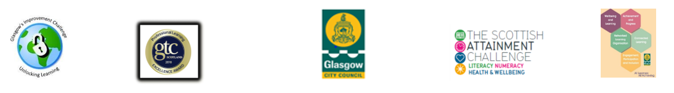

Family Learning Planning, Monitoring, Evaluating and Evidence Gathering Pack

Contents

Pro Forma | Use of Pro Forma
Family Learning Action Plan | A working/live document to plan your school’s family learning across each academic year. Can be used to plan in-house and with partner agencies  Can be continually updated and can be used to inform the family learning component of your EPR
Guidance Notes for Best Practice in Family Learning | A checklist of reflection questions to ask yourself and to promote thinking about best practice in family learning/HGIOS 2.5 indicator
Family Learning Postcard | A descriptor of what family learning is and means and links about where to find out further information and toolkits to support your family learning work
Family Learning Factsheet | Some basic facts for parents/carers about the importance of family learning and why parents/carers have a role to play as partners in their children’s learning and development
Learner Questionnaire | A questionnaire that can be used to consult with parents/carers to identify their needs and wants around family learning
Baseline Questionnaire | A questionnaire to identify the reasons parents might have for attending a family learning programme. This can be used at the beginning and the end of the programme, either as a group or individually, to gauge overall outcomes
Learning Log and End Evaluation | A document that can be used to support parents/carers to plan, shape, evaluate and reflect on their learning. Can be used as an individual learner log or a group learning log. The learning might be supporting parent/carer life/employment skills as an adult in their own right (for example ESOL, ICT) or may be used to record skills being learned that will provide parent/carer with self-efficacy in supporting their child’s learning and development (for example Family Literacy or Numeracy, Homework Club, Read Write Count)
Example Parent Evaluation | A document that was successfully used with Bookbug to evidence parent learning and home activities engaged in as a family. This document and the questions can be adapted and shaped for any programme
Session/workshop planner | A template that outlines aims, objectives and outcomes of a session being delivered to parent/carers and the steps to be taken to complete the delivery of the session
Family Learning Register | A tracking document to show participation and retention rates of parent/carers on family learning programmes and record information on any challenges that arose with participation or retention rates during the programme
Sign in Sheet | A document to record attendance at one-off workshops or family learning sessions such as coffee mornings, meet the teacher or other family learning events that do not require a full register of attendance
Case Studies – Individual and Group | A showcase to highlight and evidence the family learning approach taken and the resultant benefits, learning and outcomes for parents/carers/children who participated.
Family Learning HGIOP | A tool which supports you to focus your intended outcomes, plan your evidence gathering, and gather all your data in order to self-evaluate and reflect on your Family Learning Projects.

