**ASN Parent Support Group Case Study**

|  |  |
| --- | --- |
| Establishment: | St Albert’s Primary School |
| Group Facilitator: | Kirstine Creevy |
| Case Study Date: | 2025/26 |
| No of Parents/Carers: | Ranges between 4-15 participants depending on the month. |

|  |
| --- |
| Group Background (Reason for group/access to group/how long group has been established) |
| St Albert’s Primary School is a mainstream school located in Pollokshields, we are also home to a collocated provision for children with additional learning needs. Families, enrolled in our mainstream school and provision shared with us a feeling of being ‘abandoned’ by health services following a diagnosis of a lifelong health condition or additional need. This was especially apparent when the child was given an alternative educational pathway and assumptions were made around Education picking up the ongoing, consistent family support. Working within a community context that is culturally diverse brought with it unique challenges and compounding barriers faced by our families we had a desire to understand and further support. Shame and stigma around additional support needs is something we have challenged through a dedicated commitment to awareness raising and family learning.  Families needed a space and place to connect with each other, develop a strong ‘village’ and community of support from others who could empathise and understand their parenting experience. This was in 2015, our parent support group has been active for ten years.  Currently, we meet on the first Friday of each month in Urban Community Project, 57 Glenapp Street, Pollokshields. The location has changed multiple times between cafes and community spaces, with private space for families to communicate and chat informally whilst also receiving some care and nurture in the form of a nice coffee or home baking. The spaces also needed to accommodate presentations for guest speakers and professionals who would join the group to share information around supporting the children they cared for.  The topic and focus of the guest speakers of each session is designed by the facilitator in response to the themes presenting within the informal chats, and conversation with families. My knowledge and understanding of the families we support is an integral part of identifying appropriate key speakers. I rely heavily on third sector organisations and my professional peers to enhance and support this work. |

|  |
| --- |
| Parent/Carers (who attends and why) |
| Families from St Albert’s School community are always invited to attend the monthly sessions.  I highlight this support group as regularly as possible during between school collaboration events or through the connections I make through the outreach service (CARRIS).  Parents take a responsibility for sharing the flyer on social media and amongst themselves when supporting a family they come across who might benefit from such a group.  We proactively promote and encourage anyone in the Southside or wider Glasgow area to attend our family support group sessions, to be inclusive, consistent and to ensure an equitable experience for all families. |

|  |
| --- |
| Format of a Typical Session |
| Each monthly session takes place over a two hour period.  The first hour is usually introductions, if participants are new I would encourage a ‘name game’ or short ‘getting to know you’ activity. I ensure everyone is offered a hot or cold drink and we ensure to have some food, baking or snacks available.  The second hour is usually an input from an invited service, organisation or professional. The topics covered have included, welfare rights, sleep, sensory needs, behaviour, communication and augmentative and alternative communication (AAC) including intensive interaction.  This is followed by a summary of the content of the session being shared with the participants via a communication network to ensure everyone has access to the information shared, even if unable to attend the session.  I debrief following sessions with members of the senior management team within my own school setting to ensure supervision, support and information sharing following each session. This is an essential part of the emotional wellbeing work we do to ensure the facilitator is well supported as, sometimes, the topic and themes of the groups can be quite emotionally immotive. |

|  |
| --- |
| Impacts on Parent/Carers (how have parents/carers benefitted from attending the group) |
| “*The group has a warm, positive and welcoming vibe, and I always come away feeling more upbeat. It is so beneficial to meet and share experiences with other parents/carers in a similar position to me. I don’t feel so alone and it helps to put things into perspective. Sometimes I have planned things I want to bring up and ask for support with, and other times I pick up useful tops and hacks that I didn’t even know I needed.”-* Maeve (Parent)  *“Being part of the parent carer support group has been transformative for me as a parent of a child with additional support needs (ASN). The group has provided a safe space where I can share my experiences, challenges, and triumphs without fear of judgment.The emotional support and practical advice from other parents who truly understand my journey have been invaluable. I've gained new strategies for managing daily routines and advocating for my child's needs, which has significantly reduced my stress and feelings of isolation. The sense of community and belonging has empowered me to be a more confident and resilient parent, knowing that I am not alone in this journey. Additionally, the support and knowledge I've gained have enabled me to extend my help to the wider community, offering guidance and encouragement to other families facing similar challenges.This group's ability to empower parents, foster resilience, and create a ripple effect of positive change within the wider community is invaluable”.* Lesley (Parent)  *“I have been very fortunate to have heard of this group.  I've attended the group on a regular basis. It provides a mix of valuable insight and relevant information, both from Kristine and from the guest speakers that she has arranged to attend the sessions.*  *The group format also has the benefit of acting as a support or counselling session to those that may be struggling or require support from people who have had similar experiences.*  *Another benefit of the group is that it is a forum for the parents to share and receive tips and strategies that have worked for other parents."* Fiona (Parent)  *“The parent support group has been essentially the biggest highlight in making more friends and supportive links within a world that can feel very exasperating when having children with disabilities. With so many systems under so much pressure and diagnosis and support teams being unreachable with such long waiting lists, this group of people and Kirstine who makes it all happen has really given me so much hope and support, without it I’d feel so desperately lost and alone.*  *This week I am getting help from an advocate charity, and I would hone never heard of them if it wasn’t for input they contributed at the parent group. Without this group I wouldn’t have a community network of parents able to advise and help all round the clock. Sometimes even just meeting someone new and hearing their experience and offering help or a shoulder to cry on can feel really powerful too. It’s a really amazing feeling going and having a tea and some biscuits and letting out some stresses to a group. Talking to others is essential when you’re in a place that is so lonely.*  *I can see how it’s helped a lot of Parents and I’m sure so many more will continue to feel supported, I genuinely feel this group is so positive and I hope so many more get to experience what this community has done for me my family and now some of my new friends and their kids”.* Terri (Parent) |

|  |
| --- |
| Any Information/Advice that could be Shared with Other Parents/Carers who Require Support |
| Flyer attached below (see appendix 1). |

|  |
| --- |
| What’s Next for Parents/Carers/Group (staffing, planning time/delivery time/budget) |
| Continue to roll out the model next academic school year and ensure adequate promotion of the service relying on professional communication networks to promote the service to ensure families who would benefit from such work are able to access it. Ensure sustainability of staff equipped to develop and continue this work long term, including myself.  Continue to support other schools developing their own family support networks as well as developing our own. This ensures individual school communities are supported in having the opportunity to develop their own ‘villages’ of support within their own unique community context. I would like to create a professional network to support the practitioners facilitating these groups.  A branch of the family support group has been developing the training, ‘The Impact of Caring’ an insight into the parenting experience when caring for a child with additional needs. We would like to continue to deliver this regularly to other professionals, our day training and twilight sessions are on the NHS training calendar and are accessible to a variety of professionals including health and third sector organisations. These have been well attended, and the feedback is strong. Continue to roll out Insert flyer for Impact of Caring training (see appendix 2).  Apply to Community Partnership Fund and Postcode Lottery for a small grant to cover the costs of refreshments and hire of venue. |

|  |
| --- |
| Information on Agencies/Partners who have Supported Parents/Carers/Group |
| *Health & Social Care Partnership- Support Services for Families* acts as a directory of organisations I can reference and contact. I also collaborate with Kirkriggs Primary School and a practitioner there who has developed a similar resource for families within their school context.  Some organisations who have visited and presented recently are listed below;  Sense Scotland  Glasgow Centre for Inclusive Living  Voiceability  Differabled  Scottish Autistic Consultants  Carers Partnership  Cross Reach  Money Matters  Sleep Scotland  Lifelink |

|  |
| --- |
| Resources Required to Support the Group |
| A safe and accessible venue.  Funding to cover cost of venue hire and refreshments.  Referrals and promotion of the flyer so parents are aware of the supports available. |

|  |
| --- |
| Additional Information |
| To receive more information on the work detailed in this case study, please reach out to Kirstine Creevy, Principal Teacher at St Albert’s Primary School.  gw16creevykirstine@glow.ea.glasgow.sch.uk |

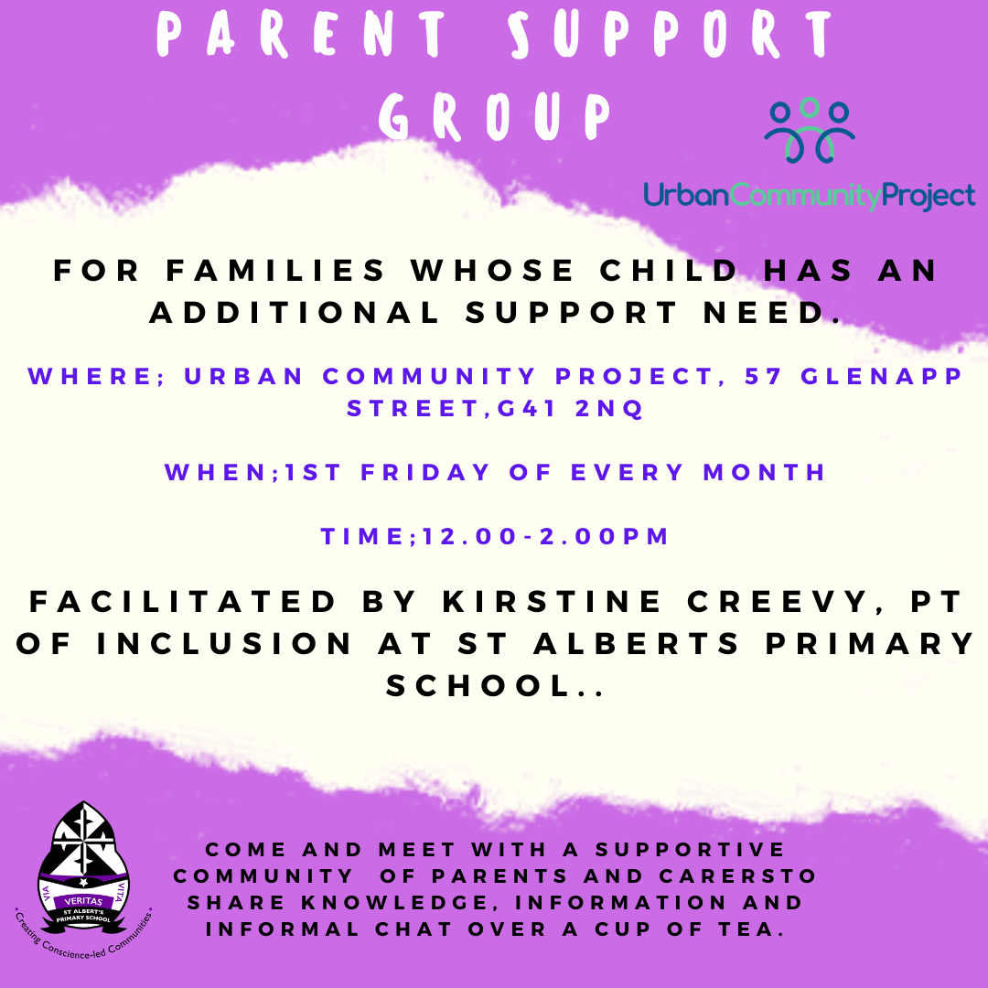

Appendix 1

Appendix 2