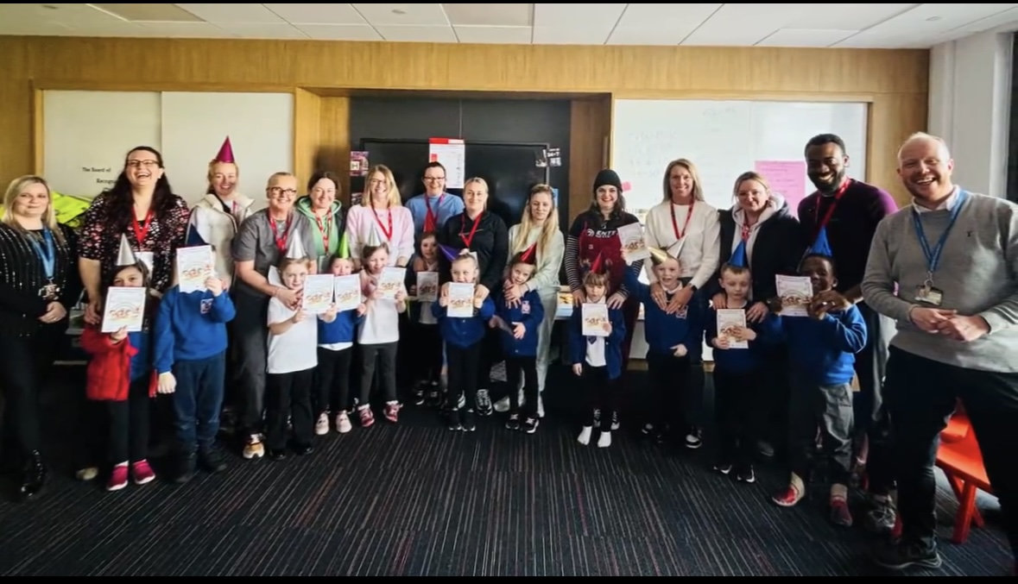

Why Families Connect?

- To increase family learning opportunities: there were already opportunities for parents/carers to become involved in the life of the school, including our weekly “Blairdardie Blether”, and for adult learning (in partnership with Glasgow Clyde College). Including through discussions with our Family Learning Officer, we identified a need to increase opportunities for family learning, deepening parental/carer engagement,
- We knew that Families Connect is an evidence-based family learning programme with proven impact in Glasgow City Council schools and beyond, and
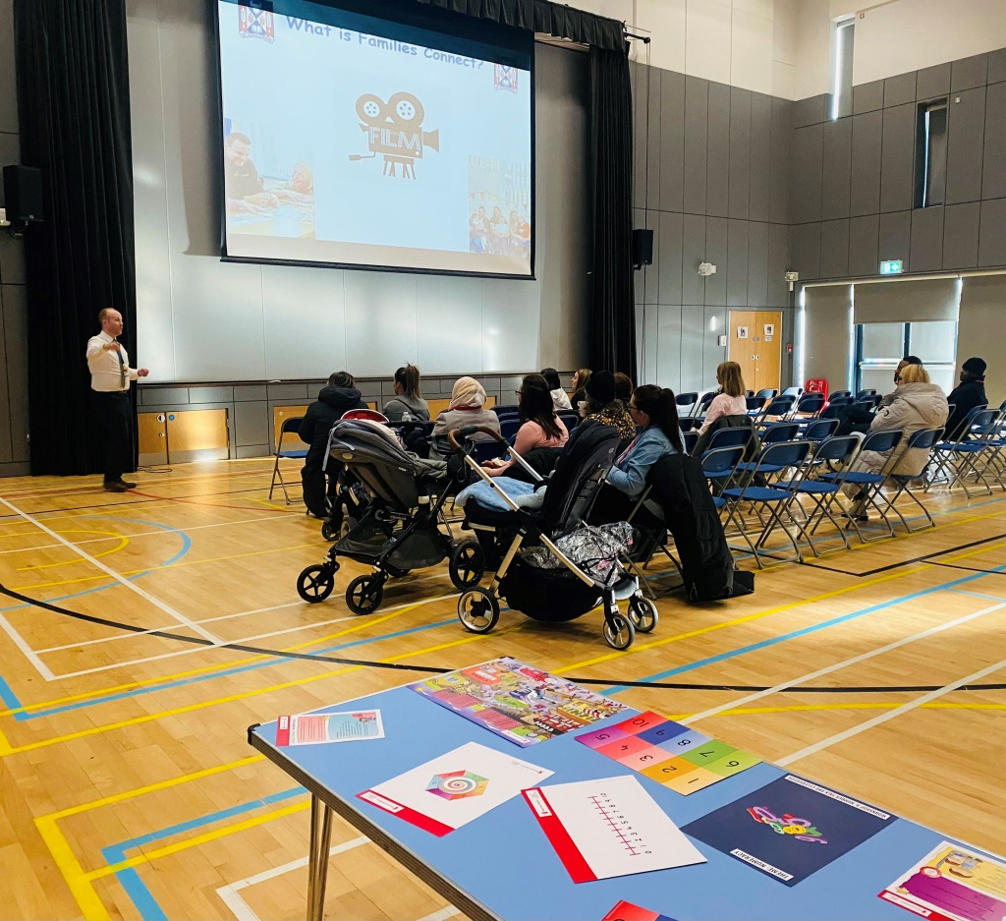
- An alignment between the intended outcomes of Families Connect for children, parents/carers, and settings as well as our own priorities: this includes improving learning and development outcomes for children, improving parental engagement in their child’s learning, improving partnerships between settings and parents/carers, as well as improving two-way communication with parents/carers about their child’s learning.

How did we deliver Families Connect?
- Our Lead Facilitator was our Acting Principal Teacher, Mr McKelvie, and our Co-Facilitator was Mrs Cameron-Lunn, Support for Learning Worker.
- The Launch, January 2024: we launched our upcoming Families Connect with pizza, a short presentation, and an extended chance for parents/carers to have a peek at the programme’s weekly resources and speak with the facilitators.
- Every Friday afternoon: we identified that this suited most parents/carers, and this did lead to the sustained attendance of almost all parents/carers.
- 15 parents/carers signed up at the Launch and 13 attended almost every week of the eight weeks.
- Every week had a special snack, including fruit and popcorn, with a special Pizza Party at the end to celebrate, suggested by our children and families!

The what of Families Connect?
- The eight topics of our weekly sessions were: Play, Feelings, Praise, Listening, BookTalk, StoryTelling, Counting, and Number Talk.
- In accordance with our training and the easy-to-follow programme, each session comprised: Welcome and Prepare, Reflection Time, Learning Together, Trying it out, Snack Tine, Doing it together, Review Time, and Closing Circle.

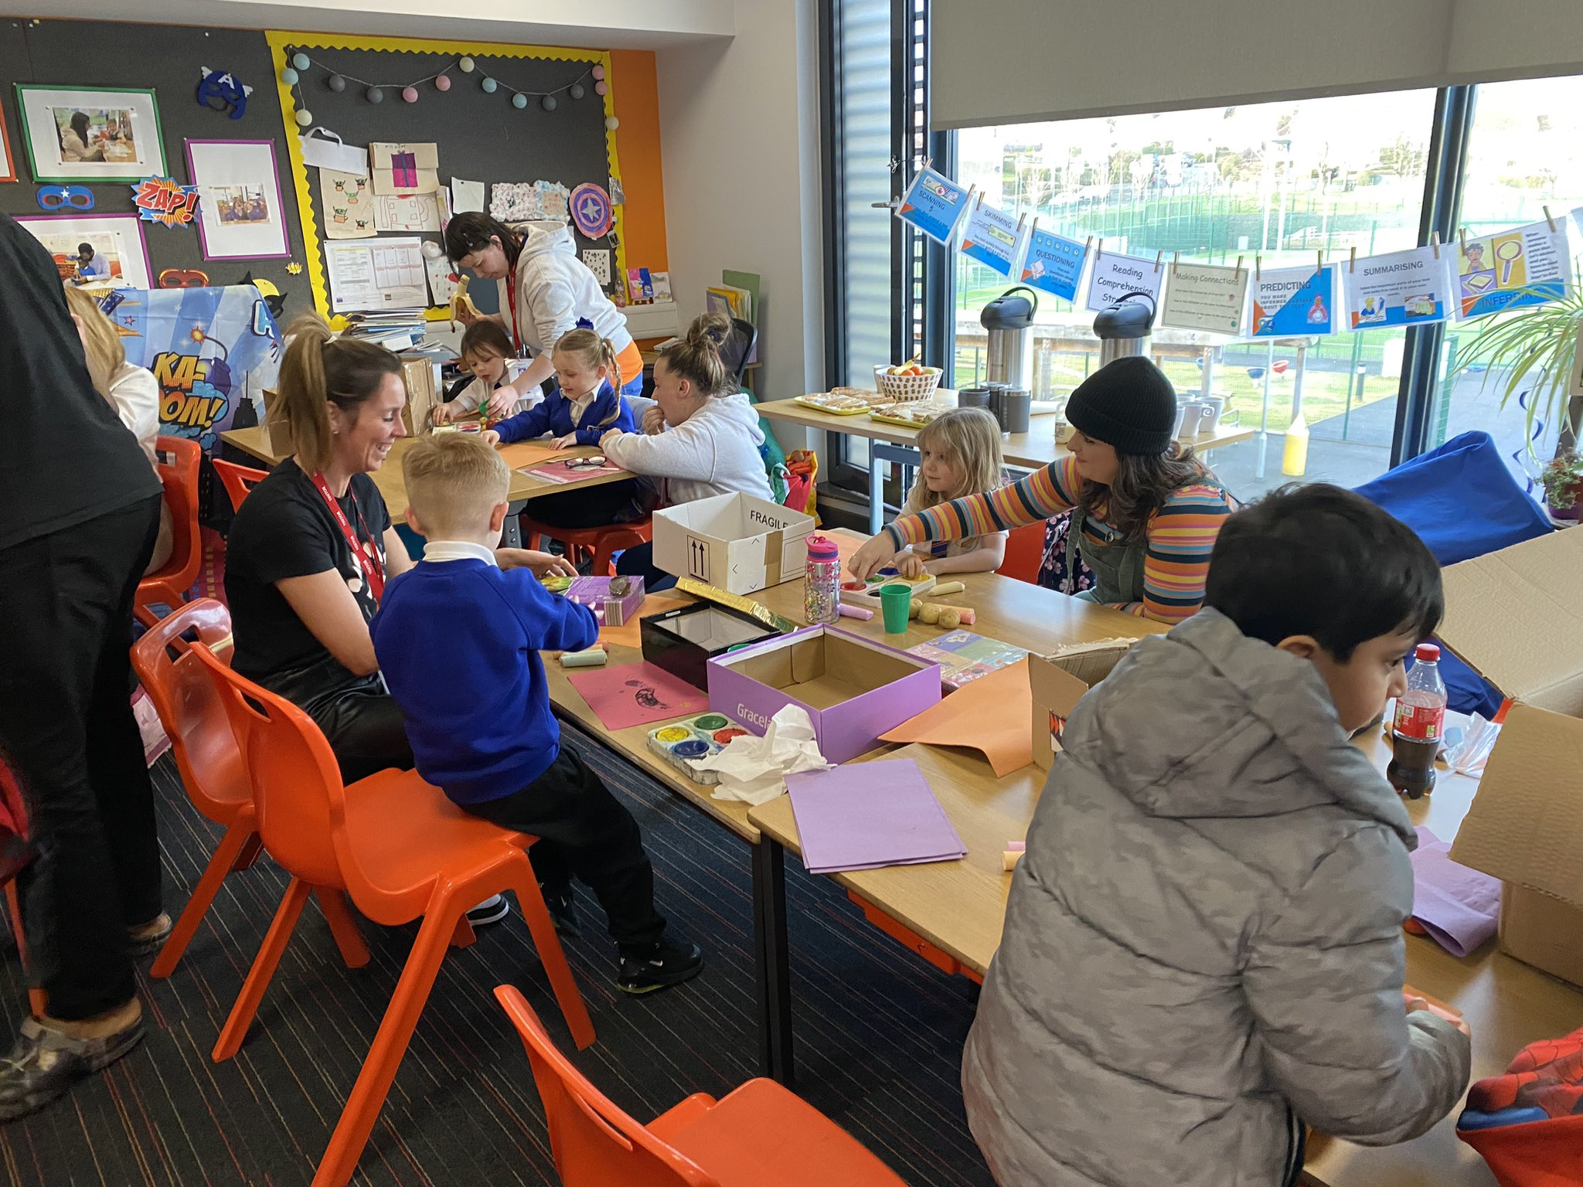
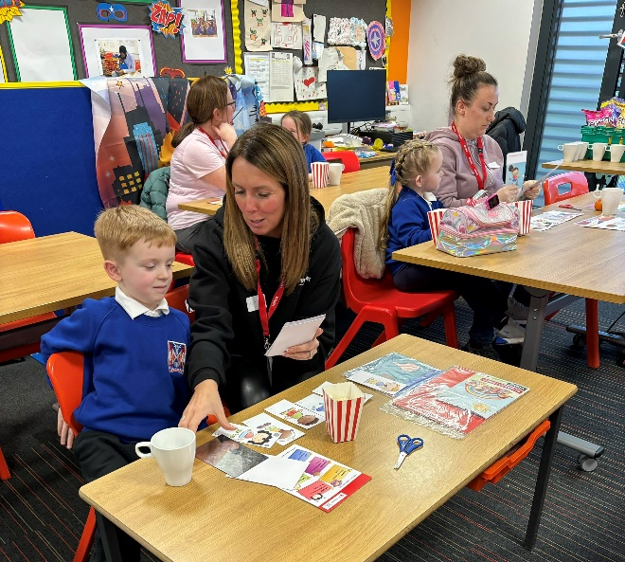
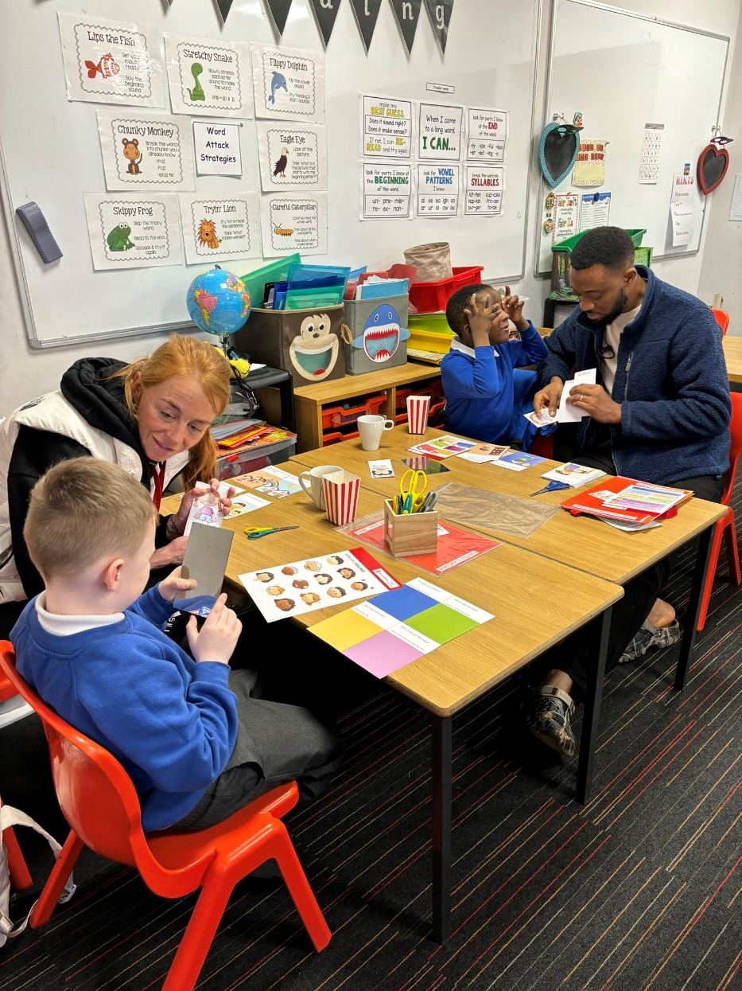
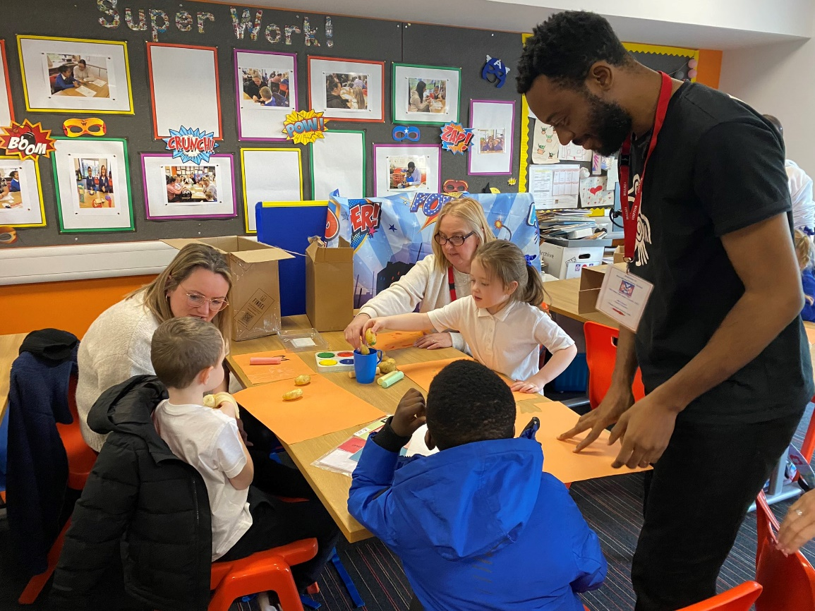

What was the impact?
- Improved outcomes for children, including improved speech, language and communication,
- Improved outcomes for parents/carers, including improved knowledge skills, and confidence in how to support their child’s learning and development at home, and
- Improved outcomes for our school, including improved parental/carer engagement.

What did parents/carers say?
We asked our parents/carers “How did our Families Connect Sessions help?” They said:
- “I will remember the advice in the praise session not to praise with a but”,
- “It helped me understanding what my child needs for learning. It also helped us as a family talk more about feelings and how to listen”;
- “My son really enjoyed me attending in school and having some fun together, then take the ideas home to use”;
- “It was helpful because it provided a great time to connect and interact with my child through fun-filled exercises. It was also great because the fun could be taken home”;
- “It helped you maybe have the knowledge and tools to help your children learn through a range of games, even I think week 5/6 the picture where you see different numbers on clay, and you don’t realise you can help them recognise or even help them count”, and
- “It helped to give new ideas of ways to communicate and learn with the children”.

We asked our parents/carers “How are you/will you continue to use the learning from Families Connect?” They said:
- “We have kept the resources given and use them at home. We use open questions regularly when speaking about our day and thoughts”,
- “We still talk about how we are feeling and as parents, we are mindful when giving praise that it’s unconditional, e.g. “You were great at football today”, but before we might have said, “You were great at football today, but you could have…”;
- “We use all the resources given to develop more at home and make it more enjoyable”;
- “…The play schedules set up during those sessions have continued. The sessions helped to develop a practice that we are keeping up with”;
- “Trying to have patience when I get asked lots of questions reading a book as I found out at Families Connect that’s a good thing. I try to break down how their day was with the little cards with different questions to ask and understand these”, and
- “The way I read stories with [my child] – now less rushed/more open to questions/imagination”.

We asked our parents/carers “What did you enjoy most about our Families Connect sessions?” They said:
- “Spending one-on-one time with [my child] and learning together”,
- “I enjoyed interacting with my child in the school building and it was a great opportunity to get to know the other parents and school staff”;
- “Spending time with [my child] in a different environment, and meeting new people and hearing their views and ideas of ways to engage with our children”;
- “Meeting other families – the atmosphere was so relaxing and listening to methods with which other families managed situations with their kids was a learning experience”;
- “Spending time with [my child], seeing her enjoy learning and joining in as she’s usually shy. It helped to get to know some other parents also. Weeks flew by sadly. Helps to engage with your child more positively and fun ways of learning”; and
- “I enjoyed meeting other parents/carers/young people sharing stories, experiences, etc.”
