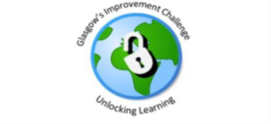

Family Counting and Cooking Project 2023
St Roch’s Childcare Centre, Royston, G21

1. Background Information on Group

Prior to undertaking this project St Roch’s Childcare had no parental engagement. This was due to previous covid restrictions that were put in place over the last few years. Staff were looking to re-engage with parents and build meaningful relationships that would benefit the children and add to raising attainment. After attending a CPD session delivered by the Family Learning Team the nursery was supported by a Family Learning Officer to apply to The Families in Partnership Fund to develop a programme of, activities, enabling them to promote positive relationships with staff, and between the parents and children.
They received £360 for a ‘Counting and Cooking’ Project via the Families in Partnership Fund, which is managed by the Family Learning Team as part of Glasgow’s Improvement Challenge.
88% of the parents participated in the first family workshop. Parents were able to understand the aim of the project and have an engaging experience with other families. During the workshop children and parents made healthy wraps and fruit kebabs. Nursery staff were able to support the families with strategies on how to work literacy and numeracy while cooking

2. Reasons for seeking or delivering services / learning (i.e. how was a need identified?)

St Roch’s Childcare is situated in the heart of Royston which has a particularly high level of children living in poverty and a very high proportion of families from an ethnic minority, many of whom were new arrivals to the city and reported feeling isolated in their community.

3. Finding Out About and Accessing Services / Learning

Parents were consulted via Facebook and at pick up and drop off times, and given 2 options to choose from. The families voted on Facebook and through a QR code using mentimeter.

Option 1 was most popular : Counting, Cooking and Connecting.
The programme consisted of 4 weeks of cooking. Each week the pre-school children took an ingredient bag and recipe card home.
To increase mathematical skills through counting and measuring the ingredients
To improve literacy through reading and interpreting the recipes

4. Form or type of Service / Learning (This should be brief but contain sufficient detail to give a sense of the service / learning

88% of children and families participated in week 1 of the project (Lentil Soup).

88% of the children and families participated in week 2 of the project (Crêpes).

76% of the children and families participated in week
3 of the project (Tomato Pasta).

65% of the children and families participated in the
week 4 of the project (Blueberry muffins).

5. Individual / Group Impressions of Services / Learning (Direct quotes or indirect statements work well. Staff’s impressions can be included but case studies with individual/group impressions are much stronger.)
Parent A:“Taught my child cooking basics”
Parent B: “My son is more confident with the numbers and letters now and he sees learning more fun. He is also more confident in the kitchen. Thank you so much that was great idea.”
Parent C: “Improved independence and patience”.
Parent D: “It was amazing idea! My boy loved it and so did the rest of the family. He is now more engaged with everyday tasks and mostly cooking. He loves to help prepare dinner and set the table… we also practice counting spelling and other fun learning activities while doing anything in the house... Either is cleaning or cooking. He learned so much from this project and I see a huge difference.”
Parent E: “Forcing me to do something interactive during the week. Normally too exhausted after a long day at work/ nursery and we save it for the weekend. Little brother very engaged and suddenly started eating carrots again after refusing them for years. They were more willing to eat something they prepared”.
Parent F: “Everything was very good”.
Parent G: “The project has improved my child counting and following the order of receipt.”
Parent H: “The project has helped me realise my son could do more than I thought helping with cooking and baking in the kitchen”.
Parent I: “Thank you and all the team for organising so many activities and the cooking is amazing kids love it... since we been having those cooking classes R and J want to help more in the kitchen while we prepare dinner. They both are really enjoying it. So, thank you. You all are amazing!!!”
Parent J: “I really liked the idea that you told us how much the ingredients cost because our shopping has increased so much recently, it was good to see that I could feed the children cheap and healthy.

6. Impact of Service / Learning (How is the service / learning impacting on the individual or group’s personal, family, community, working or cultural life. Is it impacting their physical health, mental wellbeing or financial circumstance?)

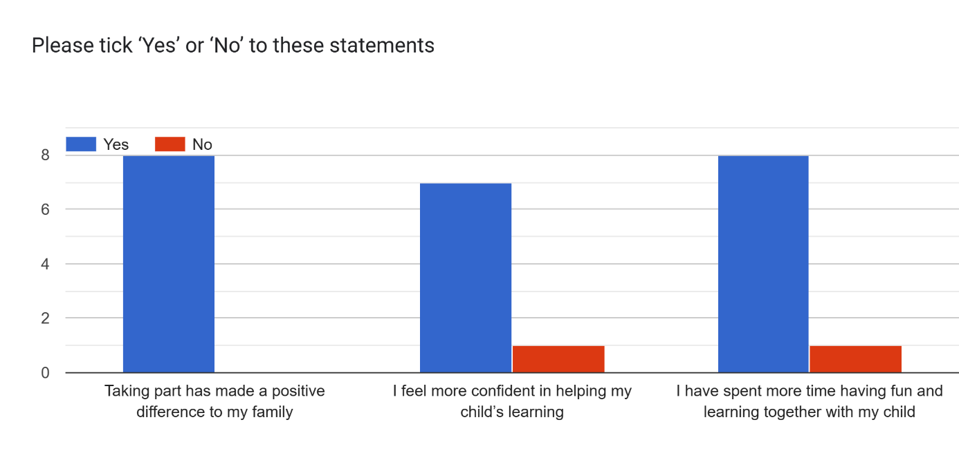

100% of the parents said yes to the statement “Taking part has made a positive difference to my family”.
90% said yes to the statement “I feel more confident in helping my child’s learning”.
90% said yes to the statement “I have spent more time having fun and learning together with my child”.

7. Permissions
Have you gained permission to use the name(s) of the individual(s) featured in this case study if names have not been changed? YES /

Have you gained permission to use photos/video of the individual(s) featured in this case study? YES /

N.B. Organisations should ensure that appropriate permission forms have been completed if names and/or images are being used.

