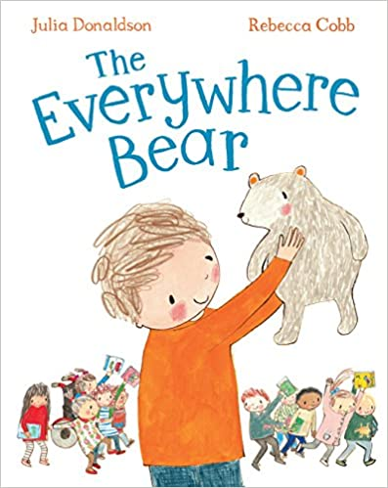

The Everywhere Bear

Families in Partnership

Primary 1 Family Learning Project Overview

‘Family Centred Transition’

**Project Aim**

* To increase levels of meaningful family engagement with targeted families around settling into primary school.

**Planned Outcomes**

* Almost all relationships between parents/carers, children and primary one staff are strengthened, thereby reinforcing family bonds and building on the home/school relationship.
* Almost all participants experience increased parental involvement in their child’s learning.
* Almost all children have opportunities to develop confidence and skills which enable them to make a positive transition into primary one.
* Most parents/carers report a better understanding of primary one learning approaches and an increased confidence in their role in supporting their child’s learning and development.
* A few parents/carers access further learning and support.

**Models of Delivery**

* **Family Learning Model Face to Face.**  Parents/carers come in for an informal session with refreshments 30 minutes before the children arrive. The children then join the group to take part in the activities with their parent/carer and any younger siblings.
* **Adapted covid model which could also be used to support working families or others who can’t attend sessions.**  Children enjoy the activities in the classroom and then they are given to parent/carer to do the activities together at home. A photo of the child doing the activity in class could also be sent via seesaw, and parents /carers can be encouraged to return photos or film. Teacher may use this method with a targeted group so that they can follow up with an agreed method of communication with the family, e.g. weekly phone call, chat at the school gates on a certain day etc.
* **Transition Visits or New P1 Family Engagement.** The programme can be used either in May as a basis for your pre-school transition visits, or in September/October as a method to build relationships with your new P1 families.

**Session One: Focussing on the Story**

**Session Two: Literacy Based Activities**

**Session Three: Numeracy Based Activities**

**Session Four: Celebration, Evaluation and Next Steps**