The Everywhere Bear Sensory Story
Page | Suggested Item | Sense
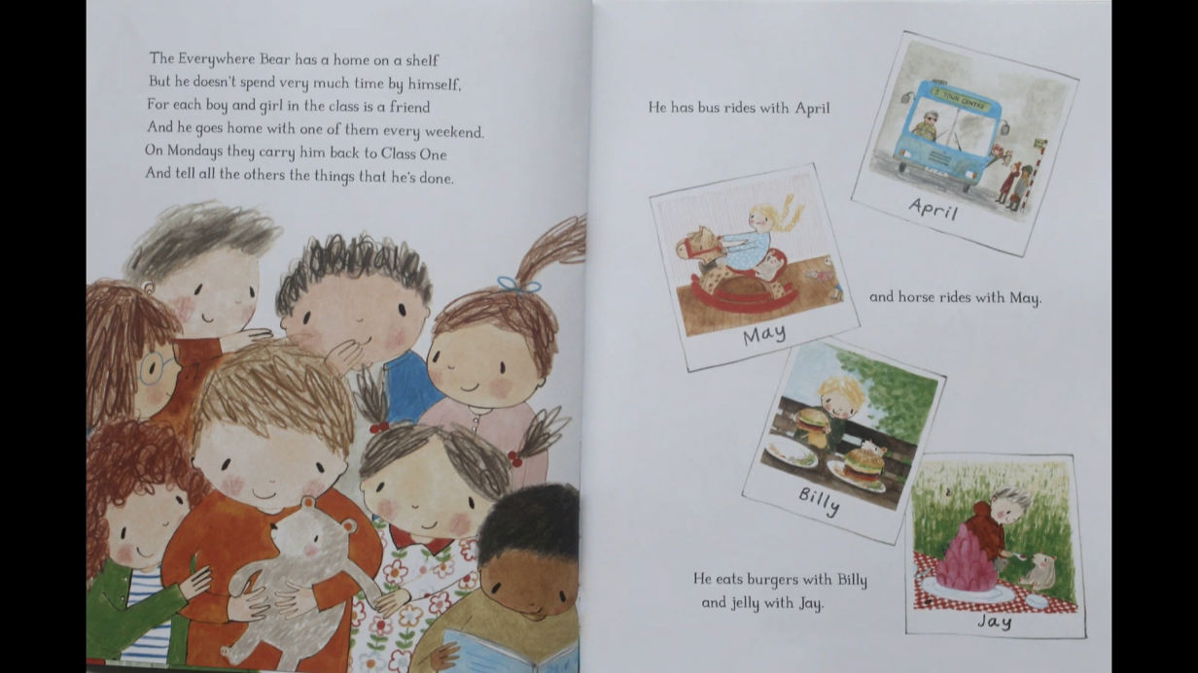 | Teddy bear  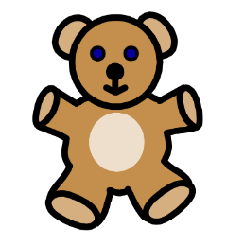 | Touch:  Explore the softness and shape of the bear
 | Toy bus   | Touch and sight:  Explore the shape and colours of the bus
 | Jelly   | Taste and touch:  Taste and explore the jelly
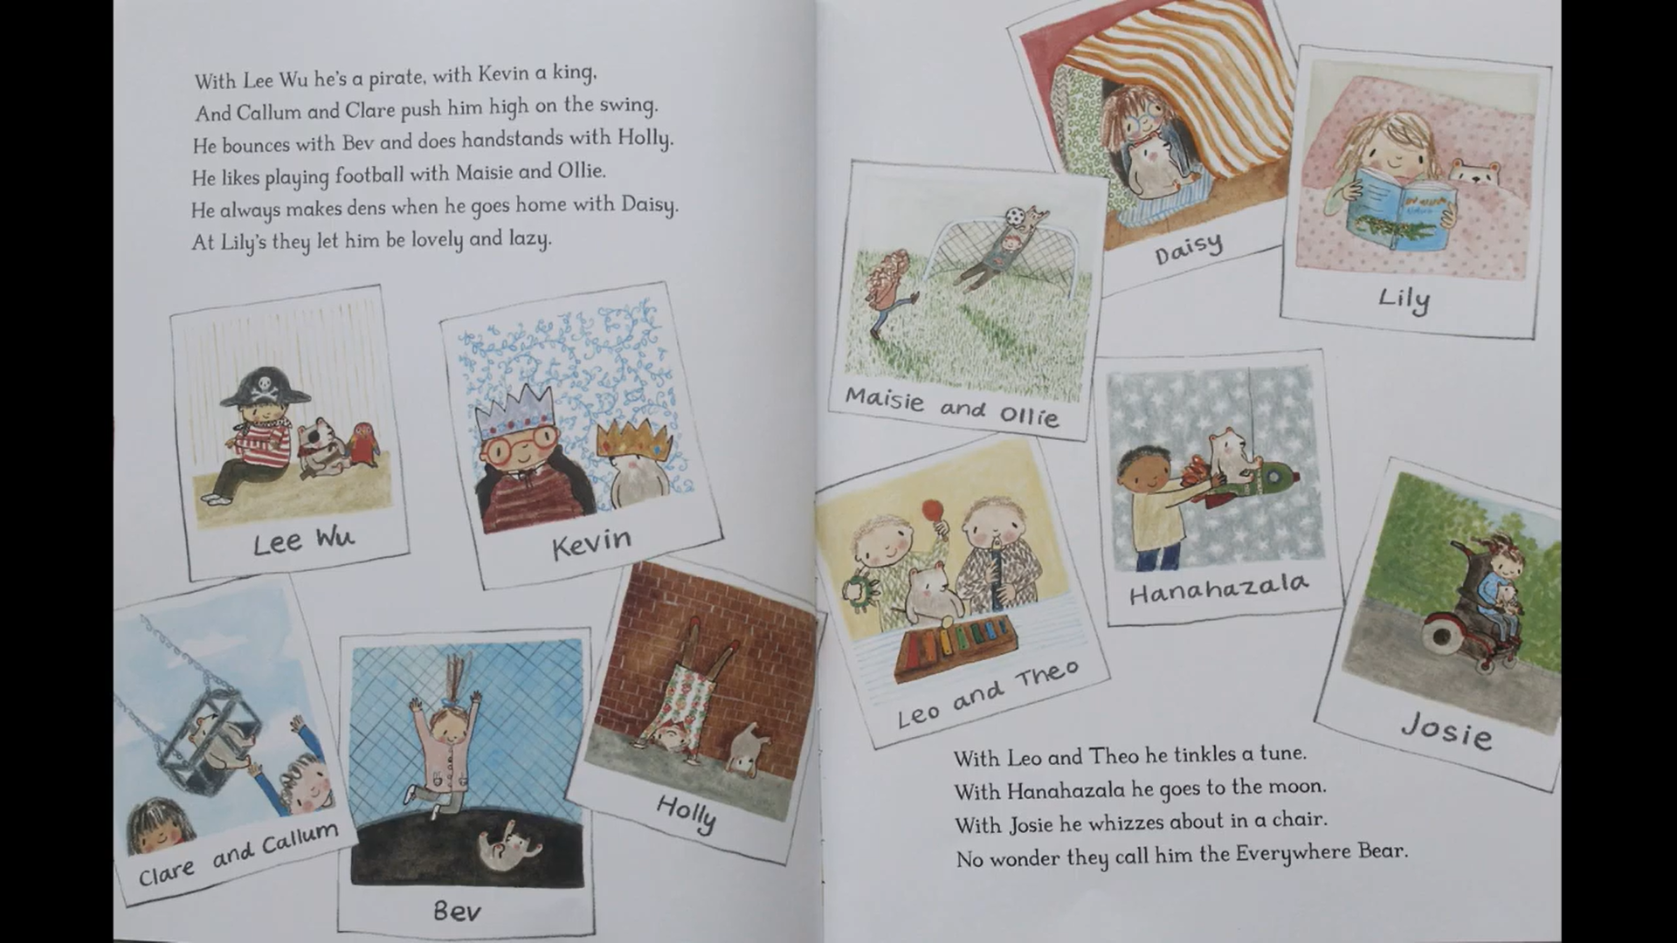 | Xylophone/ Maracas  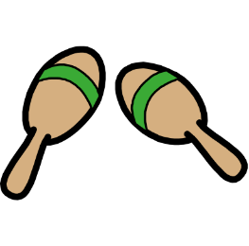  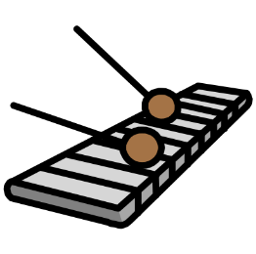 | Sound:  Play the instruments, listen to the different sounds they make
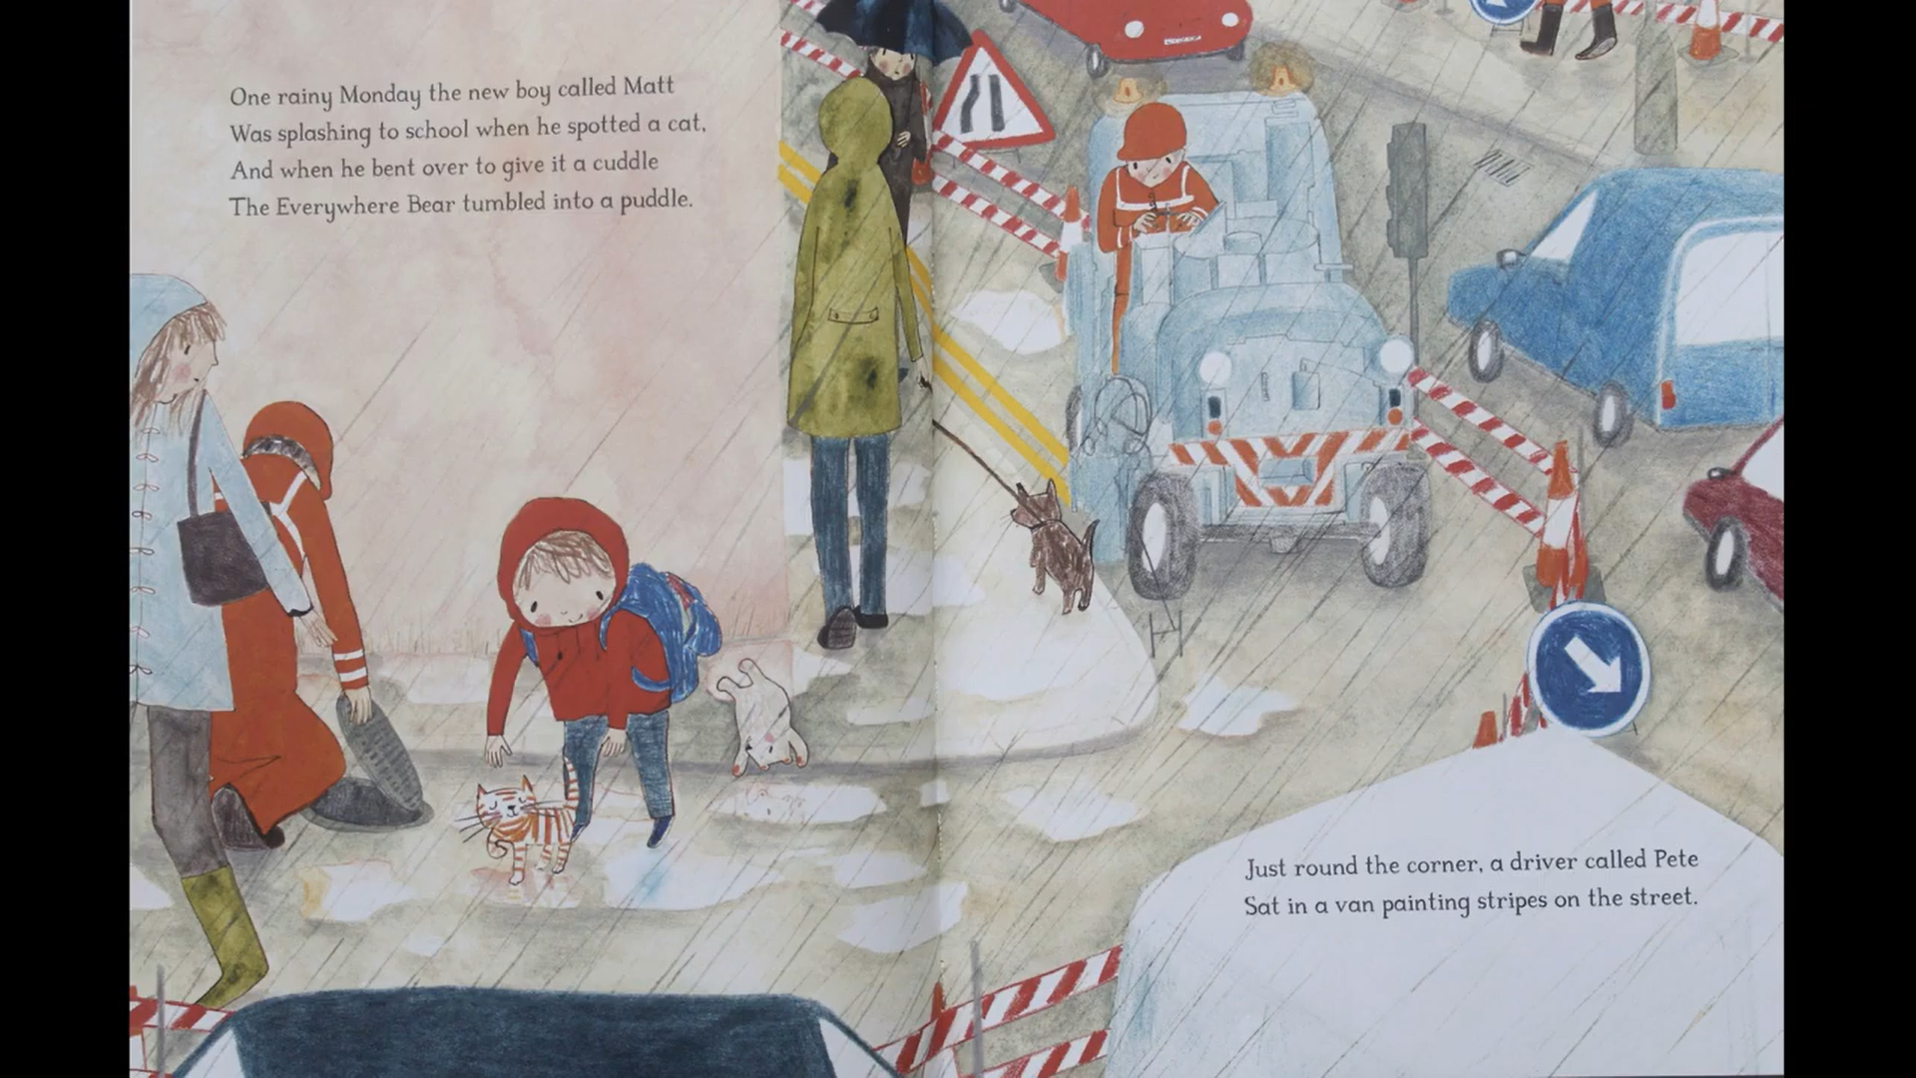 | Toy cat/ meow sound clip  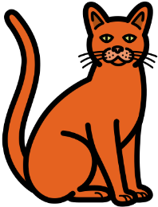 | Touch:  Explore the softness and shape of the cat  Sound:  Listen to the sound of the cat meowing
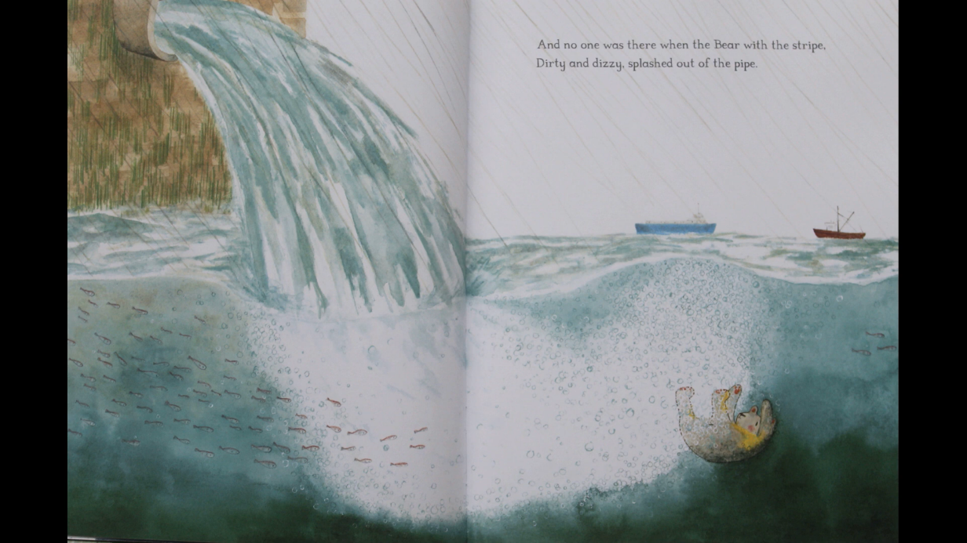 | Spray bottle   | Touch:  Spray water on children’s hand
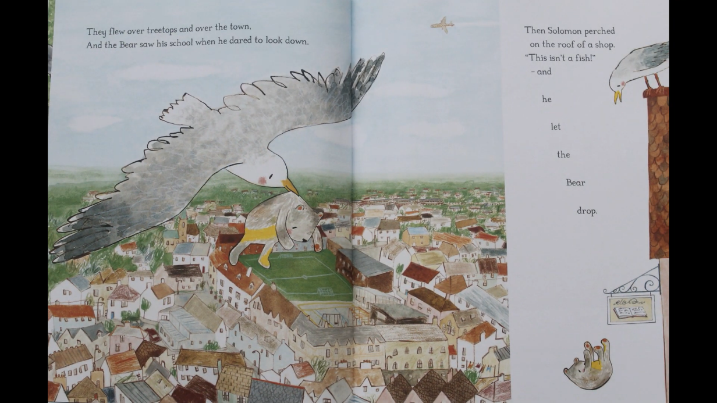 | Seagull sound clip  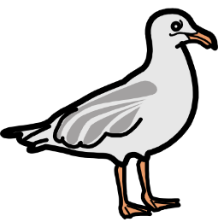 | Sound:  Listen to the sound of the seagull
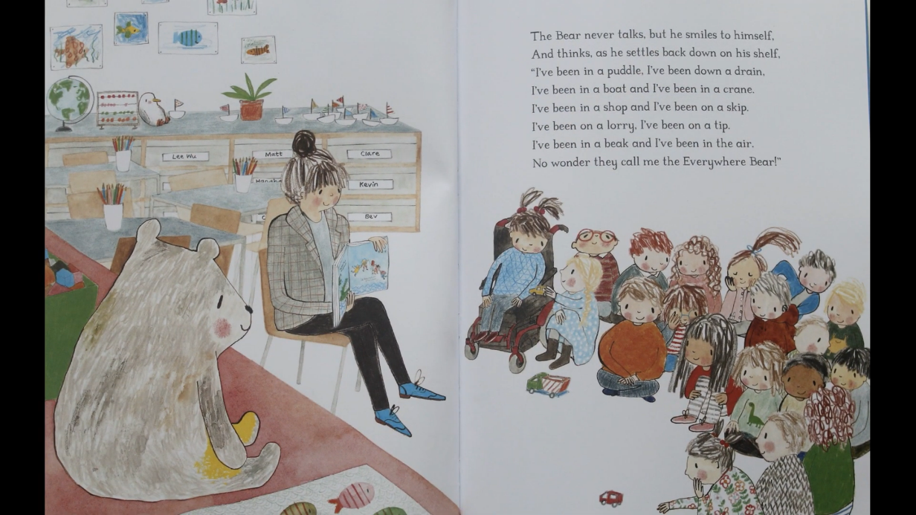 | Teddy bear  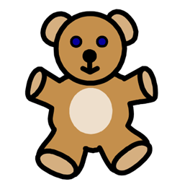 | Touch:  Explore the softness and shape of the bear

