Families in Partnership Early Years Resource List 2023
Week | Family Learning Team Provides | Early Years Establishments to provide
1 | Family Rhyme Time Activity Card  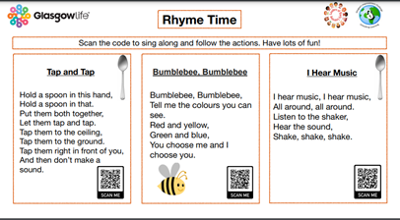 | Families use spoons, sticks or shakers to sound out the beat. Can you take families on a nature walk to collect sticks? Can you make shakers with the children, or organise a family craft session where you do this together and end with ‘Rhyme Time?’
2 | Family A3 ‘I’m a Thistle’ Board Game  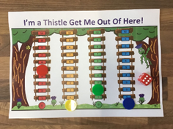 | Families will need a dice and four counters to play- can the nursery buy these or can you organise a family craft session where you make counters with family faces drawn on?
3 | 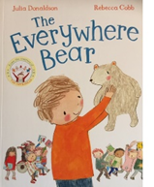  ‘Everywhere Bear’ Book by Julia Donaldson  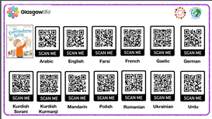  Everywhere Bear Read Aloud Card in 13 languages  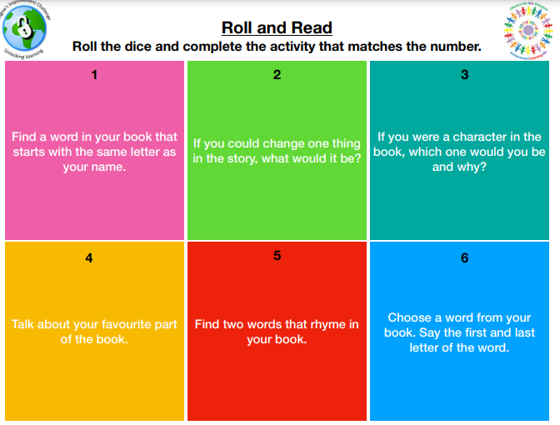  Roll and Read Activity Card  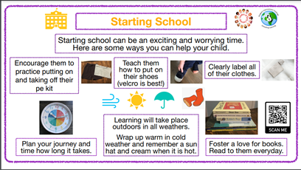  Starting School Information Card  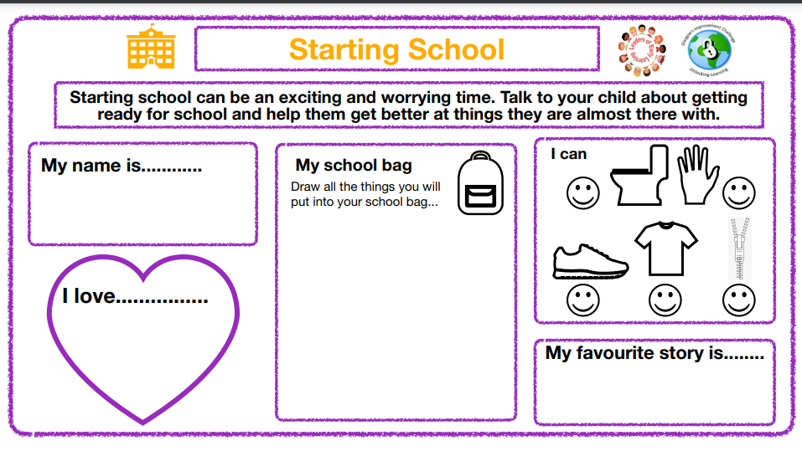  Starting School Family Activity Cards x3 | Some families may need help to access the You Tube films, being mindful of the fact that they will need a mobile phone with data. Can you have Family Storytime in the nursery?  Families will need dice for this.  Families will need coloured pencils/crayons and scissors for this. Can you provide them and/or organise this activity during a Family Fun or Everywhere Bear Storytime session?
4 | 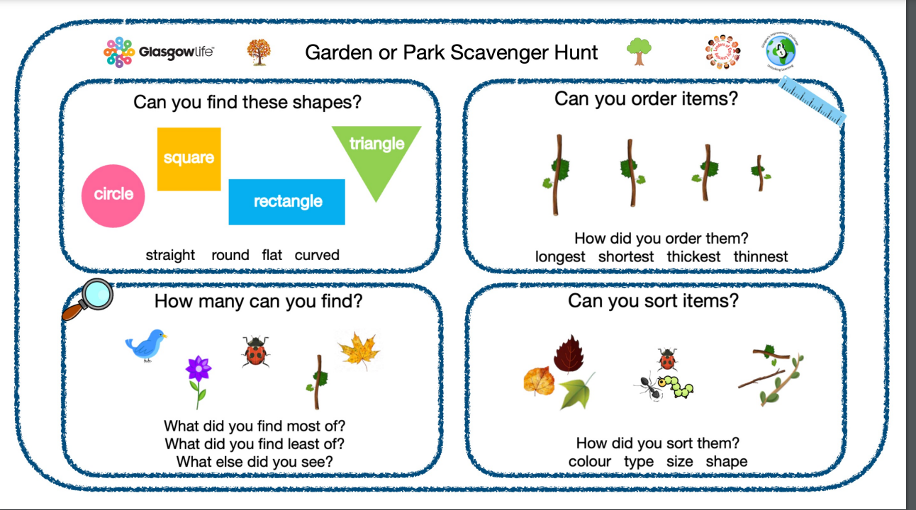  Family Scavenger Hunt Activity Card | Families will need to spend time outdoors to complete this activity. Can you do this as a group, or can you ask families to send you photos of their outing and what they found?

Additional Downloadable Material such as a suggested ‘Everywhere Bear Storytime’ for children with ASN can be found in our toolkit.

