



**Food**

**Food and Fun Club**



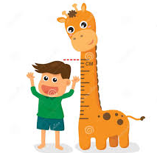

**Children, did you know you need food to grow, be active and stay healthy?**

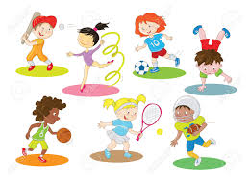

**Now draw or write your ideas. Ask your parent/carer to help.**

**I need to eat food so that I can…**



**Food and Fun Club**

**This is me when I am hungry**

**This is me when I have eaten**