



**Food**

**Food and Fun Club**

**Health & Wellbeing**

**Family Learning Programme**



**Food**

**and**

**Fun**



**Club**

**Take home resource pack**

**My name:**

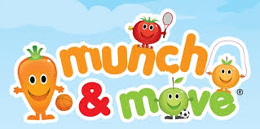



**Food and Fun Club**

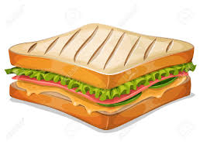

1. **Week 1 Making a healthy sandwich**
2. **Week 2 Rainbow fruit kebabs**

1. **Week 3 Healthy dips and dippers**
2. **Week 4 Healthy nachos**
3. **Week 5 Apple Doughnuts**
4. **Week 6 Houmous and veggie sticks**

**Appendices:**

**Take 10: Physical Activity Ideas**

**Top tips for healthy eating at home**

