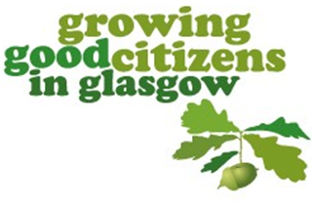
Learning for Sustainability:
Evaluating Impact &
Recognising Achievement
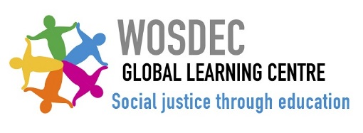
Building our understanding of interdependence
Contents:
The Global Goals and LfS wordle | 2
Background and Guidance | 3
Evaluating Impact  Growing our LfS culture:  Vision, values, ethos and climate | 4
Participation, pupil voice and empowerment | 5
Developing commitment to social justice | 6
Developing commitment to sustainability | 7
Growing our LfS practice:  Building understanding of interdependence | 8
Developing Rights based learning | 9
Taking our learning outdoors | 10
Growing our LfS systems:  Developing our policy and planning | 11
HGIOS/HGIOELC – further connections  Recognising Achievement  Growing Good Citizens in Glasgow  Recognition  The Trades House Award | 12  14  15

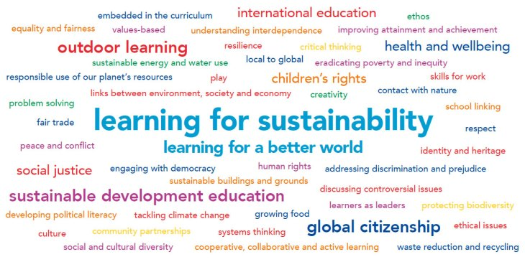
Background
In line with the GTCS Professional Standards, Learning for Sustainability (LfS) is a core responsibility of every teacher and entitlement for all learners. The term Learning for Sustainability has been adopted to reflect an extended concept that weaves together the three aspects of Global Citizenship, Sustainable Development Education, and Outdoor Learning. A whole school approach should connect knowledge, enquiry and action to support all learners to develop:
- a deeper understanding of the interdependence of ecological and human wellbeing;
- a strong sense of their role and responsibilities within our globally interdependent world;
- the values, attitudes and political literacy needed to make a difference.

Guidance
This resource will support your school to reflect on current practice across the breadth of LfS, connect with HGIOS 4/ HGIOELC and plan next steps. We have included examples of highly effective practice and further challenge questions as prompts for discussions with pupils, parents, carers and local community partners.

Please choose a minimum of two pages per year to reflect on. These can be within the same section (culture or practice), or across culture, practice or systems.

When you feel ready to celebrate achievement, please apply for the Growing Good Citizens in Glasgow Recognition from the Values and Citizenship strategy group (see Growing Good citizens in Glasgow section, p14, for more details).
Submissions should be made by the end of March each year.

Growing our LfS culture: Vision, Values, Ethos and Climate
Highly Effective Practice | What we have done so far.... | The difference this has made....... | Our plans for the future......
The strong commitment to LfS is highly visible and a lived experience for all learners, school staff and young people. Visitors frequently comment on the tangible open, warm and respectful ethos and the school’s commitment to a fairer and more sustainable world.  The whole school community (and those we work with through community partnerships) model rights respecting language and behaviour. ‘Eco’ activities are framed in terms of rights such as article 24, and the Global Goals. Our school community regularly revisits and evaluates the relevance of our values and vision within the new developments nationally and locally.  Our vision evolves through on-going reflection and debate across the whole school community. As a result of this active collaboration the school and community have ownership of the vision, values and aims. HGIOS4/ HGIOELC 1.3 |  | Children and young people say…  Families say…  Staff say…  Our community partners say…
Growing our LfS culture: Pupil Voice, Participation and Empowerment
Highly Effective Practice | What we have done so far.... | The difference this has made....... | Our plans for the future......
The whole school community feel that their views and ideas are sought, listened to and respected.  There is a tangible sense of learner empowerment and active contribution by all to the evolution of the school.  Pupil voice is strong across the school and all learners and staff have a shared understanding of participation.  All children and young people are supported to develop skills towards active engagement and self-efficacy in their community.  We ensure children and young people are active participants in discussions and decisions which affect their lives. HGIOS4/ HGIOELC 3.1  All learners are included, engaged and involved in the life of the school.  HGIOS4/ HGIOELC 3.1 |  | Children and young people say…  Families say…  Staff say…  Our community partners say…
Growing our LfS culture: Developing Commitment to Social Justice
Highly Effective Practice | What we have done so far.... | The difference this has made..... | Our plans for the future......
We are committed to creating equal grounds for dialogue and critical thinking about justice issues, where children and young people can explore, develop and express their own values and opinions, whilst respecting and learning from the viewpoints and values of others.  Our children and young people are confident in engaging with our local councillor, MP, MSP and MEP. Our whole school community is committed to supporting young people to be hopeful and positive about the future and the impact they can make by their actions.  Our school community has a shared understanding of wellbeing and the dignity and worth of every individual. HGIOS4/HGIOELC 3.1  We understand value and celebrate diversity and challenge discrimination.  HGIOS4/HGIOELC 3.1 |  | Children and young people say…  Families say…  Staff say…  Our community partners say…
Growing our LfS culture: Developing Commitment to Sustainability
Highly Effective Practice | What we have done so far.... | The difference this has made....... | Our plans for the future......
We have achieved and are maintaining our Green Flag Status.  Environmental sustainability permeates our curriculum and our young people can relate their learning to the Global Goals.  Our whole school initiatives support our young people to deepen their connection to the natural world.  The school engages effectively with partners to promote a coherent whole school approach to learning for sustainability.  HGIOS4/ HGIOELC 2.7  Learning for Sustainability is embedded across our curriculum.  HGIOS4/ HGIOELC 2.2 |  | Children and young people say…  Families say…  Staff say…  Our community partners say…
Developing our LfS practice: Building Understanding of Interdependence
Highly Effective Practice | What we have done so far.... | The difference this has made....... | Our plans for the future......
Our curriculum is co-created with our children and young people. We continue to explore the common themes and now ensure we investigate links we have to other people and places through explorations of trade, technology, migration, political systems, energy etc.  Where possible, contexts for interdisciplinary learning support learners to critically explore the relationship between current social and environmental issues. We connect these with rights and social justice.  All stakeholders contribute to the rationale, design and ongoing development of the curriculum. Everyone understands what the school is trying to achieve through its curriculum.  HGIOS4/ HGIOELC 2.2  We support staff to access high quality professional learning linked to cross-cutting themes such as global citizenship, outdoor learning and international education. HGIOS4/ HGIOELC 1.2 |  | Children and young people say…  Families say…  Staff say…  Our community partners say…

Developing our LfS practice: Developing Rights Based Learning
Highly Effective Practice | What we have done so far.... | The difference this has made....... | Our plans for the future......
Our whole school community can describe what rights are, why they are important and how they are unconditional, universal, and inalienable.  Staff identify the natural curricular opportunities for exploring rights within planned learning experiences. We regularly use Education Scotland’s ‘Recognising and Realising Rights’ Establishment Reflection Tool to self-evaluate our progress.  The whole learning community has a shared understanding of wellbeing and the children’s rights.  HGIOS4/HGIOELC 3.1 |  | Children and young people say…  Families say…  Staff say…  Our community partners say…
Developing our LfS practice: Taking Learning Outdoors
Highly Effective Practice | What we have done so far.... | The difference this has made....... | Our plans for the future......
All staff and young people recognise Outdoor Learning as a methodology. Our whole school community can state what Outdoor Learning is visible in our curriculum.  We take into account how the learner and the Experiences and Outcomes are central to planning. We utilise the full range of Outdoor Learning contexts (as described in Planning for Outdoor Learning).  We regularly use Education Scotland’s Self Evaluation Tool to reflect on our progress in Outdoor Learning and support future improvement planning.  Outdoor learning is a regular, progressive curriculum-led experience for all.  HGIOS4/ HGIOELC 2.2 |  | Children and young people say…  Families say…  Staff say…  Our community partners say…
Developing our LfS systems: Developing our policy and planning
Highly Effective Practice | What we have done so far.... | The difference this has made..... | Our plans for the future......
LfS has a high profile and is understood by all learners at their level (staff and young people) as an entitlement.  There is a co-ordinated, coherent whole school approach which is self-evaluated regularly by staff and young people. Planning for LfS is well embedded in the culture, and we take into account how the learner and the Experiences and Outcomes are central to planning.  Under the umbrella of LfS, Global Citizenship, Sustainable Development and Outdoor Learning permeate all areas of our School Improvement Plan.  Procurement policies demonstrate a commitment to fairly traded and sustainably sourced materials.  We reach out to other establishments to share ideas, practice and support mutual improvement.  The development of our curriculum is underpinned by a coherent whole school approach to learning for sustainability.  HGIOS4/ HGIOELC 2.2 |  | Children and young people say…  Families say…  Staff say…  Our community partners say…
HGIOS4/HGIOELC Further Connections
This section of the tool can be used to support professional dialogue and extended self-evaluation of Learning for Sustainability within your establishment.
Category | Quality Indicator | Challenge Questions
Leadership and Management | 1.1  Self-evaluation for self-improvement | How well do all stakeholders know and understand what is meant by the term learning for sustainability?  How do we ensure improvement for the learner is central to our LfS self-evaluation activity?  How well are we doing in global citizenship, sustainable development education and outdoor learning?  How does provision in these three areas of LfS compare? How do we know?  How well do we involve all stakeholders, including learners, in self-evaluation of LfS and planning for improvement?  How well is evidence from self-evaluation being used to drive forward change?
 | 1.2  Leadership of learning | How well do we support staff to access CLPL that builds confidence in LfS? To what extent are we utilising existing expertise to build LfS capacity across our establishment?  How do we know that our professional learning in LfS is improving outcomes for learners?  How well do we promote a culture of professional enquiry?  How effectively are staff applying relevant findings from research to improve their LfS provision?  To what extent are we encouraging learners to lead their own learning across a range of LfS contexts? How effectively do we ensure that LfS activities across our school are connected to other strategic priorities?
 | 1.3  Leadership of change | How effectively have we involved the whole school community in aligning our vision, values and aims with LfS?  How effective are we at building a culture of inclusion and participation and supporting the development of positive relationships and ethos?  To what extent does LfS feature in the PRD process for all staff?  How well does our school promote stakeholder engagement in relation to LfS policies?
Learning provision | 2.2  Curriculum  2.3  Learning, teaching and assessment | To what extent are we meeting our learners’ entitlement to LfS?  How effectively is our establishment joining up the different aspects of LfS in our curriculum?  How well are we employing LfS pedagogies to raise attainment and tackle inequity?  How well is LfS being used to support progression in learning across transitions? To what extent are we using our outdoor and community spaces to enhance learning?  How well do our approaches to profiling include LfS experiences?
 | 2.7  Partnerships | What opportunities do our learners and staff have to work with others to contribute effectively to their communities as active citizens?  To what extent do we involve parents in our LfS activities?  How well do we seek out and respond positively to potential partnerships which will help us meet the entitlement of every learner to LfS?  How well do we identify priorities, communicate, plan, monitor and evaluate our work with partners? Are we clear what added value each partnership brings?
Successes and Achievements | 3.1  Improving wellbeing, equality and inclusion  3.2  Raising attainment and achievement  3.3  Increasing creativity and employability | To what extent are we using LfS to promote inclusion and wellbeing?  How well do we recognise and value the personal achievements of all learners?  How good are we at recognising and realising children’s rights through participation?  How well do we understand and promote career opportunities linked to LfS?  To what extent do we use our school buildings and grounds (and developments/ renovations of the school estate) to develop LfS-related skills for learning, life and work? To what extent have we linked our LfS to the Career Education Standard 3 - 18?

Growing Good Citizens in Glasgow Recognition
Glasgow’s Values and Citizenship strategy group are keen to recognise your work in this area. All you need to do is submit the sections of this resource you’ve been working on. In the first instance establishments should apply for the Growing Good Citizens in Glasgow Green Acorn recognition level.
The Green Acorn demonstrates evolving culture, practice and commitment across just two areas/pages within this resource. For Primary and Secondary establishments, please submit the two relevant sections to the following member of the Values and Citizenship Strategy Group: Rachel Binnie (rachel.binnie@glasgow.gov.uk)
Copies can also be sent to Mary McLachlan (headteacher@st-ninians-pri.glasgow.sch.uk) and Jane Cerexhe (headteacher@oakgrove-pri.glasgow.sch.uk). For Early Years establishments, Lesley Morrison (headteacher@westercraigs-nursery.glasgow.sch.uk) and Lynn.Orchard@glow.ea.glasgow.sch.uk.

Following successful endorsement, the establishment will receive a certificate and the Green Acorn logo for use on stationery. If indicated by the school, successful applications will then be entered to the Trades House Citizenship Award (see p15).
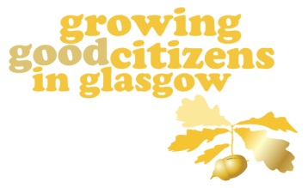 | The Gold Acorn demonstrates consistent strengths across all areas of culture, practice and systems. This will be endorsed by a central assessing team. To arrange an assessment visit please contact the above relevant members of the Values and Citizenship Strategy group for your sector. Children and young people as well as community partners may be involved in this validation visit.  Following successful endorsement, the establishment will receive a certificate and the Gold Acorn logo for use on stationery.
The Trades House of Glasgow
Established in 1605 and now a registered charity, the Trades House and its 14 Incorporated Crafts have helped shape Glasgow into the city it is today. The House and its Crafts play a major role in training, education, trade and industry through a variety of initiatives.

Please indicate if you wish your application to be submitted for entry to the Trades House Citizenship Award

From 2018 Trades House will no longer ask schools to apply separately for their Citizenship Award. Instead the Values and Citizenship Strategy group will pass commended submissions to the Trades House, who will then invite young people from these schools to present for 5 minutes on their work to a panel before deciding on an overall winner for the award.
This prestigious award recognises the excellent work being undertaken by schools in, for and with their communities. Schools qualifying for the award competition will have demonstrated some of the following in this document:
- contributing to the life of the local community
- participating in local events
- undertaking local ventures
- contributing to newspapers and other media
- linking with local industry/employers
- providing events which the local community can attend
- involving the local community in the educational life of the school by assisting pupils in a variety of activities
- enabling members of the local community to take part in educational experience to encourage lifelong learning
- any project which involves the community helping the school or the school helping the community

The Citizenship Award is open to all schools - Nursery, Primary, Secondary and ASN. There is no monetary award, rather a certificate for all commended schools and a plaque for the winning school. Each school gaining the award is entitled to display the Trades House logo on their stationery. The winning school is announced at a very special award ceremony held in the Trades Hall, in Glasgow’s Merchant City.

More information on the Scottish Government report on Learning for Sustainability and the professional responsibilities of teachers can be found in the Values and Citizenship pages within Glasgow Online.

