Regional Improvement Collaborative: West Partnership
Practitioner Moderation Template (PMT)

Prior to the moderation exercise, please complete the following information and submit it to your facilitator with assessment evidence from one learner that you judge to have successfully attained the Es and Os.
Evidence Code | J4
Curriculum Area(s) | Literacy
Level | First
Stage(s) | Primary 3

Planning | Experiences and Outcomes:  I am learning to make notes under given headings and use them to understand information, explore ideas and problems and create new texts. LIT 1-15a  I can share my thoughts about structure, characters and/or setting, recognise the writer’s message and relate it to my own experiences, and comment on the effective choice of words and other features. ENG 1-19a  Having explored the elements which writers use in different genres, I can use what I learn to create my own stories, poems and plays with interesting structures, characters and/or settings. ENG 1-31a
Learning Intentions:
Lesson 1
- Discuss the vocabulary used to describe a character in a fairy-tale
- To take notes from a text

Lesson 2/3
- To use notes to create a new text
- To describe a character in a fairy-tale
Lesson 4
- To use similes in our writing
- To create my own fairy-tale character

Assessment | Benchmarks:  - Makes notes under given headings for different purposes.  - Offers own ideas about characters, writer’s use of language, structure and/or setting.  - Creates interesting characters through their feelings and actions and physical description.
Success Criteria:
Lesson 1
- I can talk about exciting adjectives used to describe the characters
- I can highlight adjectives that describe the characters
- I can make a list of adjectives under headings – outside/inside
Lesson 2
- I can use my notes to describe Cinderella – inside and outside
- I can use interesting adjectives
- I can use capital letters and full stops
Lesson 3
- I can use my notes to describe the Big Bad Wolf – inside and outside
- I can use interesting adjective
- I can use capital letters and full stops
Lesson 4
- I can use a plan for my writing
- I can write a description of my character – inside and outside
- I can show what the character says with speech bubbles.
- I can use capital letters and full stops
- I can use a simile

Briefly outline the context and range of quality learning experiences that have been planned making reference to the chosen design principles. Make specific reference to breadth (B), challenge(C) & application(A).

Lesson 1
Share learning objectives and pick apart the key points – wow words, adjectives, describe, fairy tale, character.
Read Cinderella to the children. Ask children to listen out for who the characters are and to put their hand up when they hear an exciting adjective to describe a character (C). During follow up discussion, establish who main characters are. Discuss the difference between Cinderella and her stepsisters. Establish that fairy-tales have “good” and “bad” characters and discuss the language used to describe each one. Establish that different language is used to describe the character on the “outside” and “inside”.
The children will be given extracts from the story and pictures to work in pairs, using different coloured highlighters to highlight adjectives (A) which describe the characters of Cinderella – one colour for “inside”, one colour for “outside”. Share highlighted words which will be noted on the whiteboard under headings “inside/”outside”. Children will select words from highlighted texts to place under the headings “inside”/”outside” in jotters.(A)
Lesson 2
Children will take part in Freeze Frame activities to show how the character of Cinderella and the stepsisters are feeling during different parts of the story (B). Ask for volunteers to play the role of different characters from the story during Hot Seating activities, the other children will ask the character questions.
Teacher modelling of using notes from previous lesson to write a description of Cinderella. Shared writing to complete description in jotters.

Lesson 3
Read Little Red Riding Hood. During reading, discuss the main characters and language used to describe them. Whole group brainstorm exciting adjectives to describe the Big Bad Wolf (B). Children will take notes on whiteboards under headings “inside/outside”. Teacher will add notes to flipboard. Children will work independently to write their own character description of the Big Bad Wolf. (C)

Lesson 4
Children will be introduced to similes. Play a game on IWB where children have to choose the correct word to complete the simile. (B)
Children will be given a selection of character pictures to choose from. They will then complete a planning sheet, giving the character a name, draw a picture, tell where it lives and note down adjectives to describe what it looks like and its personality. Children then write their own character description. (C,B,A)

Record the planned assessment that will be gathered to meet the success criteria (Say, Write, Make, and Do) considering breadth, challenge and application.
Say
- Take part in discussion on author’s use of vocabulary to describe characters
- Contribute to the creation of success criteria
- Take part in brainstorming of adjectives to describe given character
Do
- Highlight relevant vocabulary from texts
- Self Assess writing against success criteria

Write
- Make notes in jotter/planning sheet of interesting adjectives to describe given character
- Write a character description of Cinderella during shared writing
- Write an independent description of the Big Bad Wolf using relevant vocabulary to describe a “bad” character.
- Apply skills to independently plan and write own character description

Briefly outline the oral/written feedback given to the pupil on progress and next steps, referring to the learning intention and success criteria.

Lesson 1- Pupil was praised when making contributions during discussion on vocabulary used to describe Cinderella characters.
Lesson 2 – You described Cinderella on the outside and inside using super adjectives – well done.
Lesson 3 - Well done, you have worked on your own and used lots of interesting adjectives to describe your character.
Lesson 4 – You used a fantastic simile to describe your character.

Next steps (created through discussion with pupil)
I will try to use similes when I am writing.
Look at character descriptions in other types of story. Can you write a description of a character from another type of story?

Did the learner successfully attain the outcomes? YES/NO
(Evidence attached below)
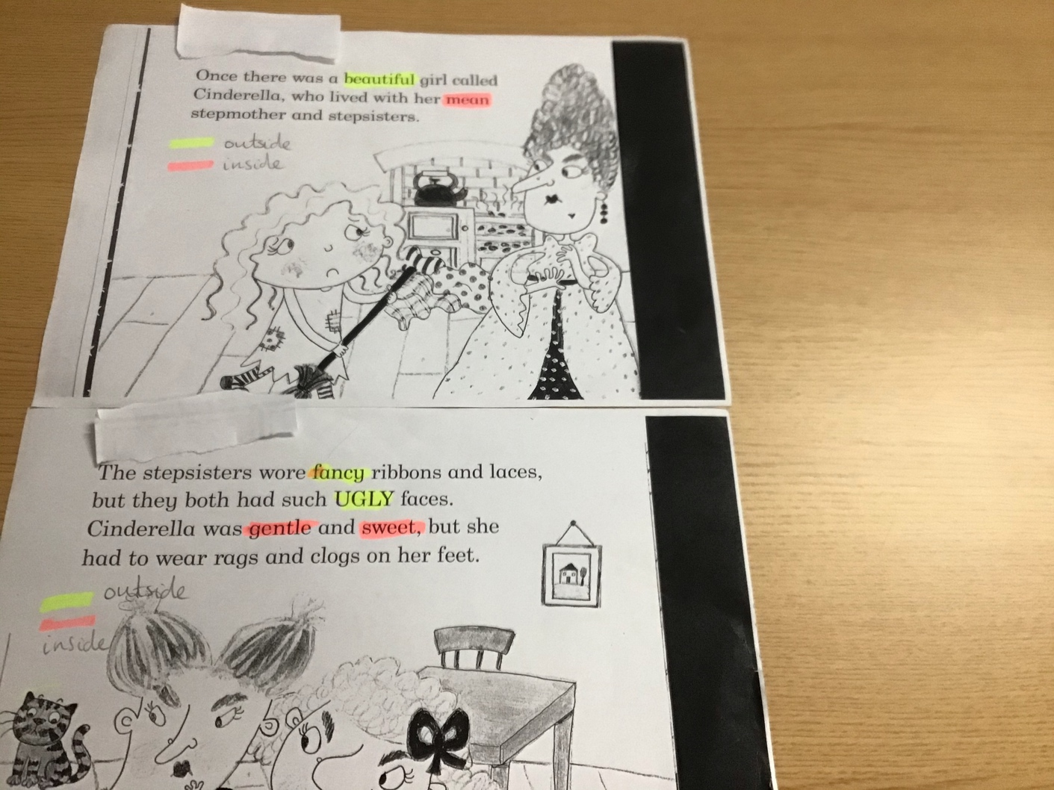
SC-I can highlight adjectives that describe the characters

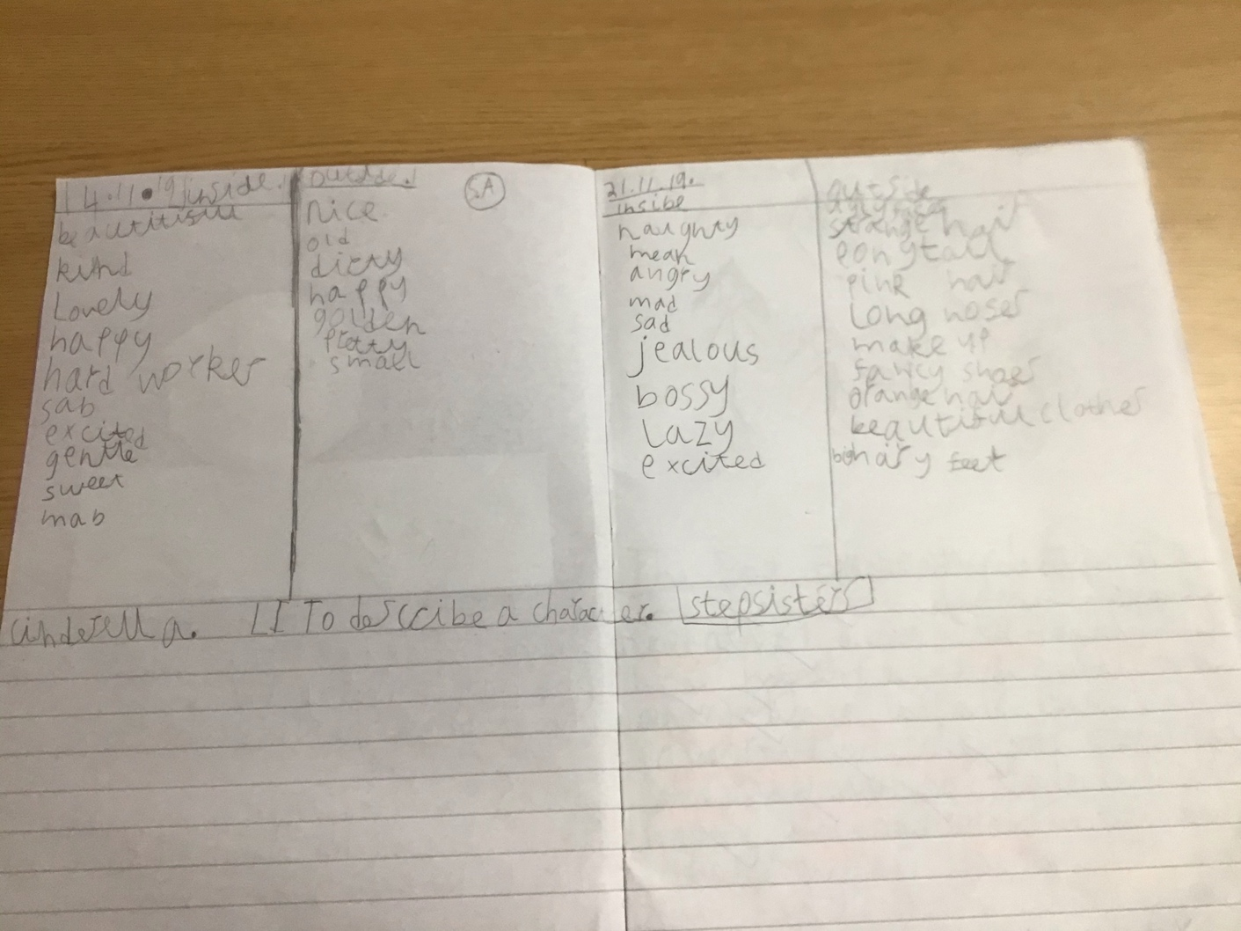
SC-I can make a list of adjectives under headings – outside/inside
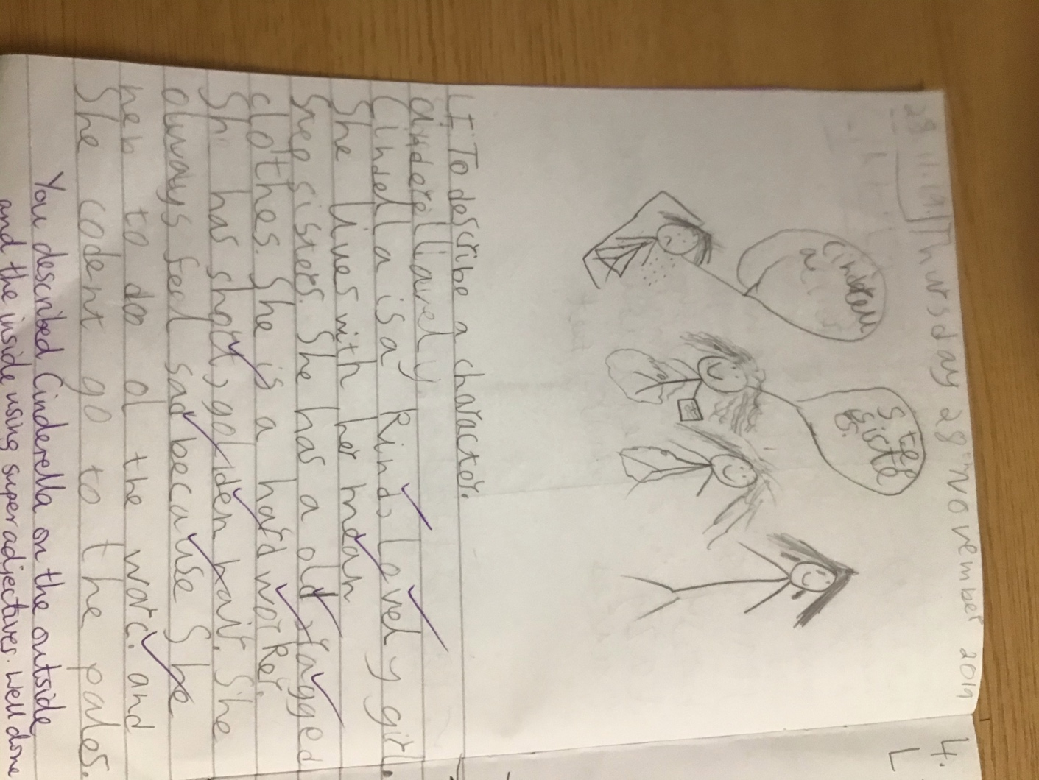
SC- I can use my notes to describe Cinderella
I can use interesting adjectives
I can use capital letters and full stops
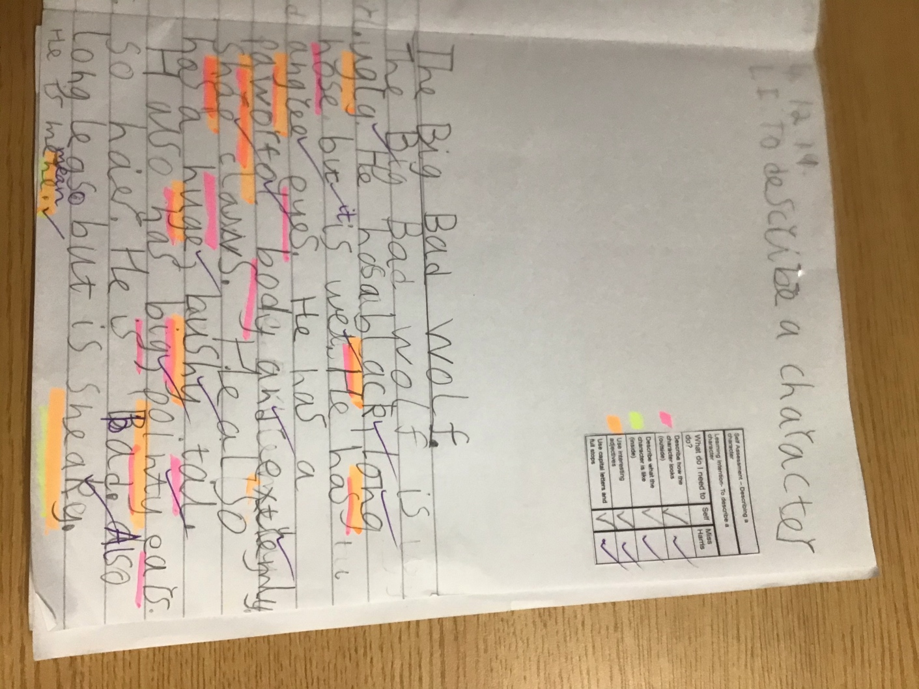
SC- I can use my notes to describe the Big Bad Wolf
I can use interesting adjectives
I can use capital letters and full stops
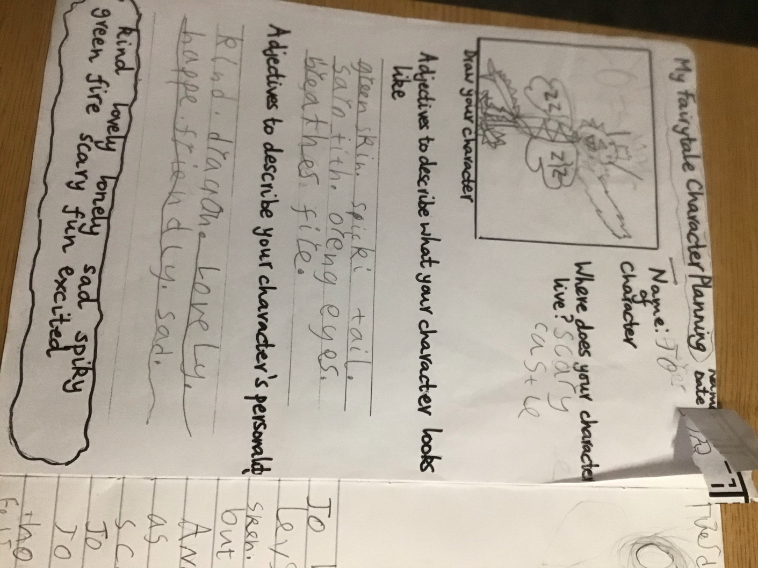
SC- I can use a plan for my writing

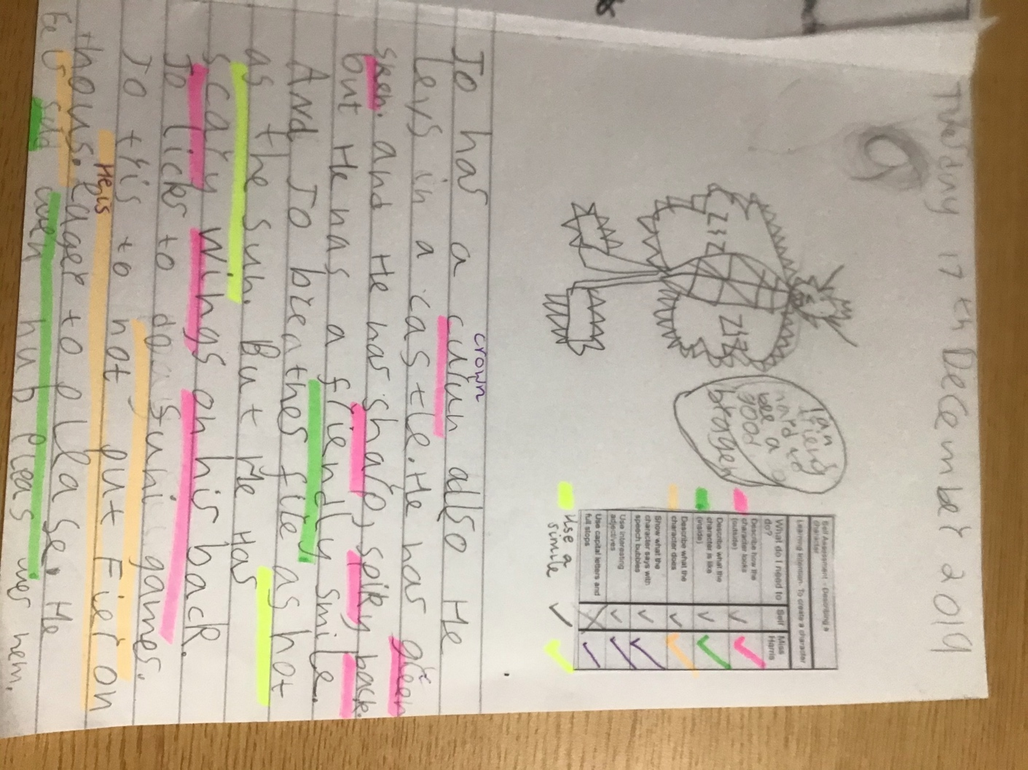
SC- I can write a description of my character
I can show what the character says with speech bubbles
I can use a simile
I can use capital letters and full stops

