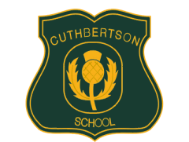
Cuthbertson Primary School November 2019 Newsletter

Parent Council Film Nights: Thanks to our Parent Council who organised our Film Nights to raise money for the school and as a fun activity for our children.
Parent Consultations: Thanks to all who attended our parent evenings. It was lovely to see so many of you.
Twitter: Please follow us on @cuthbertsonpri for Twitter updates.
Diwali Celebration: Our Parent Council organised a wonderful Diwali Celebration. We hope you enjoyed the event and we thank the Parent Council for their hard work.
Christmas Concert: Every class will be performing at our concert including our infants who will perform the Nativity. We look forward to seeing you on the morning on Thu 12 Dec at 9.30.
Parent Council: Our next Parent Council meeting will be held in January. Any items proposed for the agenda should be passed to the Headteacher or Mrs Haq (Chair of Parent Council).

What’s on:
Wed 4 Dec: Christmas Science Experience for all children
Fri 6 Dec: Winter Market at 1.15 pm, all welcome
Thu 12 Dec: Christmas Concert at 9.30, all classes taking part and families welcome
Thu 12 Dec: Festive lunch
Thur 19 Dec: Last day of term, school closes 2.30 pm
Mon 6 Jan: School re-opens and children return

Kind regards Lesley Murrie , Head Teacher

