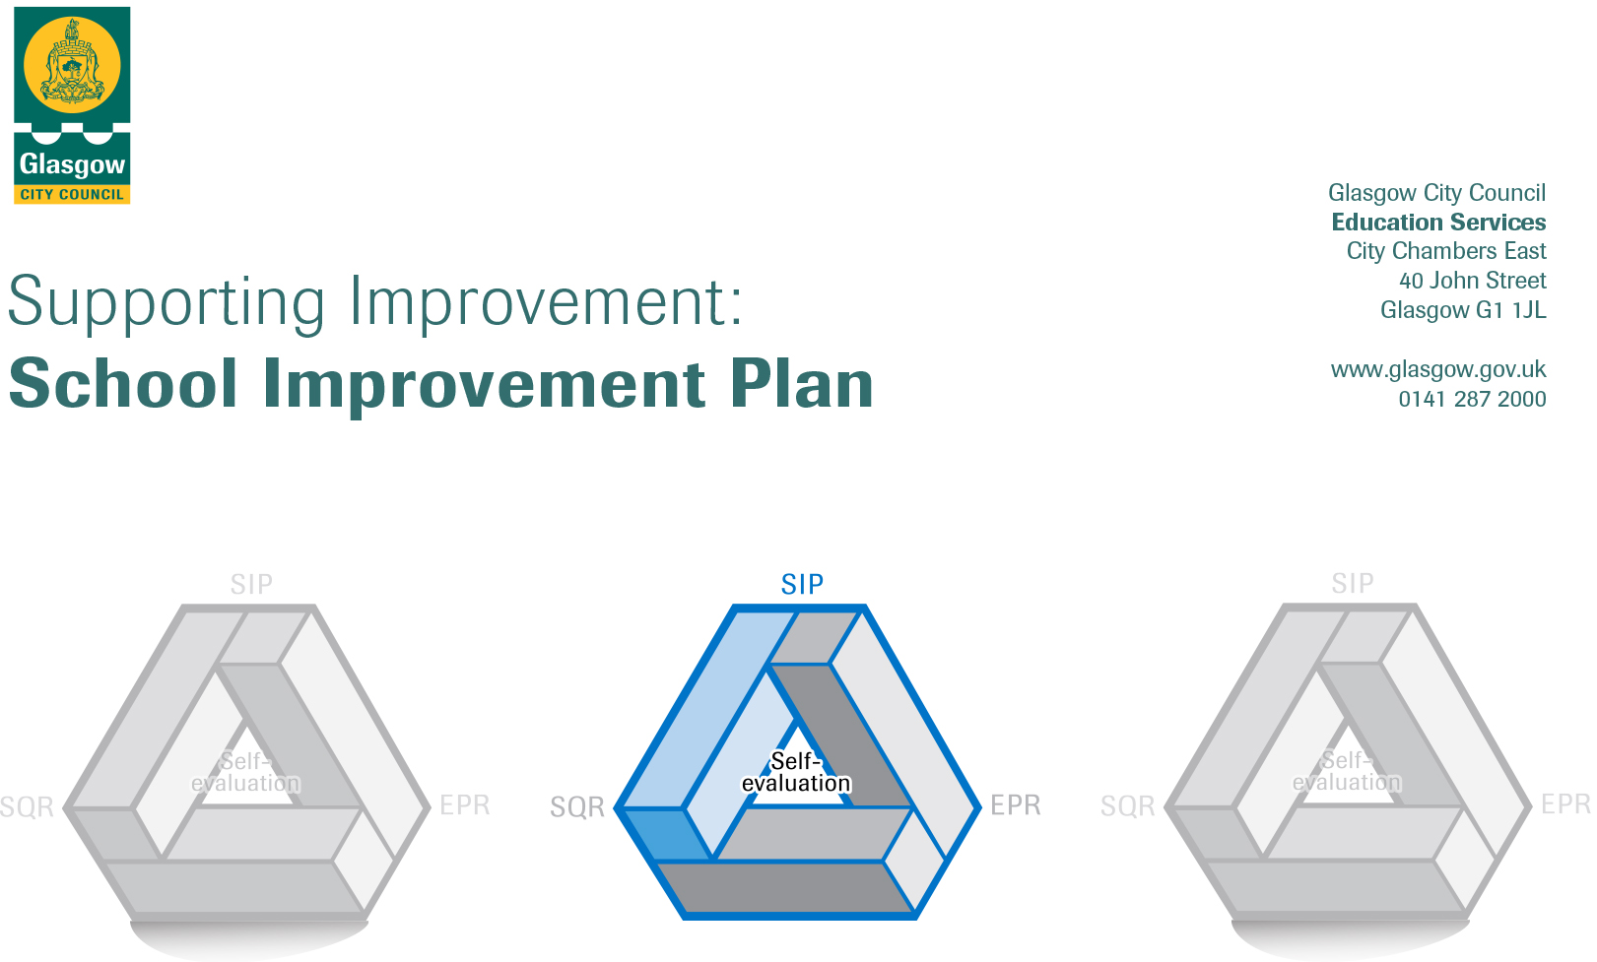

Session: 2017-18

Establishment |  | Croftfoot Primary School
Head of Establishment |  | Martine Leitch
Area/Local Improvement Group |  | South LIG 3
Head of Service |  | Jacqui Nimmo
Area Education Officer/  Quality Improvement Officer |  | Claire Harvey

CONTENTS
1. Vision, Values and Aims
2. Summary of Self-Evaluation Process / Priorities for Improvement in the current session
3. Action Planning

Action Plan Summary for Stakeholders

1. Our Vision, Values and Aims
Over the last 6 months we have been reviewing our vision and values, reflecting on what we want to achieve in our school and across the wider community. Last session parents and children took part in a shared homework activity to think about their own home and family values and what values they would like to see within the school community. Staff have been involved in a number of sessions using transformational planning to think and reflect on their hopes and vision for the school community. The Pupil and Parent Councils were involved in deciding how we go forward and embed the vision, values and aims throughout the school and a launch event was held in September 2017.
In April 2018, pupils, parents and staff reviewed our vision statement to ensure that this encapsulated our focus on health and wellbeing.

Vision

At Croftfoot Primary, we aim to create a safe and nurturing environment for all. A vibrant school where children are motivated and enthusiastic to learn, achieving their full potential. We will be creative, innovative and open to taking on new challenges. A place where everyone is respected and valued, with the child at the centre and relationships at the heart of all we do.

Values and Aims

Relationships
-A positive role model within school and the community
-Contribute to the local and wider community
-Show empathy towards others
-Support, challenge, encourage and empower myself and others
-Set high expectations for treatment of self and others

Respect
-Demonstrate respect at all times
-Respects rights and embrace diversity
-Zero tolerance to aggression
-Look after school property and environment

Nurture
-Encourage others
-Kind and caring
-Good listener
-Understanding
-Support and value others

Achievement
-Know and value my own strengths.
-Take ownership of my learning by setting personal targets and goals.
-Motivated and determined to achieve showing perseverance when challenged.
-Curious and confident with an open and enquiring mind.
-Share and celebrate my own and others success in and out of school.

2. Summary of our self-evaluation process.
Our self-evaluation process this session has involved staff, children and parents across the school. Staff have been using transformational planning tools and HGiOS 4 to evaluate and plan. All staff have been involved in analysing data and working on the PEF Plan. Staff have also been involved in agreeing areas for SIP in 2018/19 and input to the EPR.

Parents have been involved through questionnaires, consultations and online surveys. Parents have also had an opportunity to attend HT coffee morning and drop ins. Members of the Parent Council have been part of a focus group looking at priorities of the PEF Plan. The Parent Council have been an active part of discussions in all areas of self-evaluation and school improvement.

The pupil council have been involved in look at several areas; including: review and development of our vision, values and aims, reflecting on How Good is our Behaviour and How Good is Our Learning. All other children have been involved in self-evaluation through learning walks and learning conversations as part of the whole school monitoring and self-evaluation cycle.

Strengths identified:

- Engagement of staff, parents and children in the self-evaluation process and commitment to areas for school improvement
- Renewed Vision, Values and Aims
- Commitment to the PEF Plan
- Increased focus on health and wellbeing, resilience and trauma informed approaches.
- Increased use of research based practices

Priorities for development:
1: Learning, Teaching and Assessment
Targets:
- Consistent approach across the school to use of Pupil Learning Journeys – All children know their own areas of strength and next steps
- Consistent approach across the school to Class Learning Journeys – All children will be able to make relevant and coherent links across the curriculum and highlight skills for learning, life and work
- Consistent approach to collaborative learning within literacy – All children able to work collaboratively and take on group roles improved attainment in literacy
- Consistent approach to use of Restorative Practices Scripts – All children are able to deal with conflict using Restorative Practices and decrease in the number of Red Consequences in Good to be Green
- Improved levels of HBW for all children

2: Literacy
Targets:
- Increased confidence for all children in talking and listening
- Improved attainment for all children in reading
- Improved attainment for all children in writing

3: Numeracy
Targets:
- Improved attainment in Number and Number Processes for all children

4: Family Learning
Targets:
- All children and parents engaged with Child’s Learning Journey and personal target setting
- Increased involvement of parents for target groups in their child’s learning
- Improved wellbeing for target groups

3. Action Planning

No. | Quality Indicator | Priority
1 | 2.3 | Learning, Teaching and Assessment  – All children know their own areas of strength and next steps  - All children will be able to make relevant and coherent links across the curriculum and highlight skills for learning, life and work  - All children able to work collaboratively and take on group roles improved attainment in literacy  - All children are able to deal with conflict using Restorative Practices and decrease in the number of Red Consequences in Good to be Green  - Improved levels of HBW for all children

Tasks to achieve priority | Timescale  and checkpoints | Evidence of Impact > (data, observation, views)
Development of Pupil Learning Journey  - to include pupil led planning, personal learning planning and achievement records | Staff Session  6/9/17  Sent home at the end of every term  Focus for 2nd Parents Night
Development of Class Learning Journey  - To include assessment evidence of learning across the curriculum. Standardised display of learning including teaching aids across the school | Staff Session  6/9/17  Standardised displays and use from Term 2 onwards
Staff refresh training in AiFL strategies  - To include school agreement of the minimum expectations and use of certain strategies across the school | Staff Session  5/2/18
Collaborative Learning  - Team teaching  - Sharing good practice staff session – demonstrating success | On-going Friday Focus  Staff Session  5/2/18
Assessment of Children’s HWB  - Use of wellbeing Wheel to develop children’s understanding of GIRFEC and Wellbeing Indicators and Assessment of Children’s Wellbeing | To be completed:  4/9/17  8/1/18  30/4/18
Our Nurturing School  - Review of where we are and where we want to go, (to include Restorative Practices). | Staff Session  19/2/18
Restorative Practice  - Development of scripts to be used across the school when conducting restorative conversations | Staff Session  19/2/18  Consistent scripts to be used from Term 4

Staff leading on this priority – including partners | Resources and staff development
Lindsay McKinlay and Arlene McClure - Lead  Education Psychologist – Restorative Scripts | See - Tasks to achieve priority

No. | Quality Indicator | Priority
2 | 3.2 | Literacy  - Increased confidence for all children in talking and listening  - Improved attainment for all children in reading  - Improved attainment for all children in writing

Tasks to achieve priority | Timescales  and  checkpoints | Evidence of Impact > (data, observation, views)
Literacy Training from CLOL  - Early Writing – 11/9/17  - Writing Strategies, Spelling – 11/917  - Non-fiction texts, Assessment – 6/11/17  - Fiction texts, Enjoyment and Choice – 6/11/17  - Meeting Learners Needs – 13/11/17  - Multimodal Texts – 13/11/17 | Staff Session  11/9/17  6/11/17  13/11/17
Moderation of writing  - Planning effective writing lesson – 13/10/17  - Demonstrating raised standards of writing across the curriculum – 22/1/18  - Setting personal targets – 22/1/18 | Staff Session:  13/10/17  22/1/18
Accelerated Reading Programme  - Training – 13/10/17  - Embedding programme for Enjoyment and Choice for use across the school | Staff Session:  13/10/17  On-going from Term 2 – end of October
Digital Learning  - Initial increase use of digital media in literacy  - Training for the use of ipads and sharing practice – 29/1/18 | On-going from beginning of Term 2  Staff Session:  29/1/18

Staff leading on this priority – including partners | Resources and staff development
Lindsay McKinlay - Lead  Jennifer Gailey – Writing Training  Sam O’Hagan – Digital Learning  EdICT – further training and support staff training | See - Tasks to achieve priority

No. | Quality Indicator | Priority
3 | 3.2 | Numeracy  - Improved attainment in Number and Number Processes for all children

Tasks to achieve priority | Timescale  and checkpoints | Evidence of Impact > (data, observation, views)
The Good Numeracy Lesson  - Staff training using the Glasgow Counts Materials – 18/9/17  - Development of Croftfoot Primary minimum expectation for the Good Numeracy Lesson – 20/11/17 | Staff Session:  18/9/17  20/11/17  On-going from Beginning of Term 3
Focus on Number and Number Processes –  moderation and team teaching  - Estimating and rounding  - Number and number processes  - Fractions, decimal fractions and percentages  - Money | On-going focus for Friday Focus
Sumdog  - Training – 18/9/17  - Implementation across the school | Staff Session:  18/9/17  On-going from Beginning of October
Digital Learning  - Initial increase use of digital media in Numeracy  - Training for the use of ipads and sharing practice – 29/1/18 | On-going from beginning of Term 3  Staff Session:  29/1/18

Staff leading on this priority – including partners | Resources and staff development
Arlene McClure – Lead  Cheryl Docherty – staff training and team teaching  Sumdog – staff training  Sam O’Hagan – Digital Learning | See - Tasks to achieve priority

No. | Quality Indicator | Priority
4 | 2.5 | Family Learning  - All children and parents engaged with Child’s Learning Journey and personal target setting  - Increased involvement of parents for target groups in their child’s learning  - Improved wellbeing for target groups

Tasks to achieve priority | Timescale  and checkpoints | Evidence of Impact > (data, observation, views)
Class Project  - 4 week class project in Term 1 | Starting Week Beginning:  21/8/17
Vision, Values and Aims Launch Event  - Display of learning  - Balloon release  - Tea Party | Whole School Event:  21/9/17
Targeted Literacy Support  - Phonological awareness  - Scotland Reads  - Reading Strategies – guided reading  - Spelling  - GDSS – games for overlearning  - …other highlighted areas | On-going Term 2 – Term 4 -  4 Week Sessions
Numeracy Targeted Support  - Estimating and rounding  - Number and number processes  - Fractions, decimal fractions and percentages  - Money  - … other highlighted areas | On-going Term 2 – Term 4 -  4 Week Sessions
Re-launch of twitter  - Every class posting twice per week  - Whole school post once per week | Staff Session:  13/10/17  On-going from beginning of Term 2
Introduction of CAP Programme  - Targeted intense support for 4 children. Staffed with 1 teacher and 1 member of support staff. | On-going from beginning of Term 3

Staff leading on this priority – including partners | Resources and staff development
Lindsay McKinlay and Arlene McClure – Lead  All class teachers – class project and targeted literacy and numeracy support  Cheryl Docherty and Eirinn Doherty – Vision and Values Launch Event  Jennifer Gailey – Scotland Reads  Sam O’Hagan – Twitter Training | See - Tasks to achieve priority

