

The summary report is provided for parents/careers and partners to outline our achievements this session and our priorities for next session. Throughout this session we have taken forward our priorities as detailed in our school improvement plan. Through our processes of self-evaluation, we have identified how we can improve outcomes for our children and young people.

Our achievements and improvements this year.
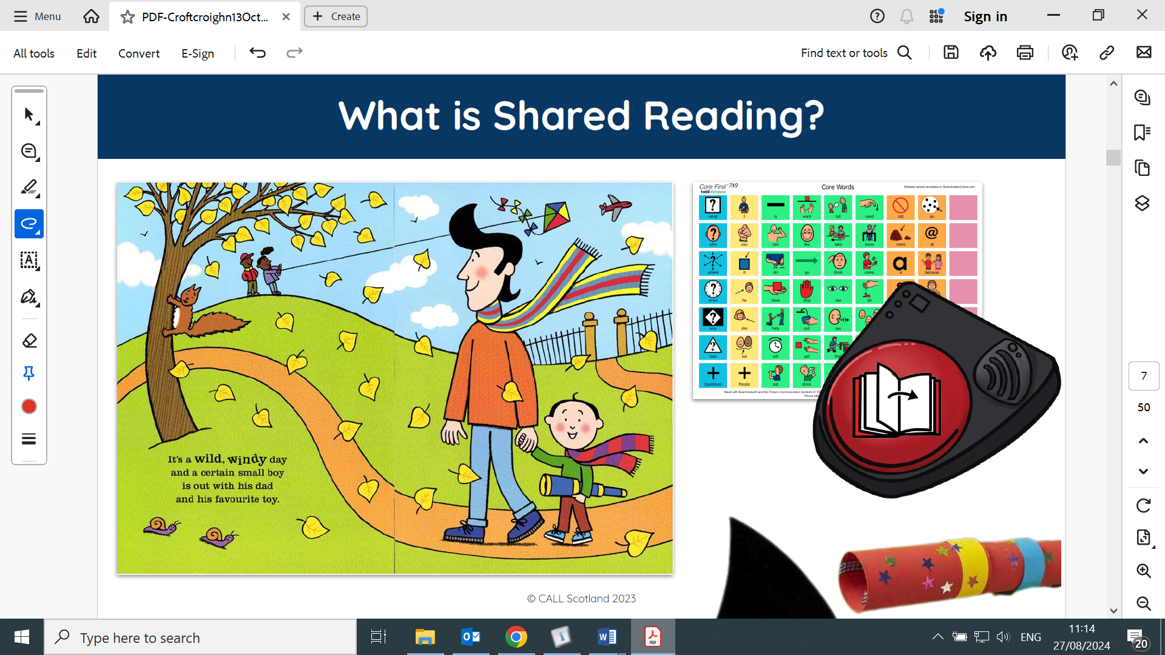
We would like to highlight the following improvements/ achievements:
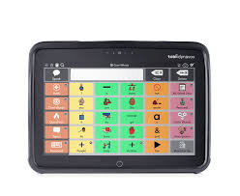
Throughout the course of the 2023-2024 school session we have continued to develop staff skills in the use of Alternative & Augmentative Communication strategies to support engagement, participation and inclusion. All staff attended ‘Core Vocabulary’ training from CALL Scotland. This focussed on how to model and use core vocabulary on various forms of augmentative & alternative communication systems. Sunnyside LCR staff joined our staff team for this session and all staff reported that they found the session very helpful.
Debbie from Tobii Dynavox came into Croftcroighn to provide some training for staff and parents of pupils who have high tech communication aids. This was also very useful and both parents and staff thanked Debbie for her support and advice. With the support of our staff and their parents our hi tech aid users are becoming much more proficient at communicating their needs and wants.
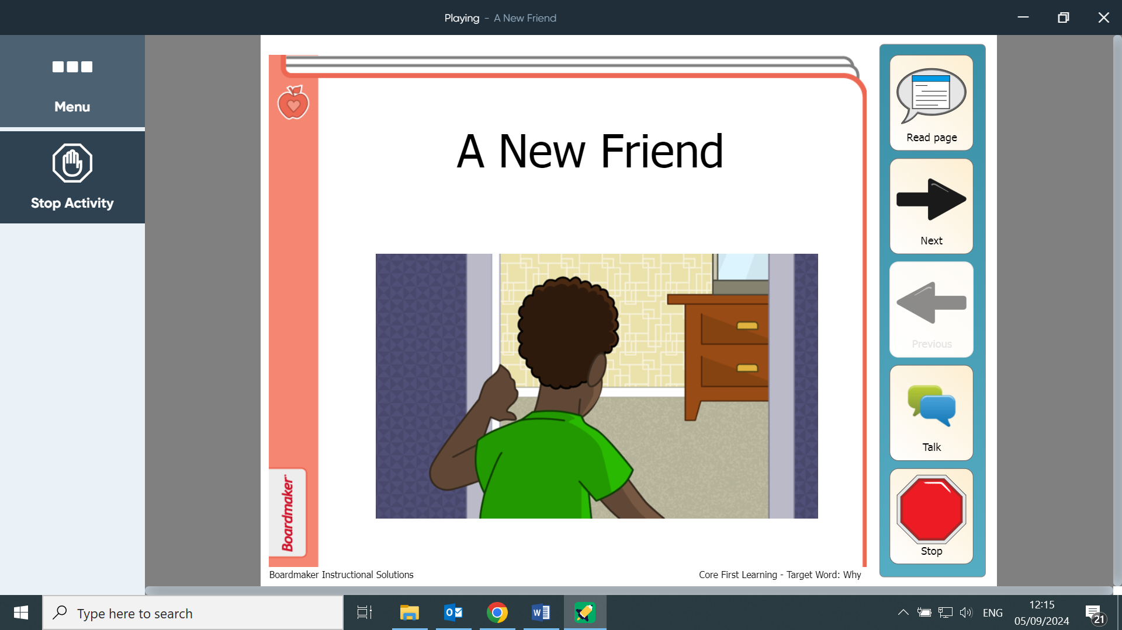
All classes at Croftcroighn now have access to Boardmaker online software, which enables staff to create personalised social stories & symbols to aid communication across the day. Many teachers have modified their core communication board to make them more easily useable for their specific class. Boardmaker also includes a core literacy programme called ’core first learning’ which has a series of learning activities to support early reading and writing tasks for children who use alternative and augmentative communication methods. These focus on the use of core words in familiar contexts. We look forward to building our experience and improving our literacy skills using this software in the coming session.

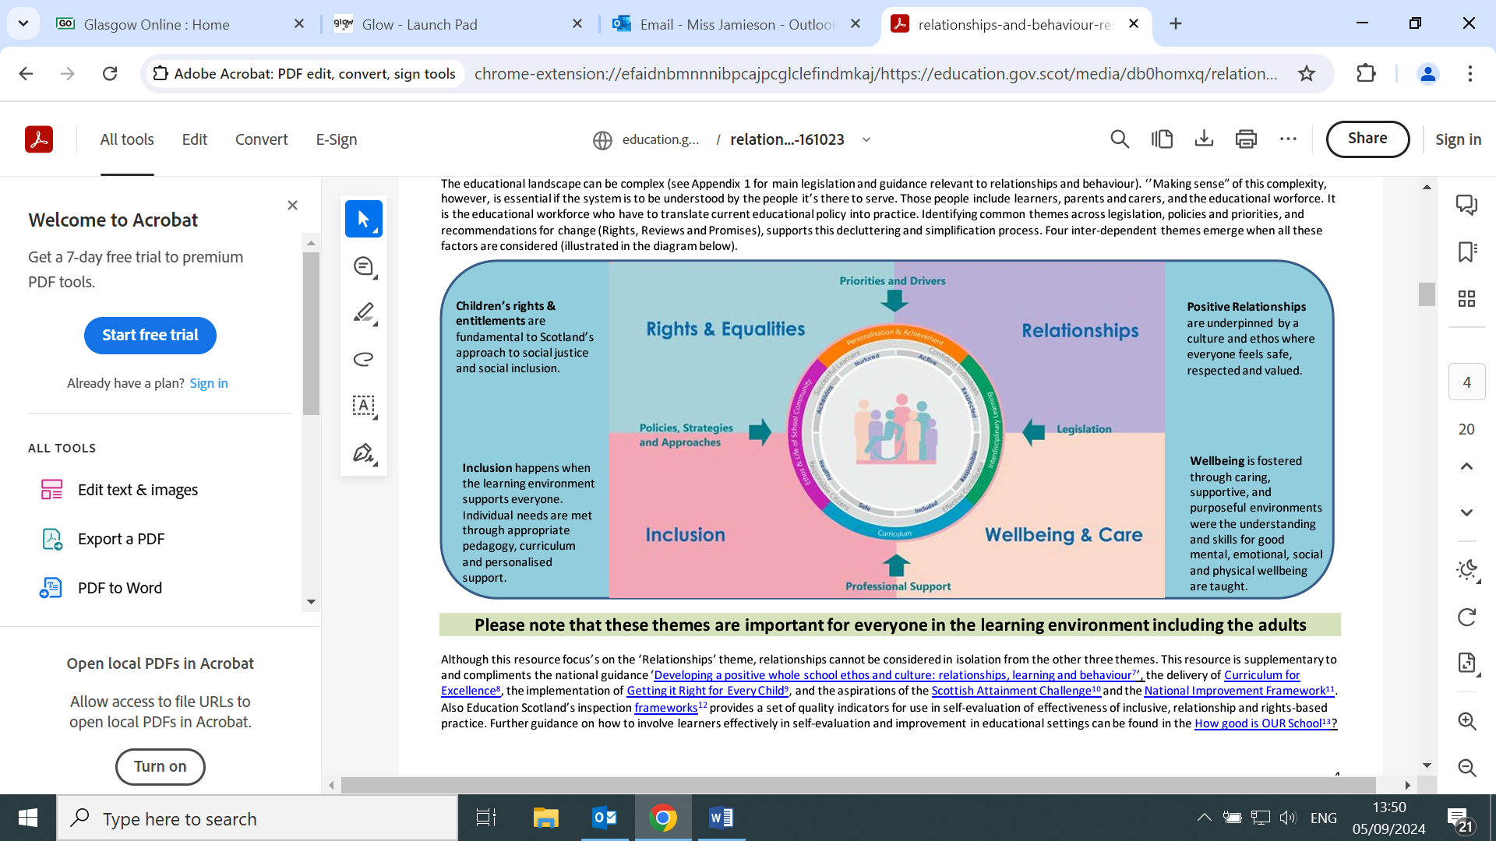
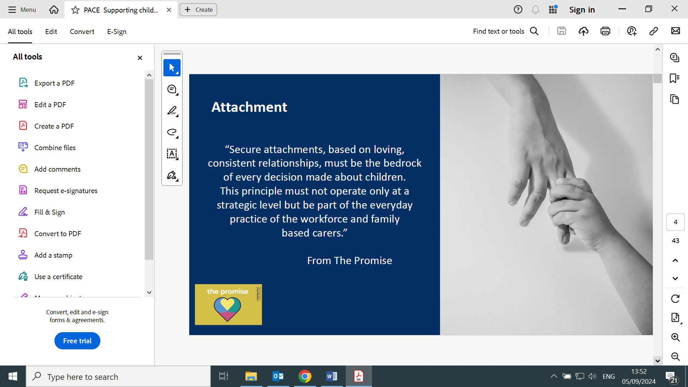
Our second challenge focussed on embedding staff knowledge and understanding of nurture approaches to promote positive relationships and understanding of distressed behaviour. In August all staff participated in training from Scottish Attachment in Action. This looked at trauma and adverse childhood experiences (ACE’s). This has helped staff to gain a better understanding of how trauma and ACE’s impact the development of the brain and the importance of relationships.
In February all staff participated in ‘Promoting Positive Relationships & Understanding Distressed Behaviour’ training. This has helped staff to develop a shared understanding of distressed behaviour and crisis incidents.
This session, both teaching and support staff have become familiar with using Teaching Talking Assessments to record individual pupils’ strengths developmentally. This information has been particularly useful when planning support strategies for regulation and has also impacted on strategies to support positive behaviour. We intend to continue to focus on developing staff skills and implementation of AAC & Nurturing approaches to promote positive relationships in the coming session.

Here is what we plan to improve next year.
1: To increase the use of a range of Alternative & Augmentative Communication strategies across the school day to support engagement, participation & inclusion. This session we have 2 staff members who have trained as Signalong Tutors. We plan to roll out a programme of training for staff and parents to promote sign supported speech. We also intend to support staff to access Boardmaker online to create low tech learning & communication supports as well as to implement the ‘Core First Learning’ resources. Teaching staff will also have the opportunity to gain greater familiarity with ‘TD Snap’ communication app which is now available on their iPads.
2: To embed staff knowledge & understanding of Nurture approaches to promote positive relationships and understanding of distressed behaviour, we plan to explore the use of the ASN Emotion Works Debrief tool to analyse incidents & plan future support strategies. We intend to complete Studio 3 Low Arousal Training, which we hope will support our staff to not only understand the approach, but also implement it in a range of settings.

How can you find out more information about our school?
Please contact us directly if you require further information or if you wish to comment on the report.

The contact e-mail address is: headteacher@croftcroighn-pri.glasgow.sch.uk

Our telephone number is: 0141 774 3760
Our school address is: Croftcroighn Primary, 290 Mossvale Rd, Garthamlock, Glasgow G33 5NY

Further information is available in: newsletters, the school website, and the school handbook

