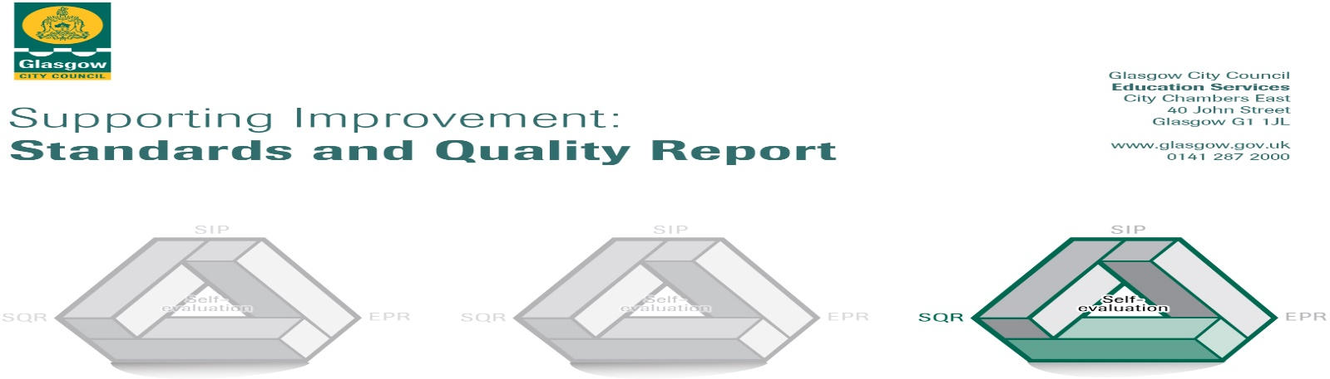

The summary report is provided for parents/careers and partners to outline our achievements this session and our priorities for next session. Throughout this session we have taken forward our priorities as detailed in our school improvement plan. Through our processes of self-evaluation, we have identified how we can improve outcomes for our children and young people.

Our achievements and improvements this year.
We would like to highlight the following improvements/achievements:
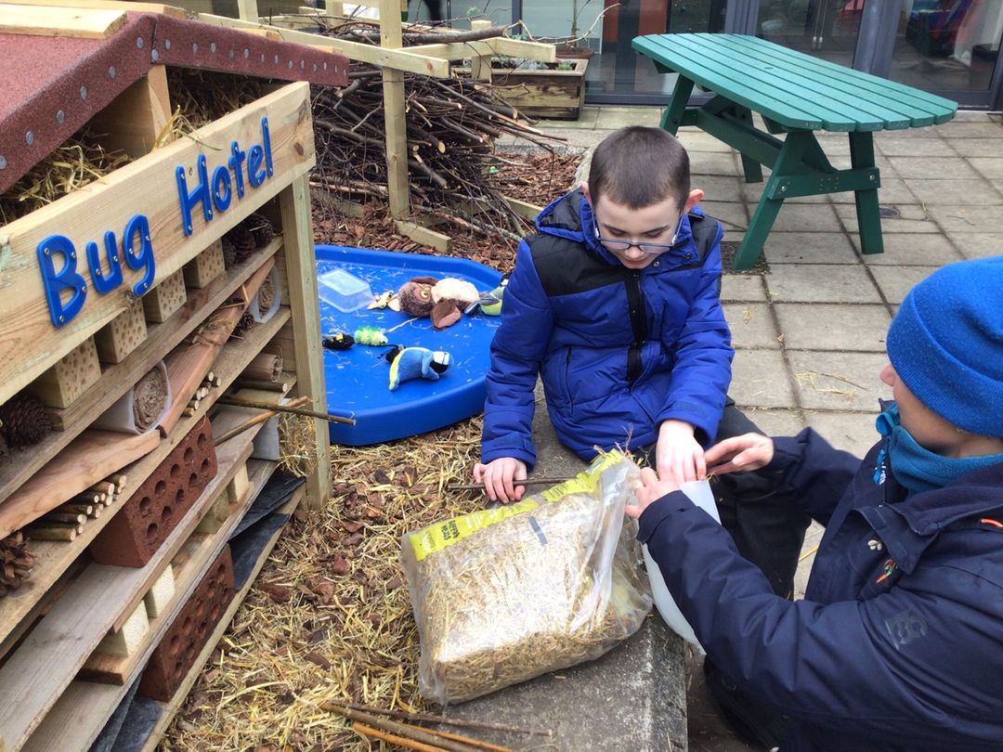
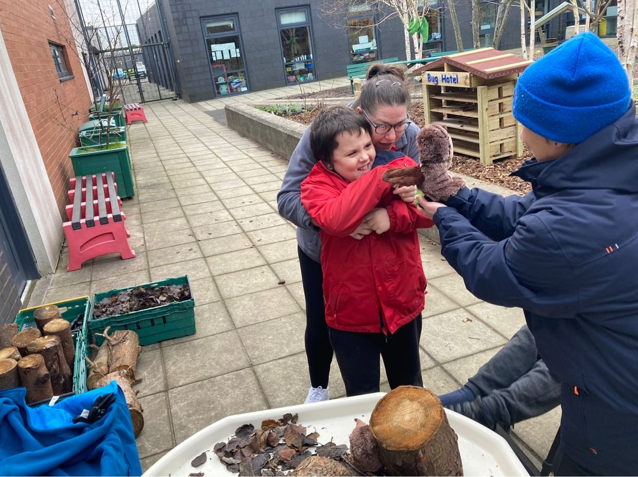
Throughout the course of the 2021-2022 school session we have focussed on developing our learning environment. During the course of the year we worked with ‘Sowing Seeds’ to develop our sensory garden. This has now been replanted with a variety of herbs, shrubs and flowers which provide scents, textures and sounds to stimulate interest and prompt our pupils to explore. All classes were able to participate in workshops with ‘Sowing Seeds’ staff to promote outdoor learning. In addition, teaching staff received 2 training sessions on outdoor learning and how to use the natural environment for learning 7 teaching.
We also focused on developing our playground to ensure that the equipment available is interesting to our pupils and meets their sensory needs, while also being accessible. The charity ‘Dreams Come True’ worked with us to provide funds to install a range of new equipment including accessible swings, spinning pots and an inground trampoline. This equipment has been particularly beneficial for supporting our pupils with their sensory needs and emotional regulation.
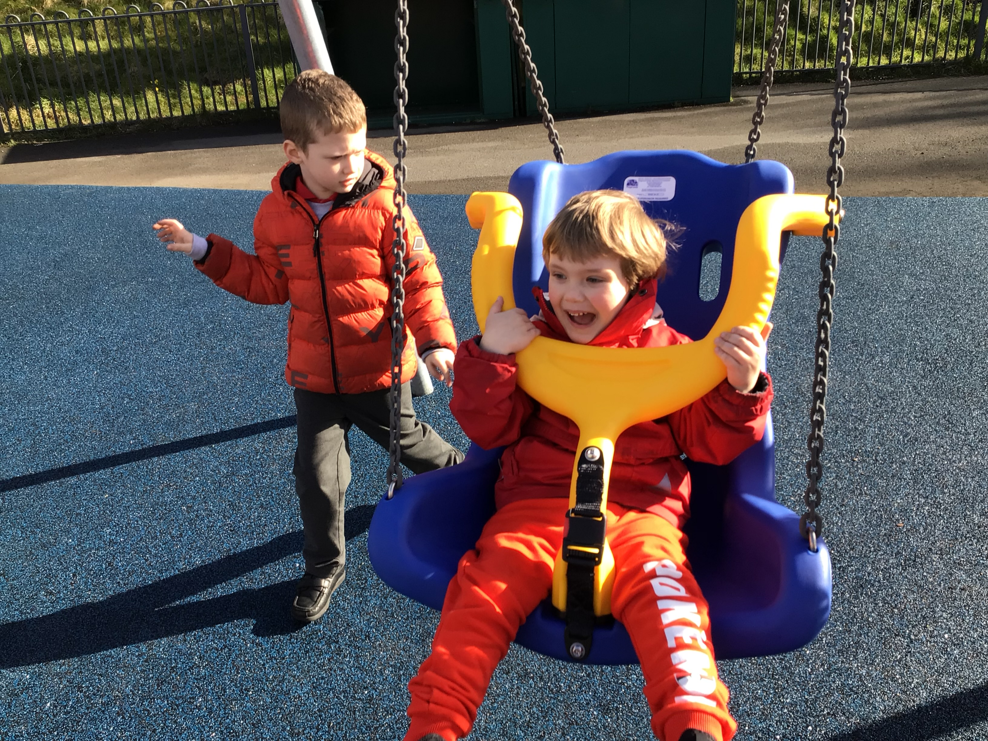
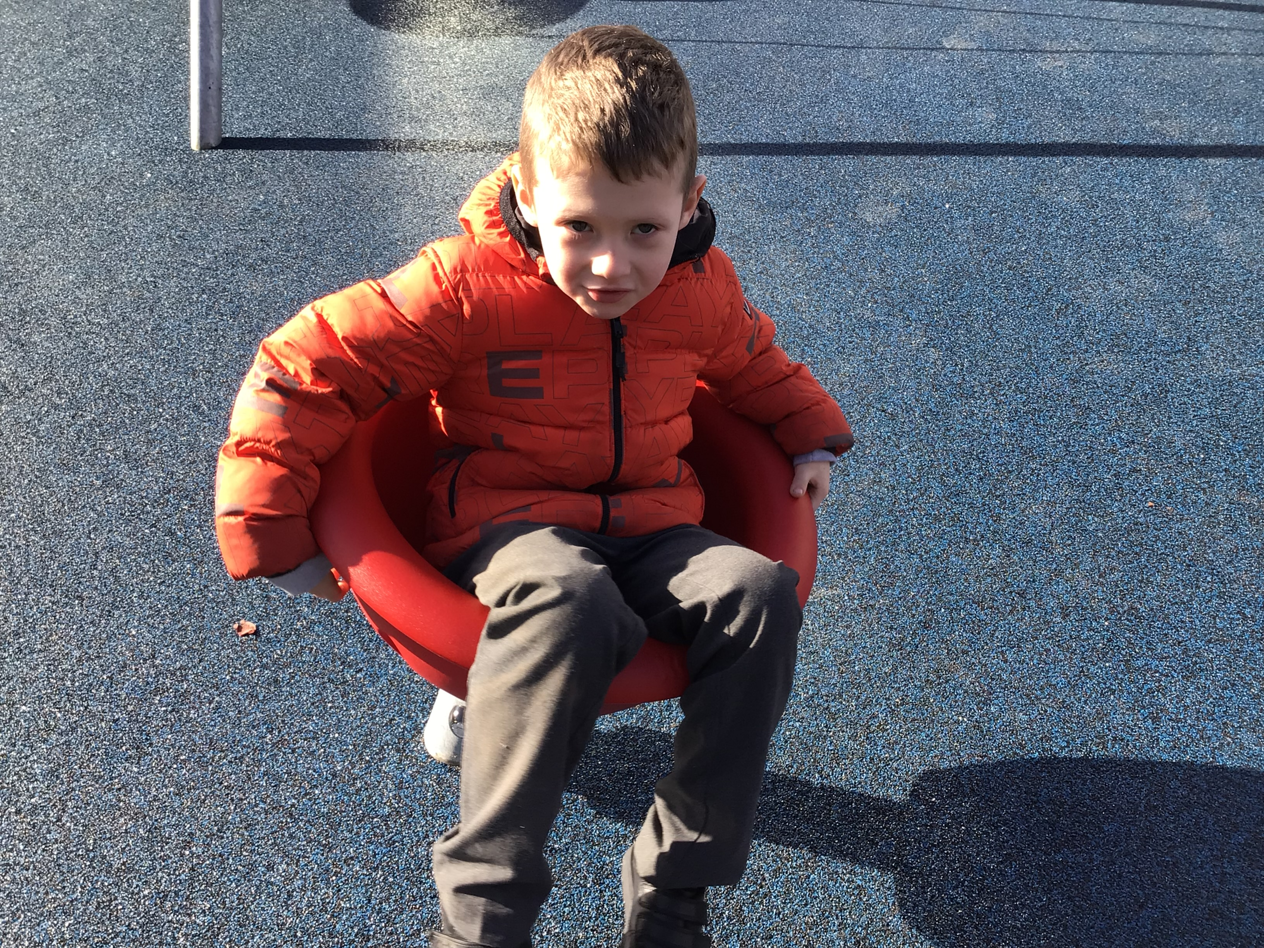
Additionally, we have worked with Jupiter Play to plan and install a new high quality wooden climbing structure, which has an accessible ramp & a double width slide to enable all pupils to use the equipment. We recognise the importance of play in learning & the challenges that many of our families face trying to access play spaces in their local communities which meet their child’s needs in terms of safety and accessibility. The developments in our environment have been very well received by our pupils.
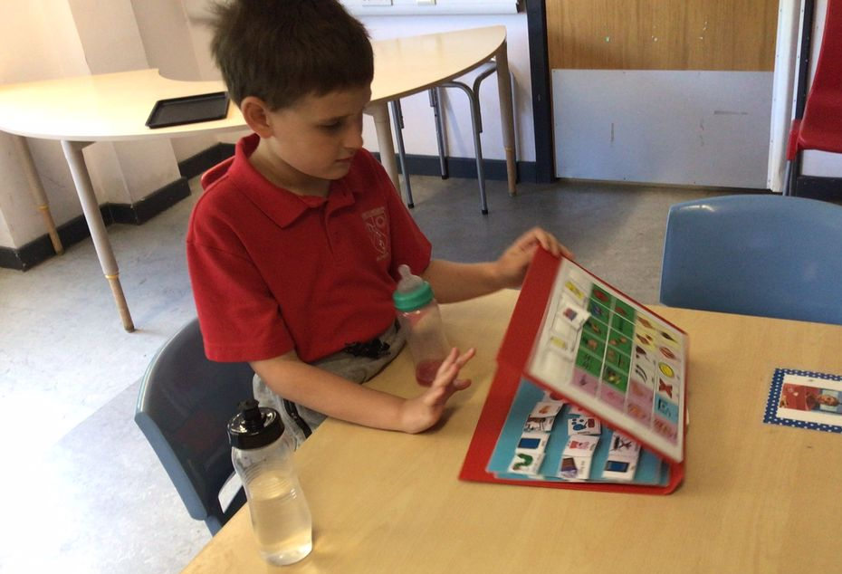
We also focused on working on developing the use of core communication boards across the school. While progress has been made in this area, we intend to work more on developing the use of AAC (Augmentative & Alternative Communication) & ICT in the coming year.

Here is what we plan to improve next year.
1: To develop trusting and supportive relationships within the school and beyond, e.g. with school colleagues, parents, Glasgow CLN colleagues, and wider community colleagues with a view to sharing /developing practice to better support the needs of individuals.

2: To review our curriculum planning to ensure all children have access to a breadth of experiences taught through relevant contexts, as well a specific target planning to meet individual needs.

3: To develop our learning & teaching to incorporate a broader range of ICT software & AAC to enable greater personalisation and adaptation of learning to meet individual needs.

How can you find out more information about our school?
Please contact us directly if you require further information or if you wish to comment on the report.

The contact e-mail address is: headteacher@croftcroighn-pri.glasgow.sch.uk

Our telephone number is: 0141 774 3760

Our school address is: Croftcroighn Primary, 290 Mossvale Rd, Garthamlock, Glasgow G33 5NY

Further information is available in: newsletters, the school website, and the school handbook

