My Covid-19 rules
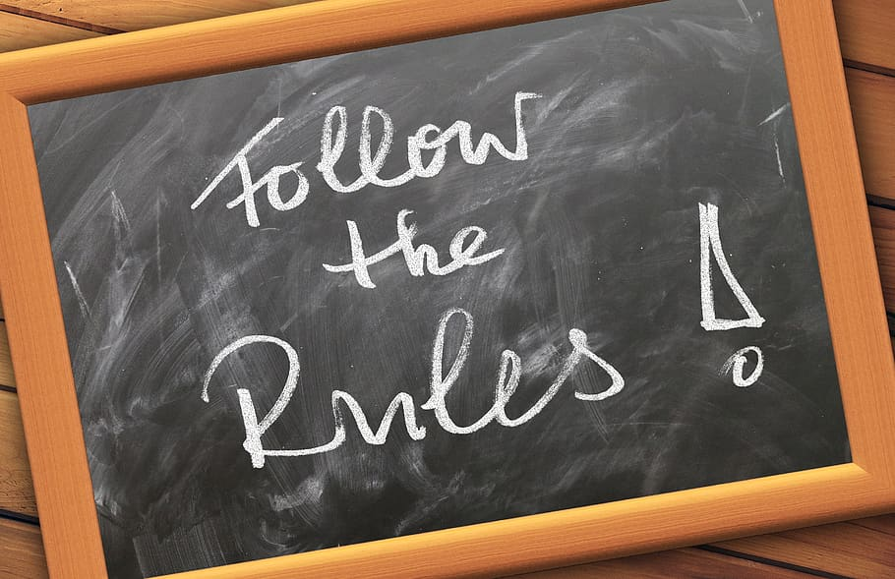
If you were able to design your own Covid-19 rules, what would those be? In this activity, learners will create a 1-page board with the rules that they would like to implement during this period.

INSTRUCTIONS
- Think about 3-6 rules that you would like to see others around you follow. Think about who the rules are for (your immediate family, your friends, family members in another country). How do you plan to present your rules so people understand and follow them (e.g., what images will you use? what words/statements would you like to include?)

- On a board (or a piece of paper) design your rules according to the following grid:

- On your board, you can use drawings, words, symbols, emojis and painting – anything that you would like to show what each of your rules is about.
Note: Your rules do not need to be official rules that you have heard on TV or in your house. Be as creative as you would like and put forward rules that you think may be missing from what you hear around you. Here is an example:
Regula 1: Uita-te pe geam cu cineva timp de 10 min
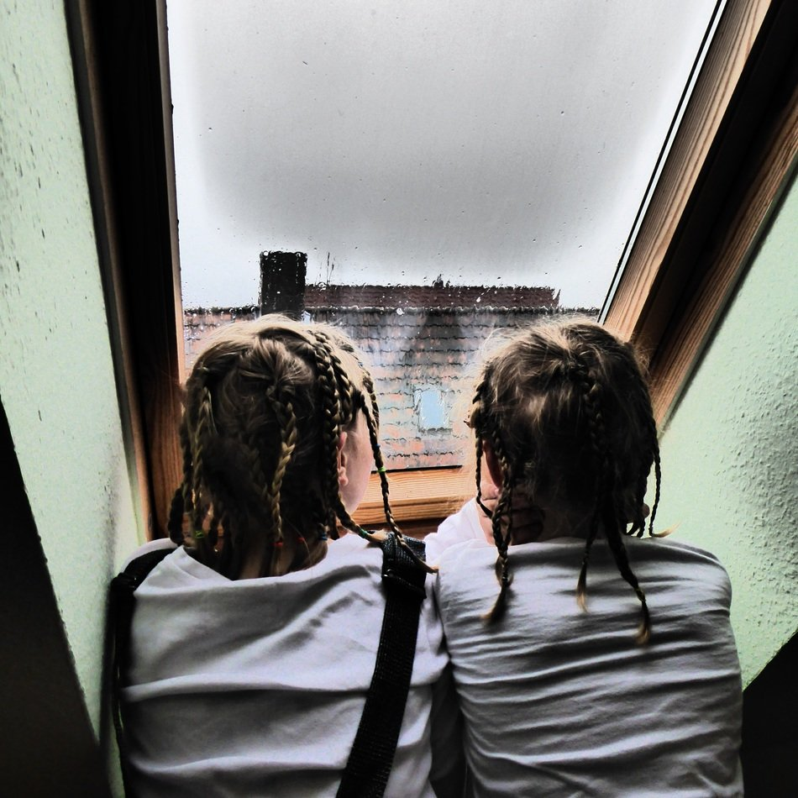

© Lavinia Hirsu, 2020
For more activities, visit the Resources tab on our project website
https://blogs.glowscotland.org.uk/gc/creativepracticestranslang/

