MY LANGUAGE PASSPORT
(or travelling around from home)
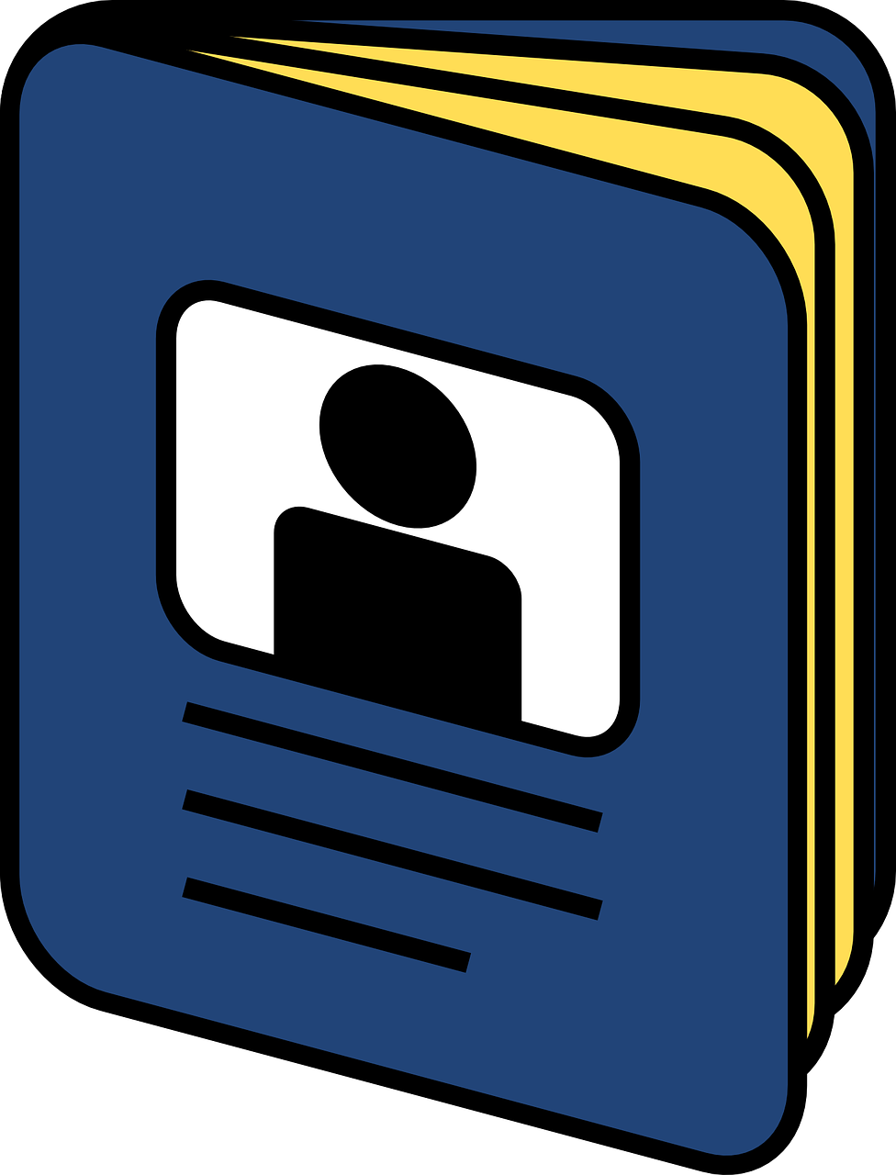

Passports are documents where we collect stamps from the places we visit. In current times, though, we may have to stay at home rather than travel from one place to another. So how can we keep our passports active? With this activity, you will create a language passport where you will collect language stamps.

INSTRUCTIONS
- Take a piece of paper and fold it to look like a booklet. You can search online how to fold your paper OR feel free to fold the paper however you like.

- Now begin your journey! In your passport, write language stamps: the words you love, the phrases you hear around you, the words you dream about or the funny things you love to hear or say to your friends. It doesn’t matter if these words are in English or in any other language. The important thing is that you keep adding language stamps to your passport in as many languages as you can and know.
Sunt puternic!
(I am strong!)

- Now, add the words and phrases from other people too. How? Ask your family to teach you the words they love. Talk to your carer about funny phrases they know. Give your grandma a call and ask her about her favourite words in her language(s). Have an online chat with your uncle and ask him to share a phrase he learned when he was young or travelled to other countries. Learn a new phrase or saying from a movie or a song. If you don’t know how to write in all the languages you hear around you, no worries! Make a drawing or a sign that will help you remember your language stamp.

