TRANSLANGUAGING COMICS

Do you like storytelling? Stories can be told in many ways, some people like writing novels, others make films or act the stories on stage, others yet - draw comics. Drawing comics can be a combination of everything: you can draw, paint, cut out pictures and words from newspapers and you can write whatever you want. Better yet, you can use any language and any tool you have at hand!
Drawing by a participant of the CPD workshop 2019

Monika Szydłowska, an artist from Poland, moved to Scotland with just a set of watercolour paint and pencils and created a story about her new life in Scotland. There were many things she found funny or strange in her new life and she documented them. She drew people she met or others she saw on the street and wrote down conversations she heard around her. She used many languages in her comic (and sometimes no languages at all!).

You can create your own comic journal documenting current times, or you can ask your friend or a family member to tell you a story from their life so you can draw it, alternatively, you can draw a story that has happened only in your imagination!

INSTRUCTIONS
- Look at the examples of Szydłowska’s work below.
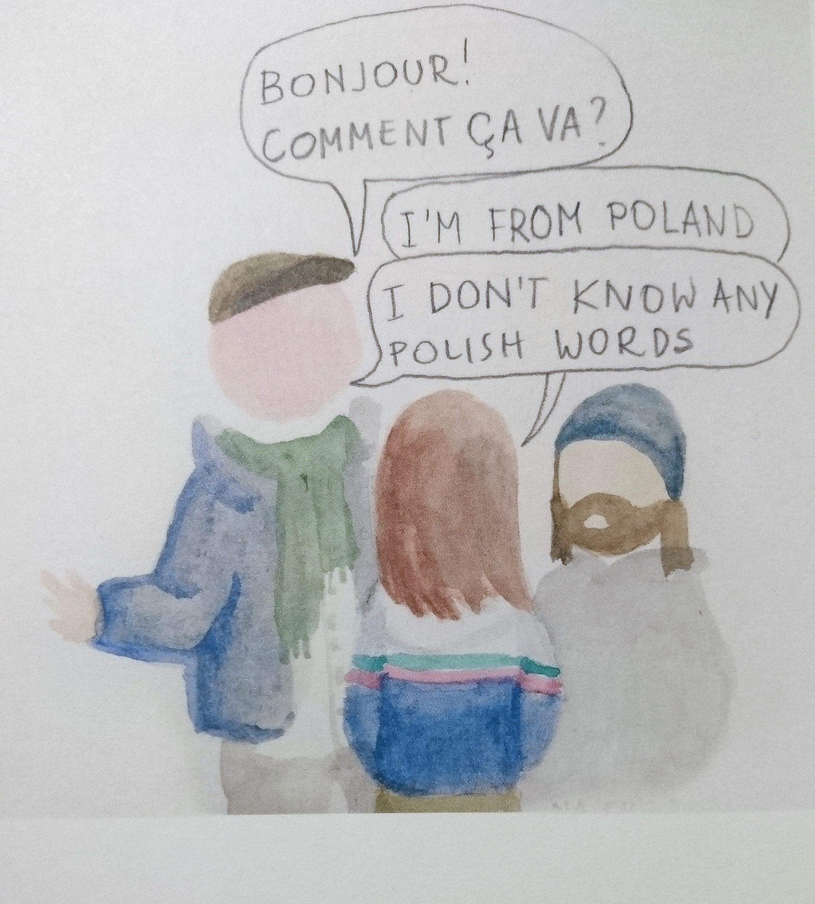
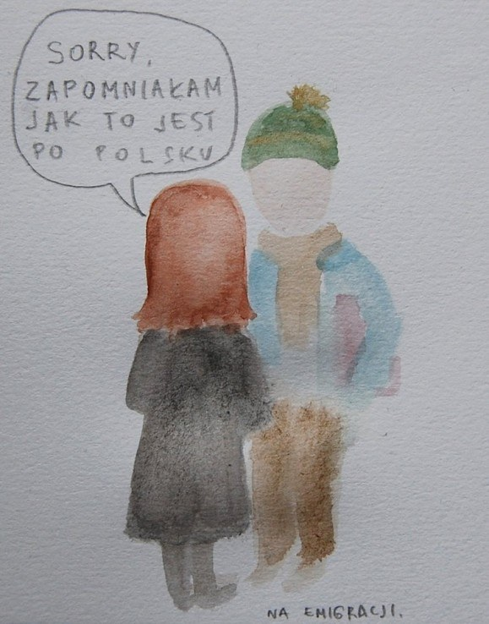
Sorry, I forgot how to say it in Polish

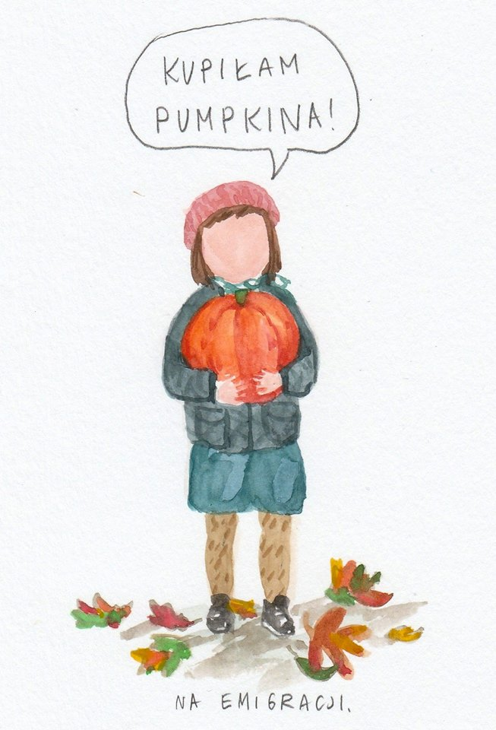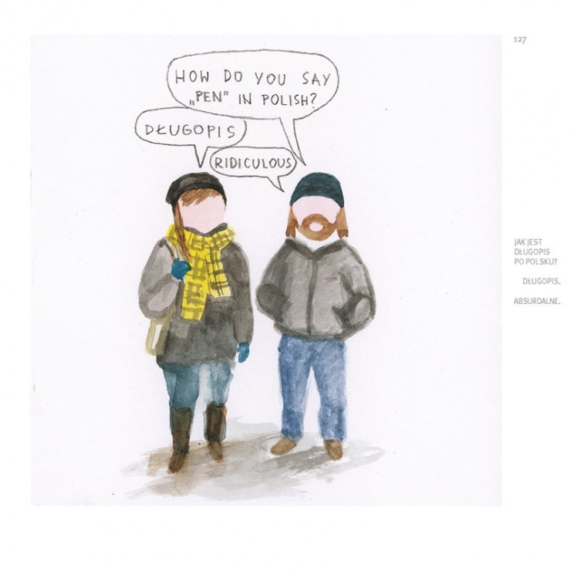
I bought a pumpkin

(You can find more on our project website https://blogs.glowscotland.org.uk/gc/creativepracticestranslang/resources , in her book: http://centrala.org.uk/shop/do-you-miss-yourcountry or on the Facebook page with her latest work: https://www.facebook.com/Na-emigracji-259304500883225 )

- Read the conversations, what do you think about them? Are they funny? Strange? Usual? Why do you think she wanted to draw them?

- Look at the way she painted people and objects – try it! You can use watercolours and pencils as she did or use anything you have at hand –pens, pencils, crayons...
Activity 1

- Look at one of Szydłowska’s drawings and imagine what might have happened next. Did a person in her drawing say something? Who might have answered them? What did they say? What did they do?

- Take a piece of paper, a pencil, brush and paint or crayons, or pens. Draw what you imagined. Remember to add speech and thought bubbles with words or emoticons. You can use words in any language.

- And now? What happened next? Make another drawing.

- And another one, and another… let the story develop into a long comic strip.

- You can collate all your drawings to create a book or display it one next to another and share your story with others.

Activity 2

- Look around, see what people do, listen to what people say. Has anything drawn your attention, felt funny, unusual or striking?

- Take a piece of paper, a pencil, brush and paint or crayons or pens. Draw what you have seen and heard. It doesn’t matter if the words in the speech bubbles are in English or in any other language. The important thing is that you document them as you heard them, adding drawings to your comic when you see, hear or think up something interesting, funny or strange.

- You can make a drawing every time something stroke you. After a while you will have a collection of drawings you can bind into a book.

Activity 3

- Take a piece of paper, a pencil, brush and paint or crayons or pens.

- Think. Who is your story going to be about? You? Your brother, grandma, your friend or a cousin? Someone else? What did they do? What did they say? How did they say it? Has someone else said something to them? What and how? In what language(s)?

- Take a piece of paper, a pencil, brush and paint or crayons or pens. Draw what you imagined. What else happened? And what happened next? Let the story develop! It doesn’t matter if the words in the speech bubbles are in English or in any other language, set your imagination free - draw and write what you want and how you want it!

