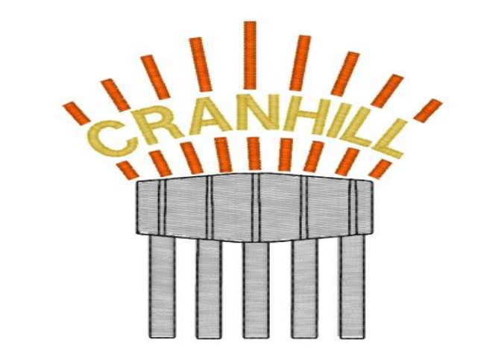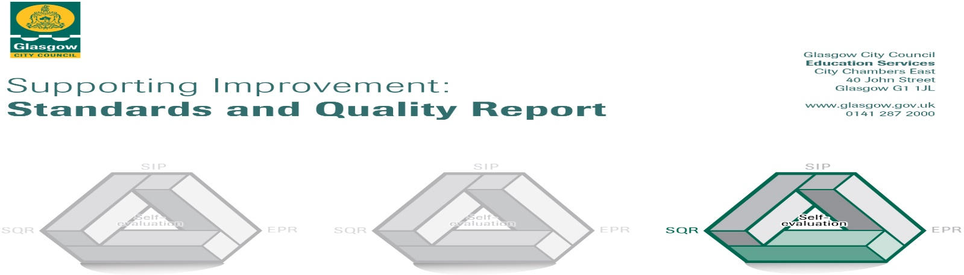

The summary report is provided for parents/careers and partners to outline our achievements this session and our priorities for next session. Throughout this session we have taken forward our priorities as detailed in our school improvement plan. Through our processes of self-evaluation, we have identified how we can improve outcomes for our children and young people.

Our achievements and improvements this year.
We would like to highlight the following improvements/achievements:
Key Developments
This year we worked on three key areas for improvement. Children, parents, staff and partners worked together throughout the year to achieve:
HWB: Inclusion, Nurture and Equity – Our actions to improve inclusion and equity for all began with a whole school approach to further embedding the principles of nurture. The aim of this improvement work was to develop consistency in our approaches and develop a calm, purposeful ethos where all children participate and engage well in the life of the school. Throughout the year all staff were involved in reviewing our relationships policy and in-house training was undertaken to review our approaches, ensuring all staff all had a clear understanding of our core values and vision for our school.
To ensure all staff had a secure understanding of how to create environments to support all learners, staff undertook training and implemented the Circle Framework for their classroom environments. Staff at all stages worked with pupils to create classroom charters linked to the UNCRC. Teaching and support staff made a commitment to training, using a new positive reward system - ‘Good to be Green’. In line with this we improved the pupil voice within the school. A new house and school parliament was created to support school improvement. This also led to leadership roles for pupils including House and Vice Captains, Sports Leaders, Eco Warriors, Peer Mediators and Librarians. Regular whole school assemblies focused on aspects of Global citizenship including children’s rights, child labour and rights respecting schools work. As a result of these processes, the most of children behave positively and show high levels of respect for themselves, adults and peers. Our children are now becoming more confident that their views will be sought, listened to and acted upon. Our work to establish a rights respecting culture has been further enhanced by our annual review and the award of the UNCRC Bronze award. In addition, our Eco Warriors led the school to achieving its first ever green flag for our work on sustainability.
Staff at all stages have continued to work collegiately to develop and action research on our work with Paul Dix (When Adults Change Everything Changes) in order to improve pedagogy and equity. All staff communicate high expectations to all learners through daily discussion on our values and newly introduced learning conversations.
A review of ASN was carried out with teaching staff. This work took place out with the working time agreement and demonstrated the commitment of staff to get things right for all pupils. This led to the implementation of a better understanding of staged intervention and assessment to meet the individual needs of all learners.

A new Parent Council was formalised this year. This has led to a stronger partnership with parents and ensured they are fully involved in planning and decision-making related to meeting the needs of children. Parents also developed a greater understanding of the school current academic position and created more opportunities for involvement and engagement with the life of the school.

In the last school session, we used PEF funding to employ a worker from Calming Minds and workers from Junction 12 to work with target groups of children on a weekly basis to support good mental health and readiness to learn. The school also employed a Family Support Worker through FARE to support individual families and children, by establishing a consistently present relationship, which promotes overall family wellbeing, engagement in activities, prevention of crisis and a response to need.

Learning, teaching and assessment: Raising attainment in literacy and Numeracy –
Overall, children are making good progress in their learning. Improve focused approaches to moderation of assessment and professional judgements in literacy and numeracy and early intervention strategies in numeracy, reading and writing have been achieved this year.
All staff undertook and completed assessment and moderation training. This allowed them to gain a better understanding of the key messages on moderation. Furthermore, it helped focus on approaches to high quality holistic assessment to ensure impact on learning and teaching.
Our actions to improve learning, teaching and assessment approaches in literacy and numeracy continue to be a significant piece of work funded by our Pupil Equity Fund allocation. The school recognises the need to improve levels of attainment in reading, writing and mathematics at all levels. There is evidence to show that attainment levels have improved in line with improvement work this year, in almost all areas.
Pupil equity funding has ensured a suite of resources were provided in all classes to enhance learners’ experiences. This includes our developments to use a Maths Mastery approach in all classrooms. Furthermore, staff have reported that our developments and partnership working with ‘Count on Us’ are having a positive effect on mental mathematics. Our work in this area has positively impacted on attainment and achievement. This has been reflected in our attainment data particularly at P1 showing the majority of the children are on track to achieve expected levels in numeracy and mathematics. We are confident that by the end of 2023 2024 that most pupils in P1 will be on track to achieve appropriate levels of numeracy and literacy.
We have also developed literacy implementing a consistent approach to handwriting, improving our approaches to reading, and in particular improving our assessment of reading levels. This has led to a higher level of challenge and expectation across the school. A whole school approach to fiction and non-fiction writing was undertaken with structural models by Alan Peat provided for all staff. This has led to increased confidence in the teaching of this area.
A new early intervention structure was implemented. At early and first level, those children ‘not yet on track’ have been identified and targeted intervention planned for. It is anticipated that at second level the number of children ‘not yet on track in literacy and numeracy’ will reduce as a direct result of our interventions. Targeted intervention is planned for individuals and small groups of learners in literacy and numeracy at early, first and second level. This support will come, in main, from the class teacher. At this time, we recognise that overall attainment is satisfactory. It is anticipated that this will move to good with the improvements put in place in the near future.

Learning pathways in all curricular areas are now in place for all areas of literacy and numeracy. We will continue to develop these as and when necessary.

CFE: Development approaches to assessment - Enhanced knowledge and understanding of assessment strategies to raise attainment.
Children in Cranhill Primary School are making good progress in their learning. The school is moving to a position of better consistency in the use of both formative and summative assessments, as well as standardised tests to support our judgements about pupil progress. We have a clear calendar of assessments in place to track children’s progress.
The ethos of Cranhill Primary is positive and purposeful. Our children are enthusiastic and engaged participants with most interacting well with others. Class teachers ensure pupil learning experiences are challenging and enjoyable.
Assessment is part of the planning of teaching and learning in Cranhill. Assessment approaches allow children to fully demonstrate their knowledge and understanding in a variety of learning styles.
Assessment throughout the year highlighted an improvement in attainment particularly in reading and numeracy. Our assessment strategy has continued to improve and ensures staff measure the impact of teaching approaches at very regular periods allowing for prompt intervention when necessary. There are robust systems in place to ensure children’s needs are analysed and met. Technology is used effectively to support this. Reviewed teaching pedagogy in literacy and numeracy has raised attainment across the school with staff ensuring learning experiences are challenging, well-paced and enjoyable. Moderation activity both in school and across the learning community has had a significant impact in ensuring high expectation in all classes.

Progress in children’s learning, raising attainment and recognising achievement
Last session we ensured our children received as wide and varied an experience as possible. We were fortunate to be able to enjoy many more class trips and visits this session.
Almost all children in Cranhill make good progress from previous levels. Attainment in numeracy, reading, writing, listening and talking is an area we will continue to focus on and we predict that most children will achieve high levels of attainment in the near future.

We ensured that we delivered a high-quality service by:
- Focussing our PEF funding on providing Additional Support for Learning for targeted groups of children. We can evidence an improvement in attainment for children who have received this. Having additional staffing in place to provide both support and challenge to children in our school has had a positive impact, ensuring attainment has been raised and working to close the attainment gap.
- Developing our whole school literacy approach with the purchase of new resources has impacted positively on the pedagogy of our teaching staff. Focusing on the development of reading skills amongst children across the school and staff training and continuous development using Read, Write, Inc is an area for further improvement.
- Developing our Mathematics programme using the Maths Mastery approach to learning and teaching. Children’s confidence in mathematics and applying learning has increased.
- High quality assessment has supported the gathering of assessment data and has provides teachers important information to guide instructional decisions.
- Family learning has had a significant impact on engagement with our families. Sharing learning and skills development with families has impacted very positively and this is an area we will focus on in the future.

Here is what we plan to improve next year.
Following on from completing self-evaluation the following areas have been identified as improvement priorities for the coming session:
What do we want for our children?
Our key drivers are underpinned by our desire to secure ‘Excellence and Equity’ for all. It is our goal to motivate and inspire all learners to be the best they can be, to aim high and be supported in their learning journey to continually improve and develop; raising attainment and achievement for all. At the heart of our school community are our children and families. We have high expectations and aspirations for all.
Our learners have an entitlement to a broad and progressive curriculum which will enable them to:
- achieve the highest possible levels of literacy and numeracy and cognitive skills
- develop skills for learning, skills for life and skills for work
- develop knowledge and understanding of society, the world and Scotland's place in it
- experience challenge and success so that they can develop well-informed views and act responsibly

1: HWB: Wellbeing, Inclusion, Equalities and Equity: Wellbeing, diversity and equality. –This is a key area of development for Cranhill Primary next session. Restorative approaches will form a key part of this work focusing on building, repairing, and sustaining positive relationships as opposed to managing and controlling behaviours. It is a philosophy which promotes wellbeing through positive interactions in our daily lives. A restorative approach in Glasgow schools is underpinned by three main themes:

1. Relationships promote positive and attuned interactions.
2. Accountability and responsibility for self and others.
3. Children and young people are active participants in conflict resolution.

To complement this improvement work we will also provide training for all staff on developing the work of Paul Dix: ‘When Adults Change, Everything Changes’. This will focus on the following:

• Establish clear boundaries
• Manage tricky behaviours with a relational focus
• Create a plan for every day and a plan for the difficult days
• Engage in serious systems thinking
• Know how to manage one’s own response
• Develop teachable moments
• See how behaviour communicates
• Time to rethink and reflect

2: Learning, teaching and assessment: Raising attainment in Literacy and Numeracy: Development of Learning, Teaching and Progression in literacy:
Improving approaches to learning, teaching and assessment in reading to enable all children to make the best possible progress in their learning. Develop our use of progressive learning pathways as a learning and teaching tool to ensure progression for all in literacy. Our Class Leader of Learning will be completing Literacy for All training. There is a need to ensure there are opportunities for challenge and support in this curricular area. Reading and writing continue to be an area for development. We believe that if we put the teaching of reading at the heart of their school and ensure teachers have the knowledge and determination to teach every child, regardless of age, background or need this will have a significant impact on attainment of both reading and writing. All staff will therefore participate in training and development sessions from Oxford Owls and moderation meetings across the school to improve teaching methods in phonics and reading. We will also continue to develop benchmarking techniques so that all staff will accurately assess and identify children correct reading level

We are particularly concerned about those children who are not succeeding – particularly at the first level – and monitoring will very much focus on the support those children are receiving. Additional opportunities for Support for Learning will be made available to support children who are not reaching key levels.

Development of Learning, Teaching and Progression in Numeracy: There is a need to review learning progression pathways to ensure clear progression of learning and skills development embedded within the Whole School Numeracy and Mathematics programme.
Currently all staff have a clear understanding of the methodology, assessment approaches & teaching resources to ensure progression in Numeracy and Mathematics. We wish to further embedded this with our work on Maths Mastery and through our partnership with Count on Us. Parents and pupils are included, participating and progressing, leading to greater engagement in the life of the school. All staff have a clear understanding of skills progression and can select appropriate assessment opportunities to measure learning and gather relevant evidence.

3: Connected Learning: Develop digital approaches, thinking skills, physical education and formative assessment across the curriculum:
Use of digital technology for profiling and sharing learning and achievement with families has impacted very positively. Our self-evaluation now shows a need for the development of the pedagogy of digital learning and use of a range of apps to improve pedagogy and engagement within the classroom.
In line with our teaching and learning policy there is a need for whole school development of thinking skills to support higher order skills development and further development of Developing the Young Workforce.
We wish to develop staff expertise in P.E. at early and first level to offer children quality-learning experiences and promote long life attitudes to positive wellbeing for all of our pupils.
Finally, there is a need to improve focused approaches in use of formative assessment. In doing so we will strengthen professional judgements in literacy and numeracy and early intervention strategies in numeracy, reading and writing. In addition teacher will collect detailed information that can be used to improve instruction and pupil understanding.

How can you find out more information about our school?
Please contact us directly if you require further information or if you wish to comment on the report.

The contact e-mail address is: headteacher@cranhill-pri.glasgow.sch.uk
Our telephone number is: 0141 7711235
Our school address is: 17 Skerryvore Road, Cranhill, G33 3LA

Further information is available on:
- School Blog - https://blogs.glowscotland.org.uk/gc/cranhillprimary/our-school/contact-us/Newsletters
- Twitter - @CranP
- Scot Ed School App
- The School Handbook 2023-2024
- School Improvement Plan 2023-2024

