 | Mathematics First Level  Remote Learning Activities | WEEK 1

Day 1 | Number Sense  You have the following digits… 7, 5, 2, 4, 6, 3. What is the largest 2-digit number you can make? What is the smallest 2-digit number? Work out your answer here:  Equality (Source: https://www.openmiddle.com/)  Using the digits 1 to 9, at most one time each, fill in the boxes to create a true number sentence with the greatest possible value.  Space to add your working  Counting  How many oranges are there? How did you count them? (Source: visualpatterns.org)
Day 2 | Word Problem  There were 3 apples on the table. Jan put 6 more apples on the table. How many apples were on the table in all? Show your work. (You may want to draw a picture below)  Guess My Number Game  Materials: None (Pencil and paper optional)  This is a great game you can play anywhere. One person thinks of a number between 1 and 10 (or 20, or higher), and the other players try to guess the number. After each guess, the person with the number says whether their number is greater or less than the guess. Guessers try to get the number in the fewest number of guesses possible. (Source: mathforlove.org)  Interpreting Data  Make a graph that shows a possible result of 7 freind’s favourite colour with red being the most popular colour. (Source: https://www.openmiddle.com/)  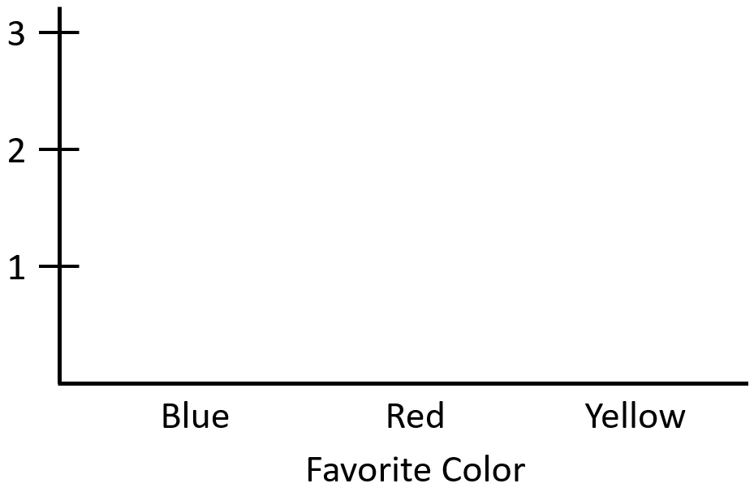  Favourite Colour
Day 3 | Drawing  Make a picture that is worth 14p .  You can use as many as you like of these shapes.  Label your picture.  Prove that it is worth 14p. (Source: mathlearningcenter.org)  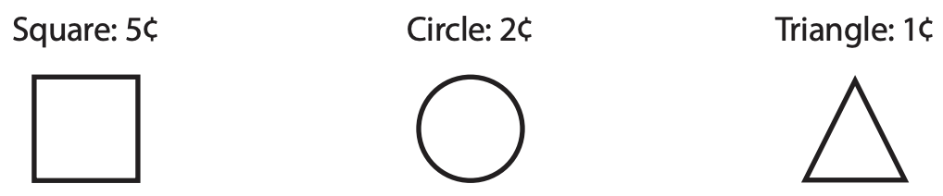  1p  2p  5p  This picture is worth 16p  2p  2p  2p  2p  2p  2p  2p  2p  Use this space to draw your picture and calculate the price.  Which One Doesn’t Belong?  Choose one shape in this picture that you don’t think it belongs with the rest. Explain why. Can you pick another shape and give a different reason? (Source: wodb.ca)  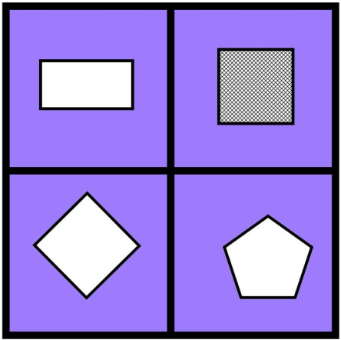  Noticing  In one column, list the things that are the same in this picture, and in the other column, list the things that are different. (Source: https://samedifferentimages.wordpress.com/)  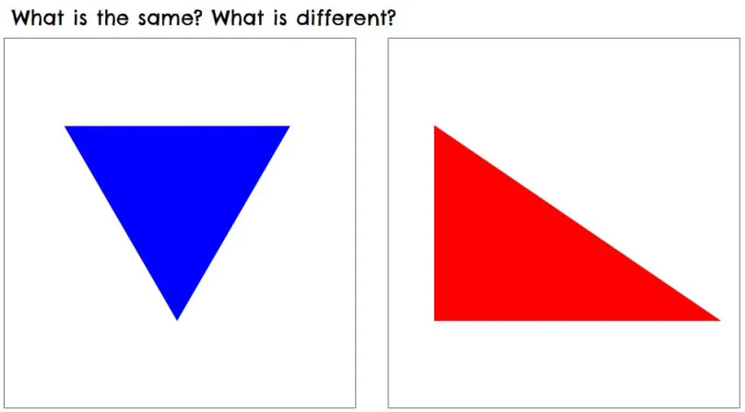  Same Different
Day 4 | Double Dot Cards for 11. (Source: mathlearningcenter.org)  Draw the dots on the right-hand side of each card to make 11. Write a fact family to match.  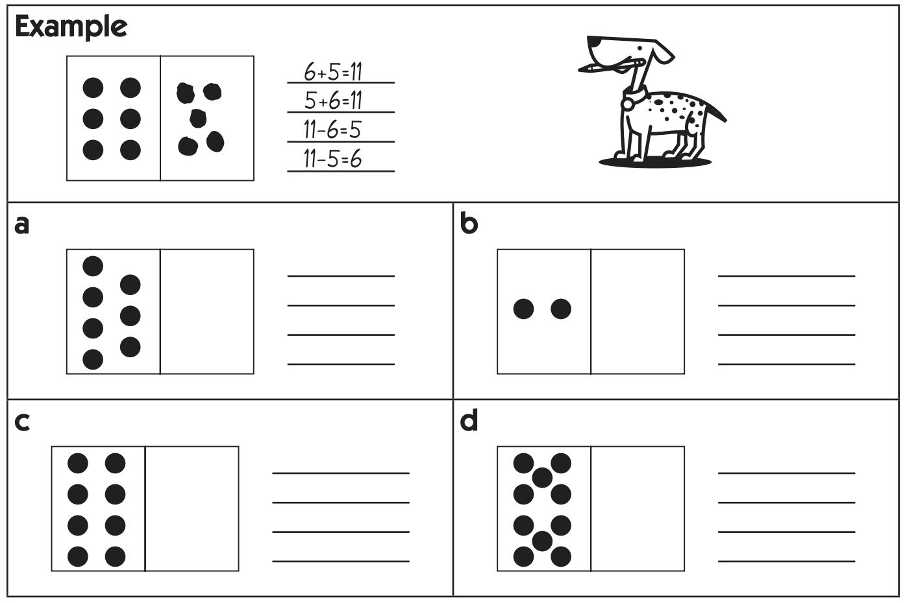  What is the question?  - The answer is 2. What is the question?  - The answer is 5. What is the question?  - The answer is 10. What is the question?  Visual Pattern  Below is a pattern of clouds in stages 1-3 below. Draw what you think stage 4 might look like. Label how many clouds are in each stage. (Source: visualpatterns.org)
Day 5 | Stories (Source: mathlearningcenter.org)  Read the story. Circle T if it is true. Circle F if it is false.  Read the story. Circle the matching equation.  Geometry  See how many of these solid shapes you can find in your home. (Source: mathlearningcenter.org)  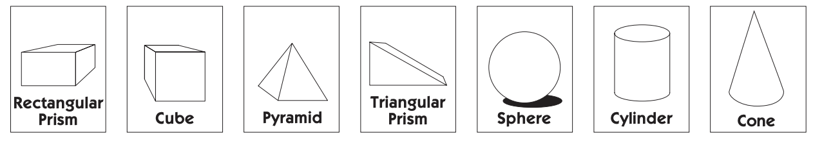  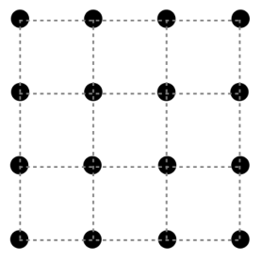  Dots and Boxes (Source: mathforlove.org)  Materials: pencil and paper  Dots and Boxes is a classic game for two players, played on a small grid of dots. On your turn, add a vertical or horizontal edge between neighbouring dots. If you complete a square, get one point and go again. Keep track of the score by colouring in your square, or writing your  initial inside it. (The grid size is up to you.)

 | Mathematics First level  Remote Learning Activities | WEEK 2

Day 1 | Ten Strips (Source: mathlearningcenter.org)  Colour the ten-strips to match each addition problem. Solve each equation.  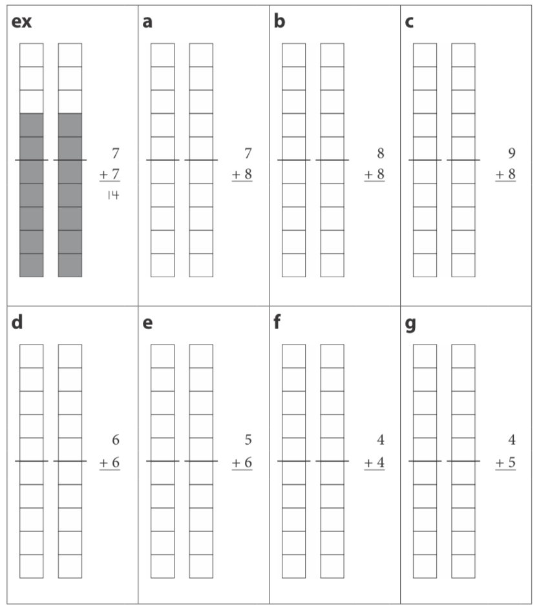  Number Line (Source: https://www.openmiddle.com/)  Fill in the missing number on the number line below. Explain your answer.  Here is why I wrote ______ in the empty box:  Mobile (Source: https://solveme.edc.org/Mobiles.html)  What is the value of the triangle?  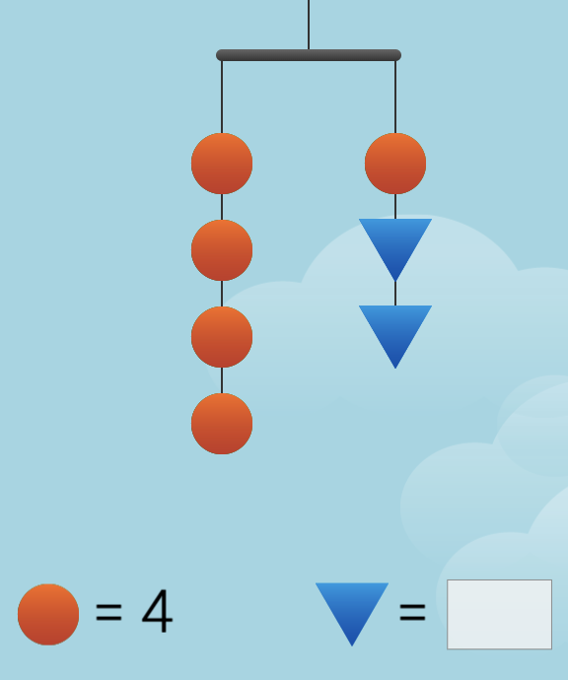
Day 2 | Counting (Source: visualpatterns.org)  How many hearts do you see? How did you count them?  Building (Source: mathlearningcenter.org)  Use some of the 3-D shapes you found a few days ago to build new shapes and creations. If you have Lego, Duplo, or building blocks, make something new with them. Draw pictures of your creations on a sheet of paper, or ask someone to take a picture of them to share.  Dominoes (Source: mathlearningcenter.org)  Write an equation to match the dominoes. Then draw a line to the word that tells how many in all. You won't find a match for every word.  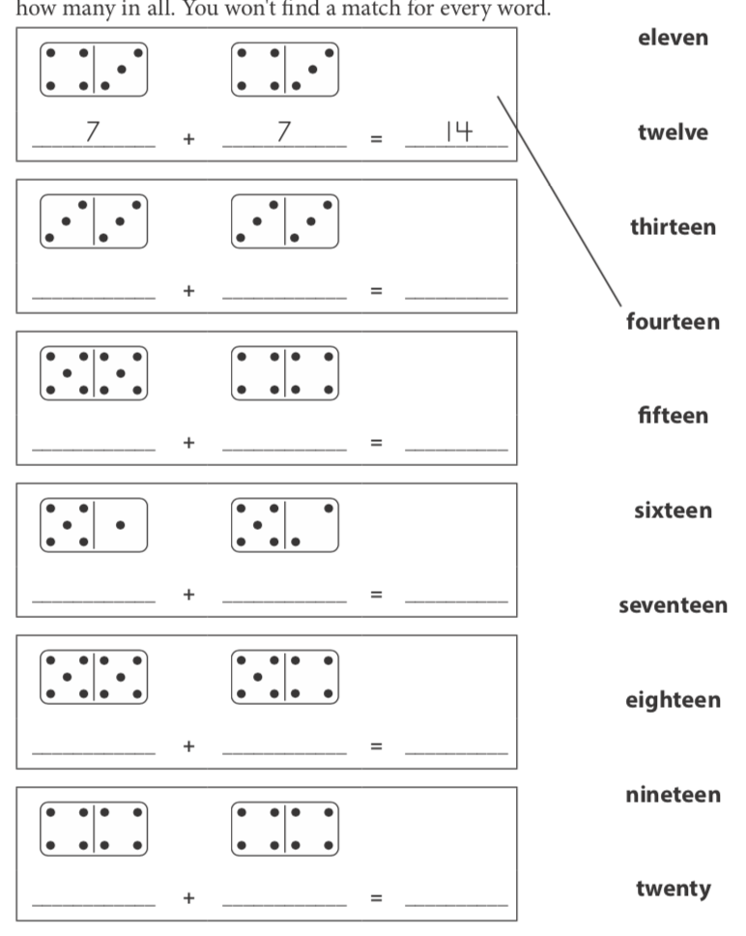
Day 3 | 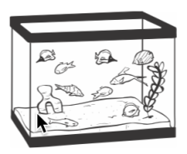  Story Problem (Source: mathlearningcenter.org)  Tim has 12 fish. Seven are yellow and the rest are red. How many red fish does Tim have? Show your work.  Make it Equal (Source: https://www.openmiddle.com/)  Using the digits 1 to 9 at most one time each, place a digit in each box to create a true statement.  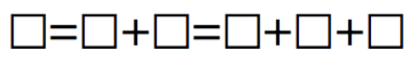  Which One Doesn’t Belong? (Source: wodb.ca)  Choose an animal in this picture that you don’t think belongs with the rest. Explain why. Can you pick another animal and give a different reason?  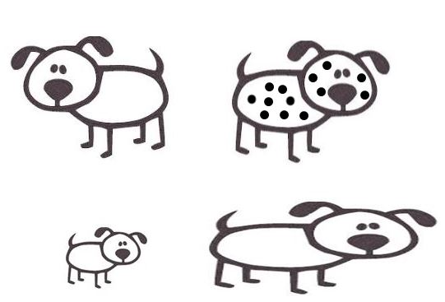
Day 4 | Coloring (Source: mathlearningcenter.org)  Colour half of each shape below.  Visual Pattern (Source: visualpatterns.org)  Below is a pattern of blocks in stages 1-3 below. Draw what you think stage 4 might look like. Label how many blocks are in each stage.  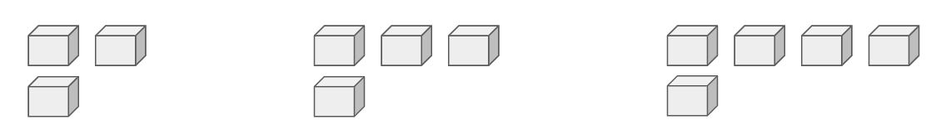  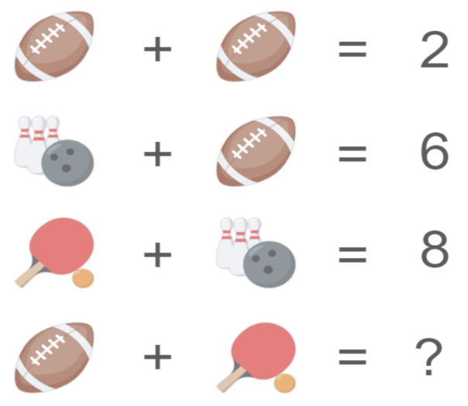  Puzzle (Source: https://www.solvemoji.com/)  What is the value of the last row?
Day 5 | Story Problems (Source: mathlearningcenter.org)  Solve the problems. Show all your work.  - Luis and his sister Elisa like to count cars as they go on walks. Luis counted 10 yesterday and Elisa counted 7 today. How many cars did they count in all?  - Breanna saved 16 pence. She spent 5 of them on stickers. How much does she have left?  Add (Source: mathlearningcenter.org)  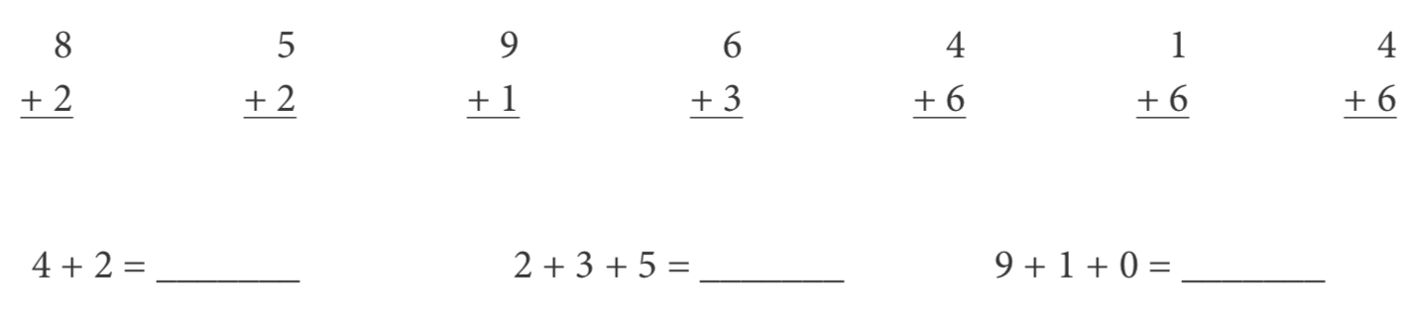  Noticing (Source: https://samedifferentimages.wordpress.com/)  In one column, list the things that are the same in this picture, and in the other column, list the things that are different.  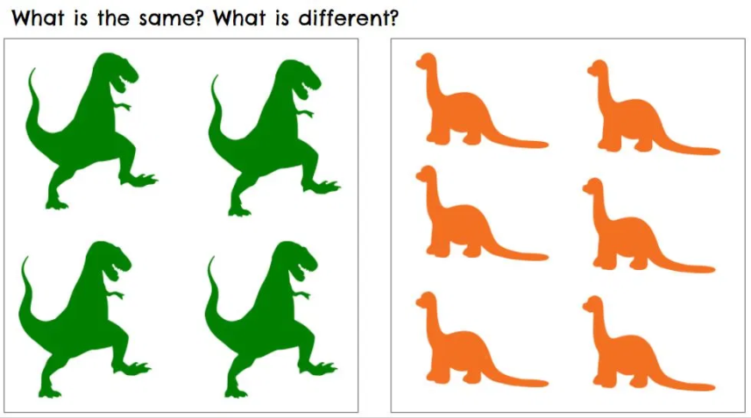  Same Different

 | Mathematics First Level  Remote Learning Activities | WEEK 3

Day 1 | Shapes & Stories (Source: mathlearningcenter.org)  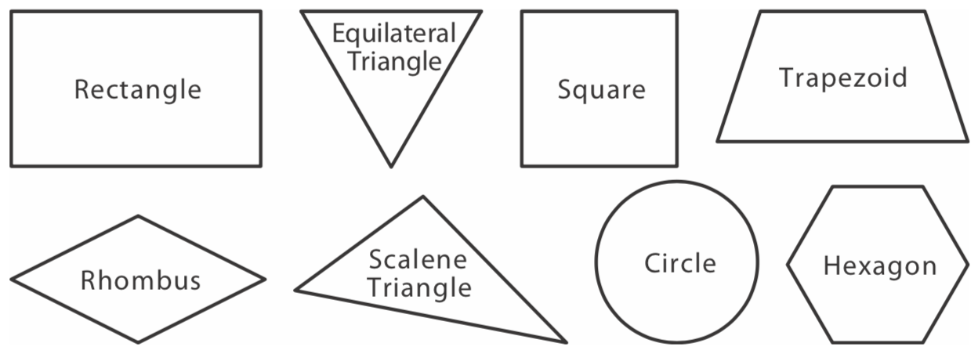  Solve the riddles below. Write the name of the shape in each box.  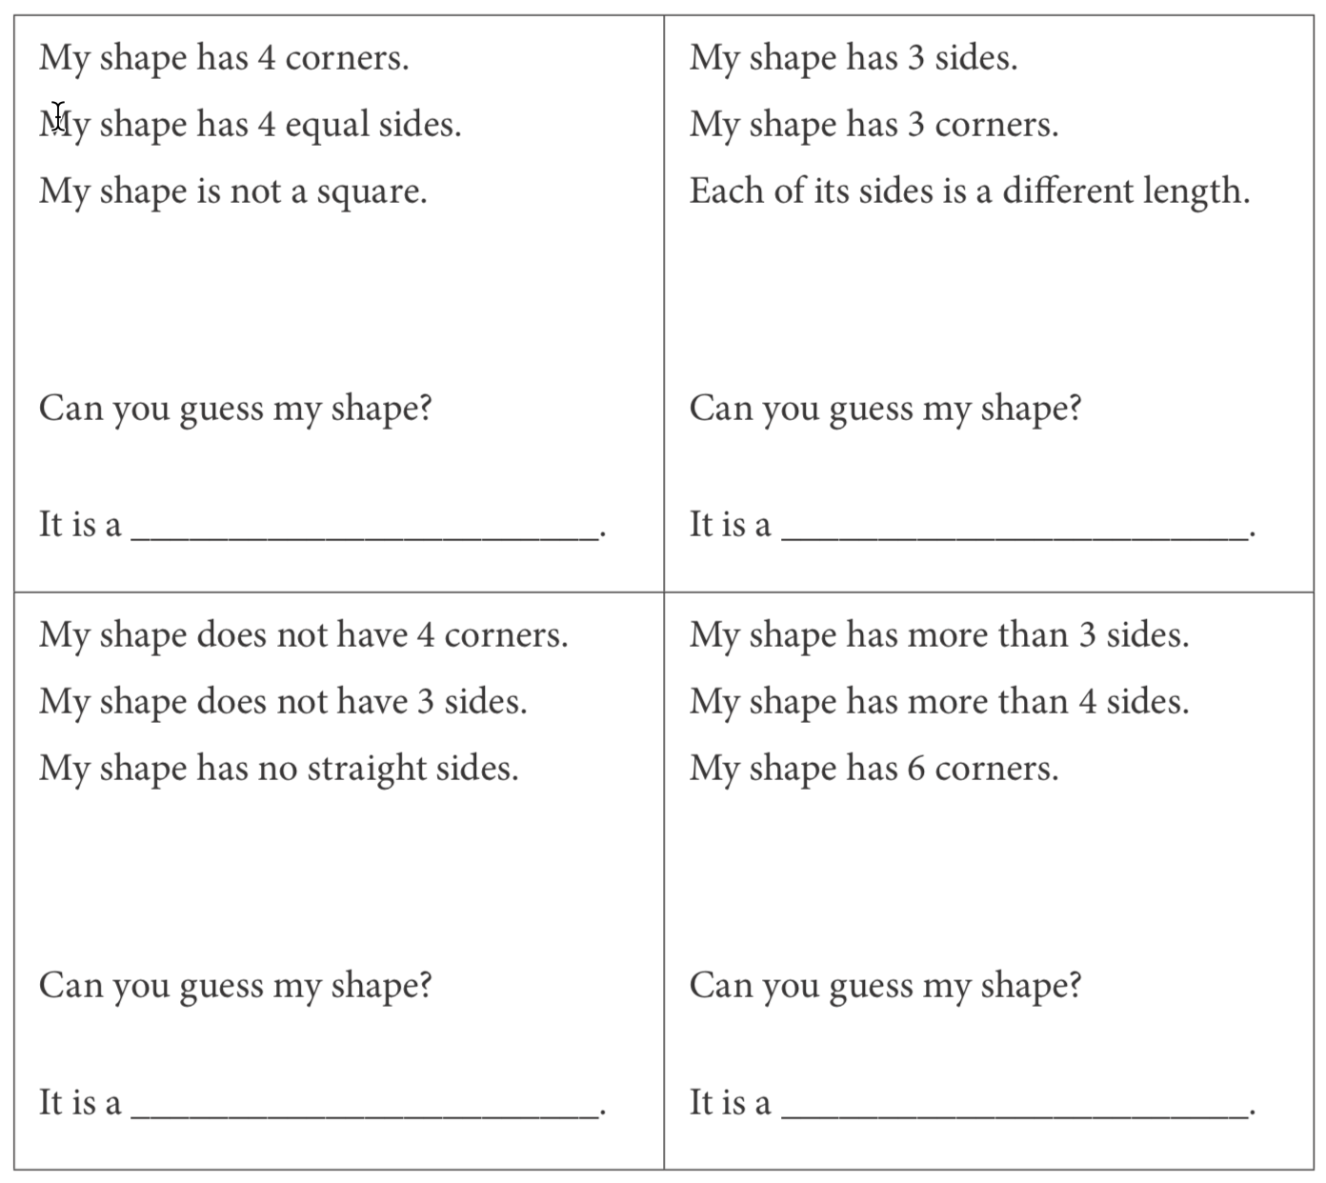  This question is a challenge question.  You might want to try it with an adult.  Window Sum (Source: https://www.openmiddle.com/)  Using the digits 0-9, no more than once, complete the puzzle so that the sum of each side is equivalent (the same).  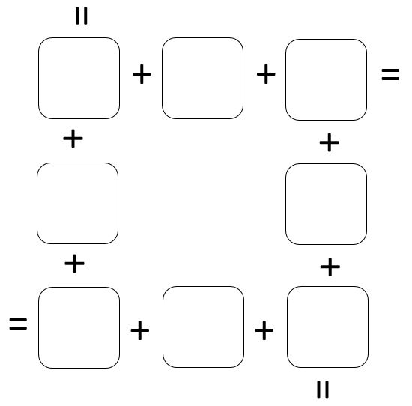  Counting (Image from https://www.mypetchicken.com/)  How many do you see? What did you count? How did you count them?  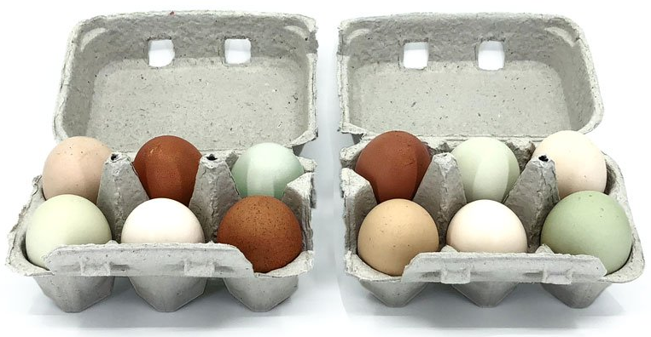
Day 2 | Figure the Facts with Penguins (Source: mathlearningcenter.org)  Here is a huddle of 10 penguins. Eight penguin pals are swimming toward the huddle so they can get warm too. How many penguins will there be in all when the 8 penguins join their friends? Write a calculation (sum) beside the picture to show.  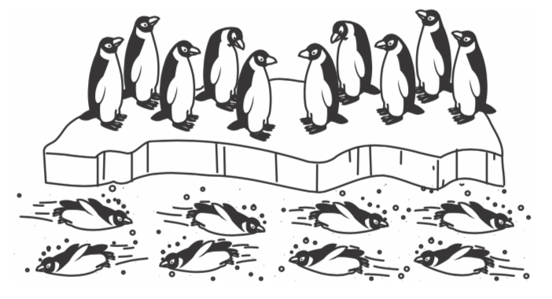  Here are 10 penguins in a huddle. Some more are coming to join them, and then there will be 13 penguins in the huddle. How many penguins are going to join the huddle? Fill in the empty box in the equation to show.  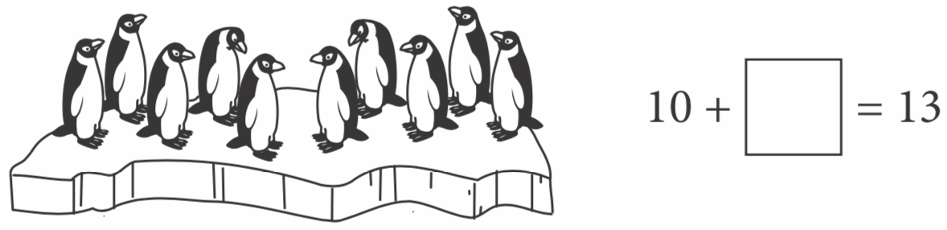  Domino Window (Source: https://www.openmiddle.com/)  Use four of these dominoes to form a square with the same number of dots on each side.  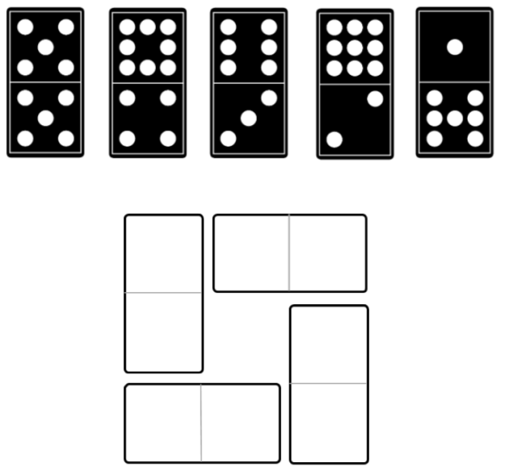  Number Talks (Source: mathforlove.org)  How many do you see? What did you count? How did you count them?
Day 3 | Addition (Source: mathlearningcenter.org)  Add.  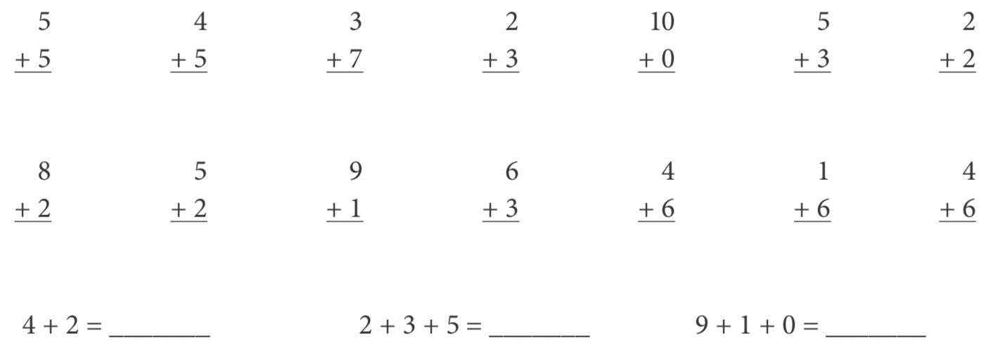  Which One Doesn’t Belong? (http://wodb.ca/)  Choose one heart in this picture that you don’t think it belongs with the rest. Explain why. Can you pick another heart and give a different reason?  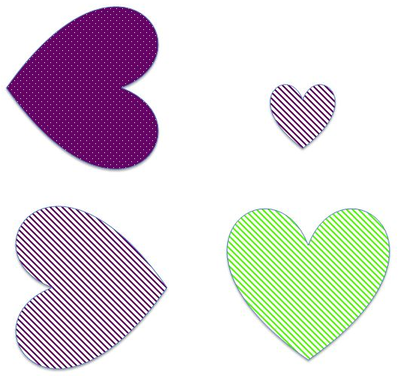  Visual Pattern (Source: visualpatterns.org)  Below is a pattern of cylinders in stages 1-3 below. Draw what you think stage 4 might look like. Label how many cylinders are in each stage.  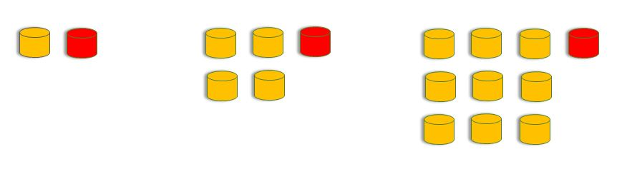  Noticing (Source: https://samedifferentimages.wordpress.com/)  On a piece of paper, make two columns. In one column, list the things that are the same in this picture, and in the other column, list the things that are different.  What is the same? What is different?  Same Different
Day 4 | Subtraction (Source: mathlearningcenter.org)  Subtract.  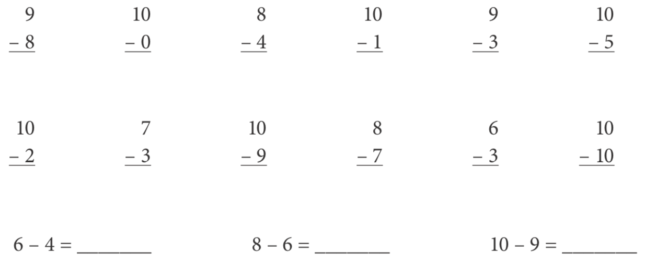  Ways to Make 10 (Source: mathlearningcenter.org)  5 + 5 is one way to make 10. 12 – 2 is another way to make 10. Think of some other ways to make 10. Write at least 10 different ways to make 10.  Would You Rather (Source: https://www.wouldyourathermath.com/)  Whichever option you choose, justify your reasoning with mathematics  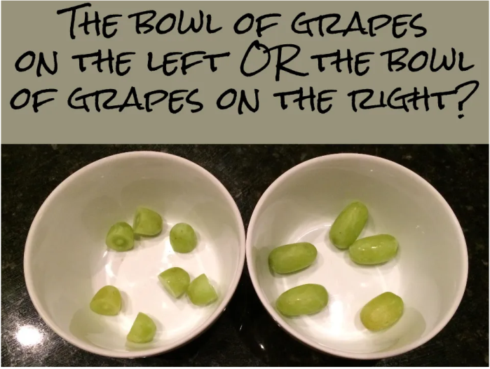  I would rather have_____________________because

Day 5 | Story Problem (Source: mathlearningcenter.org)  There were 5 penguins behind the hill, 4 penguins on the ice, and 10 penguins in the water. How many penguins in all?  Puzzle (Source: https://www.solvemoji.com/)  What is the value of the last row?  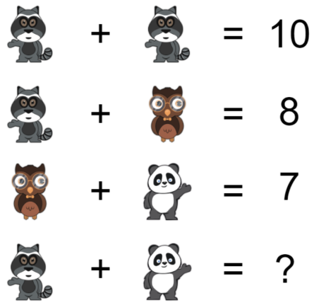  More Penguins (Source: mathlearningcenter.org)  See how many penguins are standing on the ice? Half as many are swimming in the water. How many are swimming? How many penguins in total?  