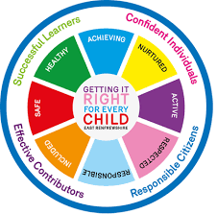

Clyde Primary School
Child Protection Policy

Safeguarding and Child Protection – QI 2.1

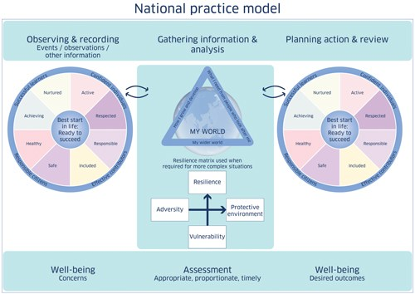
Rationale

‘We are all responsible for keeping children safe from harm, whether it be at home, at school or in the community. Child protection is not only the responsibility of social work services but is the responsibility of families, the community, education and health.’

(Glasgow City Council Website August 2015)

All educational establishments and services must take positive steps to help children protect themselves by ensuring that programmes of health and personal safety are central to the curriculum and should have in place a curriculum that ensures that children have a clear understanding of the difference between appropriate and inappropriate behaviour on the part of another person, no matter who.

Aims

- To ensure that all children are safe, well and flourishing.
- To ensure that children are respected and listened to.
- To ensure that all staff are aware of their responsibilities with regards to Child Protection Policy and Procedures.
- To ensure that programmes of health and personal safety are central to our curriculum.
- To establish and maintain close working relationships and arrangements with all other agencies to make sure that professionals collaborate effectively in protecting children.

How aims can be achieved?

- By informing parents/carers of policy and procedures.
- By discussing Management Circular 57 and Child Protection Policy and Procedures with all staff annually - August Inset Day.
- By ensuring that all temporary staff, students and visitors read Management Circular 57 and the school’s Child Protection Policy and are aware of their responsibility to keep children safe and well. These staff/students/visitors complete CP sign in form.
- By ensuring that if any member of staff has concerns regarding the welfare or safety of any child they must report these concerns to the Head Teacher or the person deputising for the Head Teacher. After judging that there may be grounds for concern regarding the welfare or safety of any child this person must then immediately advise the duty senior social worker at the local social work services area office of the circumstances.

Step by Step Guide to Procedures

MANAGEMENT CIRCULAR 57 – CHILD PROTECTION GUIDELINES
Summary of Reporting, Recording and Monitoring Procedures: Public Display

A concern prompted by any of the following should be reported in accordance with the stated procedures outlined below:

• a specific incident;
• a disclosure made by a child or parent/carer;
• information from a third party;
• adult behaviours/circumstances that may place the child at risk of harm;
• child behaviours/circumstances that may place the child at risk of harm;
• a culmination of minor concerns over a period of time.

Responsible Members of Staff

Each class teacher will be responsible for the implementation of the Child Protection Policy within their own class. This will be assisted and monitored by Scott Mowat (HT) and Mrs Montgomery (DHT), supported by Mr Digweed (DHT).

Role of Head Teacher / Depute Head Teacher

- To respond to and follow Child Protection Policy and Procedures.
- To establish and maintain close working relationships and arrangements with all other agencies to make sure that professionals collaborate effectively in protecting children.
- To ensure that all children are aware of the Child Protection Co-Ordinators on a regular basis.

Role of Class Teacher

- To ensure that all children are safe, well and flourishing.
- To ensure that children are respected and listened to.
- To ensure that they are aware of their responsibilities with regards to Child Protection Policy and Procedures.
- To ensure that programmes of health and personal safety are central to the curriculum.
- To ensure that all children are aware of the Child Protection Co-Ordinators on a regular basis.

Role of Support for Learning Worker

- To ensure that all children are safe, well and flourishing.
- To ensure that children are respected and listened to.
- To ensure that they are aware of their responsibilities with regards to Child Protection Policy and Procedures.
- To support teaching staff, where appropriate, in delivering programmes of health and personal safety.

Record Keeping

- Completion of Record of Concern Form Alert. (Please ensure the area you work in has these available.)
- Completion of Notification of Concern Referral Form to Social Services and App 5. to CYPS.
- Completion of notes on SEEMIS Pastoral Notes.

Monitoring and Review
Monitoring and review will be undertaken under the Quality Assurance procedures undertaken within the school.

Review August 2022

